Automatice Report for pypl

# Analyzing the Headline Accuracy

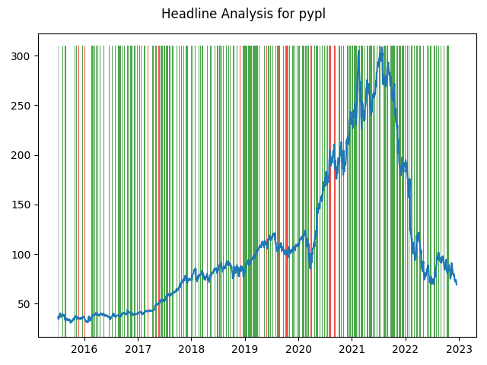

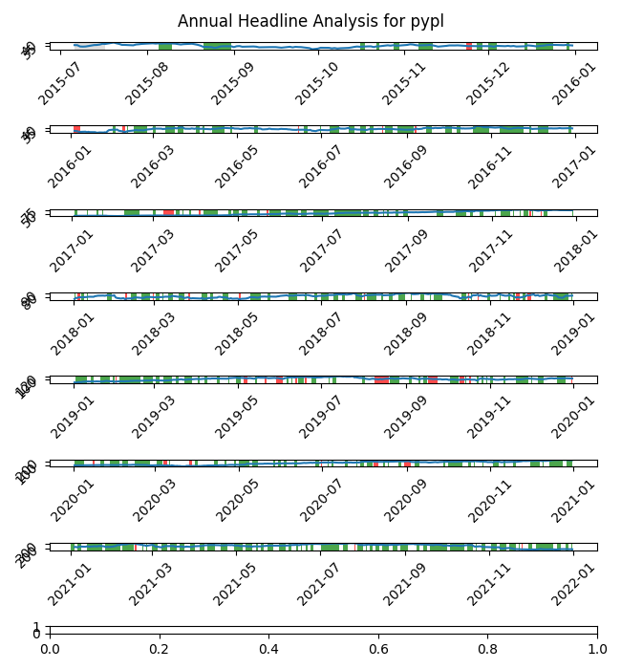

# A Little Bit More Insight Into the Headlines

The best headline was"Best ETFs for 2020: Former Champion PowerShares QQQ Trust Returns" which occured on 2019-12-12 and had a Sentiment Score of 0.9081

The worst headline was"Google Wallet is Making Strides, But it's No Venmo Killer" which occured on 2017-04-22 and had a Sentiment Score of -0.8674

|  |  |  |  |  |  |  |
| --- | --- | --- | --- | --- | --- | --- |
| Timeframe | -1_min | -1_mean | -1_max | 1_min | 1_mean | 1_max |
| 1-day | -13.15 | -0.15 | 8.46 | -43.23 | 0.02 | 18.53 |
| 3-day | -25.81 | -0.33 | 16.14 | -49.72 | 0.03 | 30.27 |
| 7-day | -37.35 | -0.63 | 29.43 | -56.78 | 0.04 | 49.89 |
| 14-day | -56.71 | -0.79 | 29.4 | -78.7 | -0.07 | 67.26 |
| 21-day | -72.5 | -0.89 | 45.68 | -74.46 | -0.13 | 62.73 |
| 28-day | -88.35 | 0.15 | 52.81 | -86.48 | -0.41 | 70.37 |

# Analyzing the Technical Indicators

## Looking at RSI

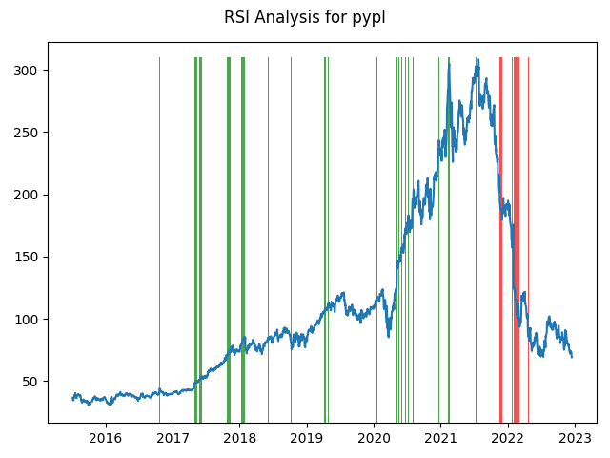

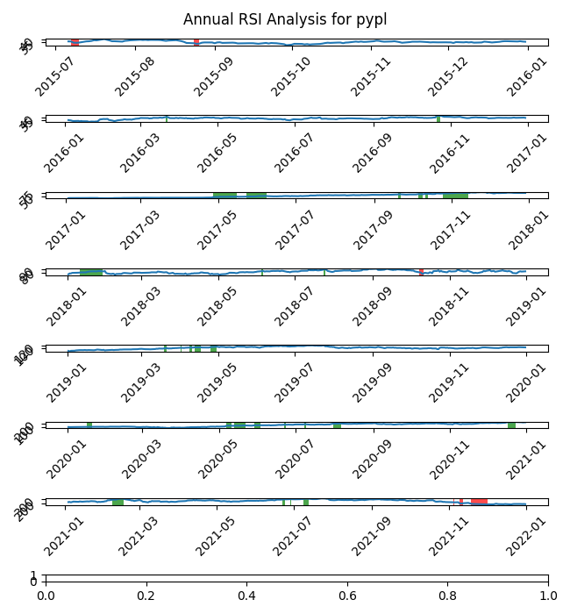

|  |  |  |  |  |  |  |
| --- | --- | --- | --- | --- | --- | --- |
| Timeframe | -1_min | -1_mean | -1_max | 1_min | 1_mean | 1_max |
| 1-day | -8.27 | -0.23 | 9.48 | -7.59 | -0.23 | 13.34 |
| 3-day | -22.8 | -0.47 | 17.69 | -24.87 | -0.65 | 21.61 |
| 7-day | -36.7 | -4.22 | 17.26 | -50.85 | -1.3 | 9.62 |
| 14-day | -47.57 | -8.64 | 21.27 | -78.7 | -1.27 | 16.01 |
| 21-day | -61.45 | -7.36 | 24.04 | -58.79 | 0.52 | 22.66 |
| 28-day | -64.59 | -6.64 | 21.14 | -64.13 | -0.06 | 30.99 |

## Looking at OBV

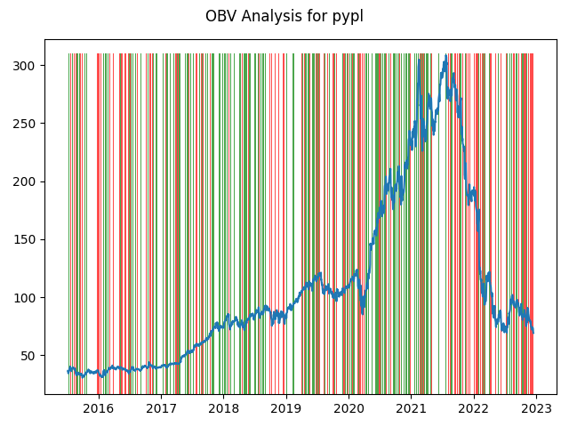

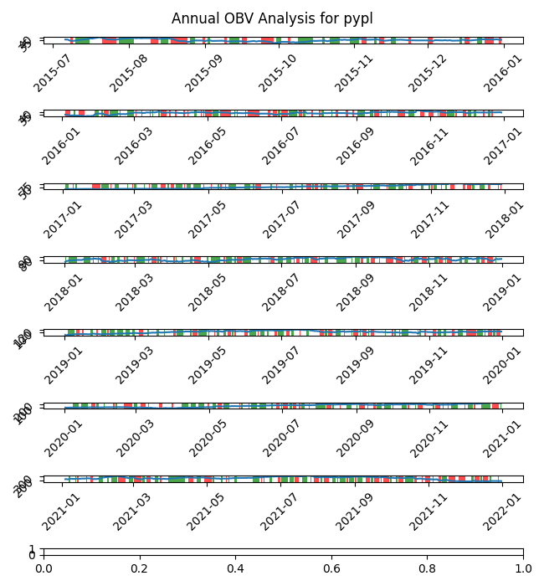

|  |  |  |  |  |  |  |
| --- | --- | --- | --- | --- | --- | --- |
| Timeframe | -1_min | -1_mean | -1_max | 1_min | 1_mean | 1_max |
| 1-day | -18.01 | 0.06 | 15.67 | -43.23 | -0.0 | 18.53 |
| 3-day | -30.14 | 0.17 | 27.74 | -49.72 | -0.01 | 30.27 |
| 7-day | -37.35 | 0.29 | 49.89 | -56.78 | 0.1 | 46.47 |
| 14-day | -56.71 | 0.23 | 67.26 | -78.7 | 0.47 | 53.02 |
| 21-day | -71.91 | 0.09 | 62.73 | -74.46 | 0.87 | 53.47 |
| 28-day | -86.48 | 0.56 | 70.37 | -88.35 | 0.69 | 69.88 |

## Looking at ADX

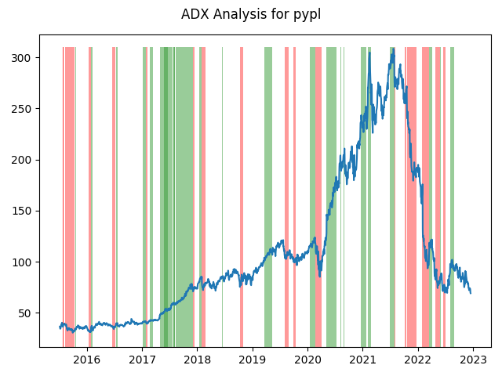

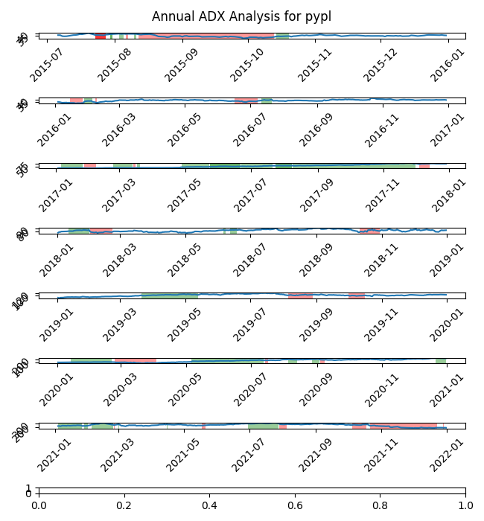

|  |  |  |  |  |  |  |  |  |  |  |  |  |
| --- | --- | --- | --- | --- | --- | --- | --- | --- | --- | --- | --- | --- |
| Timeframe | -2_min | -2_mean | -2_max | -1_min | -1_mean | -1_max | 1_min | 1_mean | 1_max | 2_min | 2_mean | 2_max |
| 1-day | 0.5 | 0.5 | 0.5 | -24.0 | 0.04 | 13.78 | -18.81 | -0.05 | 17.98 | -1.24 | 0.14 | 1.36 |
| 3-day | 1.44 | 1.44 | 1.44 | -47.64 | -0.45 | 18.31 | -34.56 | -0.17 | 28.58 | -2.33 | 0.29 | 2.46 |
| 7-day | 1.18 | 1.18 | 1.18 | -49.0 | -1.51 | 39.5 | -50.85 | -0.11 | 49.89 | -2.01 | 0.44 | 3.33 |
| 14-day | 0.04 | 0.04 | 0.04 | -68.29 | -2.1 | 67.26 | -78.7 | -0.22 | 63.79 | -2.72 | 0.75 | 3.01 |
| 21-day | -3.33 | -3.33 | -3.33 | -65.33 | -2.45 | 38.75 | -58.79 | -0.09 | 62.73 | -3.7 | 2.24 | 7.12 |
| 28-day | -3.25 | -3.25 | -3.25 | -82.54 | -2.68 | 52.81 | -65.93 | 0.64 | 70.37 | -5.24 | 3.64 | 8.31 |

# Analyzing the Analyst Agencies

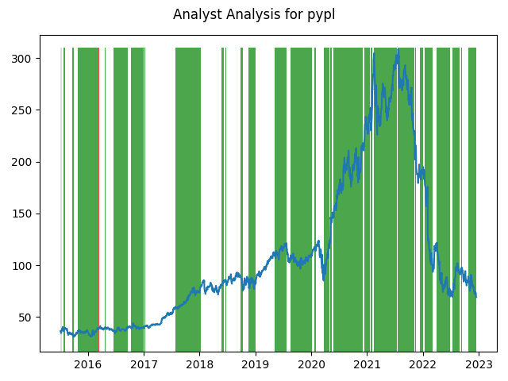

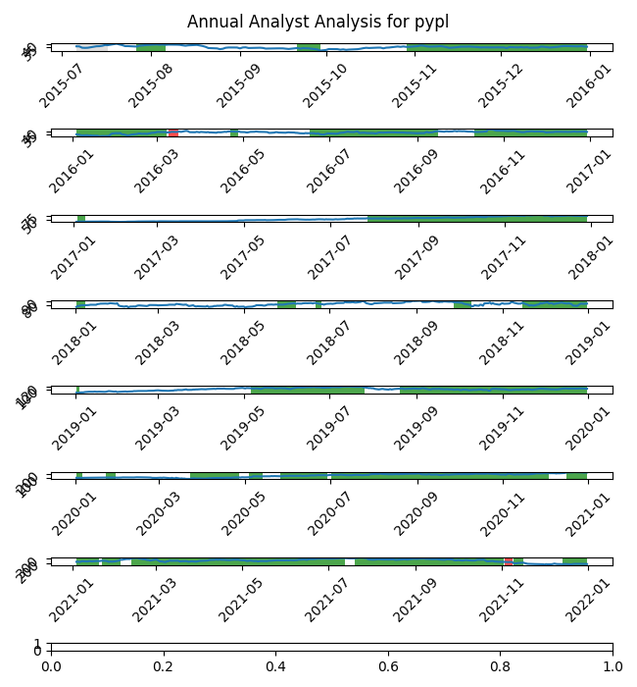

|  |  |  |  |  |  |  |
| --- | --- | --- | --- | --- | --- | --- |
| Timeframe | -1_min | -1_mean | -1_max | 1_min | 1_mean | 1_max |
| 1-day | -24.0 | -2.36 | 3.64 | -43.23 | -0.01 | 18.53 |
| 3-day | -27.39 | -6.84 | 1.3 | -49.72 | -0.01 | 30.27 |
| 7-day | -23.15 | -6.6 | 2.65 | -56.78 | 0.06 | 49.89 |
| 14-day | -42.33 | -16.35 | 0.47 | -78.7 | 0.63 | 67.26 |
| 21-day | -46.45 | -16.14 | -0.16 | -74.46 | 0.9 | 62.73 |
| 28-day | -43.58 | -15.72 | 1.59 | -88.35 | 1.27 | 70.37 |