Automatice Report for sbac

# Analyzing the Headline Accuracy

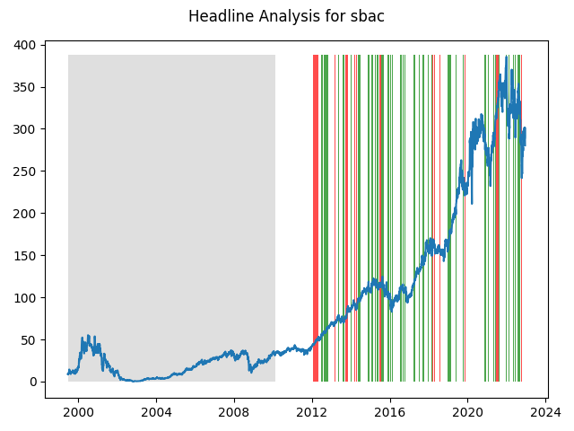

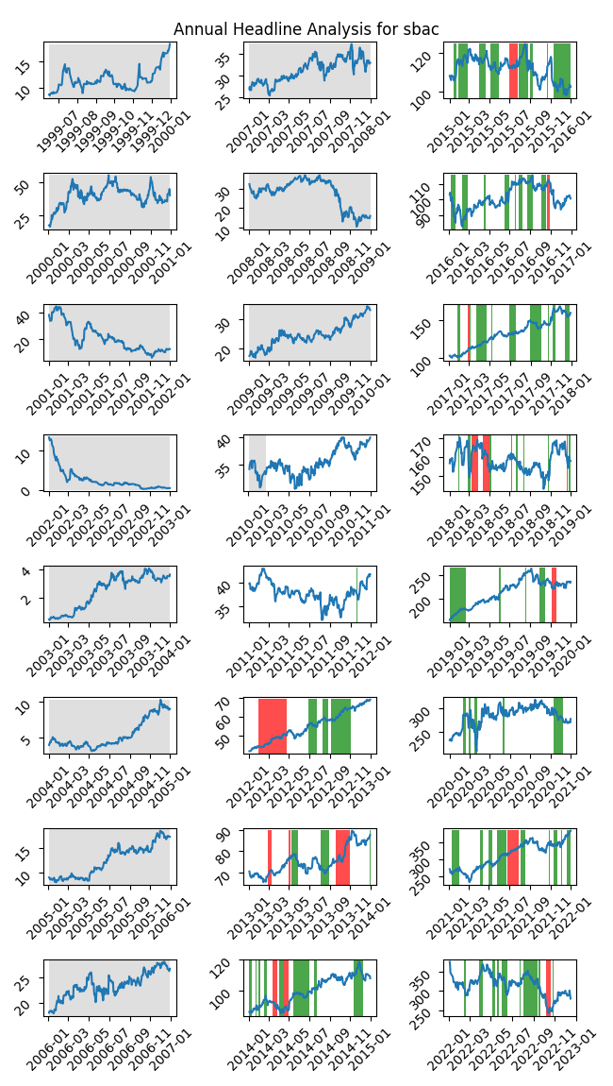

# A Little Bit More Insight Into the Headlines

The best headline was"After Hours Most Active for Aug 10, 2012 : KMI, LINTA, QQQ, EDU, TSM, ETE, DHI, ANR, WIN, EBAY, SBAC, KFT" which occured on 2012-08-10 and had a Sentiment Score of 0.8189

The worst headline was"American Tower Posts Mixed 4Q - Analyst Blog" which occured on 2012-01-30 and had a Sentiment Score of -0.7034

|  |  |  |  |  |  |  |
| --- | --- | --- | --- | --- | --- | --- |
| Timeframe | -1_min | -1_mean | -1_max | 1_min | 1_mean | 1_max |
| 1-day | -10.62 | 0.23 | 11.01 | -18.86 | 0.05 | 26.22 |
| 3-day | -17.78 | 0.58 | 13.37 | -44.18 | 0.29 | 48.0 |
| 7-day | -16.01 | 1.57 | 21.89 | -46.91 | 0.57 | 44.06 |
| 14-day | -17.76 | 3.36 | 31.11 | -76.0 | 0.55 | 74.87 |
| 21-day | -14.27 | 5.1 | 52.16 | -77.96 | -0.41 | 89.18 |
| 28-day | -18.05 | 6.12 | 56.09 | -85.21 | -0.7 | 69.8 |

# Analyzing the Technical Indicators

## Looking at RSI

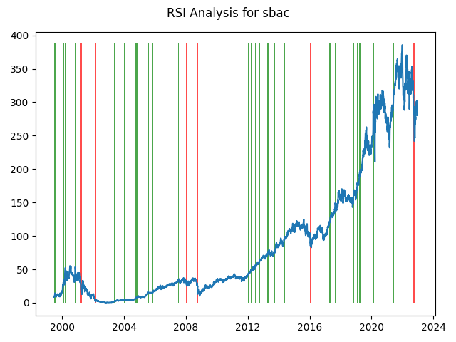

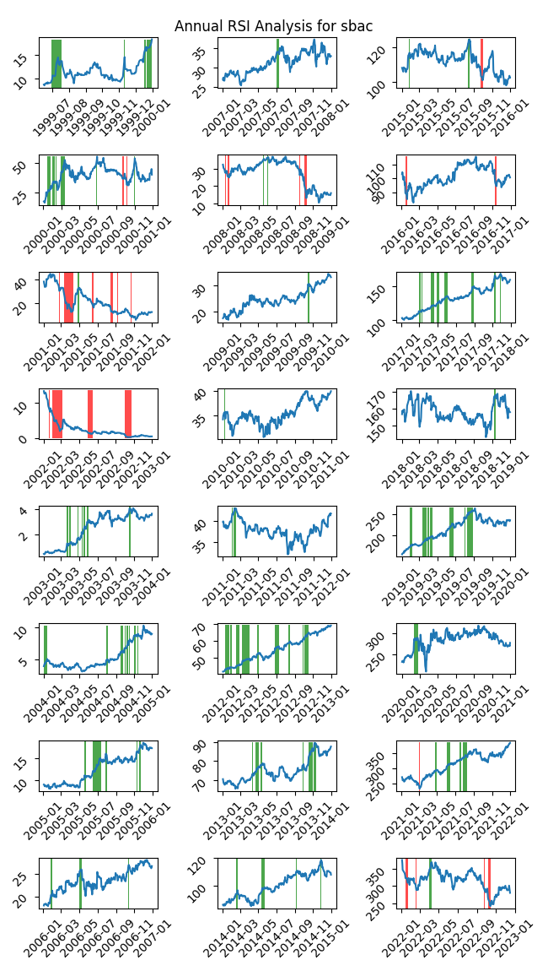

|  |  |  |  |  |  |  |
| --- | --- | --- | --- | --- | --- | --- |
| Timeframe | -1_min | -1_mean | -1_max | 1_min | 1_mean | 1_max |
| 1-day | -10.62 | -0.05 | 14.07 | -11.34 | 0.05 | 18.82 |
| 3-day | -17.78 | 0.14 | 16.05 | -37.91 | -0.12 | 24.47 |
| 7-day | -25.76 | 0.63 | 30.05 | -46.91 | -0.12 | 26.77 |
| 14-day | -50.59 | 0.83 | 36.58 | -76.0 | 0.07 | 19.85 |
| 21-day | -47.32 | 2.55 | 52.16 | -78.03 | -0.27 | 24.86 |
| 28-day | -31.6 | 4.25 | 56.09 | -70.31 | -0.11 | 28.77 |

## Looking at OBV

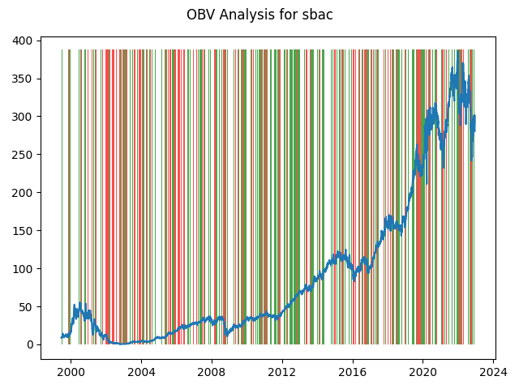

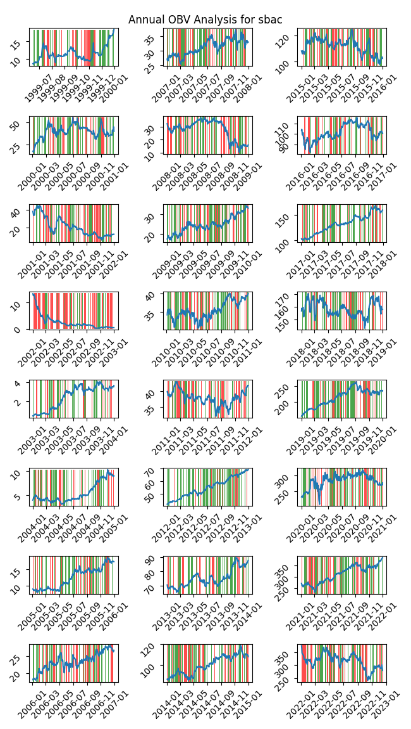

|  |  |  |  |  |  |  |
| --- | --- | --- | --- | --- | --- | --- |
| Timeframe | -1_min | -1_mean | -1_max | 1_min | 1_mean | 1_max |
| 1-day | -19.97 | 0.02 | 26.22 | -24.65 | 0.07 | 20.9 |
| 3-day | -43.85 | 0.06 | 48.0 | -44.18 | 0.22 | 34.77 |
| 7-day | -47.48 | 0.34 | 44.06 | -46.91 | 0.33 | 42.25 |
| 14-day | -55.5 | 0.84 | 74.87 | -76.0 | 0.54 | 59.1 |
| 21-day | -72.77 | 1.13 | 89.18 | -78.03 | 0.92 | 63.07 |
| 28-day | -69.16 | 1.58 | 69.8 | -85.21 | 1.15 | 63.46 |

## Looking at ADX

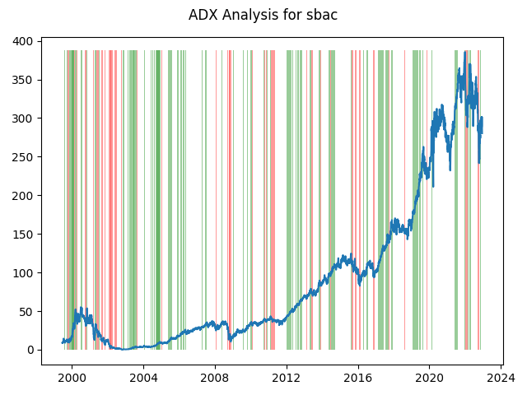

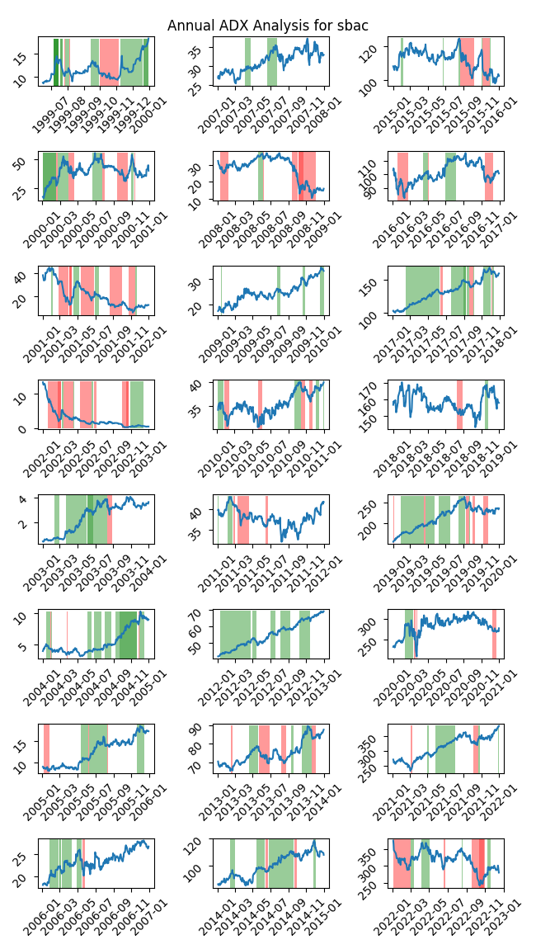

|  |  |  |  |  |  |  |  |  |  |  |  |  |
| --- | --- | --- | --- | --- | --- | --- | --- | --- | --- | --- | --- | --- |
| Timeframe | -2_min | -2_mean | -2_max | -1_min | -1_mean | -1_max | 1_min | 1_mean | 1_max | 2_min | 2_mean | 2_max |
| 1-day | -7.63 | 0.59 | 11.01 | -24.65 | -0.04 | 26.22 | -19.97 | 0.01 | 19.51 | -3.78 | 0.05 | 3.78 |
| 3-day | -10.04 | 2.03 | 15.48 | -44.18 | -0.1 | 48.0 | -37.91 | -0.05 | 37.29 | -7.13 | 0.22 | 8.71 |
| 7-day | -2.4 | 5.09 | 27.49 | -47.48 | -0.11 | 44.06 | -46.91 | -0.21 | 21.06 | -5.85 | 0.89 | 10.72 |
| 14-day | -2.41 | 10.8 | 50.52 | -50.59 | 0.18 | 71.99 | -76.0 | -0.13 | 23.06 | -9.45 | 2.33 | 15.35 |
| 21-day | -7.29 | 12.79 | 52.16 | -53.23 | 0.99 | 89.18 | -78.03 | 0.53 | 45.59 | -10.41 | 4.03 | 18.52 |
| 28-day | -7.27 | 11.69 | 56.09 | -59.58 | 2.24 | 69.8 | -70.31 | 1.32 | 56.34 | -4.5 | 5.4 | 20.1 |

# Analyzing the Analyst Agencies

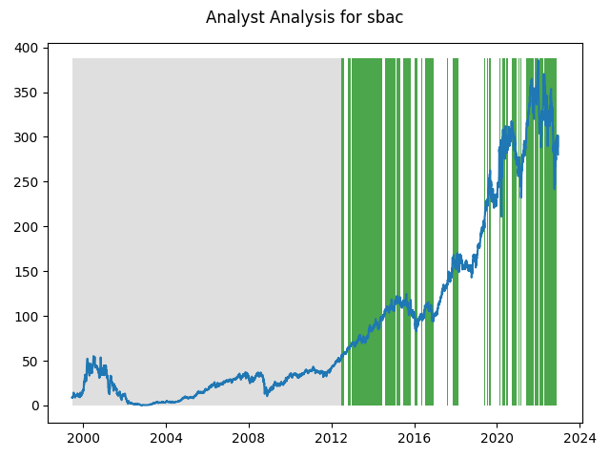

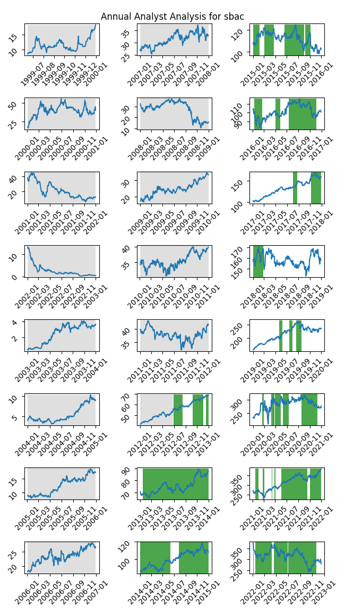

|  |  |  |  |  |  |  |
| --- | --- | --- | --- | --- | --- | --- |
| Timeframe | -1_min | -1_mean | -1_max | 1_min | 1_mean | 1_max |
| 1-day | nan | nan | nan | -18.86 | -0.02 | 24.87 |
| 3-day | nan | nan | nan | -37.91 | -0.03 | 37.29 |
| 7-day | nan | nan | nan | -46.91 | -0.02 | 39.2 |
| 14-day | nan | nan | nan | -76.0 | -0.1 | 50.52 |
| 21-day | nan | nan | nan | -78.03 | -0.26 | 52.16 |
| 28-day | nan | nan | nan | -85.21 | -0.09 | 66.12 |