Automatice Report for slb

# Analyzing the Headline Accuracy

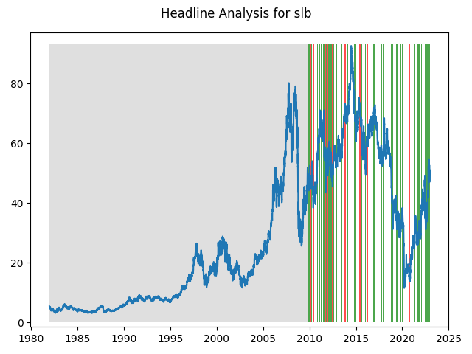

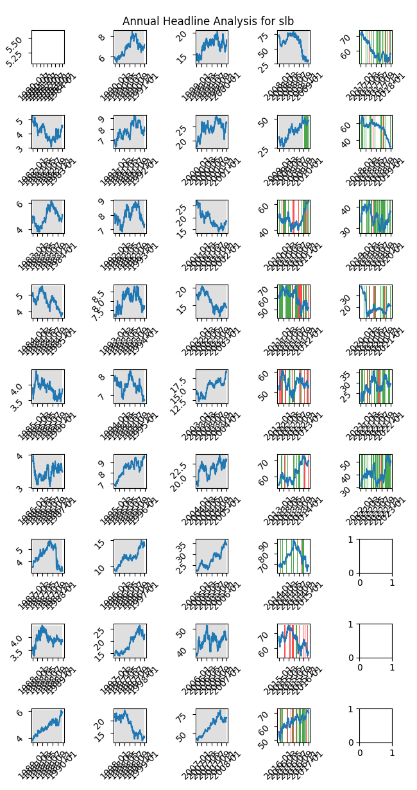

# A Little Bit More Insight Into the Headlines

The best headline was"Is Liberty Energy (LBRT) a Great Value Stock Right Now?" which occured on 2022-07-06 and had a Sentiment Score of 0.9001

The worst headline was"OPEC's No to Oil Production Cut Dents Crude Prices: 3 Energy Funds to Dump - Mutual Fund Commentary" which occured on 2014-12-03 and had a Sentiment Score of -0.8176

|  |  |  |  |  |  |  |
| --- | --- | --- | --- | --- | --- | --- |
| Timeframe | -1_min | -1_mean | -1_max | 1_min | 1_mean | 1_max |
| 1-day | -3.11 | -0.01 | 4.7 | -6.21 | 0.03 | 5.39 |
| 3-day | -7.26 | -0.05 | 6.76 | -10.14 | 0.08 | 8.49 |
| 7-day | -10.85 | -0.05 | 9.09 | -13.29 | 0.08 | 10.27 |
| 14-day | -13.78 | 0.12 | 10.89 | -15.62 | 0.06 | 11.41 |
| 21-day | -14.13 | 0.44 | 17.09 | -19.39 | 0.02 | 18.55 |
| 28-day | -18.2 | 0.71 | 16.09 | -20.38 | -0.13 | 19.3 |

# Analyzing the Technical Indicators

## Looking at RSI

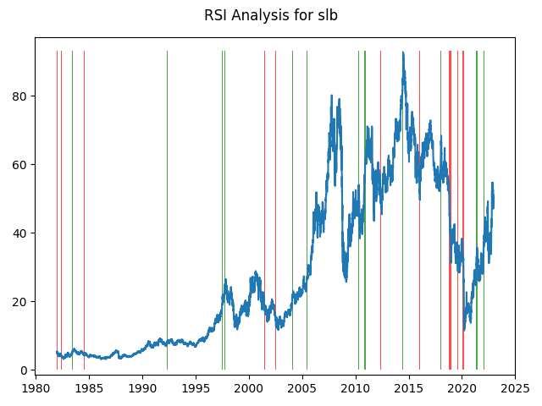

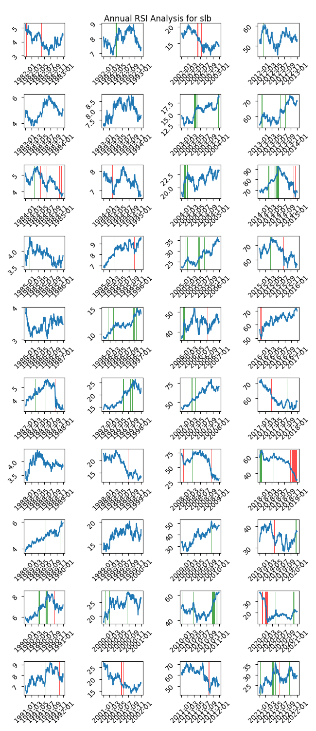

|  |  |  |  |  |  |  |
| --- | --- | --- | --- | --- | --- | --- |
| Timeframe | -1_min | -1_mean | -1_max | 1_min | 1_mean | 1_max |
| 1-day | -6.21 | 0.05 | 4.15 | -2.1 | -0.01 | 3.63 |
| 3-day | -9.28 | 0.1 | 6.83 | -9.13 | -0.05 | 5.67 |
| 7-day | -11.77 | -0.1 | 9.09 | -10.0 | -0.07 | 7.08 |
| 14-day | -16.02 | -0.15 | 7.63 | -12.53 | -0.04 | 8.97 |
| 21-day | -15.46 | -0.14 | 11.61 | -13.92 | -0.08 | 11.26 |
| 28-day | -22.29 | -0.4 | 12.28 | -15.39 | -0.11 | 10.74 |

## Looking at OBV

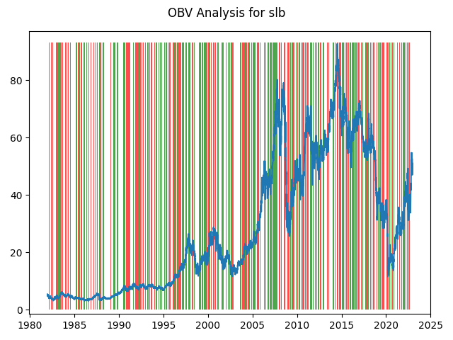

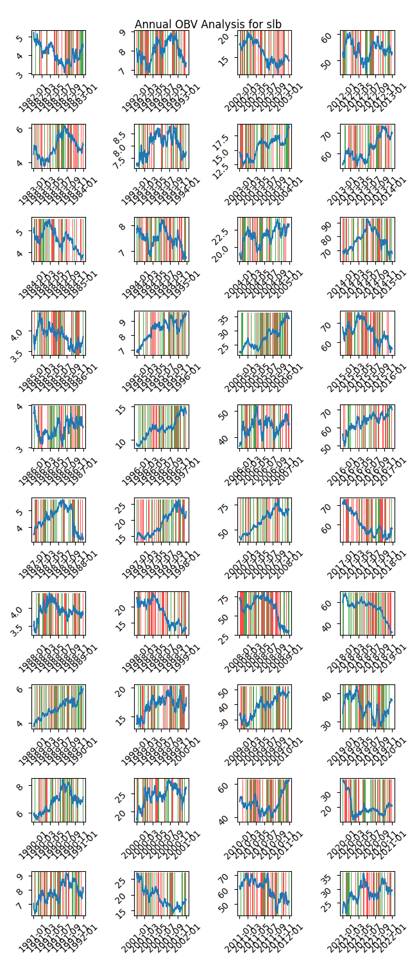

|  |  |  |  |  |  |  |
| --- | --- | --- | --- | --- | --- | --- |
| Timeframe | -1_min | -1_mean | -1_max | 1_min | 1_mean | 1_max |
| 1-day | -8.86 | 0.0 | 5.39 | -8.85 | 0.01 | 5.82 |
| 3-day | -11.22 | 0.03 | 8.49 | -12.03 | 0.0 | 8.7 |
| 7-day | -14.81 | 0.06 | 10.99 | -13.68 | 0.01 | 10.28 |
| 14-day | -23.68 | 0.09 | 10.89 | -24.25 | 0.04 | 12.99 |
| 21-day | -30.83 | 0.15 | 18.55 | -29.21 | 0.05 | 18.87 |
| 28-day | -27.94 | 0.19 | 17.88 | -28.73 | 0.07 | 19.3 |

## Looking at ADX

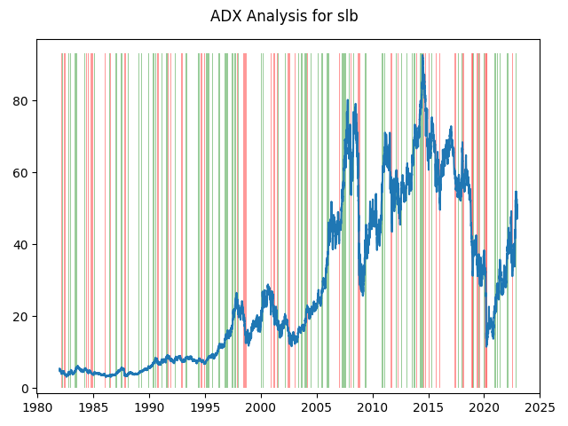

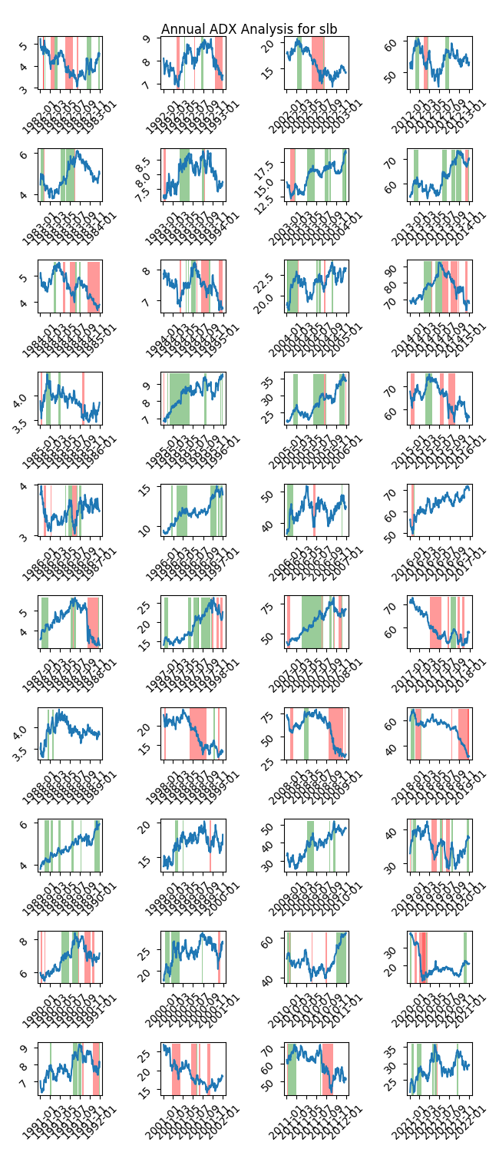

|  |  |  |  |  |  |  |  |  |  |  |  |  |
| --- | --- | --- | --- | --- | --- | --- | --- | --- | --- | --- | --- | --- |
| Timeframe | -2_min | -2_mean | -2_max | -1_min | -1_mean | -1_max | 1_min | 1_mean | 1_max | 2_min | 2_mean | 2_max |
| 1-day | -1.85 | 0.18 | 1.73 | -8.86 | 0.02 | 5.82 | -8.8 | -0.01 | 5.39 | -0.63 | -0.05 | 0.51 |
| 3-day | -1.93 | 0.81 | 2.93 | -12.03 | 0.02 | 6.83 | -11.22 | -0.01 | 8.49 | -1.14 | -0.22 | 0.65 |
| 7-day | -1.54 | 1.69 | 4.93 | -14.81 | -0.03 | 9.09 | -13.29 | 0.01 | 8.42 | -2.21 | -0.64 | 0.12 |
| 14-day | -1.4 | 2.8 | 7.2 | -23.68 | -0.18 | 10.16 | -12.81 | 0.09 | 9.19 | -0.89 | 0.41 | 2.86 |
| 21-day | -0.04 | 3.42 | 8.69 | -30.83 | -0.31 | 11.61 | -15.29 | 0.07 | 10.82 | -0.55 | 0.96 | 2.64 |
| 28-day | -0.81 | 3.74 | 8.81 | -28.73 | -0.49 | 14.05 | -15.63 | 0.11 | 12.55 | -0.72 | 1.8 | 3.26 |

# Analyzing the Analyst Agencies

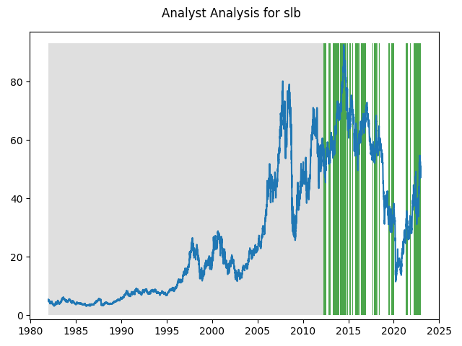

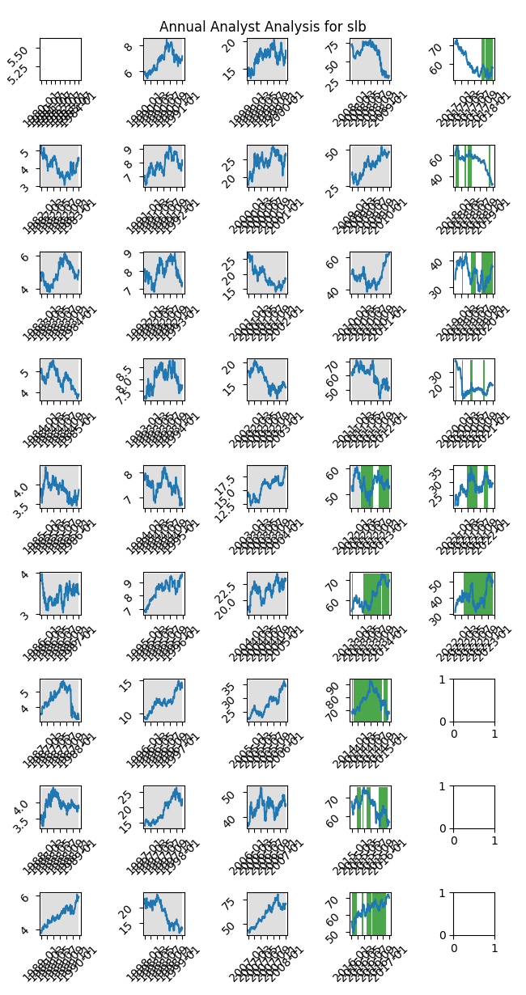

|  |  |  |  |  |  |  |
| --- | --- | --- | --- | --- | --- | --- |
| Timeframe | -1_min | -1_mean | -1_max | 1_min | 1_mean | 1_max |
| 1-day | -1.33 | -0.32 | 0.84 | -5.4 | 0.03 | 5.39 |
| 3-day | -2.74 | -1.78 | -1.09 | -9.85 | 0.08 | 8.49 |
| 7-day | -5.0 | -4.29 | -3.52 | -12.83 | 0.18 | 10.27 |
| 14-day | -5.11 | -3.85 | -3.05 | -14.32 | 0.27 | 12.99 |
| 21-day | -4.34 | -3.15 | -0.8 | -16.07 | 0.44 | 18.55 |
| 28-day | -10.8 | -8.19 | -1.93 | -15.31 | 0.63 | 19.3 |