Automatice Report for tsla

# Analyzing the Headline Accuracy

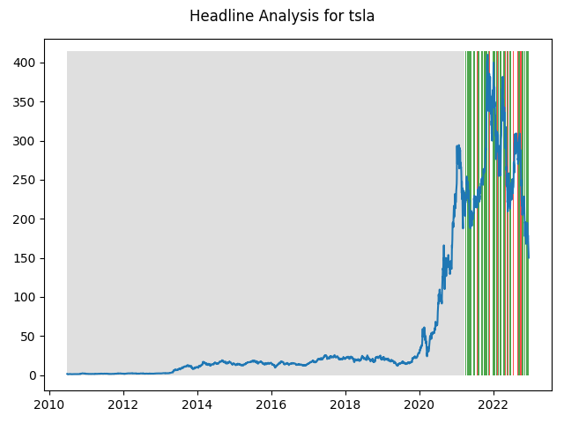

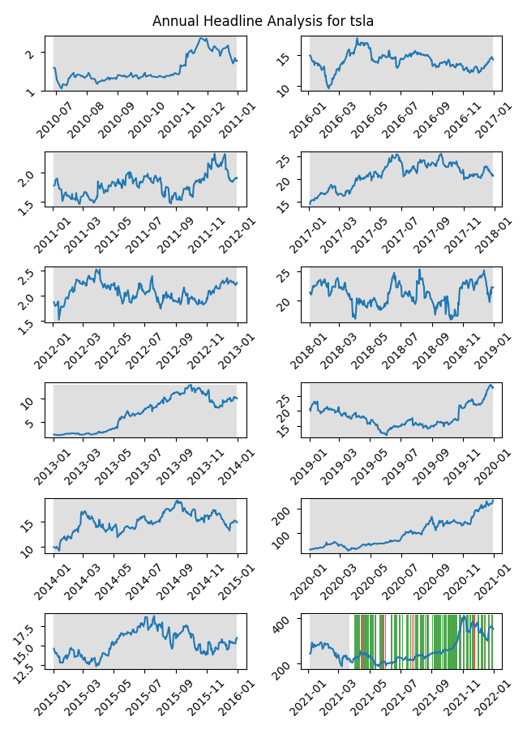

# A Little Bit More Insight Into the Headlines

The best headline was"The Best Stocks to Strike It Rich in ‘The Great EV Consolidation’" which occured on 2022-08-03 and had a Sentiment Score of 0.9081

The worst headline was"U.S. probing fatal Tesla crash that killed pedestrian" which occured on 2021-09-03 and had a Sentiment Score of -0.8934

|  |  |  |  |  |  |  |
| --- | --- | --- | --- | --- | --- | --- |
| Timeframe | -1_min | -1_mean | -1_max | 1_min | 1_mean | 1_max |
| 1-day | -22.85 | 0.37 | 24.27 | -46.48 | -0.23 | 47.67 |
| 3-day | -45.41 | 1.4 | 55.69 | -68.8 | -0.78 | 56.91 |
| 7-day | -64.74 | 0.74 | 66.21 | -72.17 | -0.94 | 104.86 |
| 14-day | -84.3 | -3.81 | 94.08 | -108.15 | -1.2 | 134.29 |
| 21-day | -93.52 | -3.0 | 83.49 | -123.29 | -2.49 | 149.05 |
| 28-day | -122.3 | -1.89 | 146.49 | -131.4 | -4.17 | 152.22 |

# Analyzing the Technical Indicators

## Looking at RSI

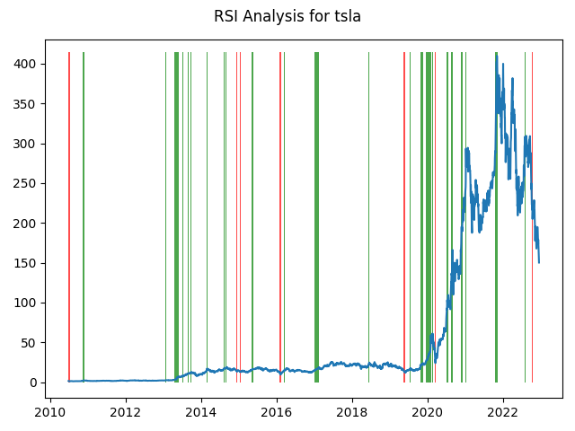

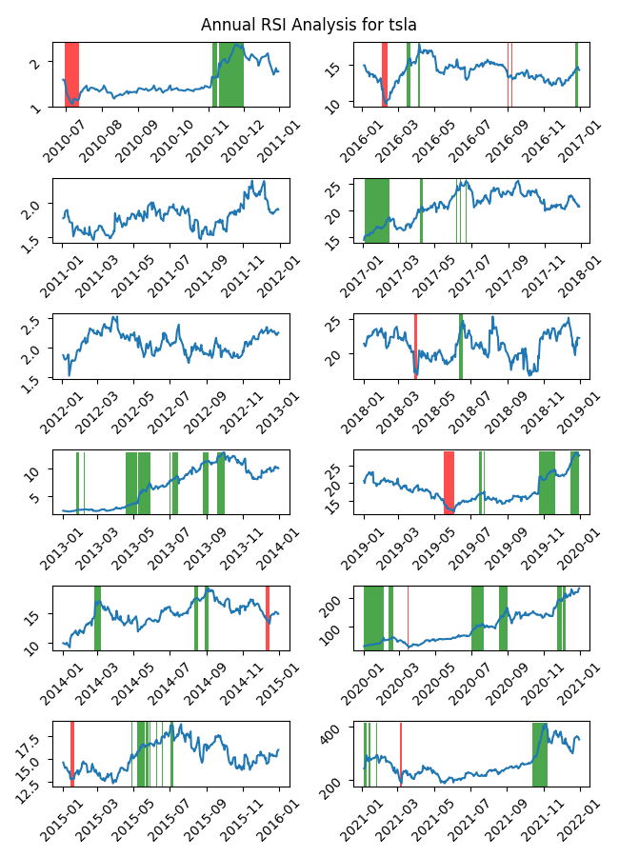

|  |  |  |  |  |  |  |
| --- | --- | --- | --- | --- | --- | --- |
| Timeframe | -1_min | -1_mean | -1_max | 1_min | 1_mean | 1_max |
| 1-day | -16.73 | 0.63 | 36.86 | -46.48 | 0.38 | 38.39 |
| 3-day | -11.51 | 1.87 | 45.53 | -68.8 | 1.12 | 56.91 |
| 7-day | -17.7 | 1.79 | 46.27 | -72.17 | 2.08 | 104.86 |
| 14-day | -6.74 | 2.49 | 18.57 | -49.14 | 2.79 | 131.85 |
| 21-day | -38.91 | 0.62 | 36.32 | -74.41 | 2.76 | 82.4 |
| 28-day | -51.81 | 0.59 | 58.93 | -125.29 | 3.33 | 98.09 |

## Looking at OBV

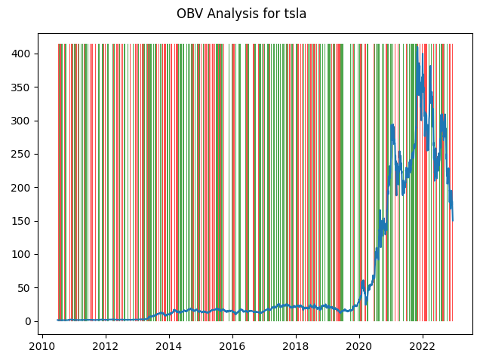

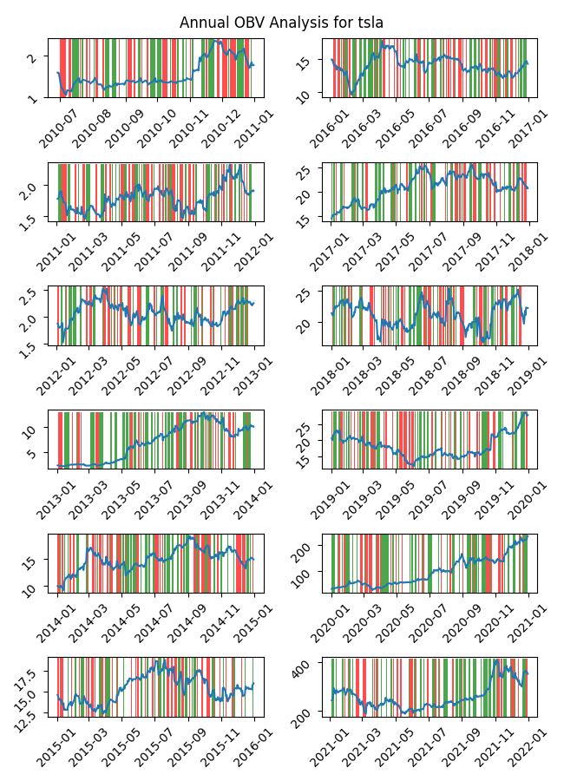

|  |  |  |  |  |  |  |
| --- | --- | --- | --- | --- | --- | --- |
| Timeframe | -1_min | -1_mean | -1_max | 1_min | 1_mean | 1_max |
| 1-day | -46.48 | 0.06 | 47.67 | -36.1 | 0.07 | 38.39 |
| 3-day | -51.38 | 0.11 | 55.69 | -68.8 | 0.25 | 56.91 |
| 7-day | -67.14 | 0.19 | 77.58 | -72.17 | 0.65 | 104.86 |
| 14-day | -92.35 | 0.61 | 106.07 | -108.15 | 1.04 | 134.29 |
| 21-day | -123.29 | 1.11 | 144.46 | -114.96 | 1.36 | 149.05 |
| 28-day | -122.3 | 1.32 | 148.18 | -131.4 | 1.88 | 152.22 |

## Looking at ADX

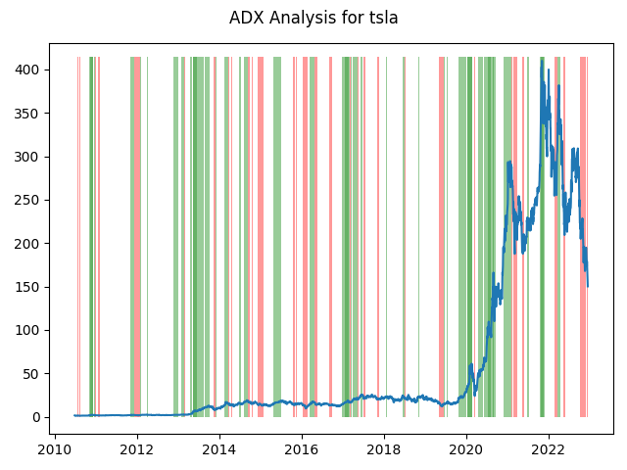

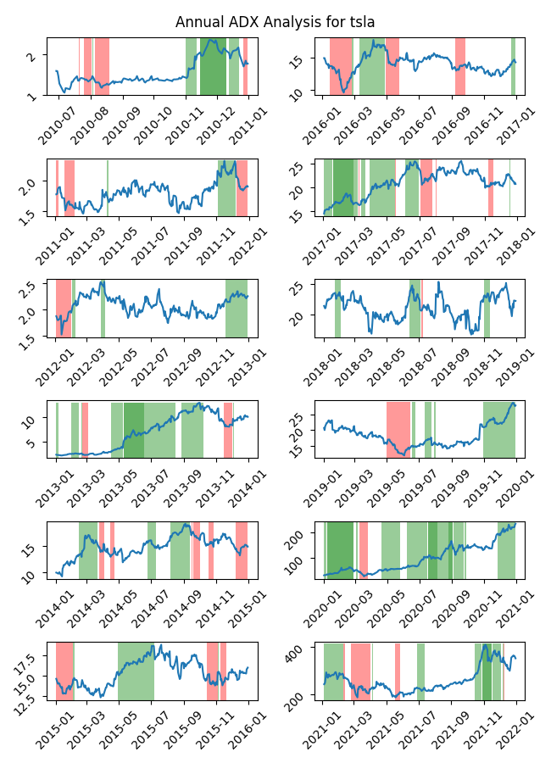

|  |  |  |  |  |  |  |  |  |  |  |  |  |
| --- | --- | --- | --- | --- | --- | --- | --- | --- | --- | --- | --- | --- |
| Timeframe | -2_min | -2_mean | -2_max | -1_min | -1_mean | -1_max | 1_min | 1_mean | 1_max | 2_min | 2_mean | 2_max |
| 1-day | -0.01 | -0.01 | -0.01 | -23.82 | 0.04 | 36.86 | -29.37 | 0.27 | 38.39 | -46.48 | 0.0 | 31.53 |
| 3-day | 0.07 | 0.07 | 0.07 | -32.57 | 0.04 | 45.53 | -43.26 | 1.02 | 56.91 | -68.8 | -0.68 | 33.29 |
| 7-day | 0.0 | 0.0 | 0.0 | -49.95 | 0.38 | 77.58 | -46.99 | 2.06 | 104.86 | -72.17 | -1.76 | 34.2 |
| 14-day | -0.05 | -0.05 | -0.05 | -72.72 | 1.63 | 114.52 | -81.61 | 1.94 | 128.96 | -46.72 | 0.56 | 40.42 |
| 21-day | -0.1 | -0.1 | -0.1 | -47.69 | 2.31 | 102.39 | -95.66 | 2.08 | 82.4 | -73.63 | 0.12 | 70.72 |
| 28-day | -0.04 | -0.04 | -0.04 | -60.46 | 1.41 | 79.56 | -131.4 | 2.14 | 98.09 | -98.39 | -1.67 | 59.95 |

# Analyzing the Analyst Agencies

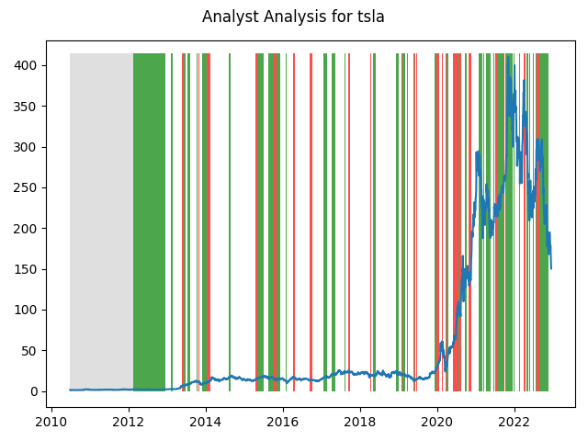

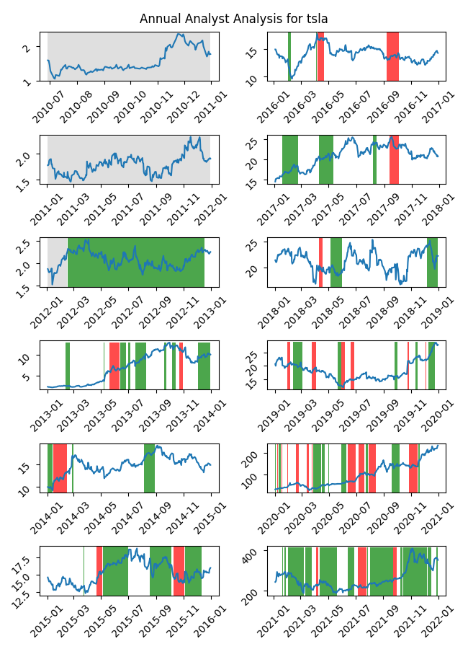

|  |  |  |  |  |  |  |
| --- | --- | --- | --- | --- | --- | --- |
| Timeframe | -1_min | -1_mean | -1_max | 1_min | 1_mean | 1_max |
| 1-day | -20.46 | 0.31 | 30.12 | -46.48 | -0.16 | 47.67 |
| 3-day | -44.12 | 0.96 | 34.05 | -68.8 | -0.36 | 56.91 |
| 7-day | -41.03 | 2.7 | 68.85 | -72.17 | -0.61 | 104.86 |
| 14-day | -91.59 | 6.31 | 131.85 | -108.15 | -1.61 | 134.29 |
| 21-day | -114.96 | 8.67 | 144.46 | -123.29 | -1.86 | 125.82 |
| 28-day | -131.4 | 9.19 | 148.18 | -106.7 | -1.16 | 152.22 |