Automatice Report for www

# Analyzing the Headline Accuracy

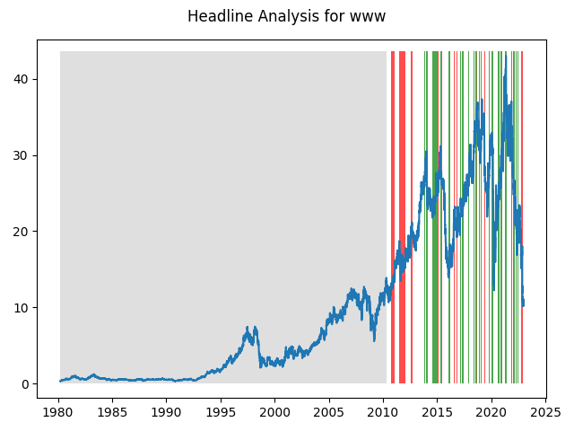

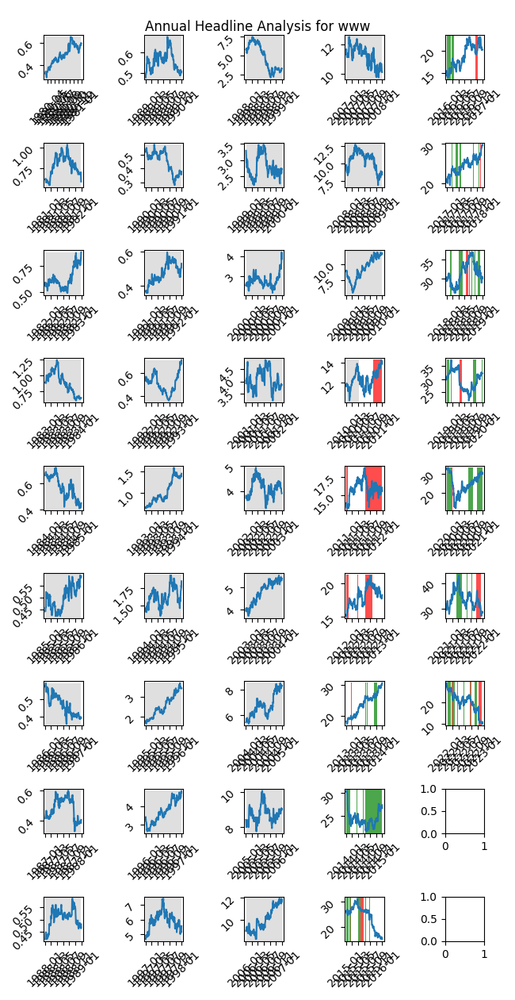

# A Little Bit More Insight Into the Headlines

The best headline was"Capri Holdings (CPRI) Gaining on Brand Strength, Growth Plans" which occured on 2022-02-14 and had a Sentiment Score of 0.8225

The worst headline was"Opening View: Anxieties High on Fears of European Contagion, Debt Ceiling" which occured on 2011-07-12 and had a Sentiment Score of -0.836

|  |  |  |  |  |  |  |
| --- | --- | --- | --- | --- | --- | --- |
| Timeframe | -1_min | -1_mean | -1_max | 1_min | 1_mean | 1_max |
| 1-day | -4.02 | -0.01 | 1.78 | -5.36 | 0.02 | 2.01 |
| 3-day | -4.11 | -0.02 | 3.0 | -6.7 | 0.03 | 2.72 |
| 7-day | -4.56 | -0.04 | 5.12 | -6.79 | 0.04 | 3.96 |
| 14-day | -12.55 | -0.16 | 3.47 | -10.93 | -0.02 | 5.25 |
| 21-day | -14.2 | -0.26 | 3.77 | -17.27 | -0.24 | 6.68 |
| 28-day | -14.92 | -0.33 | 4.33 | -18.1 | -0.4 | 6.76 |

# Analyzing the Technical Indicators

## Looking at RSI

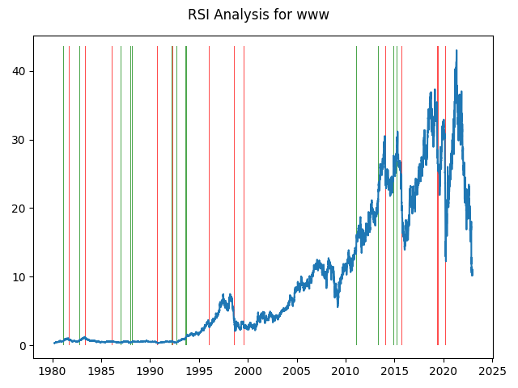

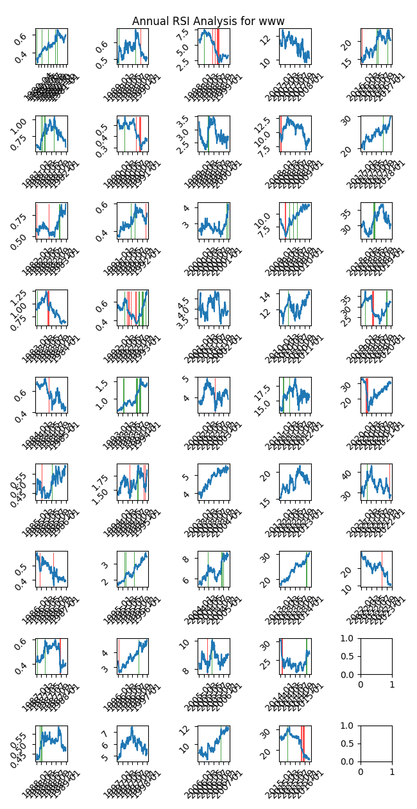

|  |  |  |  |  |  |  |
| --- | --- | --- | --- | --- | --- | --- |
| Timeframe | -1_min | -1_mean | -1_max | 1_min | 1_mean | 1_max |
| 1-day | -2.95 | -0.02 | 2.07 | -4.02 | -0.02 | 1.78 |
| 3-day | -7.01 | -0.06 | 5.18 | -4.45 | -0.08 | 2.84 |
| 7-day | -9.39 | -0.18 | 5.38 | -4.74 | -0.15 | 1.84 |
| 14-day | -12.55 | -0.3 | 5.22 | -6.49 | -0.19 | 5.42 |
| 21-day | -14.44 | -0.29 | 6.92 | -5.66 | -0.21 | 2.43 |
| 28-day | -15.44 | -0.28 | 7.51 | -9.71 | -0.26 | 3.04 |

## Looking at OBV

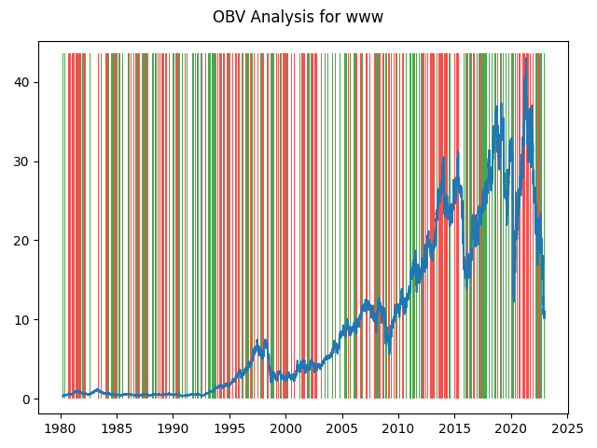

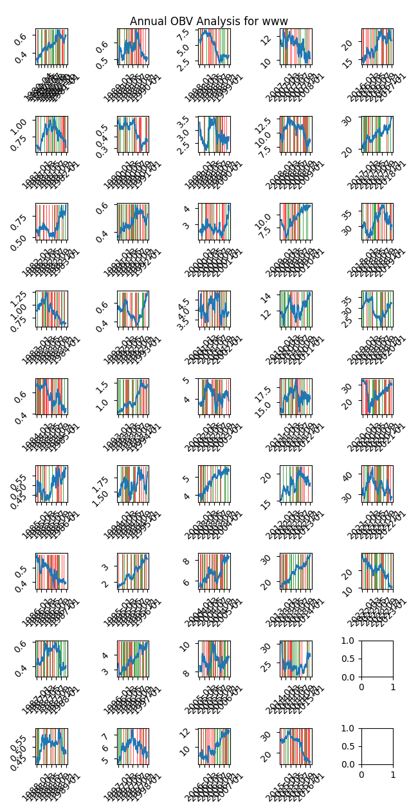

|  |  |  |  |  |  |  |
| --- | --- | --- | --- | --- | --- | --- |
| Timeframe | -1_min | -1_mean | -1_max | 1_min | 1_mean | 1_max |
| 1-day | -5.36 | 0.0 | 2.07 | -2.95 | 0.0 | 2.7 |
| 3-day | -5.28 | 0.01 | 5.18 | -7.01 | -0.0 | 4.36 |
| 7-day | -9.06 | 0.02 | 6.36 | -9.39 | -0.0 | 5.11 |
| 14-day | -12.55 | 0.02 | 7.08 | -11.01 | 0.01 | 8.89 |
| 21-day | -17.27 | 0.04 | 8.24 | -16.49 | 0.01 | 8.06 |
| 28-day | -18.1 | 0.04 | 10.77 | -17.0 | 0.02 | 11.2 |

## Looking at ADX

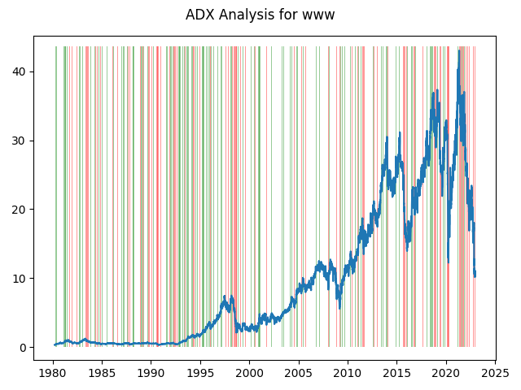

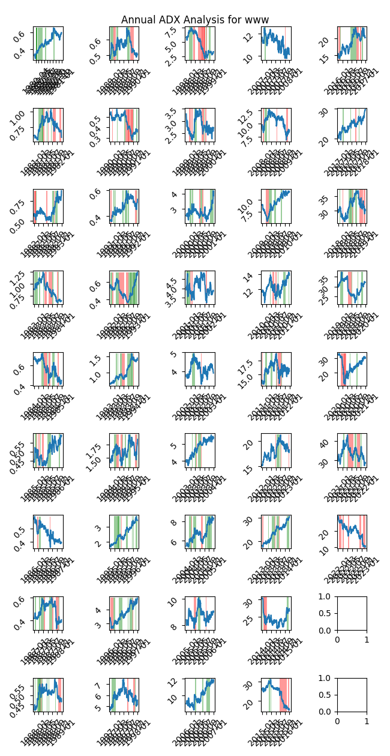

|  |  |  |  |  |  |  |  |  |  |  |  |  |
| --- | --- | --- | --- | --- | --- | --- | --- | --- | --- | --- | --- | --- |
| Timeframe | -2_min | -2_mean | -2_max | -1_min | -1_mean | -1_max | 1_min | 1_mean | 1_max | 2_min | 2_mean | 2_max |
| 1-day | -2.67 | 0.02 | 2.7 | -2.95 | -0.0 | 1.8 | -5.36 | -0.01 | 1.88 | -1.14 | -0.02 | 0.24 |
| 3-day | -2.39 | 0.11 | 5.18 | -7.01 | -0.02 | 2.48 | -6.7 | -0.03 | 3.69 | -1.62 | -0.05 | 0.57 |
| 7-day | -4.13 | 0.22 | 5.38 | -9.39 | -0.05 | 3.53 | -6.79 | -0.04 | 5.12 | -1.7 | -0.1 | 0.68 |
| 14-day | -4.85 | 0.51 | 5.22 | -12.55 | -0.11 | 6.35 | -7.42 | -0.07 | 3.85 | -2.9 | -0.16 | 0.48 |
| 21-day | -1.78 | 0.7 | 6.92 | -17.27 | -0.16 | 7.8 | -8.61 | -0.09 | 5.41 | -1.08 | -0.03 | 0.33 |
| 28-day | -1.94 | 0.67 | 6.38 | -18.1 | -0.18 | 7.51 | -9.92 | -0.07 | 6.53 | -1.42 | -0.05 | 0.8 |

# Analyzing the Analyst Agencies

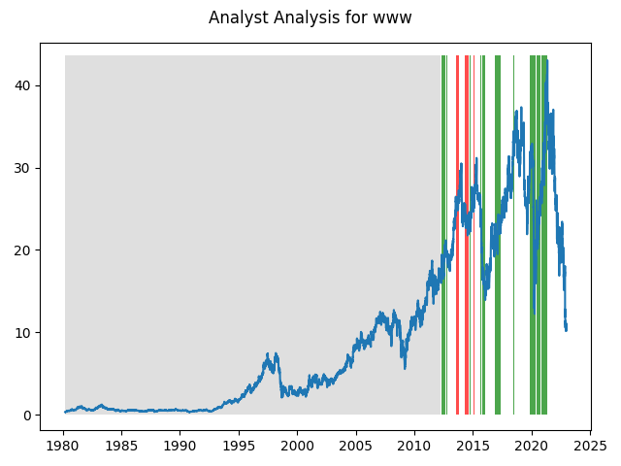

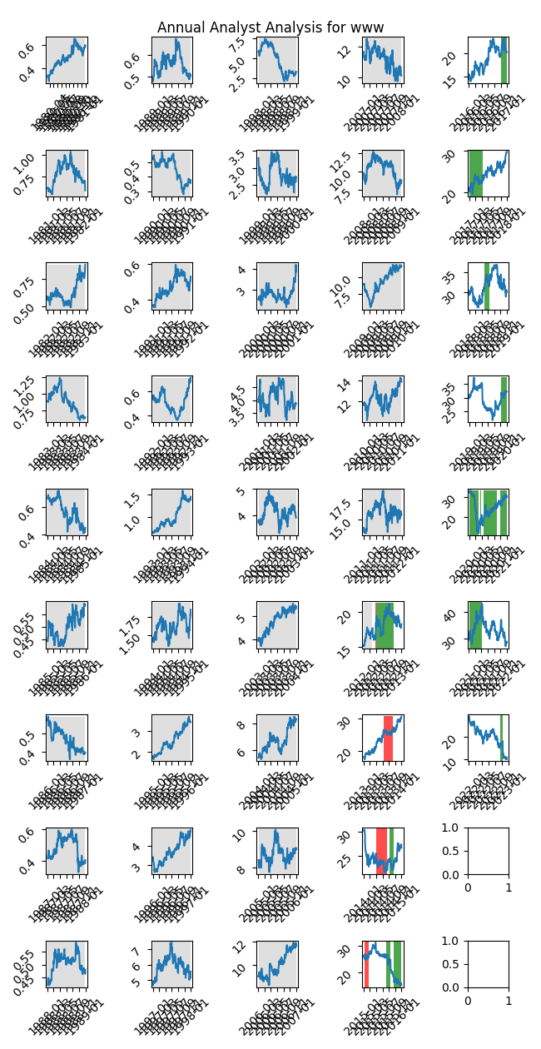

|  |  |  |  |  |  |  |
| --- | --- | --- | --- | --- | --- | --- |
| Timeframe | -1_min | -1_mean | -1_max | 1_min | 1_mean | 1_max |
| 1-day | -1.12 | 0.01 | 1.6 | -2.95 | 0.0 | 2.07 |
| 3-day | -2.1 | 0.04 | 1.93 | -7.01 | 0.01 | 5.18 |
| 7-day | -2.11 | 0.09 | 3.32 | -9.39 | -0.02 | 6.36 |
| 14-day | -2.64 | 0.21 | 2.86 | -12.55 | -0.14 | 6.87 |
| 21-day | -2.18 | 0.32 | 2.37 | -17.27 | -0.16 | 7.89 |
| 28-day | -2.29 | 0.47 | 3.84 | -18.1 | -0.16 | 11.2 |