Himalaya Patel

Aashka Pala

Jeremy Hochheiser

**Screenshots of Use of Program**

**User Login**

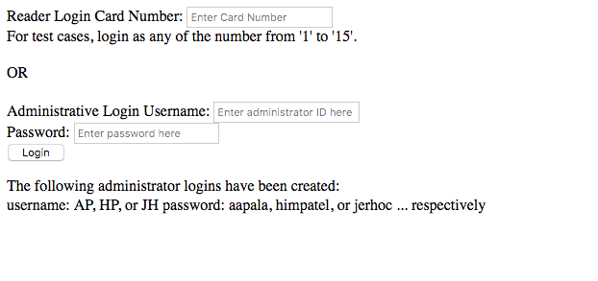

**Administrator Dashboard**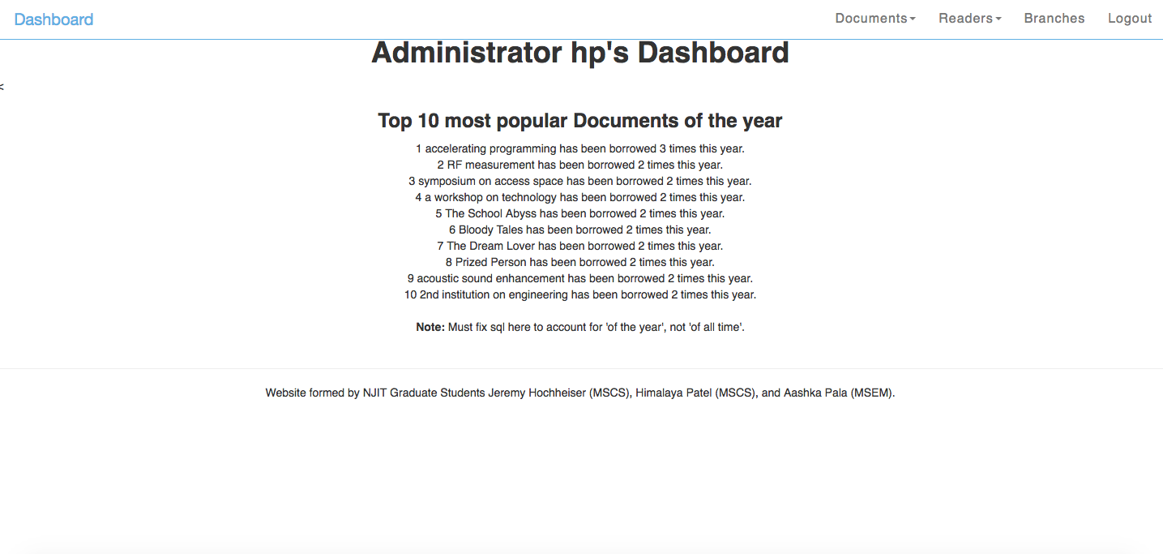

**Administrator Document Search**

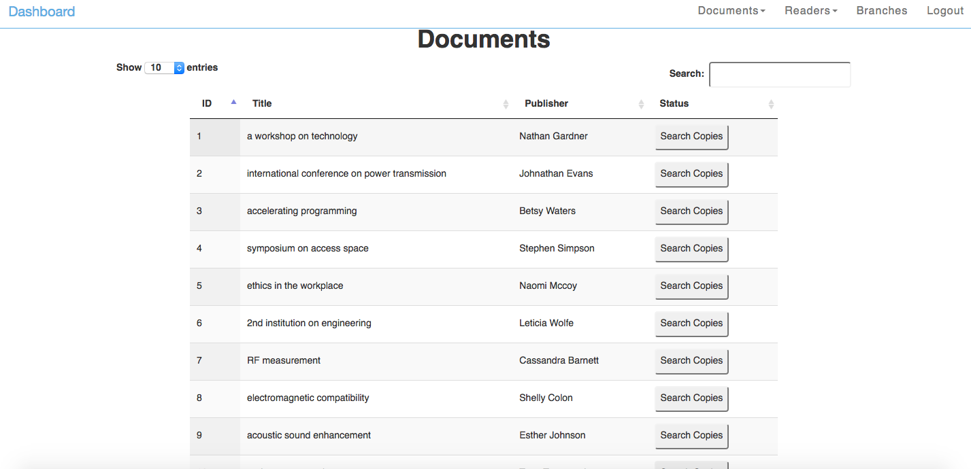

**Administrator Document Add**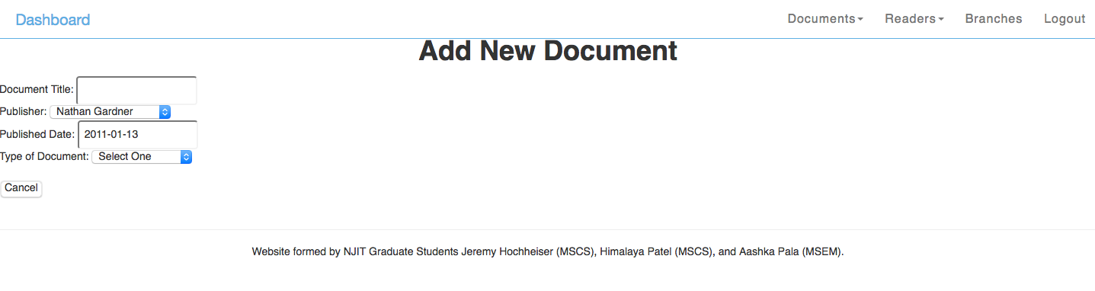

**Administrator Reader Search**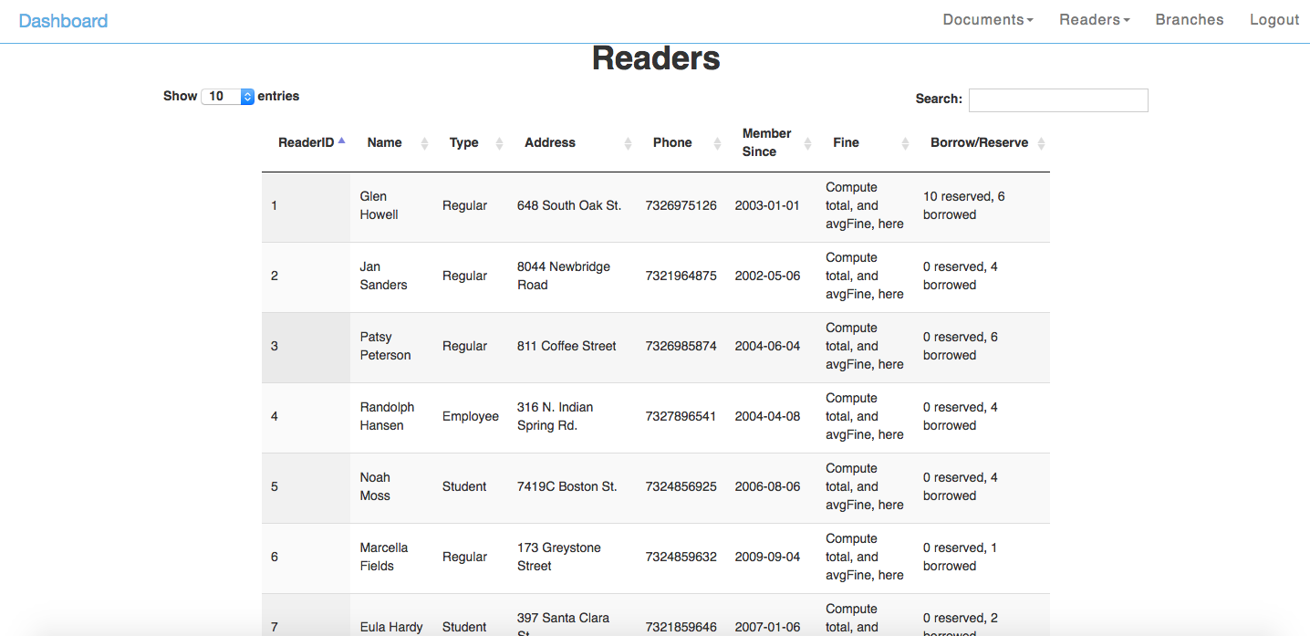

**Administrator Reader Add**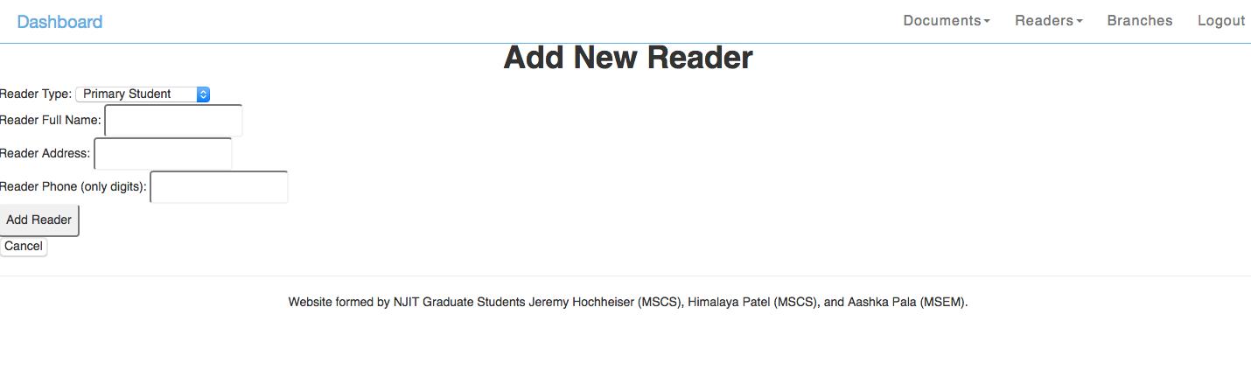

**Administrator Branches**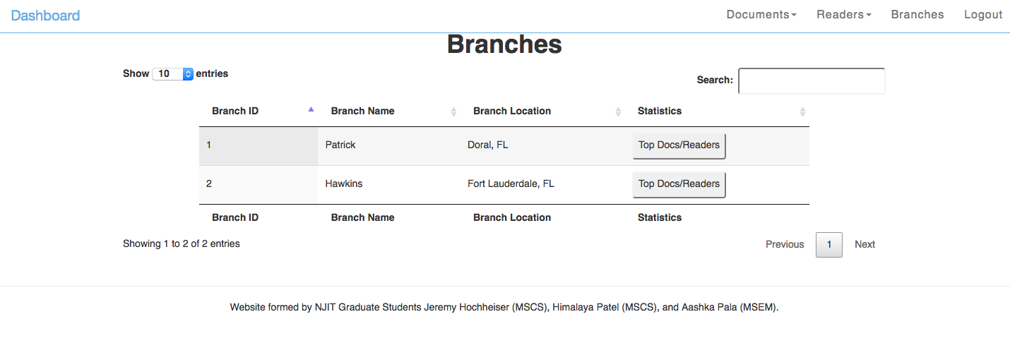

**Reader Dashboard**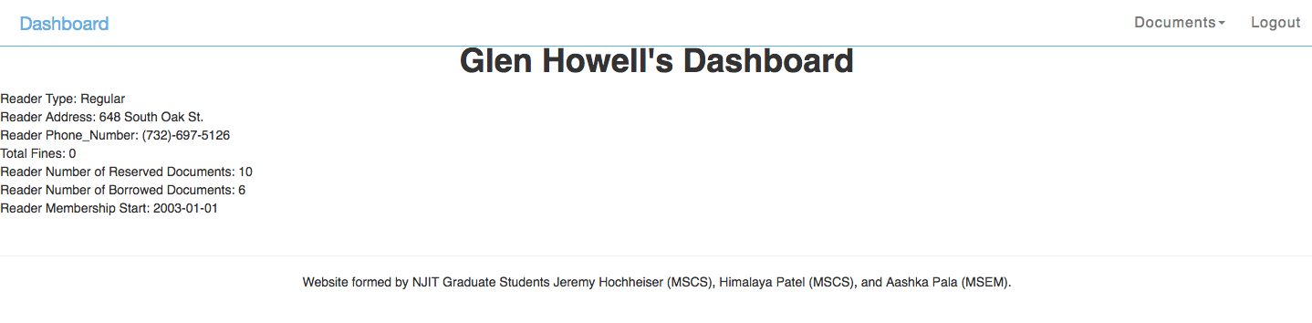

**Reader Document Search**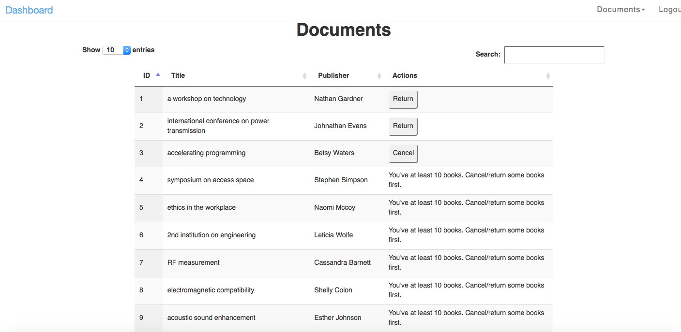

**Reader Document Reserved**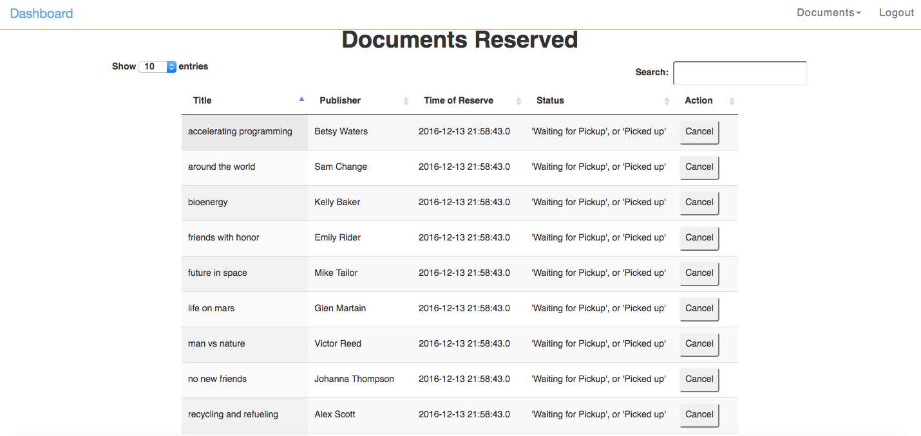

**Reader Document Checked out**

