# Base Warranty Guideline for New Instruments deals

All Illumina instruments are sold with 12 months Base Warranty.

The Base Warranty includes the following (except for iSeq 100):

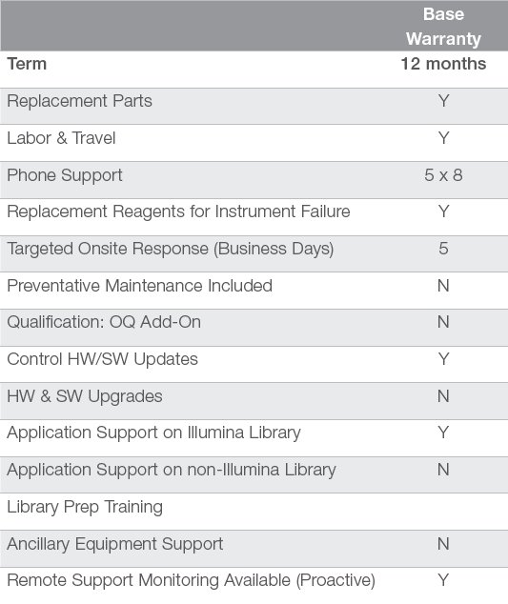

*Base Warranty Activation and Duration:*

The length of the Base Warranty is fixed to 12 months and cannot be extended.

The Base Warranty is activated on the day the instrument is installed or 30 days following the delivery, whichever event occurs first.

If for any reason, a new instrument needs to be supplied with a longer warranty, this will have to be put in place by adding a Service Contract to your instrument quotation.

*Considerations for New instrument deals:*

To avoid side deals and prevent Revenue Recognition problems, you would have to pay particular attention to the Base Warranty if any of these situations apply:

* the instrument installation cannot be performed within 30 days of delivery
* specific ACP Rev Rec requirements cannot be met within 30 days of delivery

If this applies to your deal, is Illumina or the customer at the origin of the installation/acceptance delay?

**In cases where this is due to Illumina** (trying to ship before end of Q for example), then we should prevent the customer from being negatively impacted and add a NSCO Service Contract for the estimated duration of the lost Base Warranty.

**If this is due to a customer request**, determine if there is a business case for an additional FOC cover and clearly define what Illumina will agree to provide.

This will be processed via NCSO and have a cost to Illumina: can it be justified?

If this is linked to a customer’s request, the Customer will see the NCSO value, can you use it as a leverage to get something in exchange?

*Process to quote a Base Warranty “extension”: (see next page)*

