|  |  |
| --- | --- |
|  | Quick Reference GuideQRG, Opportunity Creation Last Modified: December, 2021  Updated by: Stella Efthymiadi (EMEA version) |

**Creating a Direct Standard Opportunity**

1. **Navigate** to the Contact for whom you will be creating the opportunity
   * **Search** in the main search bar at the top of the screen, or



* + Navigate to the **Account** then click into **Related Contacts** in the **Related List Quick Links** to find the appropriate contact for your opportunity

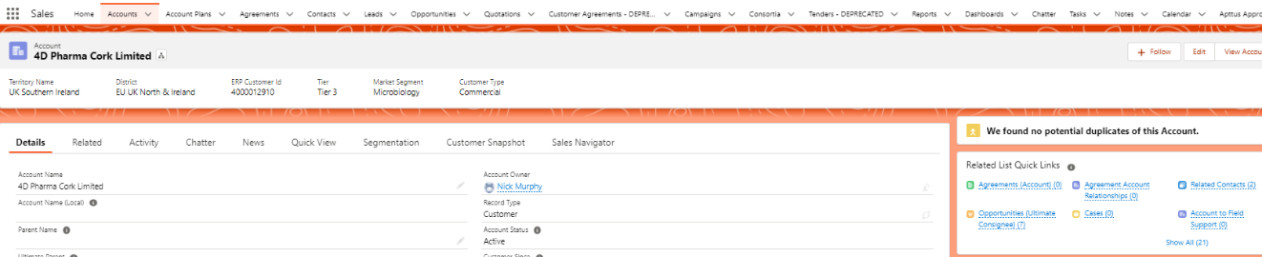

1. Within the **Contact** record, hover the mouse over **Opportunities** in the **Related Quick Links** or scroll to the **Opportunity** section in the Related tab

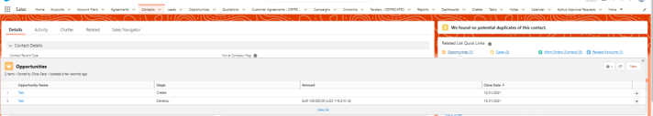

1. Click **New** to create a new opportunity
2. Choose your **Record type**:
   * Direct/Indirect Standard
   * Direct/Indirect Reorder and Customer Product

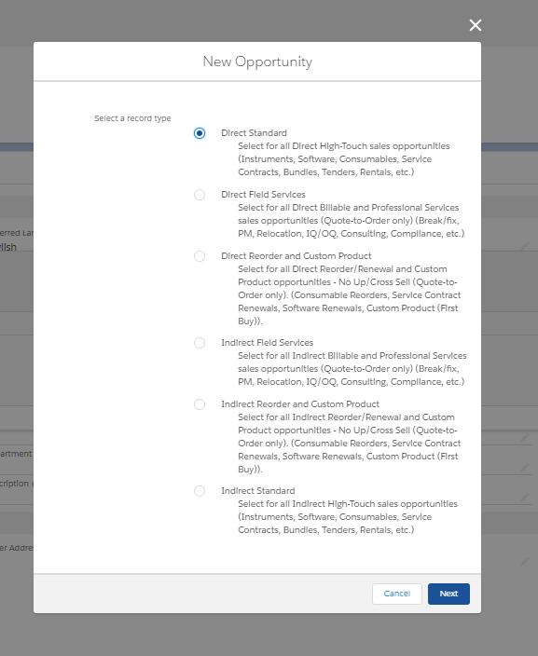

1. Enter the **following criteria** on the New Opportunity screen:
   * **Opportunity Name**
     + Recommended Naming Convention: ProductDesc_Qty_AccountName_AcctContact
   * **Account name** will auto populate; verify Account Name and the Ultimate Consignee, *if different,* are correct. For indirect opportunities, verify the Distributor account as well.
   * **Type**: choose from the dropdown; Standard, Concierge, Consortium etc.
   * **Product Interest:** Select the applicable products move them to the “chosen” side
   * **Stage**: must choose Create
   * **Probability** field will auto populate to 10%
   * **Close Date:** Choose an estimated Closed Date
   * Verify **Market Segmentation** and **Clinical Type**

*Note: Check the “Eligible for Sales Certification” flag if you need to identify the opportunity as eligible for the quarterly Sales Certification Survey.*

* + Link your campaign to the **Primary Sales Campaign**
  + Click **Save**

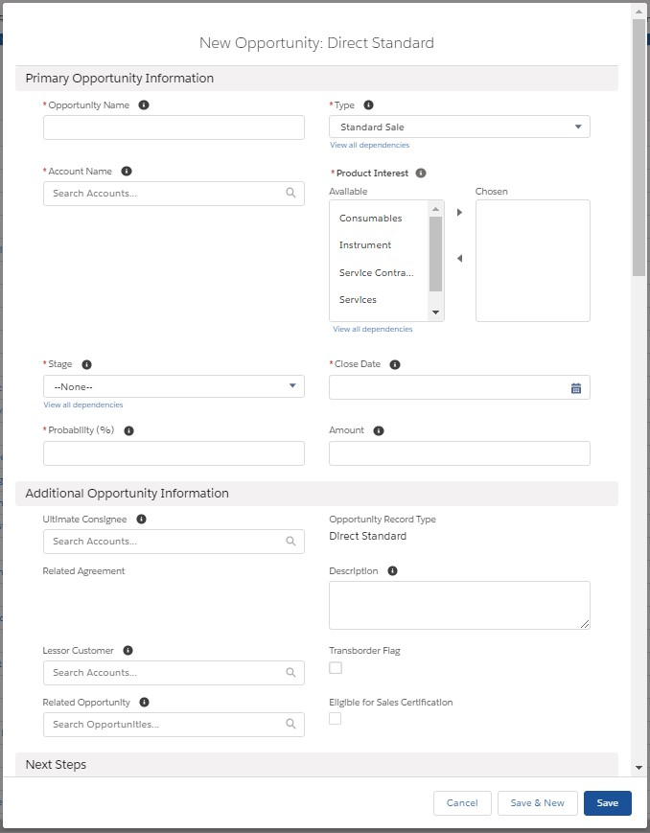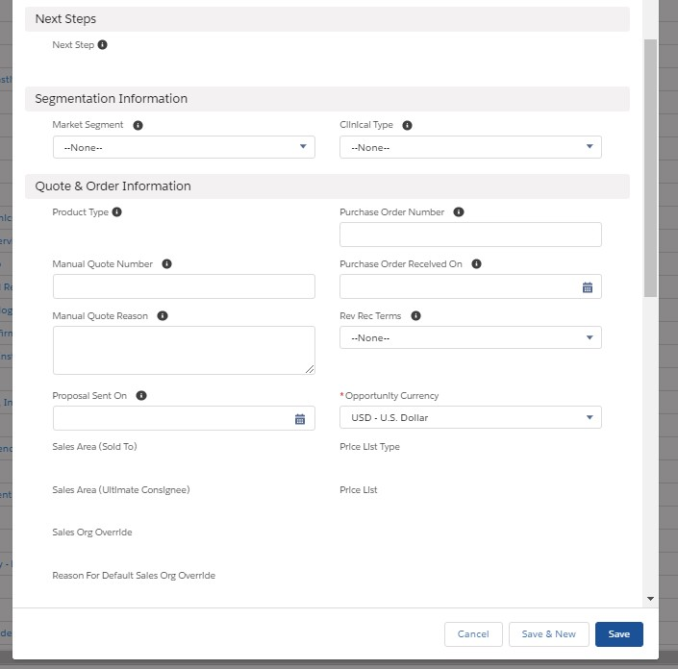

v

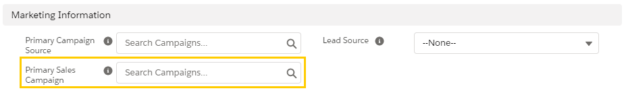

**Notes**

* If a user attempts to create an opportunity where either the Ultimate Consignee or Sold To has a status of Rejected, Suspended, Obsolete or Pending Obsolete, the system will not allow the user to proceed, and user will be presented with the below error:
* If an Ultimate Consignee or Sold To’s status is updated to Rejected, or Suspended and the account has associated open opportunities, then user will still be able to edit the opportunity
* Existing validation rule preventing opportunity edits when the Ultimate Consignee or Sold To’s status is Obsolete or Pending Obsolete remain in place

**Accessing Your Opportunity**

To access the opportunity you just created:

* + Click on the **opportunity link** within the green message that appears at the top of the screen (this will go away after a minute or so of inactivity)



* + Navigate to the **Opportunities tab** at the top of the screen and select your newly created opportunity from the list. NOTE: the Opportunity list defaults to **Recently Viewed**

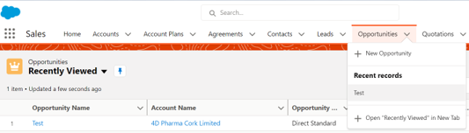

v

* + Hover over the **Opportunities** in the Related List Quick Links on the Contact Page then select your opportunity

* + Select **Recent Items** at the bottom of your screen to view the three most recent opportunities you have been working on

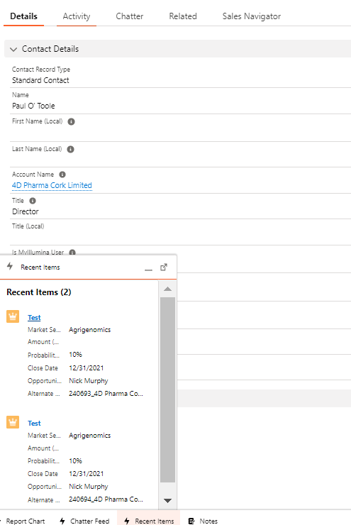

v

**Progressing Your Opportunity (Create to Finalize)**

Your Opportunity will currently be in the **Create** Stage. Fill in all the criteria listed in Guidance for Success:

* + If you did not create your Opportunity from the contact record you will need to navigate to **Related List Quick Links**, hover over Contact Roles and select **Add Contact Roles**.

* + Search for your contact or create a new contact. Select a **Contact Role** from the dropdown menu and select a **Primary Contact** (the person who will receive the quotation)

* + Add any additional Contacts, if needed, within the Add Contact Roles screen. If you can, identify the **Power Sponsor** now, otherwise you will need to do this prior to progressing from Qualify to Develop.
  + Complete the **Key Fields** in the Create Stage:
    - Budget: choose from dropdown
    - Projected Budget Range: choose from dropdown
    - Pain: choose from dropdown
    - Amount (Sold To): enter the approximate dollar amount of the quotation
    - Click **SAVE**
  + Verify Segmentation criteria
  + Select **Mark Stage as Complete**

Your Opportunity will currently be in the **Qualify** Stage. Fill in all the criteria listed in Guidance for Success:

* + In **Key Fields,** go to **Summarize Buying Vision** and enter your summary in free form text
  + Click **SAVE**
  + If you have not already assigned a **Power Sponsor** within your **Contact Roles**, do so now. Go to **Related Quick Links**, hover over **Contact Roles**, choose **Add Contact Roles** and select the **Contact** with a **Role** of **Power Sponsor.** Click **SAVE**
  + Select **Mark Stage as Complete**

Your Opportunity will currently be in the **Develop** Stage. Fill in all the criteria listed in Guidance for Success:

* + In **Key Fields** complete the following:
    - Customer’s Next Steps; summarize the next steps in free form text
    - Click **SAVE**
  + Validate the **Ultimate Consignee**
    - In the **Details** Tab, scroll down to **Additional** **Opportunity Information** and ensure you have the correct **Ultimate Consignee** selected. If it is incorrect, then change it now, prior to adding products.
  + Add products. *(For this section, please refer to the* ***How to Create a Quotation Document***)**.** Must **Finalize and Sync** the quote so that the products sync back to the opportunity and the **Are Products Added** box will be checked.
  + *(Optional)* Complete **CRF Section 1,** if an instrument is added to the opportunity
    - Go to **Related List Quick Links**, hover over **Customer Readiness Forms,** choose **NEW**

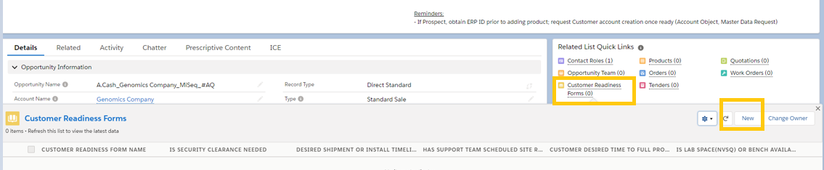

* + - Complete all fields for Section 1 of the CRF:
      1. Current Illumina Instrument Customer: choose from dropdown
      2. Is BSL Level >=3: choose from dropdown
      3. Is Security Clearance Needed: choose from dropdown
      4. Choose Application: check the appropriate box
      5. Data Storage: check the appropriate box
      6. Click **SAVE**
  + Select **Mark Stage as Complete**

Your Opportunity will currently be in the **Prove** Stage. Fill in all the criteria listed in Guidance for Success:

* + In **Key Fields** complete the following:
    - Proposal Sent On: this will auto populate after you send the quotation either to the customer or yourself during the Generate Quote step.
    - Customer Confirmed Solution Fit On: choose a date from the calendar dropdown
    - Rev Rec Terms: select the anticipated terms from the dropdown
    - Click **SAVE**
    - *(Optional)* Complete **CRF Section** 2, if an instrument is associated with the opportunity.
      1. Go to **Related Quick Links**, hover over **Customer Readiness Forms,** choose the CRF you previously created
      2. Scroll down to Section 2 and complete the following fields:
         1. Desired Shipment or Install Timelines: enter a timeframe
         2. Has Support Team Scheduled Site Review: check box if yes
      3. Click **SAVE**
      4. Navigate back to your Opportunity from the hyperlink at the top of your CRF.
    - Must identify a **Primary Contact** if you have not already done so, in order to generate a Quote output document
      1. Go to **Related List Quick Links**, hover over Contact Roles and select **Add Contact Roles**
      2. Go to **Primary Contact** search and choose a contact
      3. Click **SAVE**

*Note: The primary contact can also be changed directly on the Opp record and Quotation header.*

* + Select **Mark Stage as Complete**

Your Opportunity will currently be in the **Negotiate and Resolve** Stage. Fill in all the criteria listed in Guidance for Success:

* + In **Key Fields** complete the following:
    - Win Strategy: Select from Dropdown
    - Competitor Name: Select from dropdown. If **Other** is selected, must fill in the competitor under the **Additional Competitor Information** section 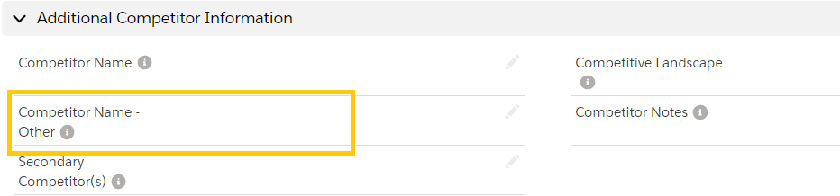
    - Customer Account Creation On: If this is a Sold-To Account, then leave blank. If this is a Prospect Account, enter the date that the upgrade to a Sold To was requested through the Master Data Request.
    - *(Optional)* Complete **CRF Section 3**
      1. Go to **Related Quick Links**, hover over **Customer Readiness Forms,** choose the CRF you were working on before
      2. Scroll down to Section 3
      3. Customer Desired Time to Full Production: select from dropdown
      4. Is Lab Space or Bench Available: choose yes or no
      5. Click **SAVE**
      6. Navigate back to your Opportunity from the hyperlink at the top of your CRF.
  + Select **Mark Stage as Complete**

Your Opportunity will currently be in the **Finalize** Stage.

* + Once your Purchase Order has been received, Customer Care will process the order and your opportunity will be automatically set to **Closed Won.** If this is not done automatically, you can contact [salesops_EMEA@illumina.com](mailto:salesops_EMEA@illumina.com) for support

**Closed Abandoned or Closed Lost**

If at any point during the Opportunity, you need to Close the Opportunity select the **Closed** chevron and then the **Select Closed Stage** button



* + If the customer has decided to not do anything, and thus the opportunity cannot be progressed
    - Select the **Closed Abandoned Stage** and an **Abandon Reason** from the drop down.

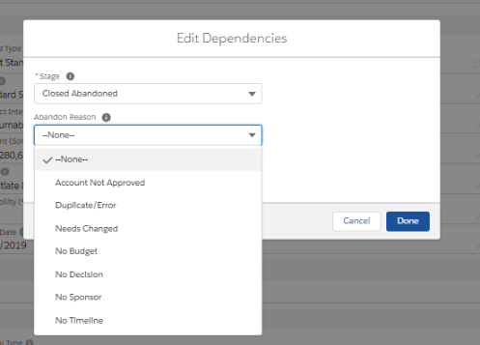

* + - Click **Done**
  + If the Opportunity has been lost and somebody else has won the opportunity
    - Select the **Closed Lost Stage** and a **Loss Reason** from the drop down.

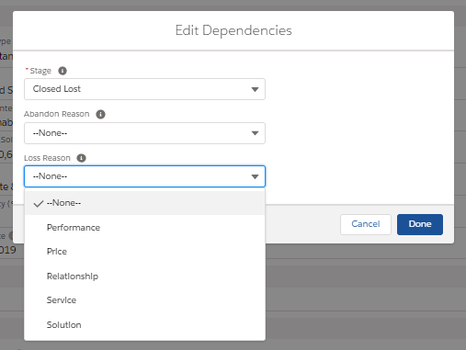

* + - Click **Done**

**Release History**

|  |  |  |  |
| --- | --- | --- | --- |
| Version | Date | Originator | Description of Change |
| 1 | March 2019 | Y. Merlin | Initial Release |
| 2 | 05/07/2020 | A. Sturgis | Addition of guidance on Opp Creation for Ineligible Accounts per DCP May Enhancement Release |
| 3 | 05/26/2020 | A. Sturgis | Addition of opportunity naming convention |
| 4 | 11/12/2020 | A. Sturgis | Additions per DCP Nov 2020 Release |
| 5 | 3/12/2021 | T. Nguyen | Additions per DCP Feb 2021 Release |
| 6 | December 2021 | S. Efthymiadi | Adjusted the document to EMEA |