AUDIENCE: All Ambulatory Users

DATE OF CHANGE: October 7, 2013

|  |  |
| --- | --- |
|  | **Surescripts NCPDP 10.6 Interface Upgrade** |

Highlights

The National Council for Prescription Drug Programs (NCPDP) requires that the Surescripts interface 8.1 be upgraded to the 10.6 version by October 31, 2013. This upgrade Implementation is a requirement for future functionality and support of Electronic Prescription of Controlled Substances (EPCS). This is also required for the CS-Link 2012 Upgrade.

Details

1. **New Link Medication button in the Refill Errors folder in the In Basket**

When external pharmacies send clinicians refill requests through CS-Link, the system cannot always match the requested medications to medication records in the CS-Link system. The Link Medications Button launches a utility that assists users identify and link new med requests with existing meds.

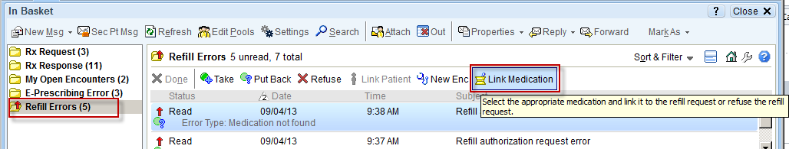

For more details regarding the Link Medication Button please reference [Job Aid JAALL0037](http://www.cslinkcentral.org/wp-content/uploads/2013/09/JAALL0037_LinkMedicationButton.pdf) under the My CS-Link section of the Training Updates tab on [www.cslinkcentral.com](http://www.cslinkcentral.com)

1. **New Requested Medication section in the Rx Request Folder in the In Basket**

This section displays information about pending medications from refill requests generated from within Epic or from an incoming pharmacy interface. It also displays information about previous orders, if available, and a hyperlink to additional previous order information.

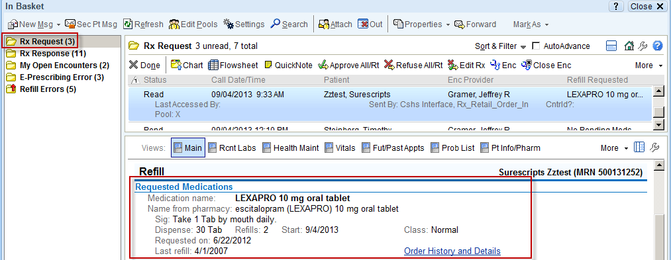

1. **New Medication Detail section in Chart Review Reports under the Medications tab**

This section displays the E-Prescribing status of an e-prescription order. The status will display if the e-prescribing order has been sent to the pharmacy or if the transmission to the pharmacy failed.

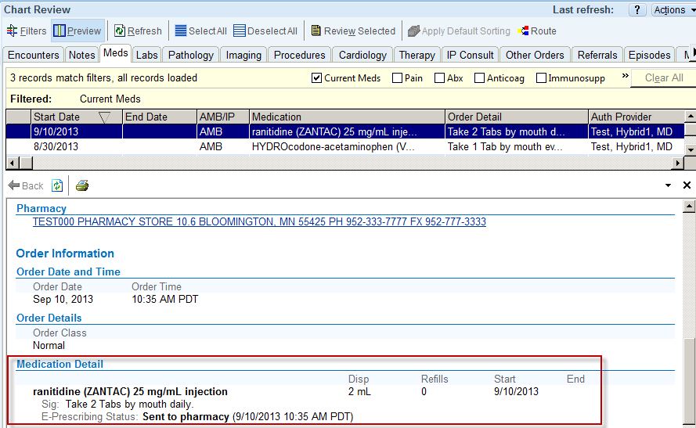

1. **New Pharmacy Operation Mode column in the Pharmacy Selection window**

When searching for a pharmacy using the “Fill prescriptions at:” field the new Operating Mode column displays the following pharmacy operating modes coming from the Surescripts database (if available): “Retail”, “Mail Order”, “Specialty”, and “Long-Term Care“.

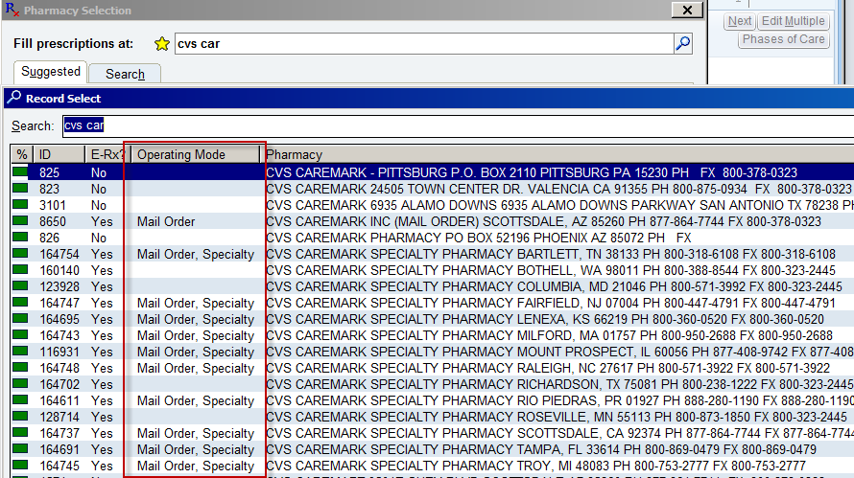

1. **Specific Dispense unit changes**

For specific rarely used dispense qualifiers - International Unit, Million Unit, and Unit that may be requested by the pharmacy for Refill Requests - the provider will see “stop signs” on the Dispense fields of the order composer once the refill request is Approved or Edited. This is due to the NCPDP (National Council for Prescription Drug Programs) standard change where specific units cannot be mapped to units in CS-Link. Providers will have to enter the correct dispense information when sending the refill request back to the pharmacy. The “Requested dispense” field is available for providers to refer to when entering dispense information.

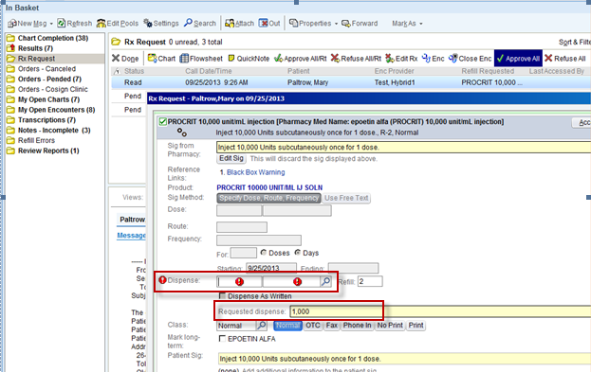

 This improvement will:

* Bring Cedars into compliance with NCPDP standards
* Fulfill a necessary requirement for the CS-Link Upgrade (EPIC version 2012)