Final Report
A comprehensive analysis on healthcare data between 2019 – 2024
Jeremy Wu
ALY 6010
2026-03-23

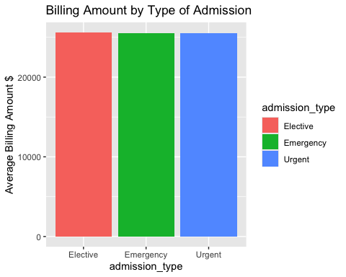
Based on my first EDA analysis from project milestone 1, we have already identified that:
1. The average billing amount is equal across all admission types (Elective, Emergency, Urgent), meaning admission type does not significantly predict or determine the billing amount shown on the bar graph on the left

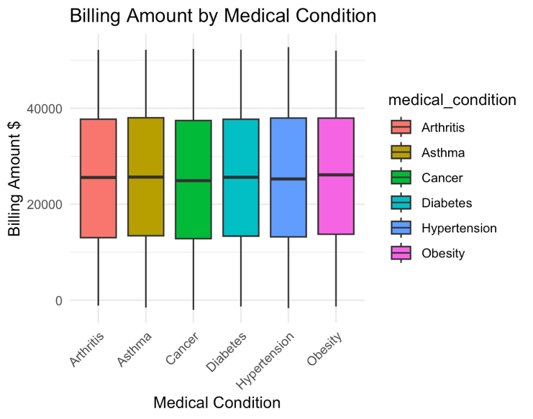

2. The average billing amount is also equally spread based on the medical condition diagnosed, with cancer having the smallest median billing amount, and obesity & asthma having the highest median billing amount shown on the boxplot.

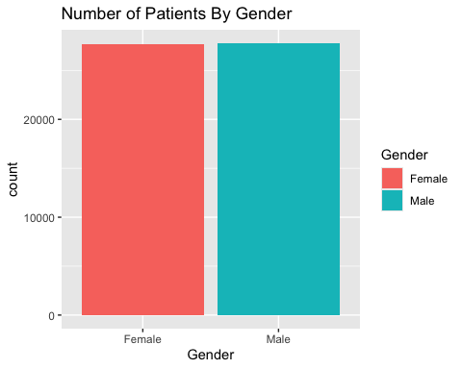

3. The total number of patients per gender are spread equally between male and female

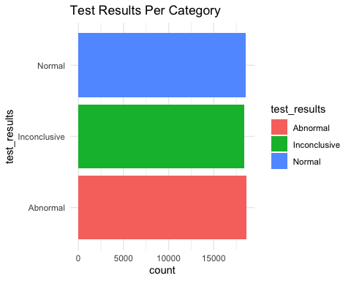
4. The total number of patients for each test result (normal, abnormal, inconclusive) is almost equal, suggesting that 1/3 of the sample population was distributed equally to all 3 test result groups. This raises alarms because 1/3 of patients that visited a hospital had an inconclusive test result, which is a very large proportion for something we want to minimize.

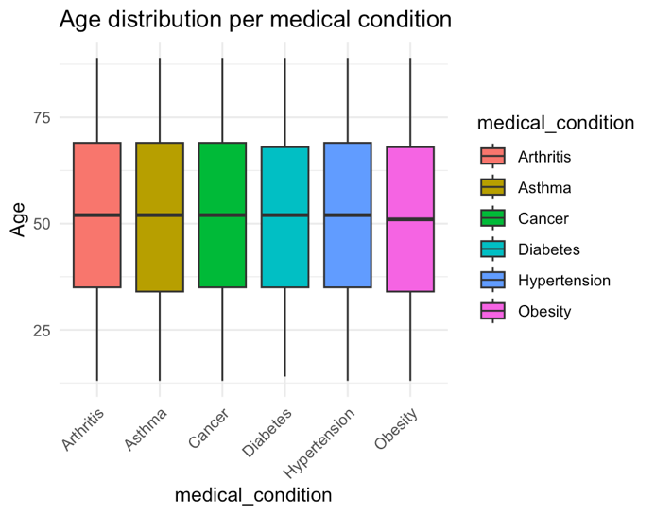
5. The age distribution in our patient sample per medical condition is also equally spread, where obesity has the slightest smallest median age group of patients compared to other medical conditions with a more similar median age. This is quite surprising since it is definitely very rare that age is evenly distributed per medical condition since certain medical conditions stem more frequently at an older age than others, and vice versa
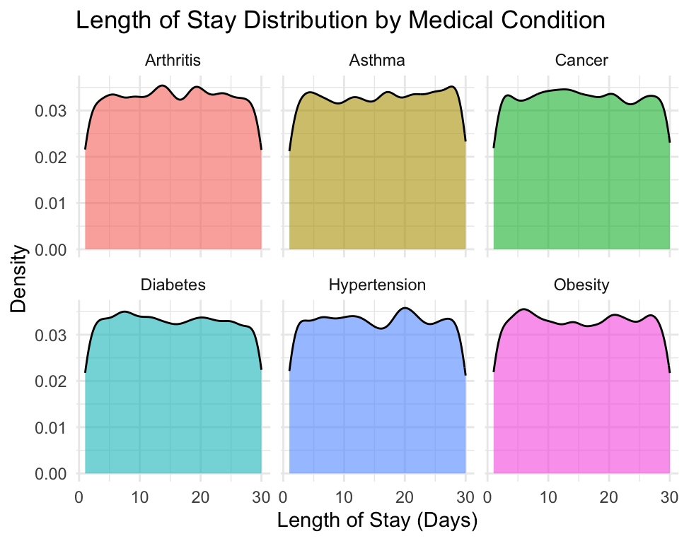
6. As for how different medical conditions affect the average length of stay in the hospital, we found that patients diagnosed with Arthritis had the most frequent number of stays between 13 - 17 days, while Asthma patients had the most patients with a total of 27 days stayed in the hospital. Hypertension patients had the greatest number of patients who stayed for 20 days in the hospital, and obesity had a higher frequency of stay below 10 days.
In our second final project milestone, we conducted multiple hypothesis testing:
1. Through our one sample t tests for the age and billing amount columns, the average age of our sample population is indeed 51.5 years old. The average billing amount = $25539.
2. Our ANOVA test previously concludes that each individual medication type has very little effect on determining the final billing amount, and the average billing amount is similar across all 5 medication types.
3. Our linear regression model tells us that age is not a good predictor for billing amount and there is little correlation between the two variables.
4. My two-sample t test on test result and its impact on the billing amount concludes that the average billing amount for normal and abnormal tests are very similar, and one test result does not cause a higher or lower billing amount than the other.
Further Research Questions:
1. Is there a significant difference in length of stay for each patient based on the insurance providers? (perhaps on the deductible, and willingness to cover for the patient’s costs)
2. Does gender, age, blood types, or medical condition significantly impact the test result with the baseline result being normal? (some blood types might make it more difficult to test, some medical conditions are harder to be tested regularly than others, certain hospitals do a bad job in getting a normal test result)
3. Does length of stay affect the billing amount?
4. Does the type of admission predict the length of stay in the hospital?

- Does the insurance provider affect the length of stay for patients?
Linear Regression Model:
H₀: Insurance provider does not significantly predict length of stay
H₁: At least one insurance provider significantly predicts length of stay
α = 0.05
Residuals Table
 | Min | 1Q | Median | 3Q | Max
Residuals | -14.6330 | -7.4859 | -0.4474 | 7.5141 | 14.5526

Coefficients Table
 | Estimate | Std. Error | t-value | p-value
(Intercept) | 15.4474 | 0.0829 | 186.350 | < 2e-16
Blue Cross | 0.0747 | 0.1168 | 0.639 | 0.523
Cigna | 0.0385 | 0.1164 | 0.331 | 0.741
Medicare | 0.1856 | 0.1166 | 1.592 | 0.111
UnitedHealthcare | 0.0079 | 0.1167 | 0.068 | 0.946
Model Summary
R² | Adjusted R² | F-statistic | p-value | df | Residual Std. Error
0.00006076 | -0.00001131 | 0.843 | 0.4976 | 55495 | 8.66
Summary:
A linear regression model was conducted to determine whether insurance provider significantly predicts a patient's length of stay. The significance level was set at α = 0.05. The results show that none of the five insurance providers (Blue Cross, Cigna, Medicare, UnitedHealthcare, Aetna) produced a p-value below 0.05, meaning we failed to reject the null hypothesis. In other words, a patient's insurance provider does not significantly influence how long patients stay in the hospital. The overall model p-value of 0.4976 further confirms this, as it is well above our significance level. The R² value of 0.00006076 is essentially 0, telling us that insurance provider explains virtually none of the variance in length of stay. Interestingly, Medicare had the highest coefficient (0.1856) among all providers from our coefficients table, suggesting a slight tendency toward longer stays, but even this was not statistically significant (p = 0.111).
2. Multinomial Logistic Regression Model
H₀: Gender, age, blood type, and medical condition do not significantly predict test result outcome
H₁: At least one predictor significantly influences whether a test result is Abnormal or Inconclusive compared to Normal
α = 0.05

Baseline = Normal test result
Residual Deviance = 121917.5
AIC = 121977.5
Coefficients & p values — Abnormal vs Normal(Baseline)
Predictor | Estimate | Std. Error | p-value
(Intercept) | 0.0152 | 0.0474 | 0.7477
Gender (Male) | -0.0238 | 0.0208 | 0.2523
Medical Condition (Asthma) | -0.0980 | 0.0360 | 0.0064
Medical Condition (Cancer) | -0.0306 | 0.0359 | 0.3943
Medical Condition (Diabetes) | -0.0230 | 0.0358 | 0.5214
Medical Condition (Hypertension) | -0.0880 | 0.0360 | 0.0145
Medical Condition (Obesity) | -0.0254 | 0.0359 | 0.4794
Blood Type (A+) | 0.0147 | 0.0415 | 0.7231
Blood Type (AB-) | -0.0115 | 0.0413 | 0.7814
Blood Type (AB+) | -0.0025 | 0.0415 | 0.9514
Blood Type (B-) | 0.0071 | 0.0414 | 0.8632
Blood Type (B+) | 0.0121 | 0.0416 | 0.7720
Blood Type (O-) | 0.0055 | 0.0415 | 0.8941
Blood Type (O+) | 0.0158 | 0.0414 | 0.7038
Age | 0.0008 | 0.0005 | 0.1276

Coefficients & p values — Inconclusive vs Normal(Baseline)
Predictor | Estimate | Std. Error | p-value
(Intercept) | -0.0237 | 0.0476 | 0.6195
Gender (Male) | -0.0269 | 0.0208 | 0.1969
Medical Condition (Asthma) | -0.0597 | 0.0361 | 0.0980
Medical Condition (Cancer) | -0.0178 | 0.0362 | 0.6235
Medical Condition (Diabetes) | -0.0309 | 0.0361 | 0.3932
Medical Condition (Hypertension) | -0.0305 | 0.0360 | 0.3963
Medical Condition (Obesity) | -0.0229 | 0.0362 | 0.5272
Blood Type (A+) | 0.0315 | 0.0416 | 0.4484
Blood Type (AB-) | -0.0328 | 0.0416 | 0.4301
Blood Type (AB+) | 0.0210 | 0.0415 | 0.6129
Blood Type (B-) | -0.0094 | 0.0416 | 0.8211
Blood Type (B+) | 0.0553 | 0.0416 | 0.1830
Blood Type (O-) | -0.0047 | 0.0417 | 0.9104
Blood Type (O+) | -0.0046 | 0.0417 | 0.9124
Age | 0.0009 | 0.0005 | 0.0778

Summary:
A multinomial logistic regression was conducted to determine whether gender, age, blood type, or medical condition significantly predicts a patient's test result, with Normal set as the baseline category. The significance level was set at α = 0.05.
For the Abnormal vs Normal comparison, two predictors came back statistically significant. Asthma had a p-value of 0.0064 and Hypertension had a p-value of 0.0145, both falling below our significance level of 0.05, meaning we reject the null hypothesis for these two predictors specifically. Both conditions produced negative coefficients (-0.0980 and -0.0880 respectively), suggesting that patients diagnosed with Asthma or Hypertension are slightly less likely to receive an Abnormal result compared to a normal result. All other predictors including gender, age, blood type, and remaining medical conditions produced p-values well above 0.05, meaning they do not significantly predict an Abnormal result.
For the Inconclusive vs Normal comparison, no predictors were statistically significant at the 0.05 level. Age came closest with a p-value of 0.0778, which is just above our threshold, suggesting a very weak tendency for older patients to receive inconclusive results but not enough to be conclusive.
Overall, we partially reject the null hypothesis since at least two predictors (Asthma and Hypertension) showed significance in predicting Abnormal results. However, the effect sizes are very small, and most predictors showed no meaningful relationship with test outcomes.
- Scatterplot of how length of stay affects the billing amount using linear regression

H₀: Length of stay does not significantly predict billing amount
H₁: Length of stay significantly predicts billing amount
α = 0.05

Coefficients Table
 | Estimate | Std. Error | t-value | p-value
(Intercept) | 25681.887 | 123.739 | 207.55 | < 2e-16
Length of Stay | -9.193 | 6.966 | -1.32 | 0.187
Model Summary
R² | Adjusted R² | F-statistic | p-value | df | Residual Std. Error
0.00003138 | 0.00001336 | 1.741 | 0.187 | 55498 | 14210
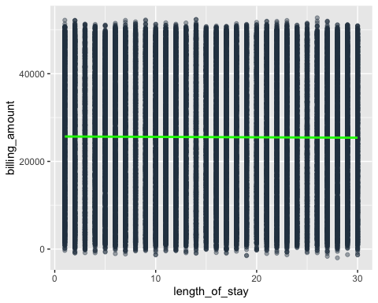
Summary:
I did not want to make a scatterplot because my dataset only has 3 columns with continuous numerical value; thus, I am already limited with what to include in my scatterplot. In addition, the scatterplot I created here clearly tells me the dataset might be synthetically generated, where there is a uniformed spread for patient billed between $0 - $52,000 for length of stay between 1 – 30 days, merely impossible. It is almost impossible to get billed $52,000 for 1 day of stay in the hospital; in addition, a patient who stays 30 days should have a dramatically higher bill than someone who stays 1 day. In addition, this scatterplot tells us essentially nothing. The linear regression best fitting line is completely horizontal, suggesting that the average billing amount is the same for stays between 1 – 30 days.
- ANOVA test on if admission type has a significant influence on the length of stay
H₀: Mean length of stay is the same across all 3 admission types
H₁: At least one admission type has a significantly different average length of stay
α = 0.05
ANOVA Table
 | Df | Sum Sq | Mean Sq | F-value | p-value
Admission Type | 2 | 330 | 164.87 | 2.199 | 0.111
Residuals | 55497 | 4161467 | 74.99

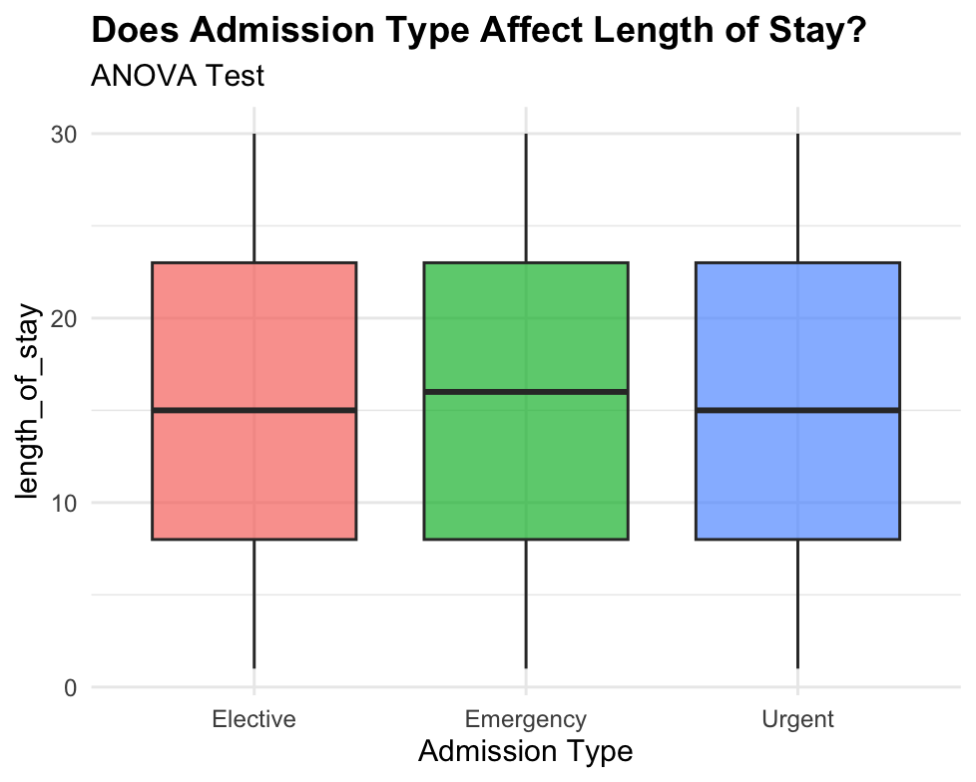
Summary:
A one-way ANOVA test was conducted here to determine whether admission type significantly predicts a patient’s length of stay across three groups (elective, emergency, urgent). The significance level was set at α = 0.05. The boxplot tells us that emergency admission type results in a higher median length of stay at 17 days, while elective and urgent admission types resulted in a lower length of stay at 15 days. Emergency admission types are usually more severe cases and require longer observation hence the higher number median length of stay.
The results show a p-value of 0.11, which is larger than our significance level at 0.05. This suggests that we failed to reject the null hypothesis, and admission type does not significantly influence how long a patient stays in the hospital.

Overall Findings:
Throughout this project, a consistent pattern kept emerging across my hypothesis tests and regression models. No variable produced a strong, statistically significant relationship with any outcomes. My analysis shows that age, medication type, admission type, insurance provider, and length of stay all failed to predict billing amount in a meaningful way. This raised my suspicion on the dataset early on. After further research, I concluded that the dataset is synthetically generated using Python’s Faker library, specifically designed for educational and research purposes due to the sensitive and heavily regulated nature of real healthcare data. This dataset was built to mirror the structure of real healthcare records so individuals like me who are interested in healthcare datasets can conduct data analysis or machine learning models. This explains why nothing predicts the billing amount, since each variable was generated independently of each other.
This is important since real healthcare data shows significance between these variables, where the billing amount would be driven by multiple factors. Nonetheless, this project still provided significant value for me to practice data visualizations, hypothesis testing and regression models in R, all skills that would transfer directly to working with real healthcare datasets in a professional setting in the future.

References:
Healthcare Dataset. (n.d.). Www.kaggle.com. https://www.kaggle.com/datasets/prasad22/healthcare-dataset/data

