HashingJobApp


Author: The Analyst: Hyposelenia
Challenge: HashingJobApp
Category: General Skills
Date: 01/16/26

- Objective

The objective of this challenge is to correctly generate MD5 hashes of given text strings and submit them to the remote service in order to retrieve the flag.

- Background

A hash function takes an input (such as text) and produces a fixed-length output called a hash. MD5 (Message Digest 5) is a commonly known hashing algorithm that outputs a 32-character hexadecimal value.
In cybersecurity, hashes are often used for:
- Verifying file integrity
- Storing passwords securely (historically)
- Identifying data without revealing the original content
This challenge tests basic familiarity with hashing and interacting with a remote service.

- Tool Used
- Oracle VirtualBox (Kali Linux) – Used as the Linux environment
- Linux Terminal – Used to execute decoding commands
- Netcat (nc) – Used to connect to the challenge serve
- Online MD5 Hash Generator – Used to compute MD5 hashes
  - https://www.md5hashgenerator.com/
- Methodology

- Launched the challenge instance to obtain the hostname and port.
- Connected to the remote service using Netcat:
nc <hostname> <port>
- The server prompted for the MD5 hash of a word enclosed in quotes (excluding the quotes).
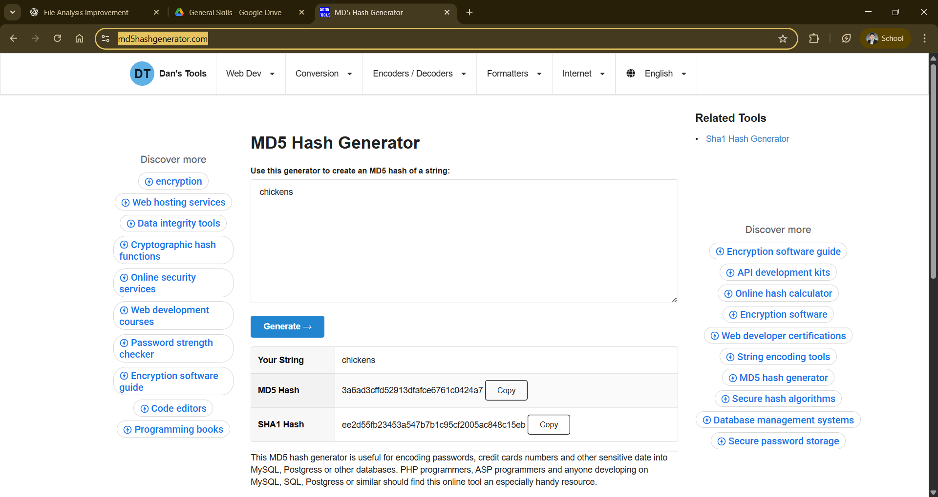
- Copied the given word and pasted it into an online MD5 hash generator.

- Submitted the generated MD5 hash back to the server.
- Repeated the process for each prompt.
- After all hashes were entered correctly, the server displayed the flag.
- Result
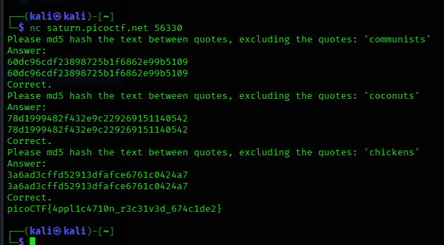
picoCTF{4ppl1c4710n_r3c31v3d_674c1de2}

- Explanation

After connecting to the server, the program requested MD5 hashes for several randomly generated words, such as:
- communists
- coconuts
- chickens

Each challenge instance generates different words, so the exact inputs may vary.
The task required hashing only the text inside the quotes, not including the quotation marks. The correct MD5 hash was then submitted back to the server.
An online MD5 generator was sufficient for solving this challenge, especially since the focus was on understanding hashing rather than scripting automation.

31b9416342e454523f7106283ff57b5f

- Conclusion

HashingJobApp introduces the concept of hashing in a simple, interactive way. It reinforces how hash functions work and how they are used in real-world applications. While manual tools are effective for this challenge, it also highlights how such tasks could be automated using scripts for efficiency in more advanced scenarios.
— The Analyst: Hyposelenia

