两圆相交，半径分别为r1, r2

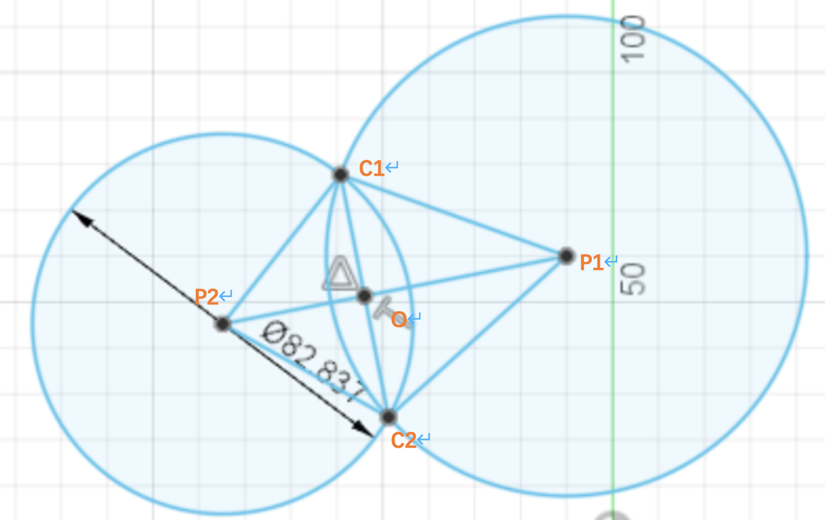

令x = ｜OP1｜，y = ｜OC1｜，d = ｜P1P2｜

R1^2 - X^2 =. R2 ^2 – (d - X)^2 = y^2

x = (d^2 + r1^2 – r2^2 ) / 2d

y = sqrt( r1 ^ 2 – x ^.2 )

O = (P2 – P1) / d * x + P1

f = ((P2 – P1) / d) ^ (-1)

C1 = O + f * y

C2 = O +.-f * y

其他公式

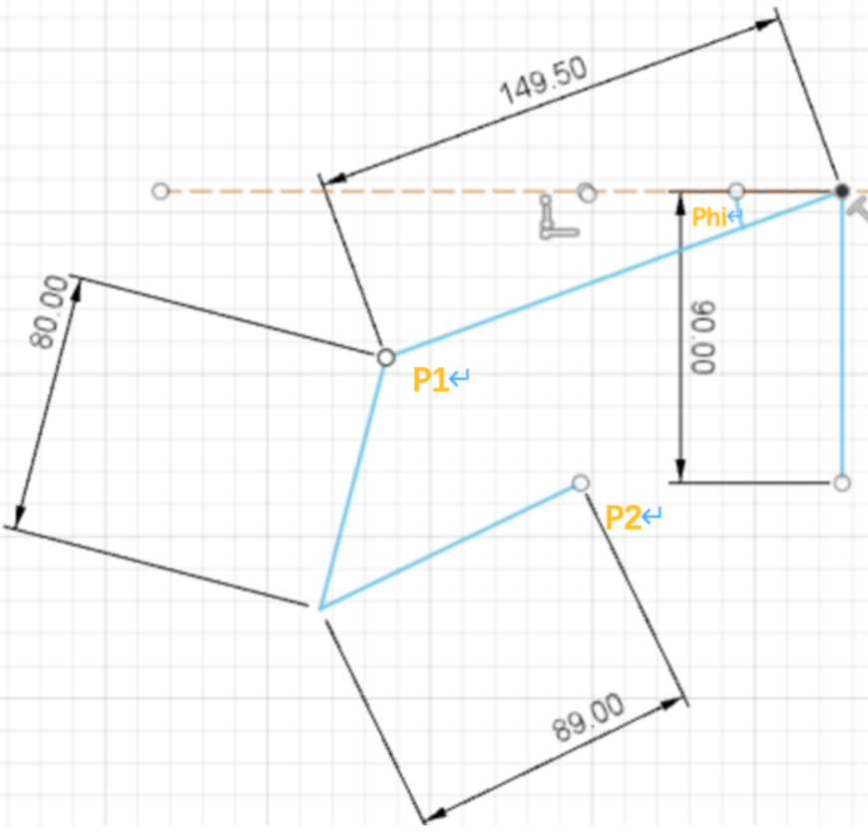

P2(-80.477, 0)

Phi = +phi_x (+phi_y)

反射模型：

2d草图

