CHAPTER III
METHODOLOGY

Research Design
This study will use a developmental and quantitative research design. The developmental approach will be used to design, develop, and evaluate a sales forecasting and inventory optimization system for a selected small to medium retail business. The quantitative approach will be used to measure the forecasting performance of the implemented models and evaluate the developed system using defined software quality characteristics.
The study will implement two forecasting approaches: a Moving Average model as the statistical baseline and an XGBoost model as the primary machine learning approach. The performance of both approaches will be compared using Mean Absolute Error (MAE) and Root Mean Squared Error (RMSE). The model with better forecasting performance will be considered in interpreting the demand forecasting results.
The resulting demand forecasts will then be used by the inventory optimization component to calculate recommended reorder points and reorder quantities. The recommendations will consider forecasted demand, supplier lead time, and a configurable safety stock buffer.
The developed system will also be evaluated based on selected ISO/IEC 25010:2023 software quality characteristics, specifically functional suitability, reliability, interaction capability, performance efficiency, and maintainability.

Development Approach
The researchers will use an iterative system development approach in developing the proposed sales forecasting and inventory optimization system. The development process will consist of the following stages:
Planning → Data Preparation → System Design → Model Development → System Development → Testing → Evaluation → Refinement
- Planning – The researchers will identify the requirements of the partner business, including its current sales and inventory management practices, the products, historical sales records, supplier lead times, and other inventory-related information needed by the system.
- Data Preparation – The collected historical sales records will be cleaned, organized, and transformed into a structured dataset for both the Moving Average baseline and the XGBoost model.
- System Design – The system architecture, database structure, forecasting process, inventory optimization process, and dashboard interface will be designed.
- Model Development – The Moving Average and XGBoost models will be implemented using the prepared dataset, with Moving Average as the statistical baseline and XGBoost as the primary machine learning model.
- System Development – The forecasting models and inventory optimization component will be integrated into the system, and a dashboard will be developed for the business owner or authorized staff to view forecasts and restocking recommendations.
- Testing – The system will undergo functional and performance testing to determine whether its components operate according to their intended functions.
- Evaluation – The forecasting models will be evaluated using MAE and RMSE, and the completed system will be evaluated using selected ISO/IEC 25010:2023 software quality characteristics.
- Refinement – The results from testing and evaluation will be used to identify issues and improve the system before the final implementation.

Moving Average Model
The Moving Average model will be implemented as the statistical baseline of the study. It will forecast future product demand by calculating the average of a fixed number of recent historical observations.
MAₜ = (Dₜ₋₁ + Dₜ₋₂ + ⋯ + Dₜ₋ₙ) / n
Where:
- MAₜ = forecasted demand for the current period
- D = actual demand
- n = number of previous periods included in the calculation
The Moving Average model will provide a baseline against which the performance of the XGBoost model can be compared.

XGBoost Model
The primary machine learning model of the study will be Extreme Gradient Boosting (XGBoost). XGBoost is an ensemble learning algorithm that builds decision trees sequentially, with subsequent trees learning from the errors of previous trees.
For this study, XGBoost will be used as a regression model to predict short-term product demand from historical sales information.
The model will use prepared historical sales features as inputs and the corresponding future demand as the target variable.
Potential input features will be based on the available historical sales data and may include:
- Previous sales quantities
- Recent sales averages
- Previous-period demand
- Product identifier
- Time-related information
- Other available sales-related variables
The final features will depend on the quality and availability of the partner business's historical records. External factors such as promotions, sudden local events, and supply disruptions will not be included unless they are explicitly available in the dataset.

Model Training and Testing
The historical dataset will be divided into training and testing portions. The training dataset will be used to develop the XGBoost model, while the testing dataset will be used to evaluate its forecasting performance on previously unseen observations.
Because sales forecasting involves time-dependent data, the observations will be maintained in chronological order during the division of the dataset. This will help prevent future observations from being used to predict earlier observations.
During model development, the training data will be evaluated using time-series cross-validation (TimeSeriesSplit), which trains and tests the model across several rotating chronological windows rather than a single split. This provides a more reliable estimate of forecasting performance than a single train/test division would, particularly given the limited size of the available dataset. Once the model configuration is finalized, a final chronological train/test split, using the most recent period as the holdout set, will be used to report the model's forecasting performance. The same holdout period will be used when comparing the Moving Average and XGBoost models to ensure their performance is compared fairly.

Safeguards for Small Datasets
Because the partner business's sales history is expected to be limited in size, the study applies three safeguards to keep the XGBoost model from overfitting or producing unreliable forecasts:
- Conservative model settings – XGBoost will be configured with a shallow maximum tree depth, a reduced learning rate, and a capped number of estimators, so that the model favors general patterns over memorizing noise specific to the training data.
- Early stopping – Training will halt once performance on a validation subset stops improving, so that no further trees are added that only fit the training data.
- Time-series cross-validation – The training data will be evaluated using TimeSeriesSplit across several rotating chronological windows, as described under Model Training and Testing, which gives a more reliable performance estimate than a single split on a small dataset.
In addition, the Moving Average baseline serves as a reference point. If XGBoost does not outperform it on the same holdout period, the study will report that result and identify the Moving Average model as the better-performing approach for the dataset.

Forecasting Evaluation
The forecasting models will be evaluated using Mean Absolute Error (MAE) and Root Mean Squared Error (RMSE), as specified in the objectives of the study.

Mean Absolute Error
MAE measures the average absolute difference between the predicted demand and the actual demand.
MAE = (1/n) Σ |yᵢ − ŷᵢ|
Where:
- n = number of observations
- yᵢ = actual demand
- ŷᵢ = predicted demand
A lower MAE indicates that the model's predictions are closer to the actual demand.

Root Mean Squared Error
RMSE measures the square root of the average squared difference between predicted and actual demand.
RMSE = √[(1/n) Σ (yᵢ − ŷᵢ)²]
A lower RMSE indicates better forecasting performance. Because the errors are squared, RMSE places greater emphasis on larger prediction errors.
The model with the lower evaluation errors will be considered the better-performing forecasting approach for the evaluated dataset.

Inventory Optimization
The inventory optimization component will convert forecasted product demand into actionable restocking recommendations by determining when to order and how much to order.

Reorder Point (When to Order)
The system will calculate the Reorder Point (ROP) using forecasted demand, supplier lead time, and safety stock.
ROP = (Dᴬ × L) + SS
Where:
- ROP = Reorder Point
- Dᴬ = average forecasted demand per period
- L = supplier lead time
- SS = safety stock
When the inventory position (I), meaning the current stock plus any quantity already ordered but not yet received, reaches or falls below the calculated reorder point, the system will generate a restocking recommendation.

Reorder Quantity (How Much to Order)
The recommended reorder quantity (Q) restores the inventory position to an order-up-to level (S), which covers the expected demand during the supplier lead time and a target coverage period, plus the safety stock.
S = Dᴬ × (L + C) + SS
Q = S − I
Where:
- S = order-up-to level (target inventory level)
- C = target coverage period, or the number of periods the order is intended to cover once delivered, set by the business owner
- I = inventory position (current stock plus any quantity on order)
- Q = recommended reorder quantity, rounded up to a whole unit
The quantities Dᴬ, L, and SS are defined in the reorder point formula above. As an illustration, if the average forecasted demand is 10 units per day, the supplier lead time is 3 days, the coverage period is 7 days, and the safety stock is 15 units, then ROP = (10 × 3) + 15 = 45 units and S = 10 × (3 + 7) + 15 = 115 units. If the inventory position falls to 40 units, the system will recommend ordering Q = 115 − 40 = 75 units.
The system will allow the safety stock, supplier lead time, and target coverage period to be configured according to the available business information. The study assumes reasonably stable supplier lead times because highly variable supply chains can reduce the accuracy of reorder recommendations.

System Evaluation
The developed system will be evaluated using selected ISO/IEC 25010:2023 software quality characteristics identified in Chapter I:
- Functional Suitability – Determines whether the system provides the functions necessary to perform sales forecasting, inventory optimization, and restocking recommendations.
- Reliability – Determines the system's ability to perform its required functions consistently under specified conditions.
- Interaction Capability – Assesses whether the dashboard and system functions can be understood and used effectively by the intended users, particularly non-technical small to medium business owners or staff. This characteristic was named Usability in the 2011 edition of the standard.
- Performance Efficiency – Assesses the system's responsiveness and resource usage while performing its forecasting, inventory optimization, and dashboard functions.
- Maintainability – Assesses how easily the system can be analyzed, modified, and maintained when changes or improvements are required.

Evaluation Instrument
The evaluation will use a questionnaire developed by the researchers based on the five selected ISO/IEC 25010:2023 characteristics. Each characteristic will be measured by a set of statements (at least three per characteristic) that respondents will rate after using the system's dashboard, forecasts, and restocking recommendations. The questionnaire will be reviewed by the thesis adviser before it is administered, and participation will be voluntary and confidential.

Rating Scale and Interpretation
Respondents will rate each statement using a five-point Likert scale. The mean rating will be interpreted using the following scale:
Rating | Mean Range | Response | Interpretation
5 | 4.21 – 5.00 | Strongly Agree | Excellent
4 | 3.41 – 4.20 | Agree | Very Good
3 | 2.61 – 3.40 | Neutral | Good
2 | 1.81 – 2.60 | Disagree | Fair
1 | 1.00 – 1.80 | Strongly Disagree | Poor

Statistical Treatment
The weighted mean will be computed for each statement using the formula below:
WM = Σ(f × x) / n
Where:
- WM = weighted mean of the statement
- f = number of respondents who gave a particular rating
- x = numerical value of the rating (1 to 5)
- n = total number of respondents
The mean of each ISO/IEC 25010:2023 characteristic will be the average of the weighted means of its statements, and the overall system rating will be the average of the five characteristic means. Because the number of respondents is small, the results will be reported as descriptive statistics only and will not be used to generalize beyond the partner business. Forecasting performance will be summarized separately using MAE and RMSE, as described under Forecasting Evaluation.

Population of the Study
The study will be conducted in partnership with a selected small to medium retail business. The business will serve as the primary source of historical sales and inventory-related information required for the development and testing of the system.
The selected business will be identified based on its suitability for the study, particularly its availability of historical sales records and an existing inventory management process that can be analyzed and improved through the proposed system. The system will focus on a defined set of products handled by the partner business. The study will not attempt to represent all small to medium retail businesses because the scope is limited to a single partner business and defined product category.
The population of this study consists of the individuals directly involved in the use and evaluation of the proposed sales forecasting and inventory optimization system. This includes the owner of the partner small to medium retail business, who is the primary decision-maker for purchasing and inventory decisions, and any sales or inventory staff involved in day-to-day stock monitoring and restocking activities.
These individuals will serve as the respondents for the system evaluation described under System Evaluation in the Research Design, providing their assessment of the developed system based on the selected ISO/IEC 25010:2023 software quality characteristics: functional suitability, reliability, interaction capability, performance efficiency, and maintainability.
Because the population is small, the study will use total enumeration: the owner and all staff members who will use the system will be included as respondents, and no sampling formula will be applied. The exact number of respondents will be stated once the partner business has been confirmed.
In addition, the historical sales and inventory records of the partner business constitute the data population from which the study's training and testing datasets are drawn.

Data Collection Procedure
The researchers will gather the historical sales records of the partner business with permission from the business owner. The collected data will be used as the primary dataset for developing and evaluating the forecasting models.
The data may include the following information:
Data | Description
Date | Date when the product was sold
Product ID/Name | Identifier or name of the product
Quantity Sold | Number of units sold
Supplier Lead Time | Number of days required to receive an order
Current Stock | Current quantity of the product in inventory
Quantity On Order | Units already ordered but not yet received, when applicable

The historical sales data may be obtained from existing digital records, spreadsheets, or point-of-sale exports. If necessary, the records will be organized into a consistent dataset before they are used by the forecasting models.
Where the partner business's records are insufficient for model development, a comparable public retail sales dataset may be used for model development and testing, as stated in the scope of the study.
The study requires basic digital sales records because the forecasting component depends on historical sales information. Businesses that rely entirely on paper-based records would require additional digitization before the system could be used.
For the forecasting model to function reliably, a minimum of eight weeks of consistent historical sales records is recommended. Datasets shorter than this, or with substantial gaps, are expected to reduce forecasting reliability regardless of the modeling techniques applied.
Business information obtained during the study will be treated confidentially and will only be used for purposes related to the research. Personally identifiable information, confidential business information, and unnecessary records will not be included in the system or research outputs.

Data Preprocessing
Before model development, the collected historical sales data will undergo preprocessing to ensure that the dataset is suitable for forecasting.
The preprocessing procedure will include:
- Data Cleaning – identifying missing, duplicated, or invalid records.
- Data Organization – arranging sales records chronologically according to their transaction dates.
- Data Aggregation – grouping sales transactions according to the selected time interval, such as daily or weekly sales.
- Missing Value Handling – identifying missing observations and applying an appropriate treatment based on the characteristics of the dataset.
- Product Selection – selecting the products that contain sufficient historical sales information for model development.
- Feature Preparation – preparing the historical sales information required by the XGBoost model.
- Dataset Splitting – separating historical observations into training and testing portions while maintaining their chronological order.
The preprocessing stage is necessary because the study's forecasting accuracy depends on the length, consistency, and completeness of the available historical sales data.

Software Project Schedule
The following schedule outlines the remaining activities for Thesis Writing 1, aligned with the institution's Midterm Period, Midterm Examination, and Finals Period timeline.
Activity | Target Dates
Complete Chapters 1-3 | Ongoing – Sept 20
Database schema and ERD | Completed
Data Flow Diagram and Project Context Diagram | Sept 21 – Sept 24
Use Case Diagram and wireframes | Sept 21 – Sept 26
Working prototype development | Sept 22 – Oct 1
Gantt chart and documentation finalization | Sept 28 – Oct 2
Internal review and revisions | Oct 2 – Oct 4
Midterm Examination (progress checkpoint) | Oct 5 – Oct 11
Proposal defense preparation | Oct 12 – Nov 15
Proposal Defense | Nov 16 – Nov 22

Hardware and Software Resources
The development and deployment of the proposed system will require the following resources:

Hardware
- Personal computers or laptops used for development, testing, and model training.
- A hosting environment (local server or cloud-based) for running the system during testing and demonstration.

Software
- Programming languages: PHP and Python
- Database management system: MySQL
- Machine learning libraries: XGBoost, scikit-learn, pandas, NumPy
- Local development environment: XAMPP or an equivalent PHP/MySQL server stack
- Version control: Git and GitHub
- Diagramming tools: for the Entity-Relationship Diagram, Data Flow Diagram, Use Case Diagram, and wireframes
- Documentation tools: Microsoft Word and related office productivity software

Data Flow Diagram
The Data Flow Diagram illustrates how data moves through the system's four main processes (data collection and preprocessing, demand forecasting, inventory optimization, and dashboard reporting) and its three data stores (sales records, forecast results, and reorder recommendations). The business owner appears twice to keep the flows uncluttered: once as the source of historical sales data and the recipient of forecasts and alerts, and again as the source of the safety stock and coverage settings used in inventory optimization.
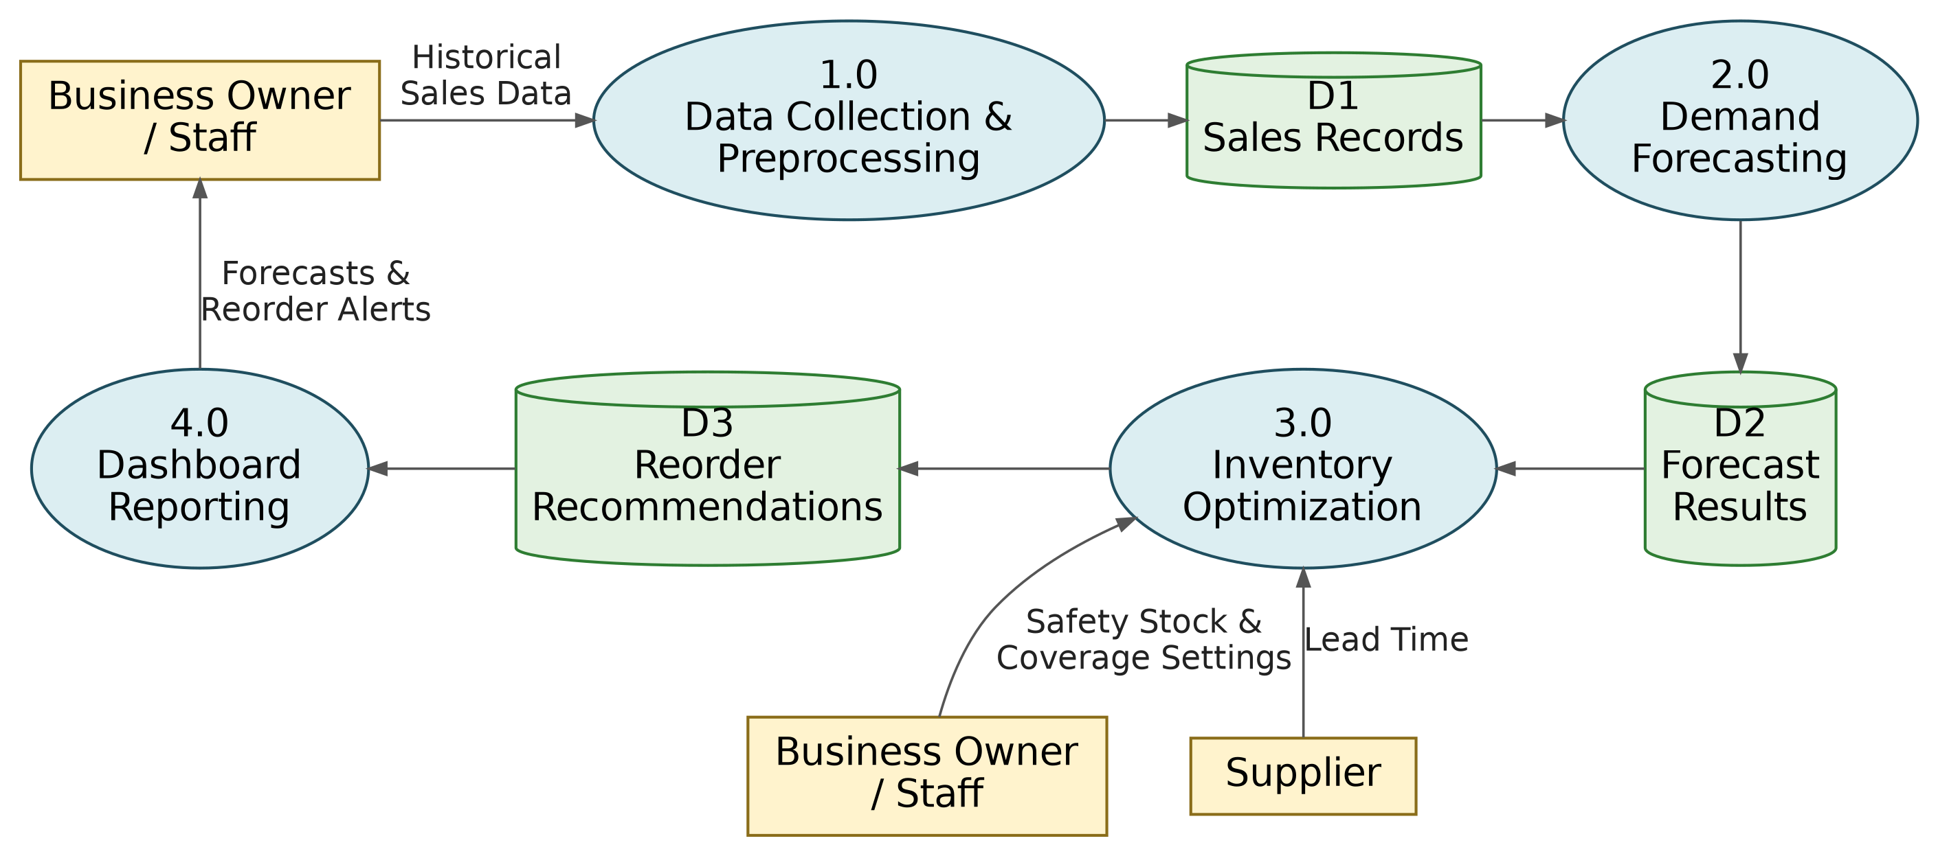
Figure 1. Data Flow Diagram

Project Context Diagram
The Project Context Diagram presents the proposed system as a single process and shows how it exchanges data with its external entities. The business owner or staff provide historical sales data, product information, and safety stock and coverage settings, and receive demand forecasts and reorder recommendations, while the supplier provides lead time information.
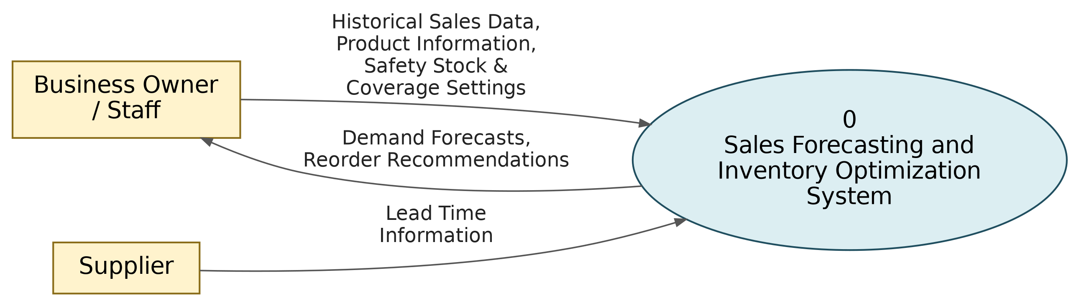
Figure 2. Project Context Diagram

Survey Results
Survey results will be included once the study's partner business has been confirmed and the system evaluation questionnaire, based on the ISO/IEC 25010:2023 characteristics described under System Evaluation in the Research Design, has been administered to the business owner and relevant staff.

Implementation Plan
Upon completion of development and successful evaluation, the system will be implemented at the partner business following a phased approach:
Phase 1: Pilot Testing — The system will be deployed in a controlled setting using the partner business's actual historical data, allowing the researchers to verify that forecasts and reorder recommendations behave as expected before full use.
Phase 2: Staff Orientation — The business owner and relevant staff will be given a walkthrough of the dashboard, covering how to interpret demand forecasts, reorder point alerts, and restocking recommendations.
Phase 3: Parallel Monitoring — For an initial period, the business will continue its existing inventory practices alongside the system's recommendations, allowing the owner to compare the system's suggestions against their own judgment before fully relying on it.
Phase 4: Full Adoption — Once the business owner is confident in the system's reliability, the dashboard becomes the primary reference for restocking decisions, with continued monitoring of forecast accuracy over time.

