CSS 475

Homework 07 (Lecture 06B)

Use the database file db03

These queries use both the airplane package system schema, and the meetings schema.

#1 Find the number of meetings for each employee ( including employees with no meetings)

Columns: **name, num_meet**

OrderBy: num_meet, employee.id

#2 Count the number of phone numbers by each type

Columns: **name, count**

Order By: name

#3 Count the number of packages for each shipper in the system. Note that packages with a pickup date in the record are not considered to be in the system.

Columns**: lastname, firstname, num_packages**

OrderBy: num_packages, lastname, firstname

#4 Find the number of meetings in each room

Columns: **roomnumber, building, num_meetings**

Order By: building, roomnumber

#5 Find all employees with no phones

Columns: **employeenumber**, **name**

Order By: name

#6 Find all employees with no meetings

Columns: **employeenumber**, **name**

OrderBy : employee.id

#7 Find all phone numbers for all employees who do not have a cell phone. *Suggestion. Start with a sub select that returns employeeIDs for all employees with no cell phone.*

Columns: **employeenumber**, **name, phone_type, number**

ORDER BY employeenumber , phone_type, number

#8 Find all employees who are in any staff meeting

Columns employeenumber, **name**;

Order By employeenumber;

#9 Find all employees who are not in any staff meeting

Columns **employeenumber, name**

Order By: employeenumber

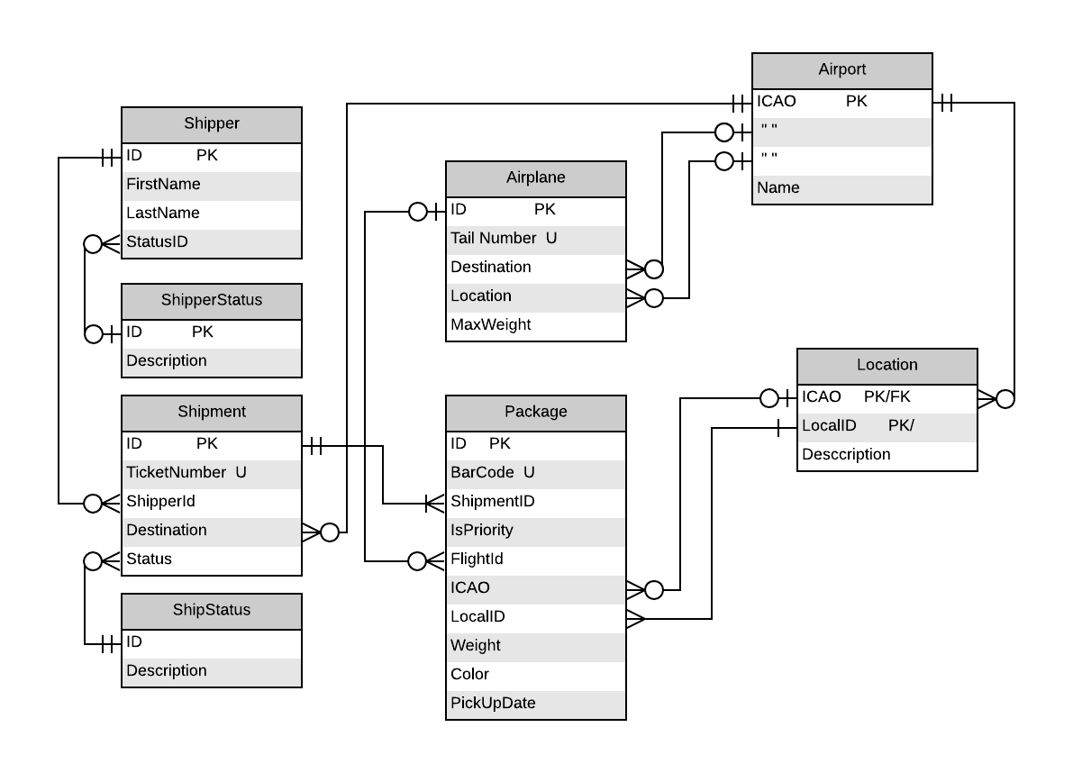

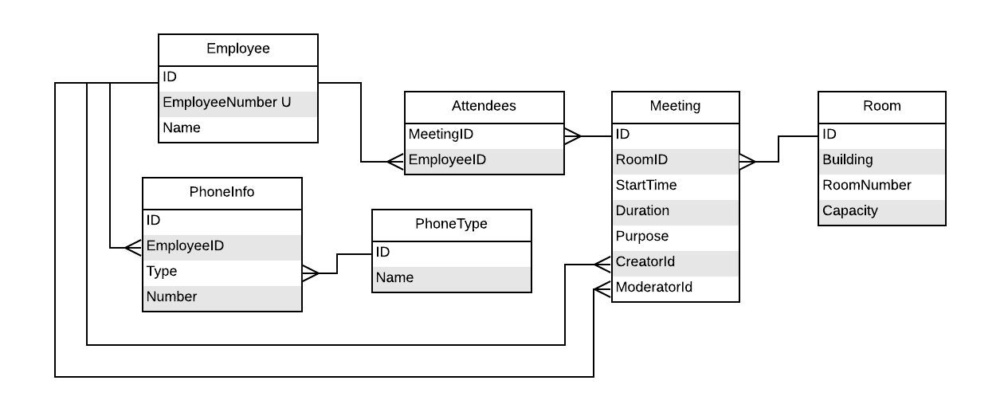

**Expected Output:**

StudentName

#1 find the Num of meetings per employee.

name | num_meet

---------+----------

Wendy | 0

Belle | 0

Harry | 4

John | 5

Winston | 5

Max | 5

Dan | 5

Sarah | 6

Mark | 6

Sarah | 7

James | 7

Ariel | 8

Martha | 8

Alice | 8

Albert | 9

Jack | 10

Dave | 11

(17 rows)

#2 Count the number of phone numbers by each type

name | count

----------+-------

Business | 0

Cell | 10

Home | 8

Pager | 3

Work | 15

(5 rows)

#3 Count the number of packages for each shipper in the system.

lastname | firstname | num_packages

------------+-----------+--------------

Adams | Mary | 0

Adans | John | 0

Disney | Walt | 0

Martin | Wilma | 0

Rabbit | Roger | 0

Smith | John | 0

Smith | John | 0

Spade | Sam | 0

Chenault | Martha | 2

Jefferson | Thomas | 2

Franklin | Ben | 3

Martin | George | 3

Flintstone | Fred | 4

Rogers | Fred | 4

Washington | Martha | 4

Cotts | Stu | 5

Rubble | Barney | 5

Zurgulost | Fred | 7

Bradshaw | John | 9

(19 rows)

#4 Find number of meetings in each room

roomnumber | building | num_meetings

------------+----------+--------------

101 | A | 4

102 | A | 1

103 | A | 2

104 | A | 4

101 | B | 4

102 | B | 0

104 | B | 0

201 | B | 2

202 | B | 1

(9 rows)

#5 Find all employees with no phone numbers listed

employeenumber | name

----------------+-------

X324236 | Belle

X321456 | Wendy

(2 rows)

#6 Find all employees who are in no meetings.

employeenumber | name

----------------+-------

X321456 | Wendy

X324236 | Belle

(2 rows)

#7 Find all phone numbers for every employee who does not have a cell phone

employeenumber | name | phone_type | number

----------------+---------+------------+----------

X311236 | Winston | P | 124-7890

X311236 | Winston | W | 124-6789

X311237 | Max | W | 124-4567

X311240 | Harry | H | 126-7890

X311240 | Harry | W | 126-6789

X311241 | Sarah | W | 127-4567

X311242 | Mark | W | 127-5678

(7 rows)

#8 Find all employees who are in any staff meeting

employeenumber | name

----------------+---------

X311234 | Sarah

X311235 | John

X311236 | Winston

X311237 | Max

X311238 | Dan

X311239 | Ariel

X311241 | Sarah

X311243 | Dave

X311244 | Jack

X311245 | James

X311246 | Martha

X311247 | Alice

X311248 | Albert

(13 rows)

#9 Find all employees who are NOT in any staff meeting

employeenumber | name

----------------+-------

X311240 | Harry

X311242 | Mark

X321456 | Wendy

X324236 | Belle

(4 rows)