Jericho Timbol Sub-select practice

1 – Find the number of attendees in each meeting, as well as the capacity of the room and the creator ID ( by id I mean meeting.id)

Column Names: **id, butsinseat, capacity, creatorid**

Order by meeting.id

*Note – this query will be very useful in the next problem.*

2 – For each creator of a meeting. Find the total number of attendees in their meetings, the total capacity of all of their meetings, and the available number of seats in all their meetings.

Column Names: **name, attendees, capacity, availseats**

Order By **creatorid, availseats**

3 – Find the name of the employee who is attending the most meetings. Compute a number ( maxMeeetings) which is 75% of the total number of meetings for that person.

Column Names: **name maxmeetings**

4 – Find all employees who are attending almost as many meetings as the most prolific meeting attender. ‘almost as many’ is defined as attending 75% of the number of meetings the most prolific meetening attender attends.

Column Names: **name, numMeetings**

Order by numMeetings;

5 – Find the average room utilization for all rooms occurring on 2018-03-04 at 10:00 AM . Express the utilization as a percentage value which is ‘total number of rooms with meeting’ / ‘total number of rooms’

Column Names: **Util in %**

6 – Find the number of employees we have for each phone type. ( Cell, Home etc)

Column Names category, num_employees

Order By category

7 – Find the number of phone listings we have for each phone type ( Cell, Home, etc)

Column Names: category, num_listings

Order By category

*Note – the difference between #6 and #7 is that if an employee has 2 phone numbers of*

*The same type – under 6 it would increase the count by 1. In #7 it would increase the count by*

*2*

8 – Find the number of cell phones in each meeting that takes place in building B

Column Names: **meetingid, purpose, numphones**

Order By meetingid

9 – Find the average number of cell phones in each meeting in building B Display answer to two decimal places

Column Names: **avg_phones**

10 – Find the total number of cell phones, and average number of phones for each building in building B

Column Names: **purpose numphone avg_phones**

Order By purpose, meeting.id

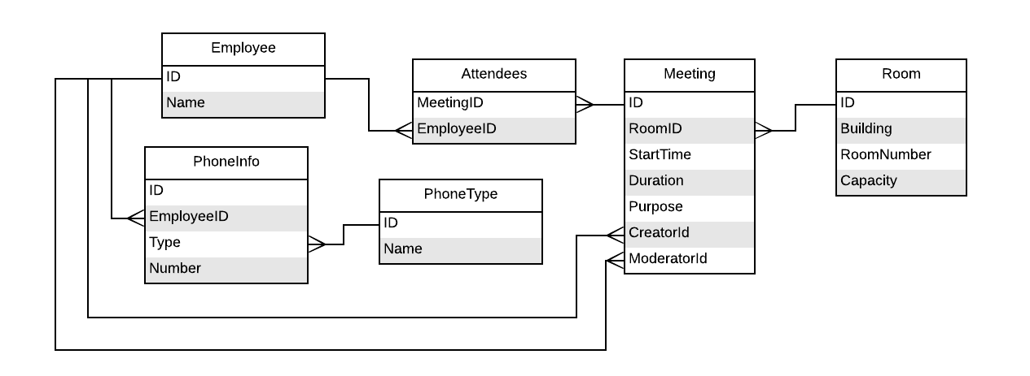

**Expected Output**

Expected output from homework 4B

#1 Get total number of attendees and capacity for all meetings created by each employee

( This query will be useful in #2)

id | butsinseat | capacity | creatorid

-----+------------+----------+-----------

101 | 6 | 10 | 14

102 | 6 | 10 | 14

103 | 8 | 10 | 14

104 | 6 | 10 | 14

105 | 6 | 20 | 3

106 | 7 | 20 | 3

107 | 3 | 5 | 3

108 | 4 | 20 | 6

109 | 6 | 20 | 5

110 | 14 | 30 | 11

111 | 6 | 30 | 14

112 | 6 | 20 | 14

113 | 7 | 20 | 14

114 | 6 | 20 | 14

115 | 7 | 20 | 3

116 | 6 | 5 | 5

(16 rows)

#2 - By creator. How many total attendes in meeting they have created,

what is the capacity, and what are avail seats.

name | attendees | capacity | availseats

---------+-----------+----------+------------

Winston | 23 | 65 | 42

Dan | 12 | 25 | 13

Ariel | 4 | 20 | 16

Alice | 14 | 30 | 16

Alice | 51 | 130 | 79

(5 rows)

#3 print the employee attending the most meetings,

and print 75% of the total number of meetings

name | maxmeetings

------+-------------

Dave | 8.25

(1 row)

#4 Return all employes who are attending more that 75% of the employee

with the most meetings

name | nummeetings

--------+-------------

Albert | 9

Alice | 10

Dave | 11

(3 rows)

#5 - Find average utilization of rooms as percentage value, for any meetings

occuring on 2018-03-04 at 10:00 AM

Util in %

-----------

22

(1 row)

#6 Show how many employees we have using each phone type

category | num_employees

----------+---------------

Cell | 10

Home | 7

Pager | 3

Work | 15

(4 rows)

#7 Show how many phone listings we have for each phone type

category | numlistings

----------+-------------

Cell | 10

Home | 8

Pager | 3

Work | 15

(4 rows)

#8 Number of cell phones in each meeting in building B

( This will be useful in the next query)

meetingid | purpose | numphones

-----------+-----------------+-----------

108 | DB Issues | 3

109 | Post Mortem | 6

110 | HR Presentation | 9

112 | Lunch | 3

113 | Lunch | 4

114 | Lunch | 3

115 | PlanningLunch | 5

(7 rows)

#9 Print the average number of cell phones that attendes have in

meetings in building B

avg_phones

------------

4.71

(1 row)

#10 find number of phones, and average number of phones for

Each meeting in building B

purpose | num_phones | avg_phones

-----------------+------------+------------

DB Issues | 3 | 4.71

HR Presentation | 9 | 4.71

Lunch | 3 | 4.71

Lunch | 4 | 4.71

Lunch | 3 | 4.71

PlanningLunch | 5 | 4.71

Post Mortem | 6 | 4.71

(7 rows)