**ITE3714 – Multimedia Website Design Practices**

# **Lab 1 – Introduction to HTML**

1. Open **Notepad++**
2. Click **File** 🡪 **Save As**
3. Input the file name as **lab1.html**

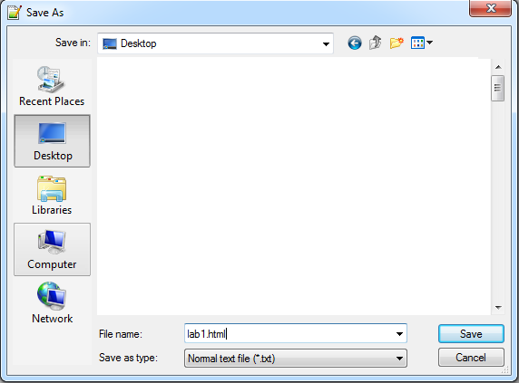

1. Type the following HTML code

|  |
| --- |
| <html>  <head>  <title></title>  </head>  <body>  </body>  </html> |

1. In the **<title>** tag, add the text **"Lab 1"**

|  |
| --- |
| <title>Lab 1</title> |

1. Add the following after the **<body>** tag

|  |
| --- |
| <h1> IVE Foundation Diploma (Information Technology) </h1>  <h2> IVE Foundation Diploma (Information Technology) </h2>  <h3> IVE Foundation Diploma (Information Technology) </h3>  <h4> IVE Foundation Diploma (Information Technology) </h4>  <h5> IVE Foundation Diploma (Information Technology) </h5>  <h6> IVE Foundation Diploma (Information Technology) </h6> |

1. Add the following after the **</h6>** tag

|  |
| --- |
| <p>  This Programme aims to deliver a quality education, with generic and IT knowledge and skills, that will enable students to achieve the skills required for developing a career in the IT industry, and a solid foundation for further studies.  </p> |

1. Add a pair of **<b>** tag to the text **"quality education"**

|  |
| --- |
| <b>quality education</b> |

1. Add a pair of **<i>** tag to the text **"generic and IT knowledge and skills"**

|  |
| --- |
| <i>generic and IT knowledge and skills</i> |

1. Add a pair of **<u>** tag to the text **"IT industry"**

|  |
| --- |
| <u>IT industry</u> |

1. Add a pair of **<b>** tag, **<i>** tag and **<u>** tag to the text **"solid foundation for further studies."**

|  |
| --- |
| <b><i><u>solid foundation for further studies.</u></i></b> |

1. Add the following tag after the **</p>** tag

|  |
| --- |
| <hr>  <br> |

1. Add the following after the **<br>** tag

|  |
| --- |
| Major IT modules:  <ul type="square">  <li>Programming Concepts and Applications</li>  <li>Database Applications Development</li>  <li>Computer Systems and Communication Fundamentals</li>  <li>Multimedia Website Design Practices</li>  </ul> |

1. Add the following after the **</ul>** tag

|  |
| --- |
| Articulation Path:  <ol type="I">  <li>Higher Diploma</li>  <li>Undergraduate Programme</li>  <li>Postgraduate Programme</li>  </ol> |

1. Add the following after the **</ol>** tag

|  |
| --- |
| Institute of Vocational Education<sup>TM</sup>  <br>  This is <sub>Lab 1</sub> |

1. Open **lab1.htm**l by using Google Chrome to see the result

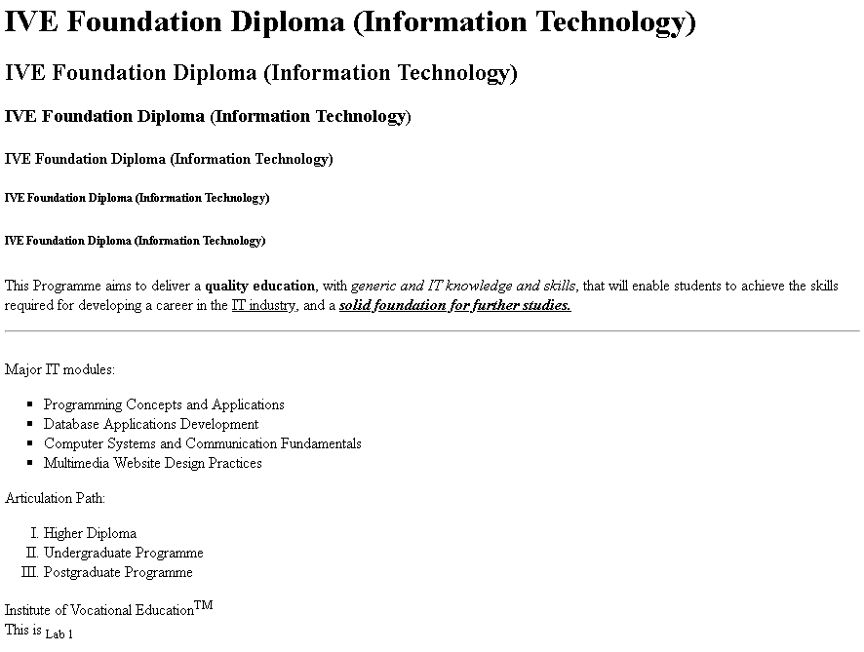

Source Code for Reference:

