**TEAM METADATA**

|  |  |
| --- | --- |
| **Course** | **SP23: APPLIED DATABASE TECHNOLOGIES** |
| **Assignment** | **Week-11 Final Project – Phase-2** |
| **Project Title** | **BLOOD BANK MANAGEMENT SYSTEM** |
| **Team Members**: | 1. **Aniruddho Chatterjee** 2. **Jerin Easo Thomas** 3. **Shreya Mariam Varghese** |
| **Submission Date** | **04/02/2023** |

1. **SCHEMA for Database:**

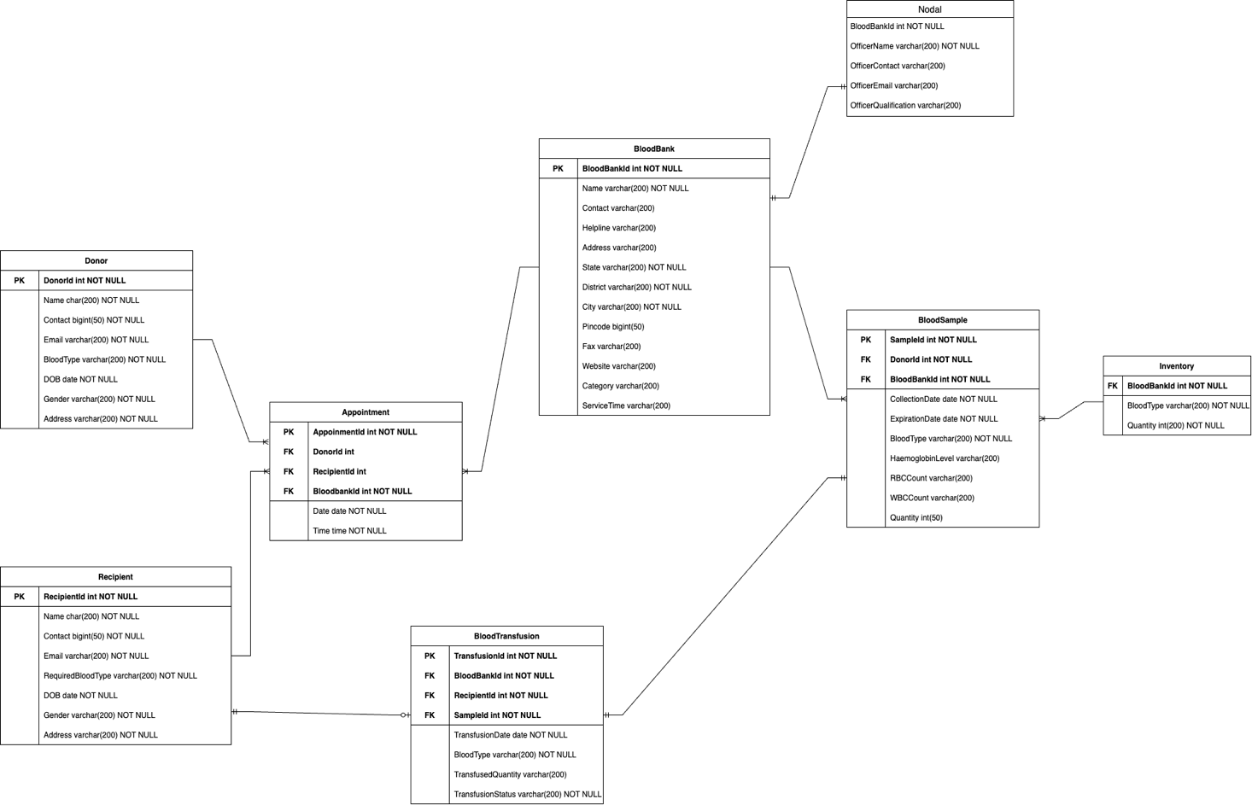

**Entities and Attributes:**

For our Blood Bank Management System, we have defined the following entities and attributes:

* Donor Table:

This entity contains details of the person who donates blood. The attributes used in this table are DonorId, Name, contact, Email, BloodType, DOB, Gender, Address. The DonorId acts as the primary key in this table.

* Recipient Table:

This entity contains the details of the person who receives the blood. The attributes used in this table are RecipientId, Name, contact, Email, BloodType, DOB, Gender, Address and the RecipientId acts as the primary key here.

* Appointment Table:

This table will contain the details of the appointment made by the donor or recipient. AppointmentId is the primary key in this table. AppointmentId will be generated and the UserID will be referenced accordingly from either the Donor table or the Recipient table based on the user type and hence the DonorId and RecipientId are used as foreign keys here. BloodBankId is used as foreign key here to fetch the details regarding the BloodBank. The other attributes used to track the appointment information are the data and time of the appointment.

* BloodBank Table:

It consists of information regarding the organization that manages the collection, storage, and the distribution of blood units. The data for this table has been populated from the csv data from Kaggle. The attributes used here are BloodBankId, name, contact, helpline, email, address, state, district, city, pincode, fax, website, category and servicetime. The BloodBankId acts as the primary key in this table.

* BloodSample Table:

This entity contains information about the blood unit. The attributes here are SampleId, DonorId, BloodBankId, CollectionDate, ExpirationDate, BloodType, HeamoglobinLevel, RBCCount, WBCCount, Quantity. SampleId acts as the foreign key here while DonorId and BloodBankId act as foreign keys as we reference this information from their respective tables.

* BloodTransfusion table:

This table consists of information regarding blood transfusions done like TransfusionId, BloodBankId, RecipientId, SampleId, TransfusionDate, BloodType, TransfusedQuantity, TransfusionStatus. Here TransfusionId acts as primary key while BloodBankId, RecipientId and SampleId act as foreign keys as their data needs to be referenced from their corresponding tables.

* Inventory:

This table will contain information regarding the quantity of each blood type. The attributes used here are BloodBankId, BloodType, Quantity. In this table, BloodBankId acts as the foreign key to get the quantity of each BloodType in the Blood Banks.

* Nodal:

This table contains details about the officials who will oversee all the tasks in the blood bank. The attributes in this table are BloodBankId, OfficerName, OfficerContact, OfficerEmail, OfficerQualification.

**Relationships:**

We have used crow foot notation in the above ER diagram to define the relationships between the entities. The relationships are defined as follows:

* One-to-many relationship is defined between the Donor entity and the Appointment entity as one donor can make multiple appointments.
* One-to-many relationship is defined between the Recipient entity and the Appointment entity as one recipient can also make multiple appointments.
* One-to-optional one can be seen between the recipient entity and BloodTransfusion entity as sometimes the recipient may be just enquiring regarding Blood transfusion and may or may not considering doing so.
* Many-to-one relation can be seen between the appointment entity and Blood bank entity as multiple appointments could be scheduled for a single Blood Bank.
* One-to-one relation is seen between the Blood bank entity and the Nodal entity as each blood bank has only one nodal officer.
* One-to-many relation is present between the entities Blood bank entity and Blood Sample entity as one blood bank has many blood samples.
* One-to-one relationship is seen between Blood sample entity and the Blood Transfusion entity as only one sample type will be used for the blood transfusion.
* Many-to-one relationship can be seen between the Blood sample entity and inventory entity as multiple samples would be clustered into a single entry for each Blood Bank.

1. **DATABASE**

**Database Constraints:**

* **No null Values and Uniqueness:** In our database schema the following entities cannot be NULL and must be unique. 1. Donor: DonorId

2. Recipient: RecipientId

3. Appointment: AppointmentId

4. Blood Bank: BloodBankId

5. Blood Transfusion: TransfusionId

6. Blood Sample: SampleId

7. Inventory: BloodBankId

All of the above fields cannot be NULL as they are used to uniquely identify each of the above entities.

* **VIEWS:**

We plan on creating the following views:

1. **Viewing the availability of specific blood type at a Blood Bank:**

For this view, we plan on joining the Inventory table, the Blood Sample table and also the Blood Bank table so that the user can view the quantity of a specific type of blood at a particular Blood bank.

1. **Viewing hospitals in a particular region:**

User can view the hospitals in a particular location in this view.

1. **Blood Bank can view the appointment details:**

Blood Bank can view the donor or recipient appointment details.

* **PROCEDURES:**

We have planned the creation of following procedures:

1. **Blood Sample Details and Quantity Updated:**

Each time a donor donates or a recipient request for a blood bag the inventory as well as the blood sample details will be updated accordingly.

1. **Updating User details:**

Users can update their details like contact and email.

1. **Procedure for insert operation:**

Details of new donors, recipients and blood bank details will be added using procedures.

**4. Assessment Table: Add your individual assessment/evaluation for your work.**

|  |  |
| --- | --- |
| Team Member | Aniruddho Swapan Chatterjee |
| Task Completion | 10/10 |
| Teamwork | 10/10 |
| Time Commitment | 10/10 |
| What could be done better | Communication and teamwork between the teammates were amazing. However, I would suggest thinking out of the box and allowing experimentation and risk taking to foster innovative solutions. This can help deliver the project in a better way. |

|  |  |
| --- | --- |
| Team Member | Jerin Easo Thomas |
| Task Completion | 10/10 |
| Teamwork | 10/10 |
| Time Commitment | 10/10 |
| What could be done better | Although our most recent project phase was successful, I would like to emphasize that there is always potential for development. Even better outcomes may have been attained with better preparation, an earlier start, and better execution. I would like to draw attention to the fact that we were able to get past the minor obstacles we ran into while working on the project and produced a high-quality end result. With the knowledge gained from this experience, we can refine our methods and ensure the greatest outcomes for upcoming project phases. |

|  |  |
| --- | --- |
| Team Member | Shreya Mariam Varghese |
| Task Completion | 10/10 |
| Teamwork | 10/10 |
| Time Commitment | 10/10 |
| What could be done better | All the team members communicated and contributed equally to this phase. Although, I feel an earlier start and better planning could have helped us to deliver even better results. |