Q:1) what is 2+2 =?
Paragraph: Paragraph here
Sol: description here
A:) 4
B:) 5
C:) 6
D:) 3
Correct: A
Q:1) what is 2+2 =? – This is second language question
Note – keep question number same as its primary language question
Paragraph: Paragraph here
Sol: description here
A:) 4 second language
B:) 5 second language
C:) 6 second language
D:) 3 second language
Correct: A

Q:2) what is 2+6 =?
Sol:
A:) 4
B:) 8
C:) 6
D:) Eight
Correct: B,D

Q:3) Who is in the picture?
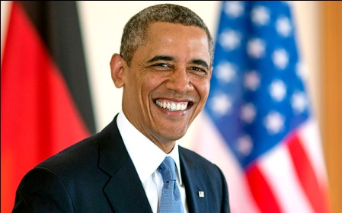
Sol:
A:) Osama
B:) Obama
C:) Arvind
D:) Anil
Correct: B

