Q:1) what is 2+2 =?
Desc: description here
A:) 4
B:) 5
C:) 6
D:) 3
Correct: A

Q:2) what is 2+6 =?
Desc:
A:) 4
B:) 8
C:) 6
D:) Eight
Correct: B,D

Q:3) Who is in the picture?
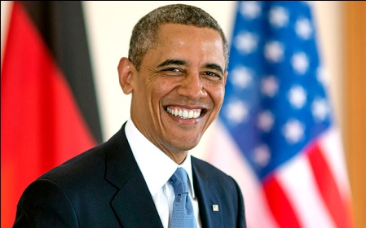
Desc:
A:) Osama
B:) Obama
C:) Arvind
D:) Anil
Correct: B

