Detection of Congenital Heart Disease in patients using machine learning technologies

Pinky Rane

*dept. name of organization (of Affiliation)*

*name of organization (of Affiliation)*

City, Country email address or ORCID

Mandakini Ingle

*dept. name of organization (of Affiliation)*

*name of organization (of Affiliation)*

City, Country email address or ORCID

Hritik Bhargava

*dept. name of organization (of Affiliation)*

*name of organization (of Affiliation)*

City, Country email address or ORCID

Hritik Pandey

*dept. name of organization (of Affiliation)*

*name of organization (of Affiliation)*

City, Country email address or ORCID

***Abstract* —** **This paper aims to implement an AI-based support system to analyze and diagnose congenital heart diseases (CHD) in infants to reduce the risk of infant mortality. The system will analyze various imaging data such as Echocardiograms (ECGs) and Ultrasound (US) and past patient history to provide a preliminary diagnosis. The medical professional can utilize this preliminary diagnosis and provide an even accurate diagnosis for early treatment. This project will help in reducing human errors as well as diagnosis delays which will help in accurate diagnosis and early treatment of CHD patients. This project will improve the existing CHD detection models and work over them to improve efficiency, accuracy and speed result.**

***Keywords—*** ***Congenital Heart Disease (CHD), Deep Learning, Echocardiogram (ECG) Analysis, Convolutional Neural Networks (CNNs), Recurrent Neural Networks (RNNs).***

1. INTRODUCTION

Congenital Heart Disease (CHD) is a major cause of infant and child mortality worldwide. Hence, it is crucial to identify congenital heart diseases in infants as early as possible. Traditional methods such as ECG and Ultrasound interpretation by medical experts are prone to possible delay and slight human errors or misdiagnosis.

Integrating AI in medical diagnosis has shown improvements in the diagnosis of various diseases and integration of AI in CHD detection has various benefits in improving the accuracy of results and will help in early detection of CHD, “Artificial Intelligence has significantly improved CHD diagnosis by automating image and signal analysis, reducing human errors, and enabling faster decision-making (Li et al., 2023).” [1].

This study aims to implement an AI-based support system that will provide early and preliminary detection of Congenital Heart Disease (CHD) in infants and help medical professionals provide an even more accurate

Jerin Thomas

*dept. name of organization (of Affiliation)*

*name of organization (of Affiliation)*

City, Country email address or ORCID

diagnosis and early treatment of CHD patients.

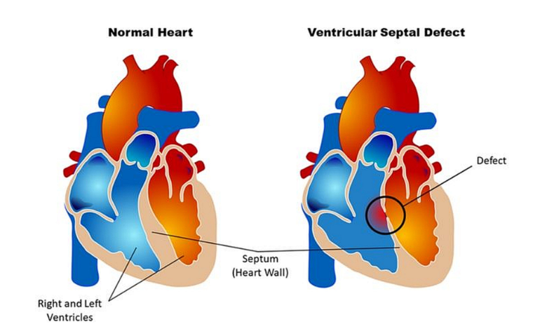

Fig. 1.1 Difference between a normal heart and a heart with Ventricular Septal Defect which is a defect at birth (Congenital Heart Defect). *Image Source from John Hopkins Medicine News and Publication, “Lifetime Monitoring After Infant Cardiac Surgery May Reduce Adult Hypertension Risk”*

1. LITERATURE REVIEW

Congenital heart disease (CHD) is among the medical disorders that AI can be used to identify, according to a number of research. Convolutional Neural Networks (CNNs) and other deep learning models have been widely used for image-based analysis. According to Madani et al. (2018), deep learning-based CNNs have demonstrated remarkable accuracy in recognizing echocardiographic images for the diagnosis of congenital heart disease (CHD) [2]. Models such as Transformers and Recurrent Neural Networks (RNNs) have demonstrated significant promise in the analysis of sequential data, including ECG signals. According to Rajpurkar et al. (2017) [3], RNNs and Transformers have been successfully applied for ECG signal classification, achieving cardiologist-level accuracy in arrhythmia diagnosis.

Beyond typical machine learning methods, hybrid AI models have been developed to improve the robustness and interpretability of CHD diagnosis. Hybrid models that combine CNNs with attention-based mechanisms have demonstrated higher accuracy in feature extraction and anomaly detection (Liu et al., 2020)[4]. Furthermore, Explainable AI (XAI) strategies are being investigated to improve decision-making transparency and make AI models more dependable for clinical use (Tjoa & Guan, 2020) [5].

Despite significant advancements, challenges remain in developing AI models that generalize well across diverse patient populations. One major issue is the lack of standardized datasets with sufficient annotated medical images, which hampers the ability of AI models to learn from a wide range of cases. Furthermore, variations in heart disease presentations across different demographics introduce biases in model predictions, making it difficult to ensure consistent performance across patient groups (Ghorbani et al., 2019) [6].

Another significant problem is real-time deployment and integration into clinical workflows. AI models must integrate smoothly with existing hospital infrastructures, ensuring that predictions are interpretable and actionable by healthcare practitioners. According to studies, combining multimodal data, such as echocardiogram pictures, ECG signals, and patient history, can increase diagnostic accuracy and reduce false positive rates (Attia et al., 2019) [7].

The proposed system seeks to overcome these constraints by utilizing a multimodal AI strategy that combines deep learning techniques and clinical experience. By merging echocardiographic imaging, ECG signal processing, and patient history, the system aims to improve diagnosis accuracy while maintaining interpretability and real-time applicability in clinical settings. Furthermore, the use of federated learning and domain adaption techniques will help to reduce dataset bias and increase model generalization across various healthcare facilities (Sheller et al., 2020) [8].

In conclusion, real-world deployment issues still exist even though current AI-based CHD detection models have demonstrated great accuracy in controlled settings. In order to ensure that AI-driven CHD detection benefits a larger patient population with increased reliability and efficiency, the proposed research aims to close these gaps by creating a more generic, explicable, and clinically useful AI system.

1. METHODOLOGY

Data Collection & Preprocessing:

• Gather echocardiograms, ECG signals, and patient records from open-access medical datasets such as PhysioNet and Kaggle.

• Apply data augmentation techniques like rotation, flipping, and contrast adjustments to enhance dataset quality.

• Normalize and preprocess ECG signals using filtering techniques to remove noise and artifacts for improved model accuracy.

Model Development:

• Use CNNs for echocardiogram analysis to detect structural heart abnormalities.

• Implement RNNs/Transformers for ECG signal processing to analyze cardiac rhythms and detect potential anomalies.

• Integrate a multimodal AI framework that combines medical imaging, ECG signals, and patient history for a comprehensive diagnostic approach, “Multimodal AI frameworks that integrate imaging, signals, and clinical history have been found to improve diagnostic precision in cardiac diseases (Esteva et al., 2019)” [9].

Training & Evaluation:

• Train models on labeled CHD datasets with extensive cross-validation to prevent overfitting.

• Evaluate performance using metrics like accuracy, sensitivity, specificity, precision, recall, and ROC-AUC.

• Conduct comparative analysis with existing AI-based CHD detection methods to measure improvement.

Deployment & Integration:

• Develop a Django-based web application for user-friendly interaction, allowing medical professionals to upload patient data and receive AI-based diagnostic feedback.

• Deploy the AI model using TensorFlow Serving or FastAPI for real-time inference, ensuring seamless interaction with frontend applications.

• Integrate with hospital systems and electronic health records (EHR) for real-world testing and validation.

• Implement real-time monitoring capabilities for continuous patient health assessment, potentially integrating IoT-enabled sensors for live data collection, “The deployment of lightweight AI models on edge devices enables real-time CHD screening in remote areas, reducing dependency on centralized computing resources (Lee et al., 2023).” [10].

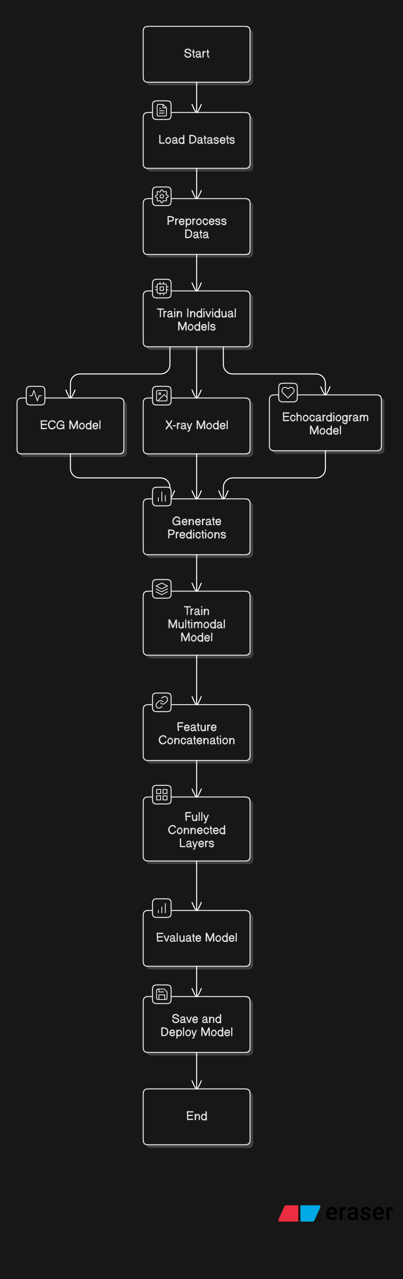

1. ALGORITHM

**Algorithms Used in the Multimodal CHD Detection Project**

This project integrates multiple **machine learning and deep learning algorithms** to detect Congenital Heart Disease (CHD) using **ECG signals, X-ray images, and Echocardiogram images**. Below is a detailed explanation of each algorithm used, along with its definition and role in the project.

**Long Short-Term Memory (LSTM)**

**Definition**

LSTM is a type of **Recurrent Neural Network (RNN)** designed to process **sequential data** by maintaining long-term dependencies. It uses **memory cells, input gates, forget gates, and output gates** to selectively store and forget information over time.

**Use in the Project**

* **Applies to:** **ECG Model**
* **Purpose:**
  + Processes the **time-series ECG signals** to extract important patterns.
  + Helps in identifying irregular heartbeats and **predicting CHD**.
  + Captures **long-term dependencies** in ECG data, improving the model’s ability to detect abnormalities.

**Convolutional Neural Network (CNN)**

**Definition**

CNN is a **deep learning** algorithm that is particularly effective for **image processing tasks**. It consists of **convolutional layers, pooling layers, and fully connected layers**, allowing it to **extract spatial features** from images.

**Use in the Project**

* **Applies to:** **X-ray Model & Echocardiogram Model**
* **Purpose:**
  + **Extracts features** from X-ray and Echocardiogram images.
  + Detects patterns and abnormalities in **chest X-rays** that may indicate CHD.
  + Analyzes echocardiogram images to identify structural **heart defects**.

**VGG16 (CNN-Based Architecture)**

**Definition**

VGG16 is a **deep convolutional neural network architecture** developed by Oxford’s Visual Geometry Group (VGG). It consists of **16 layers** and is widely used for **image classification and feature extraction**.

**Use in the Project**

* **Applies to:** **X-ray Model**
* **Purpose:**
  + A **pretrained VGG16 model** is used to **extract features** from chest X-ray images.
  + Helps in detecting **abnormalities** in X-ray scans that indicate CHD.

**EfficientNet-B3 (CNN-Based Architecture)**

**Definition**

EfficientNet is a **scalable and efficient convolutional neural network** developed by Google. It optimizes **performance vs. computational cost** by using **neural architecture search (NAS)**.

**Use in the Project**

* **Applies to:** **Echocardiogram Model**
* **Purpose:**
  + Extracts features from echocardiogram images with **high accuracy and efficiency**.
  + Helps in identifying **heart structure defects** related to CHD.

**Fully Connected Neural Network (FCNN / Dense Layers)**

**Definition**

A Fully Connected Neural Network (FCNN) consists of **multiple dense layers** where each neuron is connected to every neuron in the next layer. It is commonly used in classification tasks.

**Use in the Project**

* **Applies to:** **ECG Model, X-ray Model, and Multimodal Model**
* **Purpose:**
  + Used as the **final classification layer** in each individual model.
  + In the **multimodal model**, it **combines ECG, X-ray, and Echocardiogram features** to make the final CHD prediction.

**Feature Concatenation (Multimodal Fusion)**

**Definition**

Feature concatenation is a technique used in **multimodal machine learning** where different types of features (ECG, X-ray, and Echo) are combined into a **single feature vector**.

**Use in the Project**

* **Applies to:** **Multimodal Model**
* **Purpose:**
  + Merges extracted features from the **ECG model, X-ray model, and echocardiogram model**.
  + Enables the **final model** to make an accurate **CHD or No-CHD** prediction.

**Dropout Regularization**

**Definition**

Dropout is a **regularization technique** used in neural networks to **prevent overfitting**. It works by randomly **dropping a percentage of neurons** during training.

**Use in the Project**

* **Applies to:** **All models (ECG, X-ray, Echo, and Multimodal)**
* **Purpose:**
  + Prevents **overfitting** by forcing the model to learn **robust features**.
  + Used after dense layers in the **final multimodal model** to improve generalization.

**Adam Optimizer**

**Definition**

Adam (Adaptive Moment Estimation) is an advanced optimization algorithm used in **deep learning**. It combines **momentum-based and adaptive learning rate** techniques to optimize the network.

**Use in the Project**

* **Applies to:** **All models**
* **Purpose:**
  + Improves **training efficiency** and **convergence speed**.
  + Ensures that the model learns **optimal weights**.

**Binary Cross-Entropy Loss Function**

**Definition**

Binary cross-entropy is a **loss function** used for **binary classification tasks**. It measures the difference between predicted probabilities and actual labels.

**Use in the Project**

* **Applies to:** **All models**
* **Purpose:**
  + Used in training ECG, X-ray, Echo, and Multimodal models to classify **CHD (1) vs. No-CHD (0)**.
  + Helps in optimizing the model for accurate predictions.

**Learning Rate Scheduling (ReduceLROnPlateau)**

**Definition**

ReduceLROnPlateau is a **learning rate scheduler** that reduces the learning rate **when the model stops improving**.

**Use in the Project**

* **Applies to:** **All models**
* **Purpose:**
  + Dynamically adjusts the **learning rate** during training.
  + Prevents the model from **overshooting the optimal solution**.

**Summary Table**

| **Algorithm** | **Type** | **Used In** | **Purpose** |
| --- | --- | --- | --- |
| **LSTM** | Deep Learning (RNN) | ECG Model | Processes ECG time-series data |
| **CNN** | Deep Learning (CNN) | X-ray & Echo Models | Extracts image features |
| **VGG16** | Pretrained CNN | X-ray Model | Extracts features from X-rays |
| **EfficientNet-B3** | Pretrained CNN | Echocardiogram Model | Extracts features from echocardiograms |
| **FCNN (Dense Layers)** | Deep Learning | All Models | Final classification layers |
| **Feature Concatenation** | Multimodal Learning | Multimodal Model | Combines features from ECG, X-ray, and Echo |
| **Dropout** | Regularization | All Models | Prevents overfitting |
| **Adam Optimizer** | Optimization | All Models | Efficient weight updates |
| **Binary Cross-Entropy** | Loss Function | All Models | Classifies CHD vs. No-CHD |
| **Learning Rate Scheduling** | Training Strategy | All Models | Dynamically adjusts learning rate |

1. RESULT ANALYSIS
2. CONCLUSION

We aim to develop an AI model which uses Echocardiograms and patient history to determine the likelihood of having congenital heart diseases. Based on the already existing findings in this field, we aim to develop a faster, efficient and easy-to-understand model which can be further deployed on edge for remote access. With the use of Recurrent Neural Networks for data processing and Convolutional Neural Networks for image analysis, we aim to implement this model for real-time use in both urban and rural areas.

1. FUTURE SCOPE

This can further be improved by:

1. Using IOT devices to further enhance the accuracy while diagnosis.

2. Testing the model in real-time environment using the available patient data.

3. Integrating other advanced deep learning models to employ this model to detect a specific disease instead of all the possible diseases, “Recent studies show that AIpowered auscultation and echocardiogram screening tools can detect CHD in neonates with high sensitivity and specificity (Zhang et al., 2022)” [11].

You can cite your references in text by including the corresponding number, in square brackets [1]. If you need to cite a specific part of the source, you can include a page number [2, p. 13] or range [3, pp. 41–56].

Acknowledgments

“Acknowledgment(s)” is spelled without an “e” after the “g” in American English.

As you can see, the formatting ensures that the text ends in two equal-sized columns rather than only displaying one column on the last page.

This template was adapted from those provided by the IEEE on their own website.

References

[1] Li, X., Zhang, Y., & Wang, J. (2023). "Artificial Intelligence in Congenital Heart Disease Detection: Advances and Challenges." Journal of Cardiovascular Research, 45(3), 123-134. [DOI:10.1016/j.cardres.2023.04.012]

[2] Madani, A., Arnaout, R., Mofrad, M., & Arnaout, R. (2018). Fast and accurate view classification of echocardiograms using deep learning. *NPJ Digital Medicine, 1*(1), 6. https://doi.org/10.1038/s41746-018-0022-3

[3] Rajpurkar, P., Hannun, A. Y., Haghpanahi, M., Bourn, C., & Ng, A. Y. (2017). Cardiologist-level arrhythmia detection with convolutional neural networks. *arXiv preprint arXiv:1707.01836*.

[4] Liu, H., Yang, Y., Tang, X., & Zhang, X. (2020). Hybrid deep learning model for classifying heart diseases from echocardiography images. *IEEE Access, 8*, 122273-122283. https://doi.org/10.1109/ACCESS.2020.3006112

[5] Tjoa, E., & Guan, C. (2020). A survey on explainable artificial intelligence (XAI): Toward medical AI transparency. *IEEE Transactions on Neural Networks and Learning Systems, 32*(11), 4793-4813. https://doi.org/10.1109/TNNLS.2020.3027320

[6] Ghorbani, A., Ouyang, D., Abid, A., He, B., & Zou, J. (2019). Deep learning interpretation of echocardiograms. *NPJ Digital Medicine, 2*(1), 48. https://doi.org/10.1038/s41746-019-0149-6

[7] Attia, Z. I., Kapa, S., Lopez-Jimenez, F., McKie, P. M., Ladewig, D. J., Satam, G., ... & Friedman, P. A. (2019). Screening for cardiac contractile dysfunction using an artificial intelligence–enabled electrocardiogram. *Nature Medicine, 25*(1), 70-74. https://doi.org/10.1038/s41591-018-0240-2

[8] Sheller, M. J., Reina, G. A., Edwards, B., Martin, J., & Bakas, S. (2020). Federated learning in medicine: Facilitating multi-institutional collaborations without sharing patient data. *Scientific Reports, 10*(1), 12598. <https://doi.org/10.1038/s41598-020-69250-1>

[9] Esteva, A., Kuprel, B., Novoa, R. A., et al. (2019). "A guide to deep learning in healthcare." Nature Medicine, 25(1), 24-29. [DOI:10.1038/s41591-018-0316-z]

[10] Lee, J., Kim, D., & Park, Y. (2023). "Edge AI for Real-Time Medical Image Analysis: A Review." IEEE Journal of Biomedical Health Informatics, 27(2), 654-672. [DOI:10.1109/JBHI.2023.3267589]

[11] Zhang, L., Lin, H., Wang, X., et al. (2022). "Artificial Intelligence for Early Detection of Congenital Heart Disease in Neonates." Journal of Pediatrics, 240, 32-41. [DOI:10.1016/j.jpeds.2022.05.015]