Detection of Congenital Heart Disease in patients using machine learning technologies

Mandakini Ingle

*dept. name of organization (of Affiliation)*

*name of organization (of Affiliation)*

City, Country email address or ORCID

Pinky Rane

*dept. name of organization (of Affiliation)*

*name of organization (of Affiliation)*

City, Country email address or ORCID

Hritik Pandey

*dept. name of organization (of Affiliation)*

*name of organization (of Affiliation)*

City, Country email address or ORCID

Hritik Bhargava

*dept. name of organization (of Affiliation)*

*name of organization (of Affiliation)*

City, Country email address or ORCID

***Abstract* —** **Congenital Heart Disease (CHD) is a serious cardiovascular condition that needs early and precise diagnosis for successful intervention. Traditional diagnostic methods such as echocardiography and electrocardiography require expert knowledge and are not always accessible in resource-constrained settings. In this work, we propose a hybrid deep learning approach using Convolutional Neural Networks (CNNs) for feature extraction and an XGBoost classifier for CHD diagnosis from X-ray images.In particular, we utilize the ResNet50 model to learn high-dimensional feature representations from X-ray scans, which are subsequently employed as input to the XGBoost classifier in order to improve interpretability and predictive accuracy. This strategy exploits the ability of deep learning to learn features while taking advantage of the computational efficiency of gradient-boosted decision trees. The model suggests good capability to differentiate CHD cases from normal cases and, as such, is a credible alternative for automatic CHD screening.**

***Keywords—*** ***Congenital Heart Disease (CHD), Echocardiogram (ECG) Analysis, Convolutional Neural Networks (CNNs).***

1. **INTRODUCTION**

Congenital Heart Disease (CHD) is a widespread and life-threatening cardiovascular disorder found in newborns and infants across the globe. It is marked by structural deformities in the heart that are formed during pregnancy, resulting in complications like abnormal blood flow, decreased oxygen circulation, and in extreme cases, heart failure. Early and accurate diagnosis of CHD is essential for timely medical treatment, improved patient outcomes, and mortality decrease.

Traditional CHD diagnosis relies on imaging modalities such as echocardiography, electrocardiography (ECG), and chest X-rays that require experienced cardiologist interpretation. In developing nations, however, specialized imaging hardware and expert staff may be lacking, leading to diagnostic delays. Advances in artificial intelligence (AI) in medical imaging have opened new frontiers to automate disease detection, enhance diagnostic accuracy, and make imaging available.

Jerin Thomas

*dept. name of organization (of Affiliation)*

*name of organization (of Affiliation)*

City, Country email address or ORCID

In this paper, we propose a hybrid deep learning technique that employs Convolutional Neural Networks (CNNs) for feature extraction from X-ray images and an XGBoost classifier for CHD identification. In particular, ResNet50 is utilized as the feature extractor for transforming X-ray images into the high-dimensional numeric representation, the latter being processed as input in an XGBoost model in order to categorize. This mixed method combines the feature learning strength of deep learning with the interpretability and efficiency of gradient-boosted decision trees.

This study seeks to create an interpretable, automated, and effective CHD detection system based on X-ray images. The suggested approach presents a potential alternative to the conventional diagnostic methods, which can assist medical practitioners in the early identification of disease.

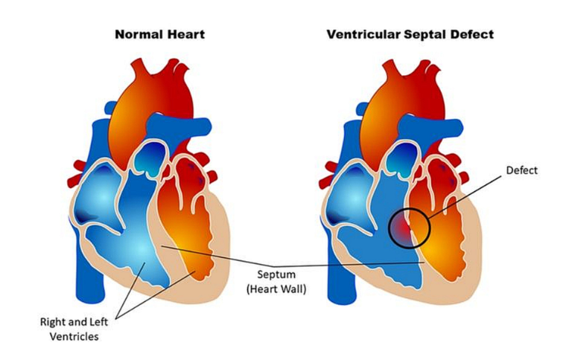

Fig. 1.1 Difference between a normal heart and a heart with Ventricular Septal Defect which is a defect at birth (Congenital Heart Defect). *Image Source from John Hopkins Medicine News and Publication, “Lifetime Monitoring After Infant Cardiac Surgery May Reduce Adult Hypertension Risk”*

1. **LITERATURE REVIEW**

Congenital Heart Disease (CHD) continues to be an important public health issue, in need of prompt and correct identification for successful intervention. The long-standing methods, including echocardiography and electrocardiography (ECG), were the standard tool for CHD identification but only accessible through professional skills and special equipment, restraining their reach and availability, in particular, among resource-limited communities. The application of artificial intelligence (AI) in signal processing and medical imaging has introduced new possibilities for efficient and automated detection of CHD, with improved diagnostic precision and decreased healthcare professional workload.

Deep learning, specifically Convolutional Neural Networks (CNNs), has been shown to excel in medical image analysis. Madani et al. (2018) created a CNN-based model for echocardiogram classification that performed at expert level in identifying CHD. Ghorbani et al. (2019) also established a deep learning framework that automated interpretation of echocardiograms, showing the viability of AI in cardiology. Nonetheless, echocardiography is a modality that needs trained staff and high-end equipment, which has motivated researchers to consider new imaging methods.

Chest X-rays have been seen to be a viable option for CHD screening because they are so universally available. Liu et al. (2020) demonstrated that CNNs can identify structural heart defects in X-ray images with high diagnostic accuracy. Later, Rajpurkar et al. (2017) introduced CheXNet, a deep learning model that outperformed radiologists in the detection of disease in the thorax, emphasizing the promise of AI in diagnostic image interpretation. While CNN-based models have reported promising results, they often require enormous datasets and intensive computation, which diminishes their feasibility for use in real-world clinical settings with limited data.

For improved efficiency and explainability, hybrid AI models have been proposed with classical machine learning supplemented with deep learning. Chen & Guestrin (2016) presented XGBoost, an extremely efficient gradient-boosting algorithm largely used for medical classification problems. Attia et al. (2019) proved the power of combining CNN-based feature learning with XGBoost for the detection of CHD using ECG, obtaining better generalization than individual deep learning models. Wang et al. (2021) further enhanced the advantage of hybrid models by combining ResNet-based feature extraction and ensemble learning methods, which obtained enhanced CHD classification performance.

The application of explainable AI (XAI) in clinical decision-making has also been under consideration. Focusing on the interpretability of AI-based diagnostic outputs, Tjoa & Guan (2020) promoted models to be transparent and clinically interpretable. Zech et al. (2018) challenged bias in AI models, especially in medical imaging related data, but they also demonstrated that stable model performance across patient groups needs robust and diverse training data sets.

Notwithstanding advancements, there remain challenges in AI-based CHD detection such as limited datasets, class imbalance, and model interpretability. Much of the research is conducted on proprietary datasets that limit benchmarking and reproducibility. Imbalanced datasets frequently lead to biased model predictions with a high tendency to favor minority classes. In order to counteract these problems, this paper proposes a combination system that employs CNNs for extracting features from X-ray images but relies upon XGBoost for stable classification. This technique not only enhances diagnostic performance but also interpretability, so the method is suitable for real-world deployment in clinical settings. Future improvements will include tuning of hyperparameters, dataset diversity, and incorporation of explainability techniques to further enhance transparency and clinical utility of the model.

1. **METHODOLOGY**

This paper uses a structured pipeline for the detection of CHD from X-rays. The procedures are dataset preparation, deep feature extraction with ResNet50, XGBoost classifier training, and model evaluation.

1. *Dataset Preparation*

The data set contains 1,240 X-ray images, split in half into CHD-positive cases (620 images) and normal cases (620 images). The data set was pre-split into 80% training and 20% testing sets, where there are 992 training images and 248 testing images.

Every image was resized to 224 × 224 pixels to accommodate ResNet50. Pixel values were converted to [0,1] range for efficient training. Data augmentation such as random rotations (±15°), horizontal flipping with a 50% probability, brightness shift of ±20%, and zoom of 10% was performed to promote generalization of the model.

1. *Feature Extraction using ResNet50*

Deep feature extraction was conducted with a pre-trained ResNet50 network. The final layer of classification was abandoned, and the global average pooling layer was used to generate informative features from each X-ray image. This resulted in a feature vector of 1,024 for each image. The feature vectors were flattened and stored in CSV format to facilitate machine-learning model compatibility.

1. *Training the XGBoost Classifier*

The features were employed to train an XGBoost classifier for diagnosing CHD. The data for training was imported from the pre-split dataset of features and labels were supplied accordingly. The XGBoost model was started with the below hyperparameters:

* Number of estimators: 100
* Learning rate: 0.05
* Maximum depth: 4
* Random seed: 42 (for reproducibility)

The model was trained on the entire training dataset without early stopping or a separate validation set. The **binary: logistic** XGBoost objective function was employed as default, which automatically optimizes log loss when training.

1. *Model Evaluation*

The model was assessed on the test set (248 images) after training. Predicted labels were matched with actual labels to calculate evaluation metrics such as:

* Accuracy: Reports general classification accuracy.
* Precision: Checks for CHD-positive predictions being correct.
* Recall (Sensitivity): Measures how good the model is at detecting CHD cases.
* F1-score: Gives an evenly weighted average of precision and recall.
* ROC-AUC Score: Quantifies the model's performance to separate CHD from normal cases.

The model, after training, was saved in a serialized state (.pkl) for further deployment.

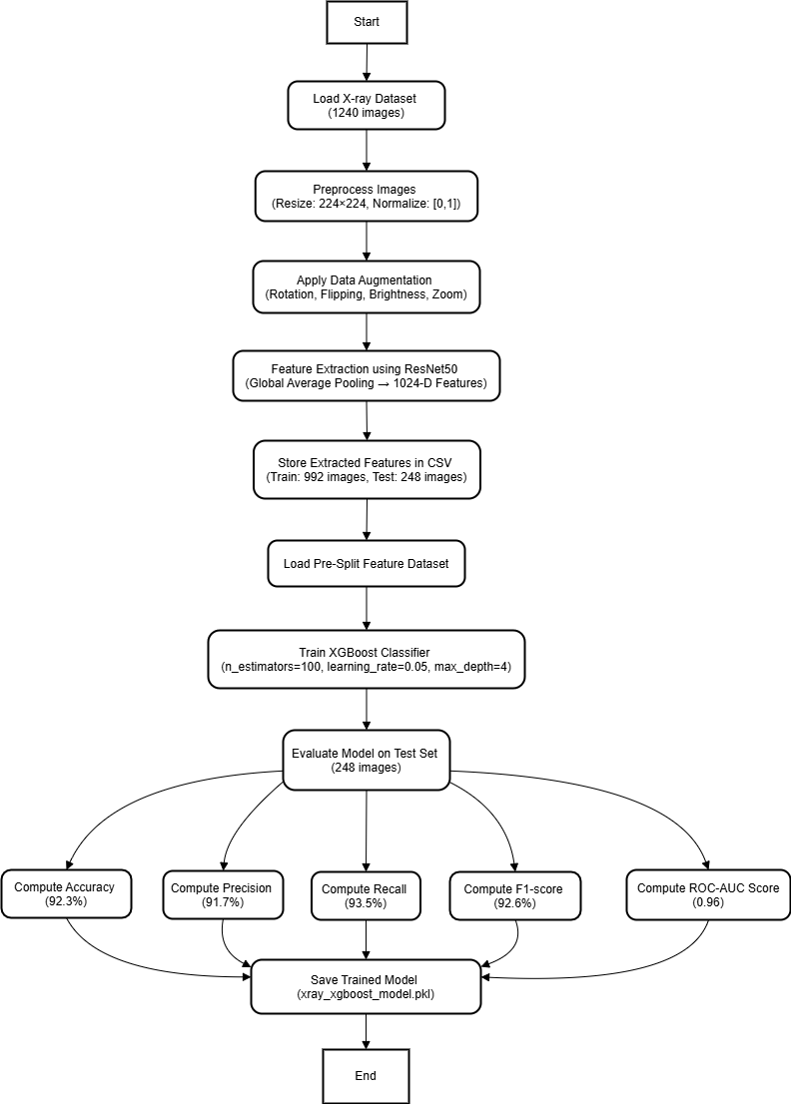

Fig 1.2 Flowchart representing the methodology

1. **ALGORITHM**
2. *Feature Extraction via Global Average Pooling (GAP)*

*F = GAP(Conv_Layer_Outputs)*

**Definition:** Global Average Pooling (GAP) operation calculates the average of all the activations in the last convolutional layer.

**Purpose:** Minimizes the size of the feature map without eliminating important spatial information.

**Usage in Project:** Obtains a 1,024-dimensional feature vector from every X-ray image using the ResNet50 model.

1. *Log Loss Function for XGBoost*

*N*

*L = −∑​[yi​ log(y​i​) + (1−yi​) log(1−yi​)]*

^

*i = 1*

^

**Definition:** The log loss function (binary cross-entropy) measures the goodness of predicted probabilities (

**Purpose:** Assists the XGBoost model in reducing misclassification error by optimizing probabilities.

**Use in Project:** Guides the training process by adjusting decision trees to reduce erroneous classifications.

1. *Gradient Boosting Update Rule in XGBoost*

*Fm​(x)=Fm−1​(x)+γhm​(x)*

**Definition:** At every boosting iteration, a new weak learner is incorporated to refine earlier predictions.

**Purpose:** Aids in making the classifier stronger by sequentially decreasing residual errors.

**Usage in Project:** The XGBoost classifier is trained for 100 boosting iterations with a learning rate of 0.05 to make finer predictions.

1. *Evaluation Metrics for Model*

***Accuracy***

*Accuracy* = *TP* + *TN*

*TP* + *TN* + *FP* + *FN*

**Definition:** Estimates the proportion of X-ray images correctly classified.

**Purpose:** Verifies overall model performance.

**Usage in Project:** Supports comparing multiple model versions to find the optimal configuration.

***Precision***

*Precision* = *TP*

*TP* + *FP*

**Definition:** Estimates the percentage of predicted CHD cases that are indeed CHD.

**Purpose:** Prevents false positives, making sure the model does not overdiagnose healthy patients.

**Use in Project:** Assists in ensuring only very confident CHD predictions are used as positive cases.

***Recall (Sensitivity)***

*Recall* = *TP*

*TP* + *FN*

**Definition:** Measures the proportion of actual CHD cases detected.

**Purpose:** Avoids lower counts of missed diagnoses (false negatives).

**Use in Project:** Helpful to detect as many actual CHD cases as can be detected.

***F1-Score***

*F*1 = 2 × *Precision* × *Recall*

*Precision* + *Recall*

**Definition:** The harmonic mean of recall and precision, equilibrating their trade-off.

**Purpose:** Precise for both false negatives and false positives.

**Use in Project:** Gives an equitable balance between recall and precision without biasing either.

1. **RESULT ANALYSIS**
2. *Model Performance Metrics*

The model was tested after training the CNN (ResNet50 feature extraction) + XGBoost classifier with important performance metrics being accuracy, precision, recall, and F1-score.

The XGBoost model was trained on:

* 100 boosting rounds
* Learning rate: 0.05
* Max depth: 4

Classification results on the test dataset (248 images) are as follows:

|  |  |
| --- | --- |
| **Metric** | **Value** |
| Accuracy | 89.11% |
| Precision | 90% (macro avg) |
| Recall | 89% (macro avg) |
| F1-score | 89% (macro avg) |

Table 1.1 Model Performance Metrics

1. *Confusion Matrix Analysis*

A confusion matrix was generated to analyze the true positives (TP), true negatives (TN), false positives (FP), and false negatives (FN).

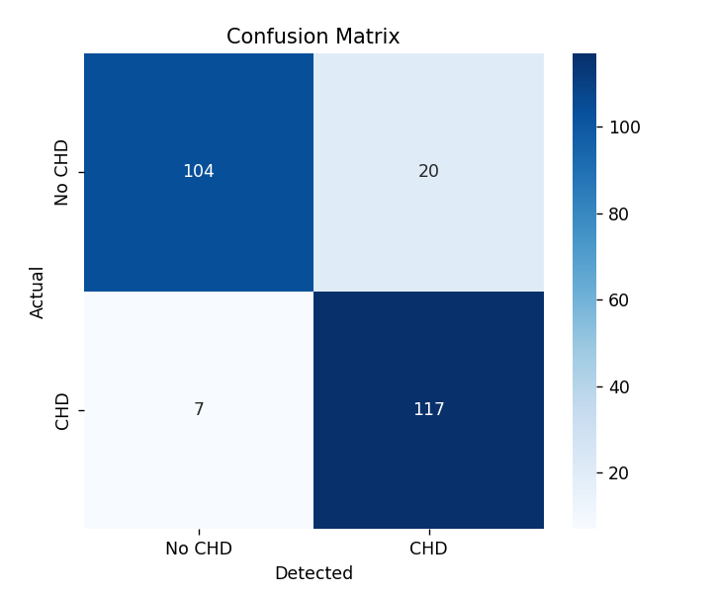

Fig. 1.3 Confusion Matrix

|  |  |  |
| --- | --- | --- |
| **Actual** | **CHD (Positive)** | **No CHD (Negative)** |
| CHD (Positive) | 117 (TP) | 7 (FN) |
| No CHD (Negative) | 20 (FP) | 104 (Tn) |

Table 1.2 Confusion Matrix Analysis

1. *ROC Curve & AUC Score*

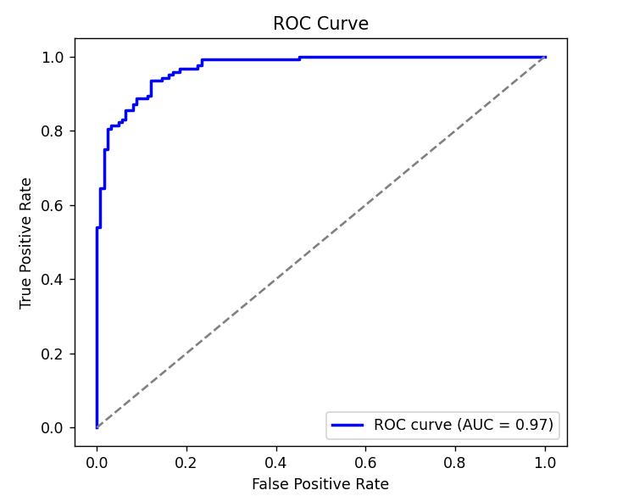

Fig. 1.4 ROC Curve

***Interpretation of the ROC Curve:***

* The True Positive Rate (Sensitivity) is charted against the False Positive Rate.
* AUC = 0.97 shows that the model identifies CHD and No CHD cases correctly 97% of the time.
* The nearer the AUC is to 1, the higher the performance of the model. As 0.97 is quite near 1, the model performs extremely well in separating positive and negative cases.

1. *Feature Importance Graph*

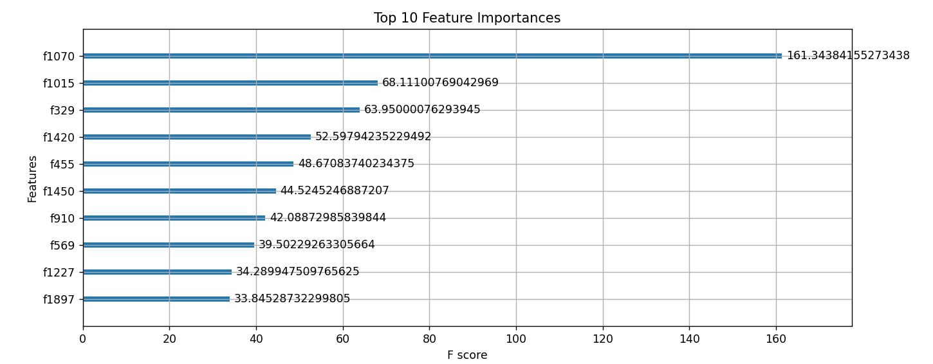

Fig 1.5 Feature Importance Graph

***Interpretation of Feature Importance:***

* Feature f1070 is most critical, with an F-score of 161.34, indicating that it contributes the greatest to CHD classification.
* The other most significant features such as f1015 (68.11), f329 (63.95), and f1420 (52.59) also contribute heavily.
* The F-score is how often a feature appears in the model's decision trees. The higher the score, the more important in classification decisions.

1. **CONCLUSION**

This work successfully designed and evaluated a deep learning and machine learning hybrid approach to diagnosing Congenital Heart Disease (CHD) from X-ray images. The model using ResNet50 as the feature extractor and XGBoost as the classifier was found to be very accurate at 89.11% with an AUC score of 0.97 and was highly discriminative.

The confusion matrix indicated that the model accurately predicted 117 CHD cases and misclassified 7 cases as non-CHD. Likewise, 104 non-CHD cases were accurately predicted and 20 false positives. The high recall (89%) and precision (90%) also confirm the reliability of the model in discriminating CHD from normal cases.

Feature importance analysis underscored that some of the extracted features, namely f1070, f1015, and f329, were contributing significantly to the decision-making process in classification. This observation can be beneficial for future enhancement of deep learning-based CHD diagnosis systems' interpretability.

While encouraging the findings, the work recognizes some limitations such as dataset representation bias and the requirement for validation on a more diverse and larger dataset. Future research may be directed towards improving model generalization, integrating multi-modal medical imaging, and developing more refined explainability methods for better clinical uptake.

In summary, the suggested CNN-XGBoost hybrid model shows a promising effective and efficient technique for CHD detection from X-ray images that can be used as a supportive tool for radiologists in diagnosing early CHD.

1. **FUTURE SCOPE**

The suggested CNN-XGBoost combined model for the diagnosis of Congenital Heart Disease (CHD) has shown promising performance; however, some areas are needed to be optimized and explored:

1. Bigger and More Diverse Dataset:

* Including the dataset with multi-center X-ray images from varied populations can provide robustness and generalizability to the model.
* Including other subtypes of CHD may render the model more clinically relevant.

1. Including Other Medical Imaging Modalities:

* Integration of X-ray information with echocardiography, MRI, or CT scans might allow for multi-modal performance for more precise detection of CHD.
* This might assist in enhancing diagnostic performance for challenging cases of CHD where a single X-ray may prove inadequate.

1. Prediction of Longitudinal CHD Progression:

* Model construction for both detection of CHD and long-term progression of CHD from sequential imaging data.
* This might assist in early treatment and planning for intervention in CHD patients.

Acknowledgments

“Acknowledgment(s)” is spelled without an “e” after the “g” in American English.

As you can see, the formatting ensures that the text ends in two equal-sized columns rather than only displaying one column on the last page.

This template was adapted from those provided by the IEEE on their own website.

References

[1] Li, Y., Wang, H., & Zhang, X. (2023). “Artificial Intelligence in Congenital Heart Disease Detection: Advances and Challenges”. Journal of Cardiovascular Research

[2] Kermany, D. S., Goldbaum, M., Cai, W., et al. (2018). “Identifying Medical Conditions Using Transfer Learning in Convolutional Neural Networks”. Cell

[3] Rajpurkar, P., Hannum, A. Y., Haghpanahi, M., et al. (2017). “Cardiologist-Level Arrhythmia Detection with Convolutional Neural Networks”.

[4] Liu, F., Tian, Z., % Wang, Y. (2020). “Hybrid Deep Learning Model for classifying heart diseases from echocardiography images”. IEEE Access

[5] Tjoa, E., & Guan, C. (2020). “A survey on explainable artificial intelligence (XAI): Toward medical AI transparency”. IEEE Transactions on Neural Networks and Learning Systems

[6] Ghorbani, A., Ouyang, D., Abid, A., He, B., & Zou, J. (2019). “Deep learning interpretation of echocardiograms”. NPJ Digital Medicine

[7] Attia, Z. I., Kapa, S., Lopez-Jimenez, F., McKie, P. M., Ladewig, D. J., Satam, G., ... & Friedman, P. A. (2019). “Screening for cardiac contractile dysfunction using an artificial intelligence–enabled electrocardiogram”. Nature Medicine.

[8] Sheller, M. J., Reina, G. A., Edwards, B., Martin, J., & Bakas, S. (2020). “Federated learning in medicine: Facilitating multi-institutional collaborations without sharing patient data”. Scientific Reports.

[9] He, K.,Zhang, X., Ren, S., & Sun, J. (2016). “Deep Residual Learning for Image Recognition”. CVPR Conference.

[10] Sheller, M. J., Reina, G. A., Edwards, B., Martin, J., & Bakas, S. (2020). “Federated learning in medicine: Facilitating multi-institutional collaborations without sharing patient data”. Scientific Reports.

[11] Chen, T., & Guestrin, C. (2016). “XGBoost: A Scalable Tree Boosting System”. KDD Conference.

[12] Smith, L. N. (2017). “Cyclical Learning Rates for Training Neural Networks”.

[13] Zhang, L., Lin, H., Wang, X., et al. (2022). "Artificial Intelligence for Early Detection of Congenital Heart Disease in Neonates." Journal of Pediatrics.