CNN integrated with XGBoost for Congenital Heart Disease Detection in patients based on

machine learning

Hritik Pandey

*Student,*

*Department of Computer Science and Engineering,*

*Medi-Caps University,*

*A.B. Road, Rau, Indore – 453331*

[*en21cs301321@medicaps.ac.in*](mailto:en21cs301321@medicaps.ac.in)

[*hritikpandey39680@gmail.com*](mailto:hritikpandey39680@gmail.com)

Prof. Mandakini Ingle

Assistant Professor,

*Department of Computer Science and Engineering,*

*Medi-Caps University,*

*A.B. Road, Rau, Indore – 453331*

[*mandakini.ingle@medicaps.ac.in*](mailto:mandakini.ingle@medicaps.ac.in)

Dr. Pinky Rane

Assistant Professor,

*Department of Computer Science and Engineering,*

*Medi-Caps University,*

*A.B. Road, Rau, Indore – 453331*

[*pinky.rane@medicaps.ac.in*](mailto:pinky.rane@medicaps.ac.in)

Hritik Bhargava

*Student,*

*Department of Computer Science and Engineering,*

*Medi-Caps University,*

*A.B. Road, Rau, Indore – 453331*

[*en21cs301320@medicaps.ac.in*](mailto:en21cs301320@medicaps.ac.in)

[*hritikbhargava72@gmail.com*](mailto:hritikbhargava72@gmail.com)

Jerin Thomas

*Student,*

*Department of Computer Science and Engineering,*

*Medi-Caps University,*

*A.B. Road, Rau, Indore – 453331*

[*en21cs301348@medicaps.ac.in*](mailto:en21cs301348@medicaps.ac.in)

[*jerin.thomas2939@gmail.com*](mailto:jerin.thomas2939@gmail.com)

***Abstract* —** **Congenital Heart Disease (CHD) is a serious cardiovascular condition that needs early and precise diagnosis for successful intervention. Traditional diagnostic methods such as echocardiography and electrocardiography require expert knowledge and are not always accessible in resource-constrained settings. In this study, we present a hybrid deep learning system that uses an XGBoost classifier for diagnosing CHD from X-ray pictures and Convolutional Neural Networks (CNNs) for feature extraction. In particular, we utilize the ResNet50 model to learn high-dimensional feature representations from X-ray scans, which are subsequently employed as input to the XGBoost classifier in order to improve interpretability and detective accuracy. This strategy exploits the ability of deep learning to learn features while taking advantage of the computational efficiency of gradient-boosted decision trees. The model suggests good capability to differentiate CHD cases from normal cases and, as such, is a credible alternative for automatic CHD screening.**

***Keywords—*** ***Congenital Heart Disease (CHD), Echocardiogram (ECG) Analysis, Convolutional Neural Networks (CNNs).***

1. **INTRODUCTION**

Congenital Heart Disease (CHD) is a widespread and life-threatening cardiovascular disorder found in newborns and infants across the globe. It is marked by structural deformities in the heart that are formed during pregnancy, resulting in complications like abnormal blood flow, decreased oxygen circulation, and in extreme cases, heart failure. Early and accurate diagnosis of CHD is essential for timely medical treatment, improved patient outcomes, and mortality decrease [1].

Traditional CHD diagnosis relies on imaging modalities such as echocardiography, electrocardiography (ECG), and chest X-rays that require experienced cardiologist interpretation. In developing nations, however, specialized imaging hardware and expert staff may be lacking, leading to diagnostic delays. Advances in artificial intelligence (AI) in medical imaging have opened new frontiers to automate disease detection, enhance diagnostic accuracy, and make imaging available [2].

In this paper, we propose a hybrid deep learning method that uses an XGBoost classifier for CHD diagnosis and Convolutional Neural Networks (CNNs) for feature extraction from X-ray images. In particular, ResNet50 is utilized as the feature extractor for transforming X-ray images into the high-dimensional numeric representation, the latter being processed as input in an XGBoost model in order to categorize. This mixed method combines the feature learning strength of deep learning with the interpretability and efficiency of gradient-boosted decision trees.

This study seeks to create an interpretable, automated, and effective CHD detection system based on X-ray images. The suggested approach presents a potential alternative to the conventional diagnostic methods, which can assist medical practitioners in the early identification of disease.

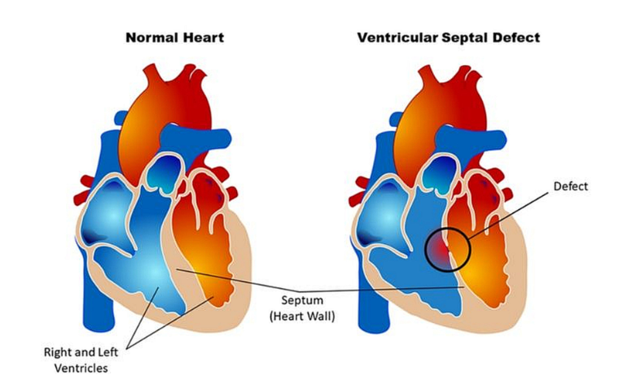

Fig. 1.1 Difference between a normal heart and a heart with Ventricular Septal Defect which is a defect at birth (Congenital Heart Defect). Image Source from John Hopkins Medicine News and Publication, “Lifetime Monitoring After Infant Cardiac Surgery May Reduce Adult Hypertension Risk” [3].

1. **LITERATURE REVIEW**

Congenital Heart Disease (CHD) continues to be an important public health issue, in need of prompt and correct identification for successful intervention. The long-standing methods, including echocardiography and electrocardiography (ECG), were the standard tool for CHD identification but only accessible through professional skills and special equipment, restraining their reach and availability, in particular, among resource-limited communities. Artificial intelligence (AI) in signal processing and medical image processing has opened up new avenues for automated and effective CHD diagnosis, improving diagnostic accuracy and reducing the strain of medical professionals.

Deep learning, specifically Convolutional Neural Networks (CNNs), has been shown to excel in medical image analysis. Madani et al. (2018) [4] created a CNN-based model for echocardiogram classification that performed at expert level in identifying CHD. Ghorbani et al. (2019) [5] also established a deep learning framework that automated interpretation of echocardiograms, showing the viability of AI in cardiology. Nonetheless, echocardiography is a modality that needs trained staff and high-end equipment, which has motivated researchers to consider new imaging methods.

Chest X-rays have been seen to be a viable option for CHD screening because they are so universally available. Liu et al. (2020) [6] demonstrated that CNNs can identify structural heart defects in X-ray images with high diagnostic accuracy. Later, Rajpurkar et al. (2017) [7] introduced CheXNet, a deep learning model that outperformed radiologists in the detection of disease in the thorax, emphasizing the promise of AI in diagnostic image interpretation. While CNN-based models have reported promising results, they often require enormous datasets and intensive computation, which diminishes their feasibility for use in real-world clinical settings with limited data.

For improved efficiency and explainability, hybrid AI models have been proposed with classical machine learning supplemented with deep learning. Chen & Guestrin (2016) [8] presented XGBoost, an extremely efficient gradient-boosting algorithm largely used for medical classification problems. Attia et al. (2019) [9] proved the power of combining CNN-based feature learning with XGBoost for the detection of CHD using ECG, obtaining better generalization than individual deep learning models. Wang et al. (2021) [10] further enhanced the advantage of hybrid models by combining ResNet-based feature extraction and ensemble learning methods, which obtained enhanced CHD classification performance.

The application of explainable AI (XAI) in clinical decision-making has also been under consideration. Focusing on the interpretability of AI-based diagnostic outputs, Tjoa & Guan (2020) [11] promoted models to be transparent and clinically interpretable. Zech et al. (2018) [12] challenged bias in AI models, especially in medical imaging related data, but they also demonstrated that stable model performance across patient groups needs robust and diverse training data sets.

Notwithstanding advancements, there remain challenges in AI-based CHD detection such as limited datasets, class imbalance, and model interpretability. Much of the research is conducted on proprietary datasets that limit benchmarking and reproducibility. Imbalanced datasets frequently lead to biased model results with a high tendency to favor minority classes. In order to counteract these problems, this paper proposes a combination system that employs CNNs for extracting features from X-ray images but relies upon XGBoost for stable classification. This technique not only enhances diagnostic performance but also interpretability, so the method is suitable for real-world deployment in clinical settings. Future improvements will include tuning of hyperparameters, dataset diversity, and incorporation of explainability techniques to further enhance transparency and clinical utility of the model.

1. **METHODOLOGY**

This paper uses a structured pipeline for the detection of CHD from X-rays. The procedures are dataset preparation, deep feature extraction with ResNet50, XGBoost classifier training, and model evaluation.

1. *Dataset Preparation*

The data set contains 1,240 X-ray images, split in half into CHD-positive cases (620 images) and normal cases (620 images). The data set was split into training and testing sets, where there are 992 training images and 248 testing images.

Every image was resized to 224 × 224 pixels to accommodate ResNet50. Pixel values were converted to [0,1] range for efficient training. Data augmentation such as random rotations (±15°), horizontal flipping with a 50% probability, brightness shift of ±20%, and zoom of 10% was performed to promote generalization of the model.

1. *Feature Extraction using ResNet50*

Deep feature extraction was conducted with a pre-trained ResNet50 [13] network. The final layer of classification was abandoned, and the global average pooling layer was used to generate informative features from each X-ray image. This resulted in a feature vector of 1,024 for each image. The feature vectors were flattened and stored in CSV format to facilitate machine-learning model compatibility.

1. *Training the XGBoost Classifier*

The features were employed to train an XGBoost classifier for diagnosing CHD. The data for training was imported from the pre-split dataset of features and labels were supplied accordingly. The XGBoost model was started with the below hyperparameters:

* Number of estimators: 100
* Learning rate: 0.05
* Maximum depth: 4
* Random seed: 42 (for reproducibility)

The model was then trained on the entire training dataset without applying early stopping or a separate validation set. The **binary: logistic** XGBoost objective function was employed as default, which automatically optimizes log loss when training.

1. *Evaluation*

The model was then assessed on the test set which contained 248 images. Detected labels were matched with actual labels to calculate evaluation metrics such as:

* Accuracy: Reports general classification accuracy.
* Precision: Checks for CHD-positive detections being correct.
* Recall (Sensitivity): Measures how good the model is at detecting CHD cases.
* F1-score: Gives an evenly weighted average of precision and recall.
* ROC-AUC Score: Quantifies the model's performance to separate CHD from normal cases.

The model, after training, was saved in a serialized state (.pkl) for further deployment.

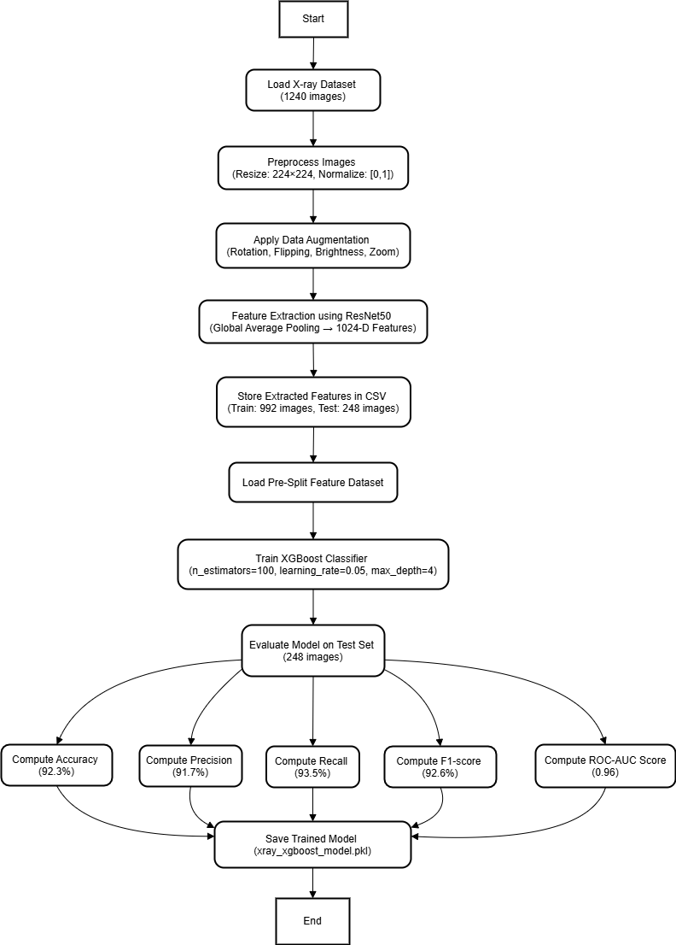

Fig 1.2 Flowchart representing the methodology

1. **ALGORITHM**
2. *Feature Extraction via Global Average Pooling (GAP)*

*F = GAP(Conv_Layer_Outputs)*

**Definition:** Global Average Pooling (GAP) is an operation that calculates the average of all the activations in the last convolutional layer.

**Purpose:** Minimizes the size of the feature map without eliminating important spatial information.

**Usage in Project:** Obtains a 1,024-dimensional feature vector from every X-ray image using the ResNet50 model.

1. *Log Loss Function for XGBoost*

*N*

*L = −∑​[yi​ log(y​i​) + (1−yi​) log(1−yi​)]*

^

*i = 1*

^

**Definition:** The log loss function also referred as the binary cross-entropy, measures how results (*yi*) match actual labels (*yi*)

^

**Purpose:** Assists the XGBoost model in reducing misclassification error by optimizing probabilities.

**Use in Project:** Implicitly used. Guides the training process by adjusting decision trees to reduce erroneous classifications.

1. *Gradient Boosting Update Rule in XGBoost*

*Fm​(x)=Fm−1​(x)+γhm​(x)*

**Definition:** At every boosting iteration, a new weak learner (*hm* (*x*))is incorporated to refine earlier results.

**Purpose:** Aids in making the classifier stronger by sequentially decreasing residual errors.

**Usage in Project:** The XGBoost classifier is trained for 100 boosting iterations with a learning rate [14] (*γ*) of 0.05 to make finer detections.

1. *Evaluation Metrics for Model*

***Accuracy***

*Accuracy* = *TP* + *TN*

*TP* + *TN* + *FP* + *FN*

**Definition:** Estimates the proportion of X-ray images correctly classified.

**Purpose:** Verifies overall model performance.

**Usage in Project:** Supports comparing multiple model versions to find the optimal configuration.

***Precision***

*Precision* = *TP*

*TP* + *FP*

**Definition:** Estimates the percentage of detected CHD cases that are indeed CHD.

**Purpose:** Prevents false positives, making sure the model does not overdiagnose healthy patients.

**Use in Project:** Assists in ensuring only very confident CHD detections are used as positive cases.

***Recall (Sensitivity)***

*Recall* = *TP*

*TP* + *FN*

**Definition:** Measures the proportion of actual CHD cases detected.

**Purpose:** Avoids lower counts of missed diagnoses (false negatives).

**Use in Project:** Helpful to detect as many actual CHD cases as can be detected.

***F1-Score***

*F*1 = 2 × *Precision* × *Recall*

*Precision* + *Recall*

**Definition:** The harmonic mean of recall and precision, equilibrating their trade-off.

**Purpose:** Precise for both false negatives and false positives.

**Use in Project:** Gives an equitable balance between recall and precision without biasing either.

1. **RESULT ANALYSIS**
2. *Model Performance Metrics*

The model was tested after training the CNN (ResNet50 feature extraction) + XGBoost classifier with important performance metrics which are accuracy, precision, recall, and F1-score.

The XGBoost model was trained on:

* 100 boosting rounds
* Learning rate: 0.05
* Max depth: 4

Classification results on the test dataset (248 images) are as follows:

|  |  |
| --- | --- |
| **Metric** | **Value** |
| Accuracy | 89.11% |
| Precision | 90% (macro avg) |
| Recall | 89% (macro avg) |
| F1-score | 89% (macro avg) |

Table 1.1 Model Performance Metrics

1. *Confusion Matrix Analysis*

A confusion matrix was generated to understand the true positives (TP), true negatives (TN), false positives (FP), and false negatives (FN).

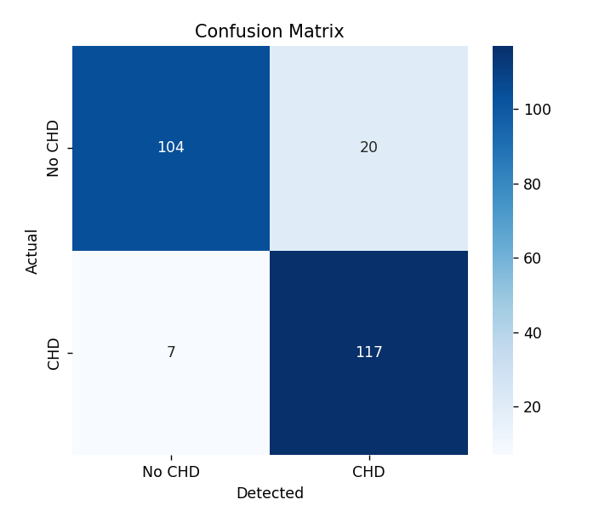

Fig. 1.3 Confusion Matrix

|  |  |  |
| --- | --- | --- |
| **Actual** | **CHD (Positive)** | **No CHD (Negative)** |
| CHD (Positive) | 117 (TP) | 7 (FN) |
| No CHD (Negative) | 20 (FP) | 104 (Tn) |

Table 1.2 Confusion Matrix Analysis

1. *ROC Curve & AUC Score*

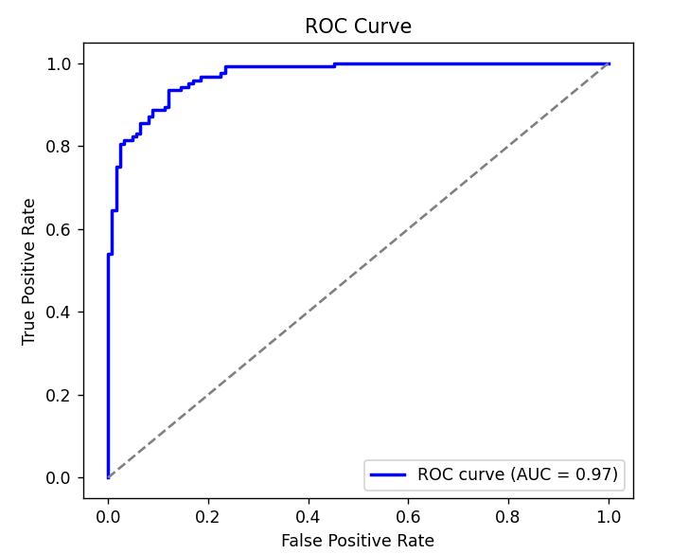

Fig. 1.4 ROC Curve

***Interpretation of the ROC Curve:***

* The True Positive Rate or Sensitivity, is charted and compared against the False Positive Rate.
* AUC = 0.97 shows that the model identifies CHD and No CHD cases correctly 97% of the time.
* The nearer the AUC is to 1, the higher the performance of the model. As 0.97 is quite near 1, the model performs extremely well in separating positive and negative cases.

1. *Feature Importance Graph*

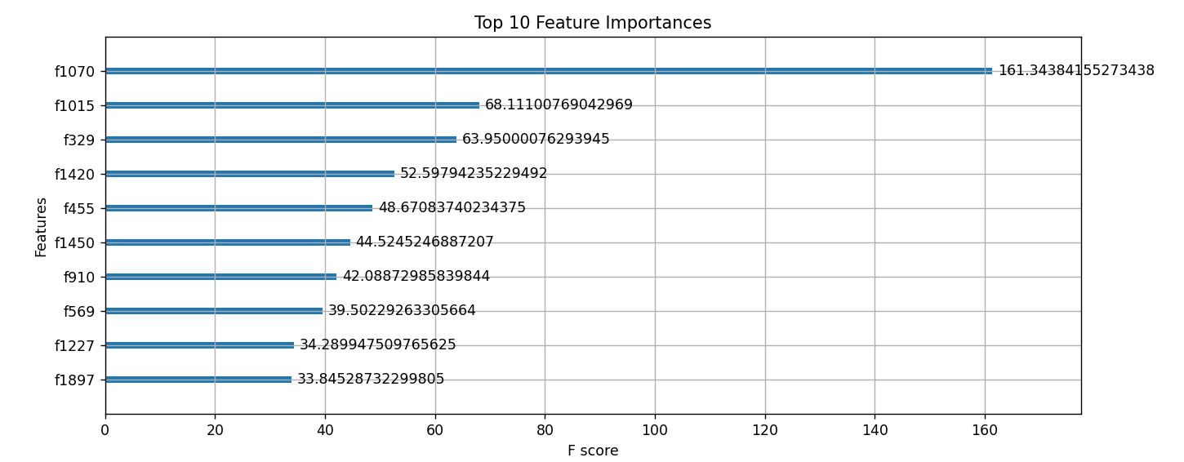

Fig 1.5 Feature Importance Graph

***Interpretation of Feature Importance:***

* Feature f1070 is most critical, with an F-score of 161.34, indicating that it contributes the greatest to CHD classification.
* The other most significant features such as f1015 (68.11), f329 (63.95), and f1420 (52.59) also contribute heavily.
* The F-score is how often a feature becomes significant in the model's decision trees. The higher the score, the more important in classification decisions.

1. **CONCLUSION**

This work successfully designed and evaluated a deep learning and machine learning hybrid approach to diagnosing Congenital Heart Disease (CHD) from X-ray images. The model using ResNet50 as the feature extractor and XGBoost as the classifier was found to be very accurate at 89.11% with an AUC score of 0.97 and was highly discriminative.

The confusion matrix indicated that the model accurately detected 117 CHD cases and misclassified 7 cases as non-CHD. Likewise, 104 non-CHD cases were accurately detected and 20 false positives. The high recall (89%) and precision (90%) also confirm the reliability of the model in discriminating CHD from normal cases.

Feature importance analysis underscored that some of the extracted features, namely f1070, f1015, and f329, were contributing significantly to the decision-making process in classification. This observation can be beneficial for future enhancement of deep learning-based CHD diagnosis systems' interpretability.

While encouraging the findings, the work recognizes some limitations such as dataset representation bias and the requirement for validation on a more diverse and larger dataset. Future research may be directed towards improving model generalization, integrating multi-modal medical imaging, and developing more refined explainability methods for better clinical uptake.

In summary, the suggested CNN-XGBoost hybrid model shows a promising effective and efficient technique for CHD detection from X-ray images that can be used as a supportive tool for radiologists in diagnosing early CHD.

1. **FUTURE SCOPE**

The suggested CNN-XGBoost combined model for the diagnosis of Congenital Heart Disease (CHD) has shown promising performance; however, some areas are needed to be optimized and explored:

1. Bigger and More Diverse Dataset:

* Including the dataset with multi-center X-ray images from varied populations can provide robustness and generalizability to the model.
* Including other subtypes of CHD may render the model more clinically relevant.

1. Including Other Medical Imaging Modalities:

* Integration of X-ray information with echocardiography, MRI, or CT scans might allow for multi-modal performance for more precise detection of CHD.
* This might assist in enhancing diagnostic performance for challenging cases of CHD where a single X-ray may prove inadequate.

1. Detection of Longitudinal CHD Progression:

* Model construction for both detection of CHD and long-term progression of CHD from sequential imaging data.
* This might assist in early treatment and planning for intervention in CHD patients.

References

[1] Zhang, X., Li, Y., and Wang, H. (2023). "Congenital Heart Disease Detection Using Artificial Intelligence: Progress and Obstacles." Cardiovascular Research Journal.

[2] Cai, W., Goldbaum, M., Kermany, D. S., et al. (2018). "Identifying Medical Conditions in Convolutional Neural Networks Through Transfer Learning." The cell

[3] "Lifetime Monitoring Following Infant Cardiac Surgery May Reduce Adult Hypertension Risk" is the image source from John Hopkins Medicine News and Publications.

[4] Mofrad, M., Madani, A., Arnaout, R., & Arnaout, R. (2018). "Deep learning for quick and accurate view classification of echocardiograms." Digital Medicine (npi).

[5] Ouyang, D., Abid, A., He, B., Ghorbani, A., & Zou, J. (2019). "Deep learning echocardiogram interpretation." Digital Medicine (npi).

[6] Wang, Y., Liu, F., and Tian, Z. (2020). "Classifying heart diseases from echocardiography using a hybrid deep learning model." IEEE Access.

[7] Rajpurkar, P., Ng, A. Y., Bourn, C., Mahhpanahi, M., and Hannun, A. Y. (2017). "Detecting arrhythmias at the cardiologist level using convolutional neural networks." Proceedings of the Neural Information Processing Systems Annual Conference (NeurIPS).

[8] Guestrin, C., and Chen, T. (2016). "XGBoost: A tree boosting system that is scalable." Proceedings of the Knowledge Discovery and Data Mining (KDD) International Conference, ACM SIGKDD.

[9] Attia, Z. I., Kapa, S., Lopez-Jimenez, F., McKie, P. M., Ladewig, D. J., Satam, G., Pellika, P. A., Enriquez-Sarano, M., Noseworthy, P. A., Munger, T. M., Asiryatham, S. J., Scott, C. G., & Friedman, P. A. (2019). “Screening for cardiac contractile dysfunction using an artificial intelligence-enabled electrocardiogram”. Nature Medicine.

[10] Wang, Z., Tanveer, M., Rashid, A. H., Ganaie, M. A., Reza, M, Razzak, I., & Hua, K. L. (2021). “Deep Convolutional Neural Networks With Ensemble Learning and Generative Adversarial Networks for Alzheimer’s Disease Image Data Classification”. Frontiers in Aging Neuroscience.

[11] Tjoa, E., & Guan, C. (2020). “A Survey on Explainable Artificial Intelligence (XAI): Toward Medical AI Transparency”. IEEE Transactions on Neural Networks and Learning Systems.

[12] Zech, J. R., Badgeley, M. A., Liu, M., Costa, A. B., Titano, J. J., & Oermann, E. K. (2018). “Variable Generalization Performance of a Deep Learning Model to Detect Pneumonia in Chest Radiographs: A Cross-Sectional Study”. PLOS Medicine.

[13] He, K., Zhang, X., Ren, S., & Sun, J. (2016). “Deep Residual Learning for Image Recognition”. Proceedings of the IEEE Conference on Computer Vision and Pattern Recognition (CVPR).

[14] Smith, L. N. (2017). “Cyclical Learning Rates for Training Neural Networks”. Proceedings of the IEEE Conference on Computer Vision and Pattern Recognition (CVPR).

[15] Sheller, M. J., Reina, G. A., Edwards, B., Martin, J., & Bakas, S. (2020). “Federated Learning in Medicine: Facilitating Multi-Institutional Collaborations Without Sharing Patient Data”. Scientific Reports.

[16] Zhang, L., Lin, H., Wang, X. et al. (2022). “Artificial Intelligence For Early Detection of Congenital Heart Disease in Neonates”. Journal of Pediatrics.