{{ CLIENT_NAME }}

{{ REPORT_TITLE }}

TO
{{ REPORT_TO }}

21 JUL 2025
MitKat Advisory Services Pvt. Ltd.


© Copyright 2025 MitKat Advisory Services Private Limited

Disclaimer

All information contained in this document is confidential and proprietary to MitKat and Reproduction, disclosure or use of any information contained in this document by photographic, electronic or any other means, in whole or part, for any reason other than for the purpose of operations is strictly prohibited without written consent.

Limitations on Disclosure and Use

This document contains sensitive and confidential information concerning vulnerabilities of target applications. MitKat recommends that special precautions be taken to protect the confidentiality of the information contained in this report.

While the VAPT Team is confident that the major security vulnerabilities of the target applications have been identified, there can be no assurance that an assessment of this nature will identify all possible security exposures. Additionally, the findings and recommendations presented in this document are based on the technologies and known threats as of the date of this report. As technologies and risks change over time, the vulnerabilities and the recommendations associated with the target applications may also change.

Table of Content

Document Control 4
Introduction 5
Engagement Scope 5
Details of the Auditing team 5
Executive Summary 7
Observations 9
Overall Findings 11

Report Release Date | {{ REPORT_RELEASE_DATE }}
Type of Audit | {{ TYPE_OF_AUDIT }}
Type of Audit Report | {{ TYPE_OF_AUDIT_REPORT }}
Period | {{ PERIOD }}

Document Control

Document Preparation
Document Title | {{ DOCUMENT_TITLE }}
Document ID | {{ DOCUMENT_ID }}
Document Version | {{ DOCUMENT_VERSION }}
Prepared by | {{ PREPARED_BY }}
Reviewed by | {{ REVIEWED_BY }}
Approved by | {{ APPROVED_BY }}
Released by | {{ RELEASED_BY }}
Release date | {{ RELEASE_DATE }}

Document Change History
Version | Date | Remarks / Reason of change
{% for change in DOCUMENT_CHANGE_HISTORY %}
{{ change.version }} | {{ change.date }} | {{ change.remarks }}{% endfor %}

Document Distribution List
Name | Organization | Designation | Email Id
{% for dist in DISTRIBUTION_LIST %}
{{ dist.name }} | {{ dist.organization }} | {{ dist.designation }} | {{ dist.email }}

Introduction

With a view to safeguard critical information RXIL engaged MitKat Advisory for identifying vulnerabilities and assessing the overall security posture of their organization involves systematically scanning for weaknesses and exploiting them to gain access, providing, actionable insights for remediation and comprehensive, multi-faceted simulations that mimic adversary behaviour, providing a holistic view of security readiness.

Engagement Scope
Below details of assets (whichever is / are applicable based on the type of audit) covered in the scope be included in this section along with other relevant details:

S. No. | Asset Description | Criticality of  Asset | Url | Location | Hash Value (in case of applications) | Version (in case of applications) | Other details such as make and model in case of network devices or security devices.
{% for scope in ENGAGEMENT_SCOPE %}
{{ scope.sr_no }} | {{ scope.asset_description }} | {{ scope.criticality }} | {{ scope.url }} | {{ scope.location }} | {{ scope.hash_value }} | {{ scope.version }} | {{ scope.other_details }}

Details of the Auditing team
S. No | Name | Designation | Email Id | Professional  Qualifications/  Certifications | Whether the resource has been listed in the Snapshot  information  published on CERT-In’s website(Yes/No)
{% for team in AUDITING_TEAM %}
{{ team.sr_no }} | {{ team.name }} | {{ team.designation }} | {{ team.email }} | {{ team.qualifications }} | {{ team.certin_listed }}{% endfor %}

Tools/ Software used

S. No | Name of Tool/Software used | Version of the tool /Software used | Open Source/Licensed
{% for tool in TOOLS_SOFTWARE %}
{{ tool.sr_no }} | {{ tool.name }} | {{ tool.version }} | {{ tool.type }}{% endfor %}

Executive Summary

A comprehensive security assessment of the application identified multiple vulnerabilities across identity validation, input handling, financial integrity, and client-side security. These weaknesses included improper PAN card validation, lack of server-side input sanitization, susceptibility to stored XSS and injection attacks, absence of rate limiting, handling of negative financial inputs, and exposure to text/Unicode-based denial-of-service conditions. In combination, these flaws created opportunities for unauthorized access, large-scale fraud, denial-of-service, sensitive data compromise, and regulatory non-compliance. Immediate remediation steps were implemented, and continuous monitoring is now in place to prevent re-exploitation.

Findings & Impact:
1. PAN Card Validation Weaknesses
1.1. The system allows duplicate, temporary, or false PAN card entries without proper uniqueness checks, and PAN inputs are not rate limited.
1.2. Impact: Enables large-scale identity theft, PAN enumeration attacks, fraud, regulatory non-compliance, reputational damage, and potential legal actions.
1.3. Remediation: Enforce PAN uniqueness at database and application levels, add duplicate PAN detection, and apply strict rate limiting with monitoring.

2. Input Validation & Injection Risks (Buyer Name, Limit, Target)
2.1. Fields like Buyer Name, Limit, and Target lack proper validation, allowing malicious payloads or invalid data. Buyer Name field is also vulnerable to stored XSS.
2.2. Impact: Risks include SQLi/Command Injection, stored XSS (account takeover, malware propagation, data theft), financial fraud through manipulated values, and full data compromise with loss of system integrity.
2.3. Remediation: Implement strict server-side validation using whitelisting/regex, sanitize and encode outputs, enforce CSP, and use secure libraries for input/output handling.

3. Denial of Service via Text & Unicode Overflows
3.1. Fields (Buyer Name, Limit, Target) accept excessively long input, including Unicode strings, without length restrictions.
3.2. Impact: Attackers can trigger denial-of-service by exhausting resources, crashing servers, bypassing security filters, or corrupting data integrity in critical services.
3.3. Remediation: Set maximum input length (in characters/bytes), normalize Unicode input, reject malformed sequences, and apply input throttling early in the workflow.

4. Negative Value Exploitation in Financial Fields
4.1. Numeric fields (Limit, Target) allow negative values without boundary validation.
4.2. Impact: Enables fraudulent credits, accounting manipulation, misreporting, compliance failures, and direct financial losses.
4.3. Remediation: Enforce strict numeric validations to allow only valid positive ranges; reject negative inputs gracefully with error handling.

5. Lack of Rate Limiting Across Inputs
5.1. Critical inputs (Buyer Name, Limit, Target, PAN) lack rate limiting.
5.2. Impact: Enables brute-force, automated abuse, data exfiltration, enumeration, and large-scale denial-of-service attacks, leading to reputational and financial damage.
5.3. Remediation: Apply per-user/IP request throttling, enforce CAPTCHA on sensitive endpoints, and log abnormal submission activity.

6. Insecure Client-Side Controls
6.1. Right-click functionality is enabled on sensitive UI components, and CSP is not enforced.
6.2. Impact: Exposes application internals via code inspection, facilitates data scraping, enables client-side attacks (XSS, clickjacking), and aids reverse engineering.
6.3. Remediation: Disable right-click on sensitive pages, implement robust CSP restricting inline scripts and untrusted origins.
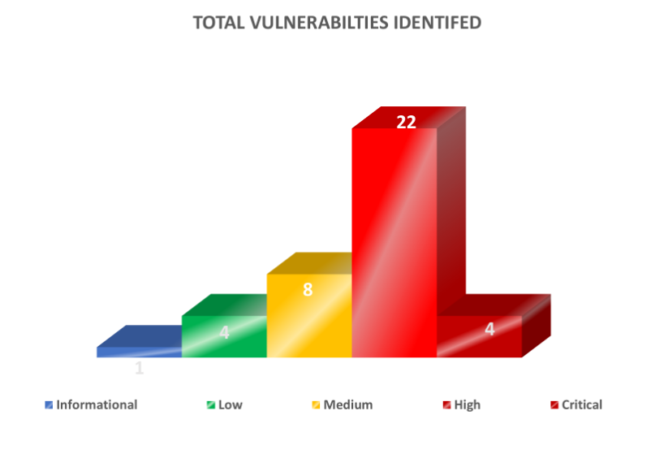

Conclusion
The identified vulnerabilities posed a significant security risk, but immediate remediation was implemented to mitigate threats. Continuous monitoring, vulnerability patching, and security best practices will be enforced to prevent similar risks in the future.

Observations

Test Case
Sr. No. | Test Case | Status
1 | Vulnerability Assessment | Completed
2 | Service Disruption Analysis | Completed

End of Report

