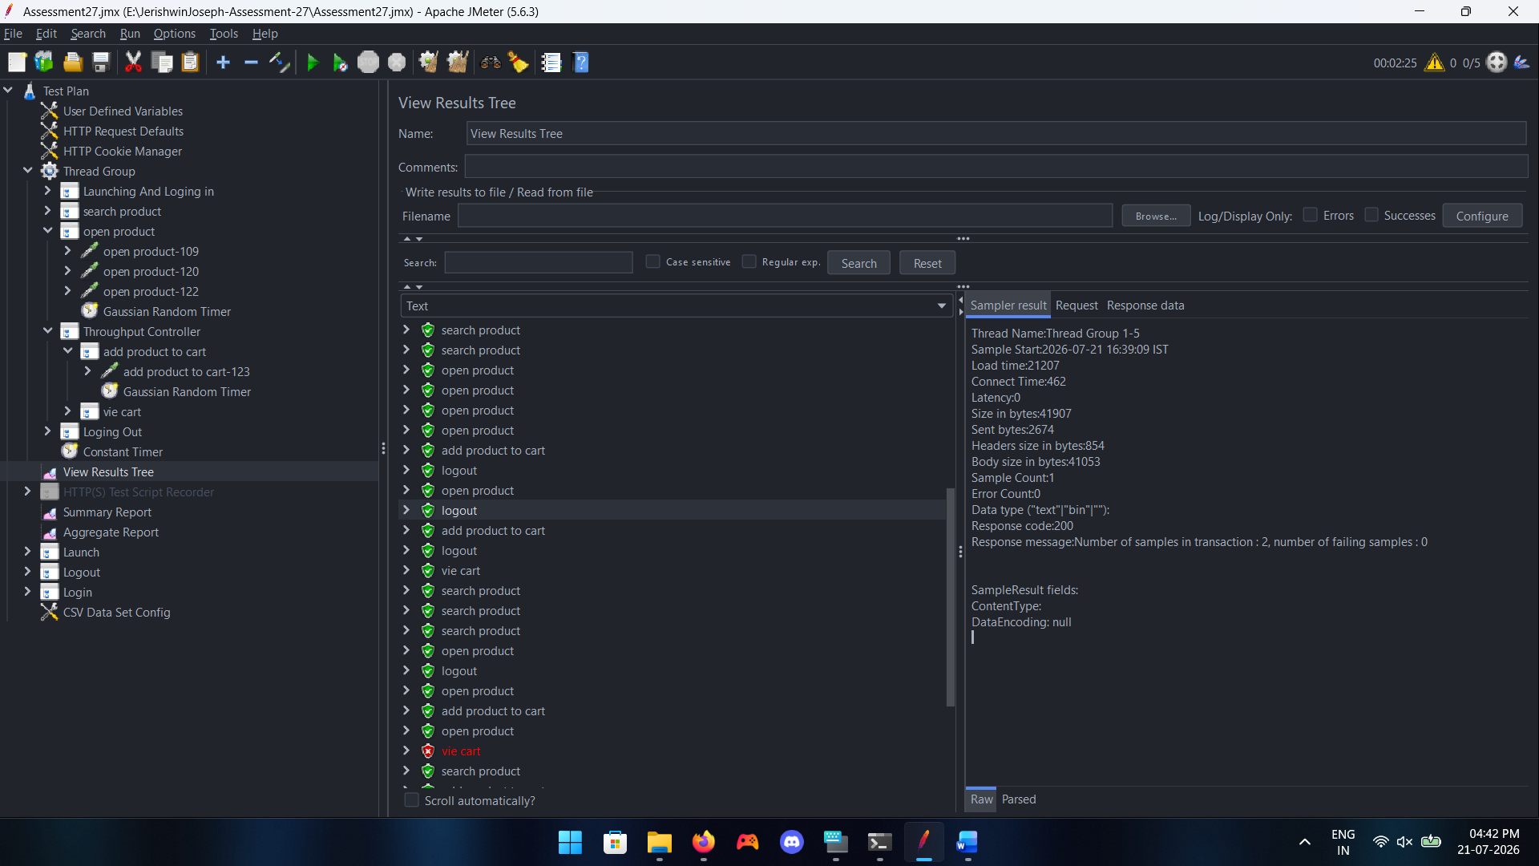

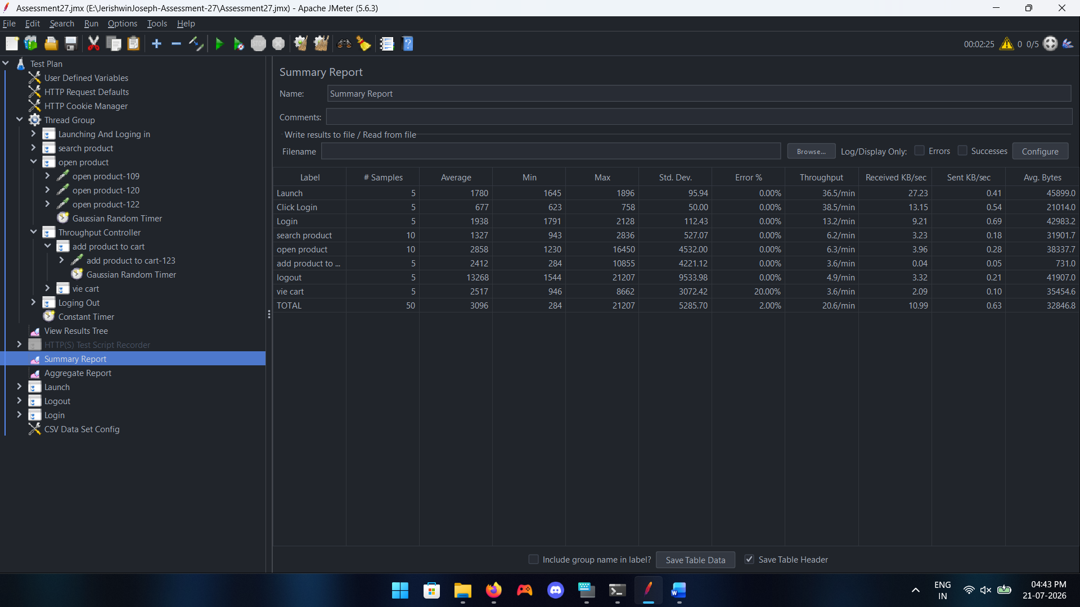

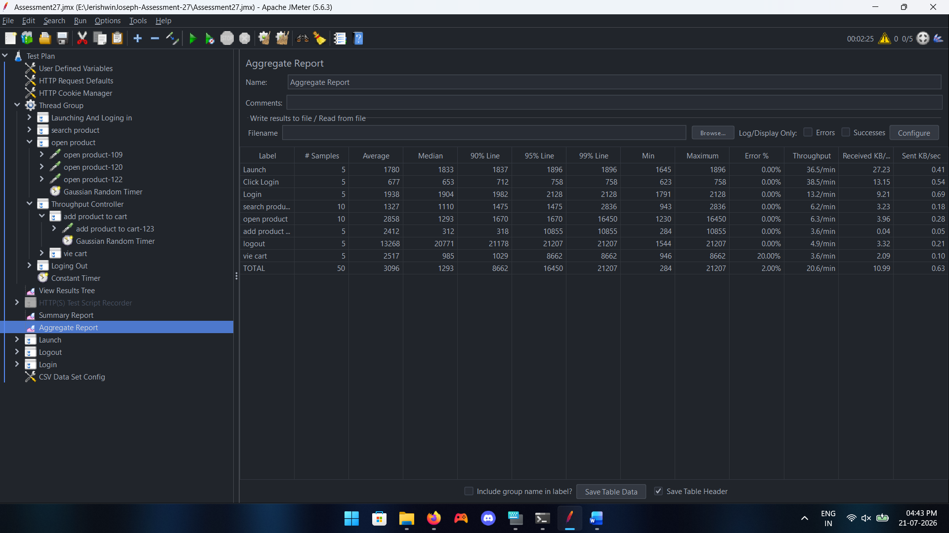

1 Which request/transaction has the Highest response time, and what is its value?
Ans: Logout

2 Which request/transaction has the Lowest response time, and what is its value?
Ans: Click Login

3 Which request/transaction has the Maximum Throughput (requests/sec), and what is its
value?
Ans: Click Login (38.5/min)

4 What is the overall Error % for the test run? List any failing requests.
Ans: 2% View Cart

5 What is the Average response time across all samples?
Ans: 3096

6 What is the Median response time?
Ans: 1293

7 What is the 90th Percentile response time?
Ans: 8662

8 What is the 95th Percentile response time?
Ans: 16450

