Data Structure and Algorithm
Laboratory Activity No. 13

Tree Algorithm

Submitted by: | Instructor:
Balana, Jerkielle Roen O.. | Engr. Maria Rizette H. Sayo

November 08, 2025

Objectives
Introduction
An abstract non-linear data type with a hierarchy-based structure is a tree. It is made up of links connecting nodes (where the data is kept). The root node of a tree data structure is where all other nodes and subtrees are connected to the root.

This laboratory activity aims to implement the principles and techniques in:
- To introduce Tree as Non-linear data structure
- To implement pre-order, in-order, and post-order of a binary tree
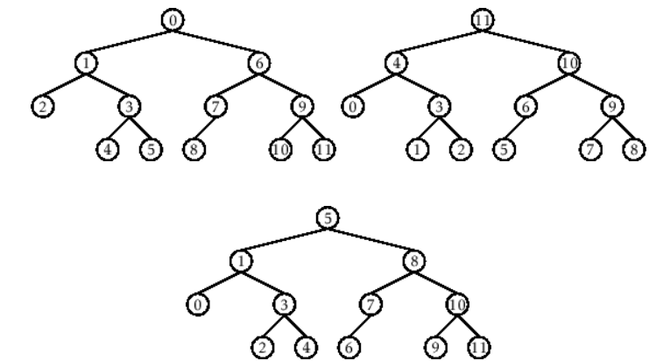

- Figure 1. Pre-order, In-order, and Post-order numberings of a binary tree

Methods
  - Copy and run the Python source codes.
  - If there is an algorithm error/s, debug the source codes.
  - Save these source codes to your GitHub.
  - Show the output

    - Tree Implementation

class TreeNode:
def __init__(self, value):
self.value = value
self.children = []

def add_child(self, child_node):
self.children.append(child_node)

def remove_child(self, child_node):
self.children = [child for child in self.children if child != child_node]

def traverse(self):
nodes = [self]
while nodes:
current_node = nodes.pop()
print(current_node.value)
nodes.extend(current_node.children)

def __str__(self, level=0):
ret = " " * level + str(self.value) + "\n"
for child in self.children:
ret += child.__str__(level + 1)
return ret

# Create a tree
root = TreeNode("Root")
child1 = TreeNode("Child 1")
child2 = TreeNode("Child 2")
grandchild1 = TreeNode("Grandchild 1")
grandchild2 = TreeNode("Grandchild 2")

root.add_child(child1)
root.add_child(child2)
child1.add_child(grandchild1)
child2.add_child(grandchild2)

print("Tree structure:")
print(root)

print("\nTraversal:")
root.traverse()

Questions:
- When would you prefer DFS over BFS and vice versa?
- What is the space complexity difference between DFS and BFS?
- How does the traversal order differ between DFS and BFS?
- When does DFS recursive fail compared to DFS iterative?

Results
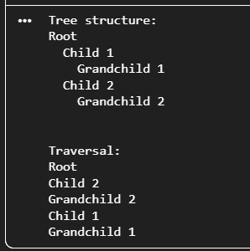
    - You would prefer DFS when the solution is expected to be found deep in the structure, memory is limited, or when all possible paths need to be explored and the shortest path is not relevant. BFS is preferred when you need the shortest path to a target node or the tree or graph is relatively shallow, making level-by-level exploration efficient.
    - DFS requires space proportional to the height of the tree, giving it a complexity of O(h), where h is the maximum depth. BFS, however, stores all nodes at a given level, which can be significantly larger. Its space complexity is O(w), where w is the maximum width of the tree. Generally, BFS consumes more memory than DFS.
    - DFS goes as deep as possible along one branch before it backtracks, following a depth-first pattern, which could be pre-order, in-order, or post-order. BFS works its way level by level, processing all nodes in one layer before moving to the next. DFS goes vertically; BFS goes horizontally.
    - Recursive DFS can fail when the recursion depth becomes too large, potentially causing a stack overflow on deep or unbalanced trees. Iterative DFS, which uses an explicit stack data structure, avoids this limitation and can safely handle much deeper structures.

Conclusion
The conclusion expresses the summary of the whole laboratory report as perceived by the authors of the report.
In this laboratory activity, the implementation and analysis of tree traversal methods highlighted the importance of understanding how hierarchical data structures operate in practice. Through hands-on coding, the differences between depth-first and breadth-first strategies became clear, especially in terms of traversal order, memory usage, and performance trade-offs. Examining recursive and iterative DFS further revealed the limitations of recursion in deep trees and the reliability of explicit stack management. Overall, this experiment strengthened the understanding of tree algorithms and their practical applications in solving real-world computing problems.

References
[1] Co Arthur O.. “University of Caloocan City Computer Engineering Department Honor Code,” UCC-CpE Departmental Policies, 2020.

