Data Structure and Algorithm
Laboratory Activity No. 14

Tree Structure Analysis

Submitted by: | Instructor:
Balana, Jerkielle Roen O. | Engr. Maria Rizette H. Sayo

November 8, 2025

Objectives
Introduction
An abstract non-linear data type with a hierarchy-based structure is a tree. It is made up of links connecting nodes (where the data is kept). The root node of a tree data structure is where all other nodes and subtrees are connected to the root.

This laboratory activity aims to implement the principles and techniques in:
- To introduce Tree as Non-linear data structure
- To implement pre-order, in-order, and post-order of a binary tree
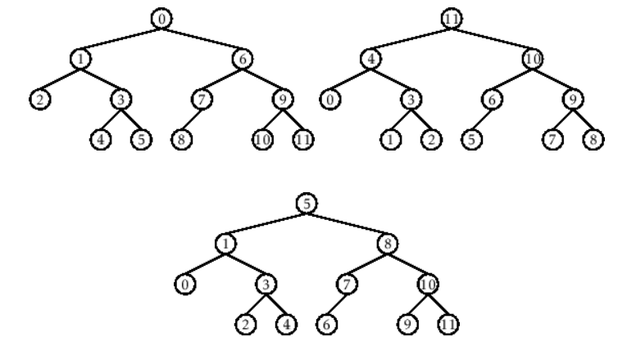

- Figure 1. Pre-order, In-order, and Post-order numberings of a binary tree

Methods
  - Copy and run the Python source codes.
  - If there is an algorithm error/s, debug the source codes.
  - Save these source codes to your GitHub.
  - Show the output

    - Tree Implementation

class TreeNode:
def __init__(self, value):
self.value = value
self.children = []

def add_child(self, child_node):
self.children.append(child_node)

def remove_child(self, child_node):
self.children = [child for child in self.children if child != child_node]

def traverse(self):
nodes = [self]
while nodes:
current_node = nodes.pop()
print(current_node.value)
nodes.extend(current_node.children)

def __str__(self, level=0):
ret = " " * level + str(self.value) + "\n"
for child in self.children:
ret += child.__str__(level + 1)
return ret

# Create a tree
root = TreeNode("Root")
child1 = TreeNode("Child 1")
child2 = TreeNode("Child 2")
grandchild1 = TreeNode("Grandchild 1")
grandchild2 = TreeNode("Grandchild 2")

root.add_child(child1)
root.add_child(child2)
child1.add_child(grandchild1)
child2.add_child(grandchild2)

print("Tree structure:")
print(root)

print("\nTraversal:")
root.traverse()

Questions:
- What is the main difference between a binary tree and a general tree?
- In a Binary Search Tree, where would you find the minimum value? Where would you find the maximum value?
- How does a complete binary tree differ from a full binary tree?
- What tree traversal method would you use to delete a tree properly? Modify the source codes.

Results
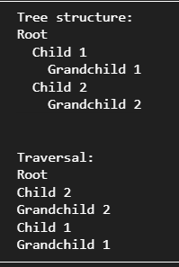
    - A binary tree restricts each node to at most two children, typically referred to as the left and right child. A general tree, meanwhile, allows any number of children per node, making it more flexible and capable of representing hierarchical structures without fixed branching limits.
    - In a Binary Search Tree (BST), the minimum value is found by traversing the leftmost branch from the root, since all left descendants hold smaller values. Conversely, the maximum value is found in the rightmost branch, as all right descendants contain larger values.
    - A complete binary tree fills all levels from left to right without gaps, except possibly the last level. A full binary tree, however, requires that every node must have either exactly two children or no children at all. Thus, completeness refers to fullness of levels, while fullness refers to the number of children per node.
    - The proper traversal for deleting a tree is post-order traversal, because it processes the children before deleting the parent node. This prevents attempts to access child nodes that have already been removed.

Conclusion
The conclusion expresses the summary of the whole laboratory report as perceived by the authors of the report.
This laboratory activity provided a practical exploration of tree structures, enabling a clearer understanding of how hierarchical data is organized, traversed, and managed in computing. By comparing binary and general trees, the differences in node constraints and data representation became evident. The activity also reinforced essential concepts such as locating minimum and maximum values in a Binary Search Tree and distinguishing between full and complete binary trees. Implementing post-order deletion further emphasized the importance of selecting the correct traversal strategy when managing memory and node dependencies. Overall, the experiments strengthened comprehension of tree algorithms and highlighted their significance in efficient data processing and software design.

References
[1] Co Arthur O.. “University of Caloocan City Computer Engineering Department Honor Code,” UCC-CpE Departmental Policies, 2020.

