Screenshots Explaining Game

GitHub
https://github.com/JermaineN/IT-Professional-Skills

AI Acknowledgement & Acknowledgement
**Claude**: Reviewed README documentation and corrected any mistakes.
Only Library used was Java

Screenshots

Name and Imports
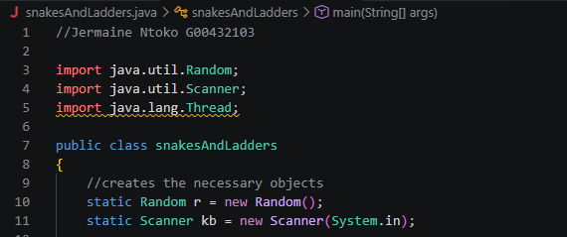
Initialised the imports and created the project.

Display of the Board
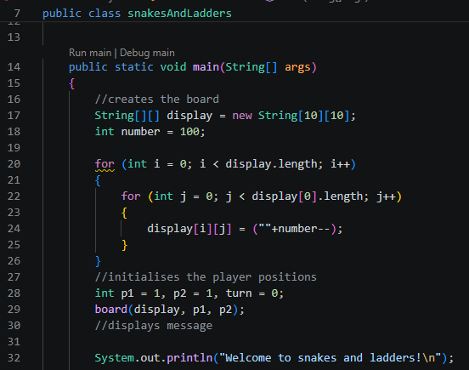
Creates the board array and passes it into the board function along with player one and player 2.

Logic
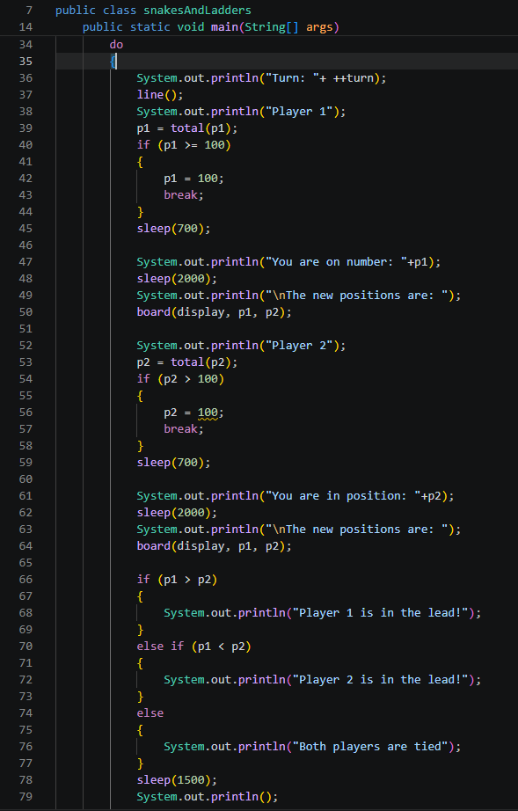
Determines the turn number and position of both players and displays who’s in the lead.

Win Condition
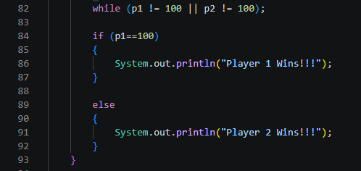
If any player reaches position 100, display that they win.

Board Function
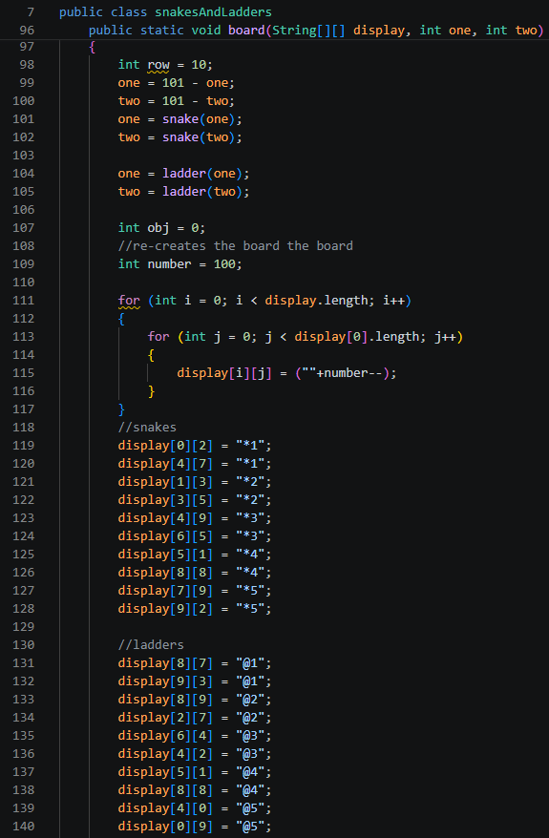
Set the positions for the snakes and ladders and calls the snakes and ladders functions.

Checks if Players are on the Same Spot
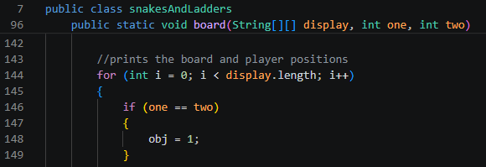

Prints the Location of Player 1 and Player 2
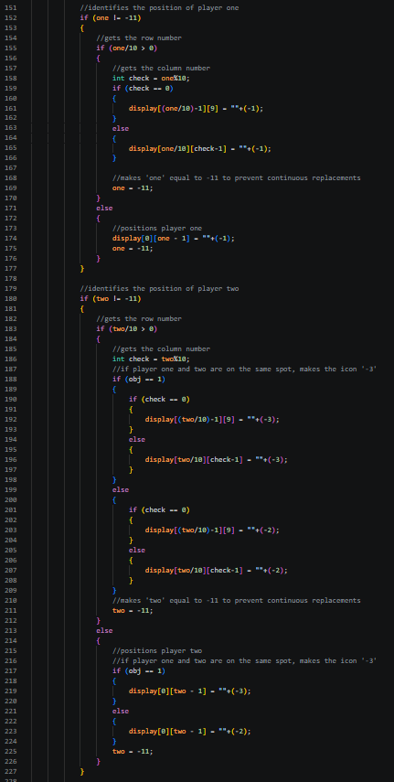
Prints the location of both players and if they are on the same spot, substitute their position tracker with -3

Prints the Board
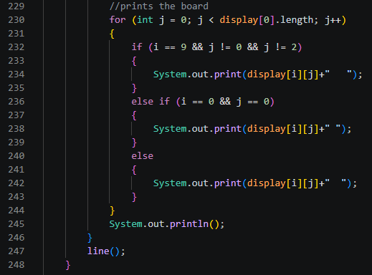
Prints the Board and all player positions.

Dice Function
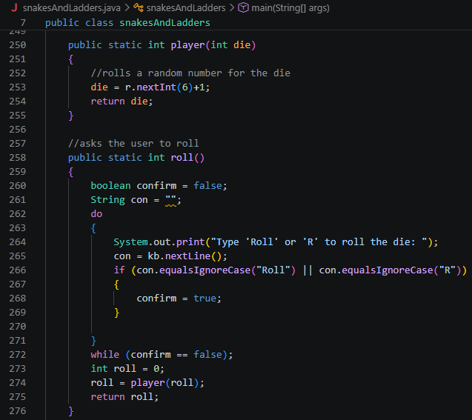
Allows the player to roll a die.

Quality of Life Functions
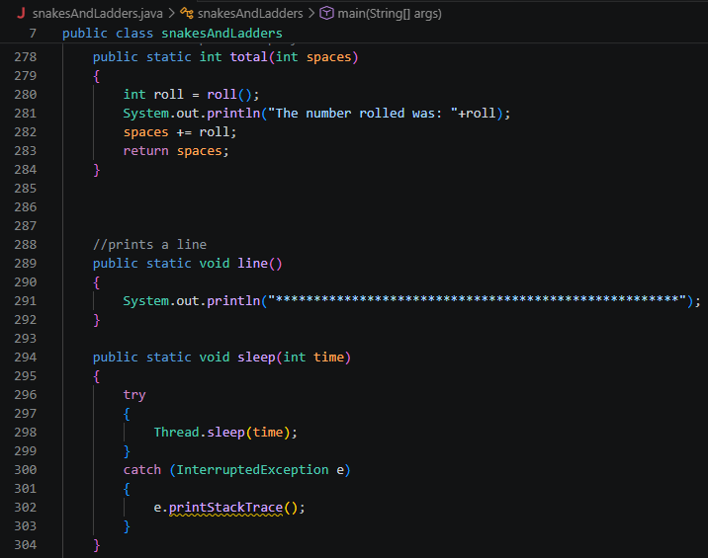
Adds functions that make the UI easier to understand.

Snakes Logic
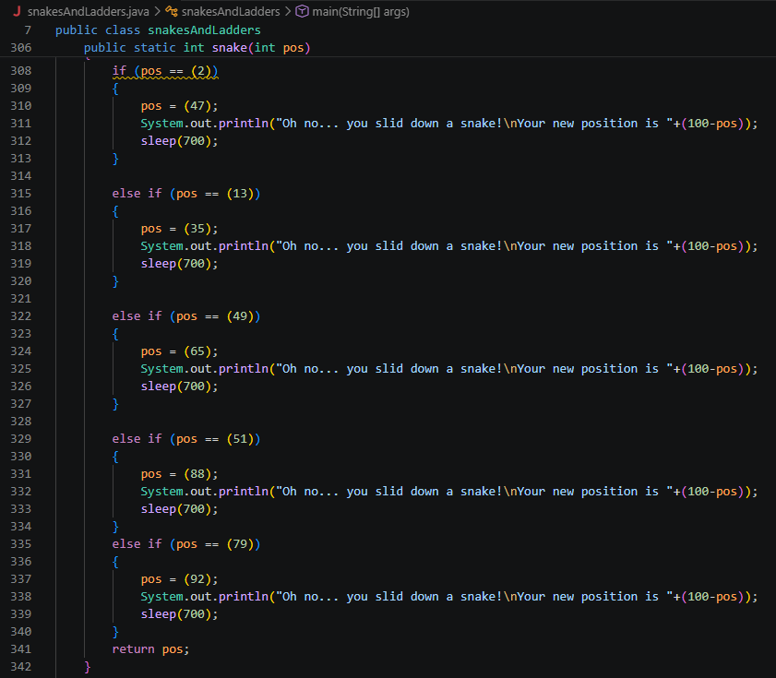
Adds the logic for the snakes.

Ladders Logic
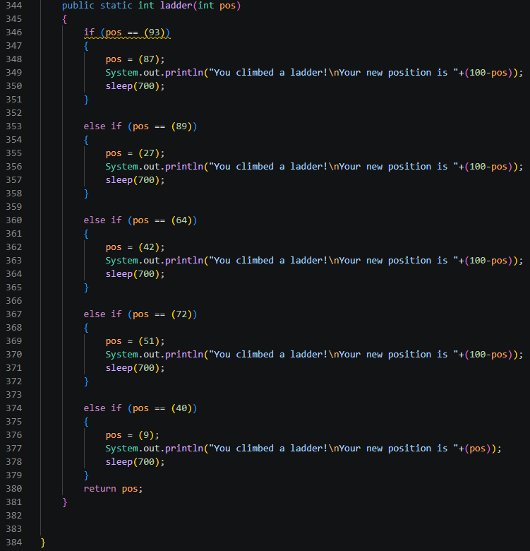
Adds the logic for the ladders.

Example of Code Running
