**Sweet Honey Plant Data for Smart Watering Mechanism** **(ACM: IA-I-RRL-PM-R-A)**

Jermedita Tion Sandigan (Student)

Student of Department of Computer Engineering, College of Engineering, Architecture and Industrial Design, Bohol Island State University-Main Campus, jermedita.sandigan@bisu.edu.ph

MAX ANGELO DAPITILLA PERIN(INSTRUCTOR)

Faculty of Department of Computer Engineering, College of Engineering, Architecture and Industrial Design, Bohol Island State University-Main Campus, [maxangelo.perin@bisu.edu.ph](mailto:maxangelo.perin@bisu.edu.ph)

Imaginative Abstract. A Sweet Honey Plant Data for Smart Watering Mechanism is a clump-forming herbaceous perennial with semi-evergreen leaves and daisy-like yellow blooms with yellow centers. It is configured to detect the moisture content of plants at specific times. If the moisture content is less than a predetermined threshold based on a plant's water requirements, the necessary amount of water is provided until the moisture content is less than the specific threshold. To increase efficiency, we employ sensors to collect real-time or historical data to inform watering procedures and change watering schedules. This technique not only saves water but also keeps the plants healthy and alive. We hope that by using this prototype, we can all be able to enjoy having plants without worrying about them.

**CCS CONCEPTS** • mechanism • sensor• microcontroller • automated system

**Additional Keywords and Phrases:** humidity sensor, watering mechanisms, humidity level **ACM Reference Format**: **Jermedita Tion Sandigan**, **MAX ANGELO DAPITILLA PERIN** . 2022. **Sweet Honey Plant Data for Smart Watering Mechanism (ACM: IA-I-RRL-PM-R-A**). In Research Project Presentation for Bachelor of Science in Computer Engineering 3 in CPE 03 – Microprocessor Systems S.Y. 2021-2022, 2nd Semester, Bohol Island State University-Main Campus, Tagbilaran City, Republic of the Philippines. ACM, New York, NY, USA

1. Introduction

We all know that plants benefit humans in a variety of ways. Plants contribute to a healthy environment by naturally cleaning the air and producing oxygen. Plants are popular in many backyards. However, because of civilization and a lack of space, many people used to grow plants in a mold or dirt pot and place them on the windowsill. Sweet Honey Plant, this plant requires traditional breeding: watering and the right amount of sunlight to survive and grow. Many people forget to water their plants due to their busy schedules, and as a result, their plants suffer from a variety of ailments and eventually die. Furthermore, the world's most pressing concern in modern society is a lack of water resources; agriculture is a labor-intensive activity that requires vast amounts of water. It is critical to make the best use of available water resources.

1. REVIEW OF RELATED LITERATURE

Plants play a critical role in providing habitat for a wide range of species. It has increasingly been demonstrated that the presence of green spaces in these areas can be critical in acting as a sink for these pollutants, thereby improving air quality. Plants and trees are critical for maintaining good soil conditions. Their roots and the microorganisms that live around them hold the soil together, reducing soil erosion. Carbon dioxide (CO2) is one of the most significant greenhouse gases contributing to climate change. Photosynthesis is the process by which plants absorb CO2 and emit oxygen (Eleanor Clark 2018).

According to the Merriam-Webster, honey plant is any of numerous flowering plants that provide nectar suitable for insect honey production. Since antiquity, the honeybee has been known for its medicinal and nutritional benefits. Honey is not only used to treat human diseases, but it is also used to treat domestic animals because it inhibits the growth of fungi and bacteria during infections and wound injuries, even in the presence of microorganism resistance. Previously, researchers demonstrated that honey's properties make it one of the most important natural antioxidants (Otmani, et al 2019).

Gerbera 'Garvinea Sweet Honey' is a herbaceous perennial with clump-forming leaves and daisy-like flowers. Indoors, they prefer bright but filtered light, to be watered on a regular basis, fed monthly, and kept moist during the growing season (Daisy 2019).

Based on the plant encyclopedia “gardentags.com”, Gerbera 'Sweet Honey' blooms consistently from mid-summer to mid-autumn, and these clump-forming hardy perennials make a big impact in borders and patio containers. This plant can reach up into 45cm in height and width. Gerbera daisy plants can be grown from seed, seedlings, or division. The cheapest method is seed, but seeds must be sown right away because they lose viability quickly after opening. Keep in mind that seeds may not be true to form. Growing from seedlings or divided plants is simpler, and you can predict the flower type.

**3 PROPOSED METHODOLOGY**

The study will be conducted using an experimental technique by the researchers. This automated system created by the researchers will replace the traditional way of watering the plants. The accuracy of this watering mechanism is determined using an experimental approach. The data collected from the Soil Moisture Sensor is sent to the system to be able to utilize the efficient operation.

**3.1 Hardware Overview**

**ARDUINO UNO:** Arduino UNO is a microcontroller on the ATmega328. It has digital input/output pins, 6 analog inputs, a 16MHz ceramic resonator, a USB connection a power jack, an ICSP header and a reset button. It contains everything needed to support the microcontroller, simply connect it to a computer with a USB cable or power it with a AC-DC adapter or battery to get started.

**SOIL HUMIDITY SENSOR:** The soil moisture sensor utilized has its voltage output proportional to the quantity of water in the soil. Its specified supply voltage is from 3.3V to 5V and with this supply, it gives an output voltage of between 0V to 2.3V for the full range of complete dryness to submersion in water. Its rating for maximum operating current is 0.15A. Its output is fed into the analog to digital converter input of the microcontroller.

**THE CONTROL UNIT:** This unit is basically the section that provides the control of the whole system. It consists of a microcontroller IC chip plus peripheral components and the control logic which the chip functions with. The microcontroller chip is the central hardware component while the program or code is the firmware component.

**THE DISPLAY UNIT:** The display unit is simply an output unit used for the purpose of giving the user the required information. The display unit is a simple 4x4 LCD module.

Table 1: Components used in this study

|  |  |
| --- | --- |
| Arduino UNO | Solenoid Actuator Valve |
| Soil Moisture Sensor | Jumper Cables |
| 8x2 LCD module | Aquarium Hose |
| Breadboard | Relay Module |
| Power Supply | Arduino Case |

**3.2 Components Used**

In Table 1, you can see the different materials and components that the researchers used in this study. One of those is the Arduino Uno microcontroller. It also has the Soil Moisture Sensor that detects the level of the soil humidity. We also used jumper wires, power supply to be able to make this study function.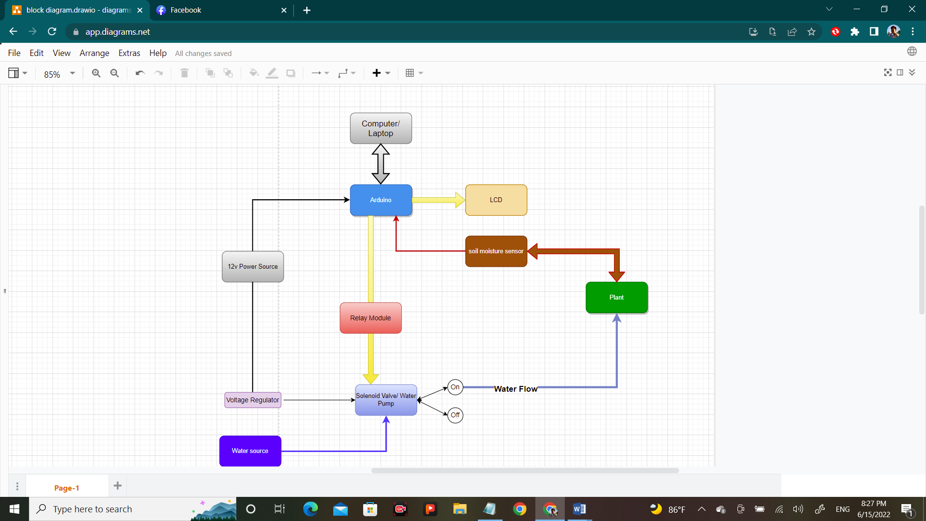

Figure 1: Block Diagram of Smart Plant Watering Mechanism using Arduino

**3.3 Block Diagram**

The block diagram shown in the Figure 1 is the system consist of power source, soil moisture sensor, Arduino, solenoid valve and LCD to be able to show the information about the humidity level of the soil.

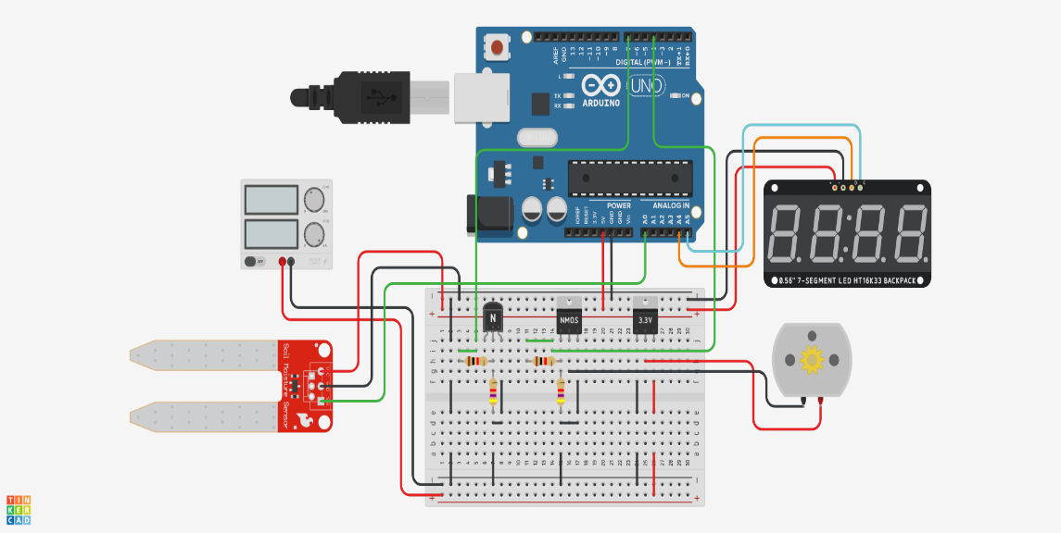

Figure 2: Circuit Diagram for the Solenoid Valve and Android UNO with Relay Module

3.4 Circuit Diagram

The circuit diagram shown in Figure 2 consists of Arduino Uno, jumper wires and Soil Moisture sensor. It is used to detect the soil humidity level of the plant through its soil.

3.5 Applications Used

The application used in this study is the Arduino IDE. It is used to write and upload code to the Arduino boards. The IDE application is suitable for different operating systems such as Windows, Mac OS X and Linux. The IDE environment mainly consists two basic parts: Editor and Compiler where former is used for writing the required code and later is used for compiling and uploading the code into the given Arduino Module.

4 aPENDIces

**Image of the Prototype**

**Internal Components.**

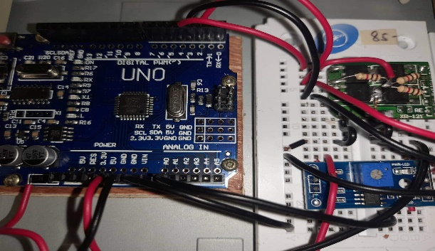 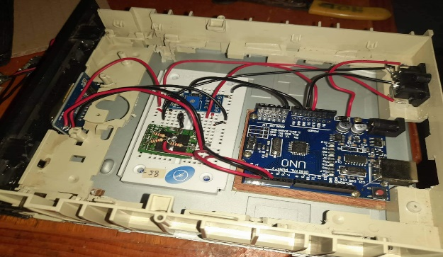

Figure 3: Image of the Components of Smart Watering Mechanism using Arduino

**Final Prototype**

 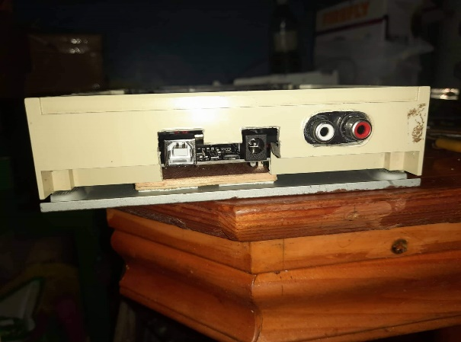

Figure 4: Image of the Final Prototype

# **REFERENCES**

[1] Hassan. (2018, December). *ResearchGate.* Retrieved from ResearchGate: researchgate.net/publication/330212779_An_Automated_Irrigation_System_Using_Arduino_Microcontroller

[2] Keshavarz. (2021, December). *High Sensitivity and Compact Time-domain Soil Moisture Sensor using Dispersive Phase Shifter for Complex Permittivity Measurement.* Retrieved from Research Gate: https://www.researchgate.net/publication/356763198

[3] Singhal, A. &. (2015). *Smart Drip Irrigation System using Raspberry Pi and Arduino.* Retrieved from Smart Drip Irrigation System using Raspberry Pi and Arduino: http://doi.org/10.1109/CCAA.2015.7148526

[4] *Why are Soils Important?* (2022). Retrieved from ISRIC - World Soil Information: https://www.isric.org/discover/about-soils/why-are-soils-important

[5] Geetha. (2022, February). *Automatic Watering System using Soil Moisture Sensor and RTC timer with Arduino*. Retrieved from https://ijarst.co.in/Paper2507

[6] Samuel. *Intelligent Plant Watering System for Rural Farmers.* Retrieved from: https://core.ac.uk/download/pdf/85162201.pdf