Milestone 1 Properties

Property 1: An instance is found for our Trace pred, so this means there is at least one way for the data to be transferred.

Step 1: all of the data is in the Sender, and none is in the receiver

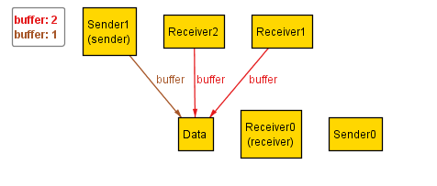

Step 2: The data has moved to the Receiver, and none is in the sender (this state is also the end state)

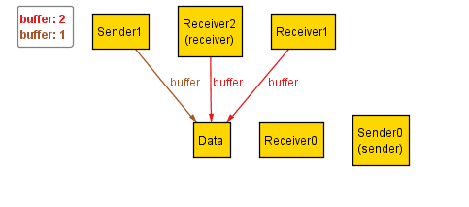

Step 3: This is also the end state, so no data is in the sender, and all is in the receiver.

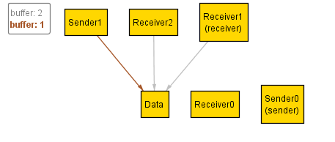

Property 2: There is a counter-example found for the “notAllDataCanBeTransferred” assertion, so this means that all data can be transferred.

Step 1: all of the data is in the Sender, and none is in the receiver



Step 2: The data has moved to the Receiver, and none is in the sender (this state is also the end state)



Step 3: This is also the end state, so no data is in the sender, and all is in the receiver.

