Milestone 2 Properties

Property 1: An instance is found for our Trace pred, so this means there is at least one way for the data to be transferred.

We run our predicate as “run Trace for 6 but 2 Data.”

State 0: Our sender has all of our data, and receiver has none. We start with an ack packet initially so that the sender can send its data instead of resending garbage data. We are in the SendState, meaning that there is a Response Packet ready for our sender.

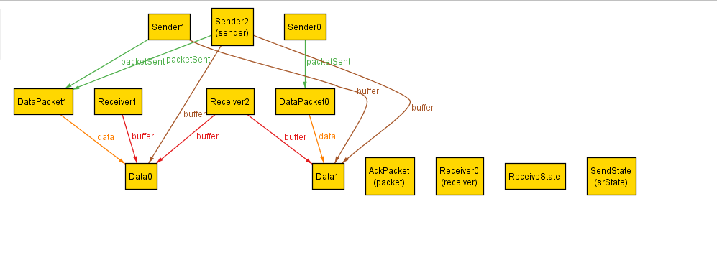

State 1: Our sender has sent a packet with Data$0 so that data is no longer in our sender’s buffer. We are now in the ReceiveState, meaning there is a data packet for the receiver. Our receiver has not received the data yet.

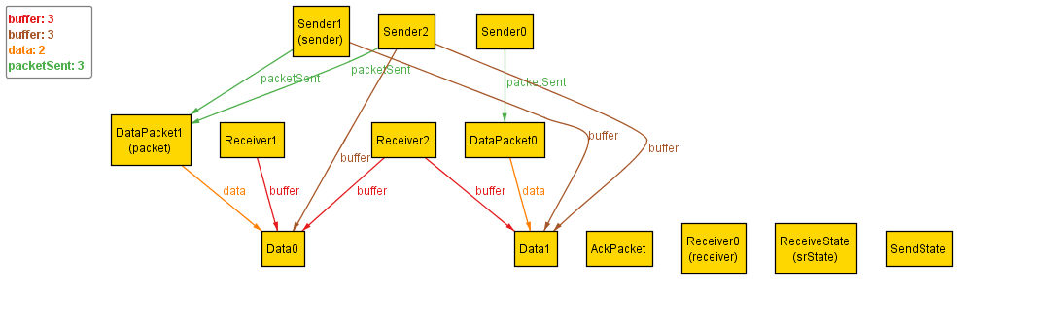

State 2: Our receiver has Data$0 in it, and is sending back an AckPacket; we are now in the SendState.

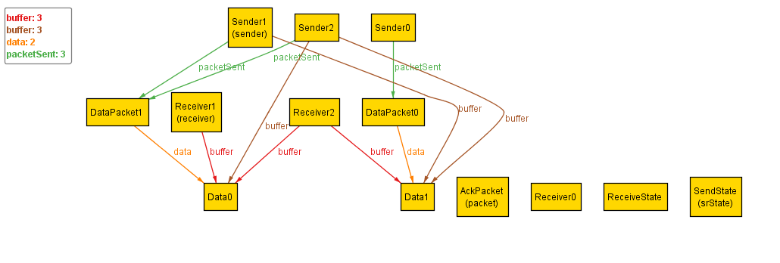

State 3: Our sender has no data in its buffer now, and the last data is in the datapacket that is sent this state. We are now in the ReceiveState.

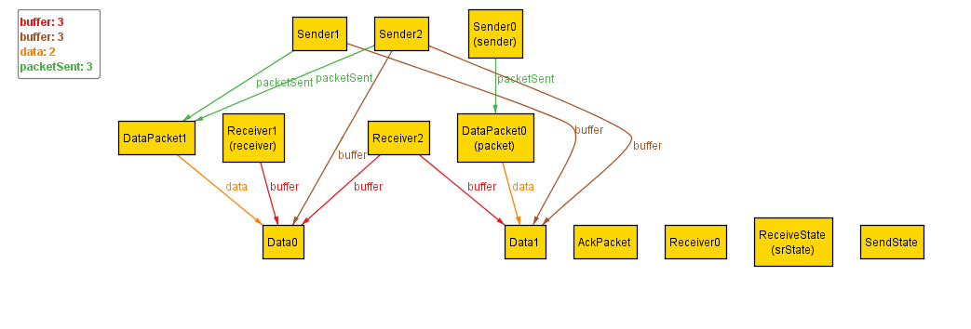

State 4: All data is in the receive buffer, and no data is in the sender buffer. This state is the end state. We also send back an AckPacket.

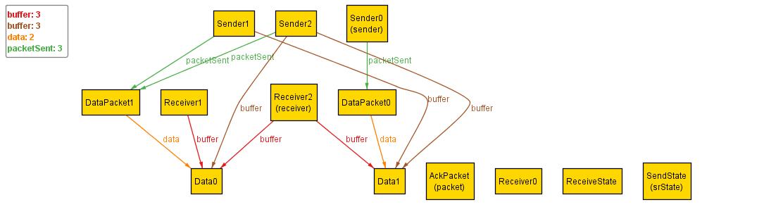

Property 2: This property is not satisfied because we are able to find a counter-example for our assertion “allDataCanBeTransferred.”

State 0: The initial state, all data is in the sender’s buffer, and no data is in the receiver’s buffer. We are in the SendState.

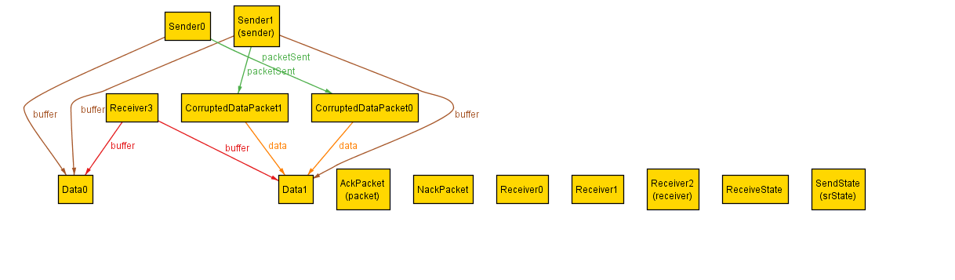

State 1: The data is sent in a CorruptedDataPacket, and removed from the sender’s buffer. We are in ReceiveState.

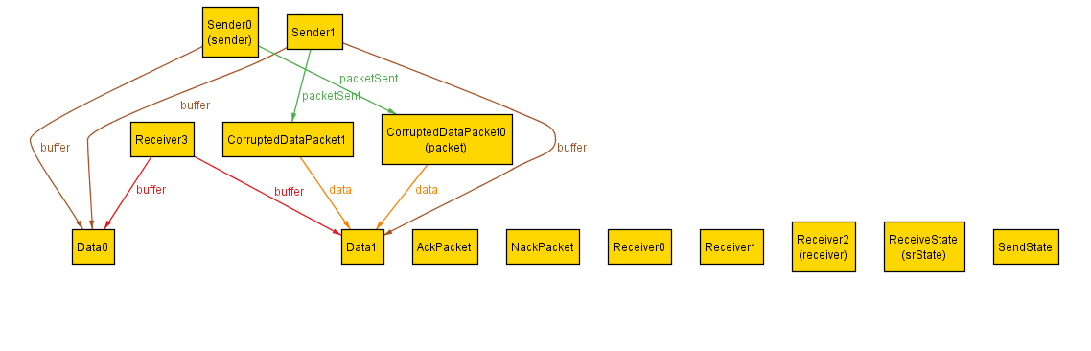

State 2: The receiver sends a NackPacket back, indicating that the DataPacket was corrupted. We are in SendState.

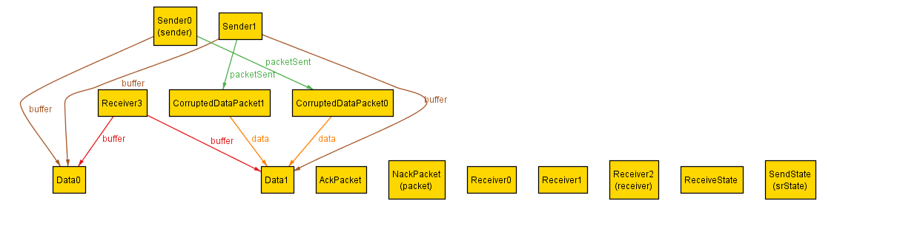

Step 3: The sender sends another CorruptedDataPacket, and this process will continue indefinitely since the sender can always send more corrupted packets and make no progress.

