Suii 3D vision

This doc contains the graphs to onderstand the 3D vision designed for Suii and know points of future improvement. Further explanation of the functions are written in comments within the code.
This code can be used for item picking from tables, straight and shelfs.

ROS2 communication
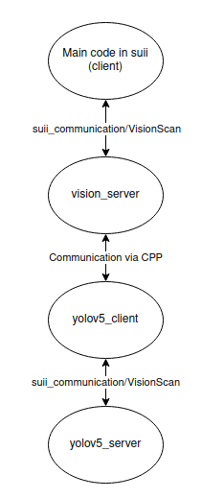

Class diagram
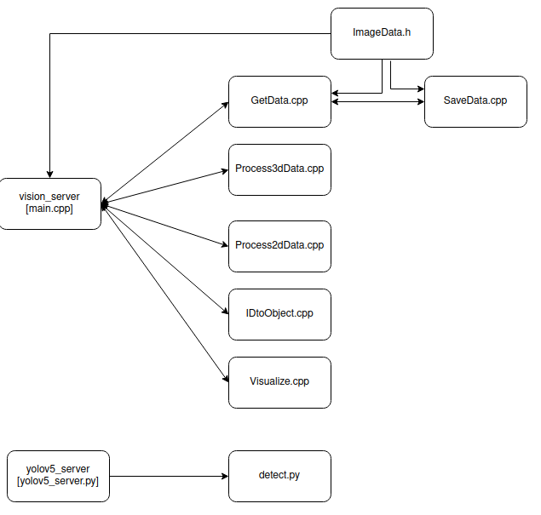

Improvement points

General:
- Research for a new camera.
  - Test with new camera
  - Test with all objects
- Increase speed of software if necessary
- Develop software to handle buckets
- Develop software to handle clusters
- Develop software for moving objects

GetData::CreateData
- Check with new camera of it is still necesarry to get 30 frames. Reduce as much as possible.
- We created a CV image from a PCD. This is done because we were not able to match the CV image pixels with the generated PCD. Check if this is still necessary with a new camera.

GetData::LoadData
- Make this code less hardoced to easier load test data

Process2dData
- Currently not used. All data is processed in 3D. 2D image processing is faster. Could be interesting to see what is possible here.

IdtoObject::ConvertIDtoObject
- Match ID & names with the rest of the Suii code

Visualize::color_changer
- Make flexible to handle unlimited number of clouds.

Visualize::visualizePCL
- Hangs when run code more than once. CTRL + C is necessary to stop script and restart code. Should be fixed to make visualization easier.

Yolov5
- Train with full data set
- Train with ID’s as used in Suii main code && IdtoObject::ConvertIDtoObject

