M-Path

Exercise bundle

*Version 3*

Contents

Preface 2

1. Creating questionnaires utilizing different unique question types 3

2. Using the library: loading and editing interactions from the library 6

3. Scheduling interactions 7

4. Adjusting personal settings and utilizing intake interactions and baseline settings 9

5. Extracting data 10

6. Creating applets 11

7. Skill test: combination exercise 13

8. Bonus exercises 14

# Preface

This document is made for individuals who have viewed the [introduction video](https://www.youtube.com/watch?v=9cYrZdXYfpA) to using m-Path. In this document, you find a set of exercises that will help you get familiarized with the platform. The original purpose of the platform is to allow for clinical use of Experience Sampling Methods (ESM). However, you may also use it to for instance digitalize existing paper and pencil methods (e.g. create an applet for psychoeducation, see section 6), or create complex tasks (e.g. picture rating tasks, see exercise 1.6).

If you are considering to use m-Path for clinical purposes, such as clinical use of ESM, we highly recommend you to get in touch with one of our team members. We will gladly provide you with support and guidance. You can do this by sending an email to [buildingbridges@kuleuven.be](mailto:buildingbridges@kuleuven.be)

Requirements

* m-Path account
  + Can be created at [https://m-path.io](https://m-path.io/)
* Smartphone or emulator with m-Path installed
  + Mobile operating systems: Android Jelly Bean, v16, 4.1. x or newer, and iOS 8 or newer. (as of 23/09/2020)
  + Suggested emulator: BlueStacks
* Internet access
  + WiFi/2g/3g/4g/5g

Citation

If you wish to cite this document, please use the citation below.

KULeuven (2020). *m-Path: Exercise bundle – Version 3.* Retrieved from URL.

# 1. Creating questionnaires utilizing different unique question types

Exercise 1.1

* Create a questionnaire that displays to you a text item that says ‘hello world!’.
* Test this on your own phone.

*Tip: have a look at the media items*

Solution: <https://www.youtube.com/watch?v=FIDRrYZd9po>

Exercise 1.2

* Create a questionnaire that contains the following item
  + I feel lonely
    - rated on a scale from 1 (not at all) to 7 (very much so)
    - item label = NA_lonely
* Copy the item and change its content to
  + I feel relaxed
    - rated on a scale from 1 (not at all) to 7 (very much so)
    - item label = PA_relaxed
* Test the questionnaire on your phone

*Tip: pay attention to the item label after you copied the first item*

Solution: <https://www.youtube.com/watch?v=aZr7IZ16MOU>

Exercise 1.3

* Try and create a questionnaire in m-Path that consists of the following item:
  + What are you doing?
    - Participant can pick 1 of 7 options, you are free to choose the content of these answer options
* Do not allow items to be visualized in the app
* Test the questionnaire on your phone

*Tip: check the advanced settings of items you make*

Solution: <https://www.youtube.com/watch?v=dBysHc9IphM>

Exercise 1.4

* Create a container that contains the following items
  + I feel cheerful
    - rated on a scale from 1 (not at all) to 7 (very much so)
    - label = PA_cheerful
  + I feel relaxed
    - rated on a scale from 1 (not at all) to 7 (very much so)
    - label = PA_relaxed
  + I feel satisfied
    - rated on a scale from 1 (not at all) to 7 (very much so)
    - label = PA_satisfied
* Make it so that, if you send yourself a notification, you only ever get displayed 1 of these items
* Curate the container so that it says ‘item pool’, also add a description

*Tip1: check the advanced settings of a container item   
Tip2: for viewing a curated item you need to be in curated view*

Solution: <https://www.youtube.com/watch?v=62Kq-xACtzE>

Exercise 1.5

* Try and display all items of exercise 1.4 on one page inside the app, it should look like this:

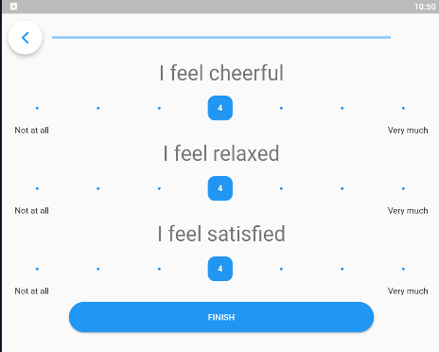

*Tip: container item, advanced options*

Solution: <https://www.youtube.com/watch?v=Mkm5J76I1ow>

Exercise 1.6

* Try and recreate the following two windows (you are free to choose your own content):

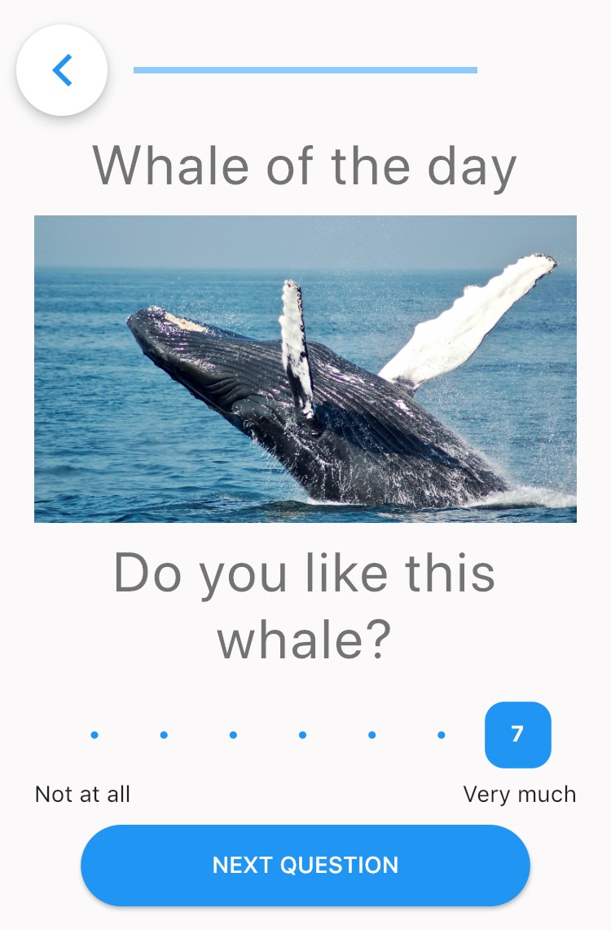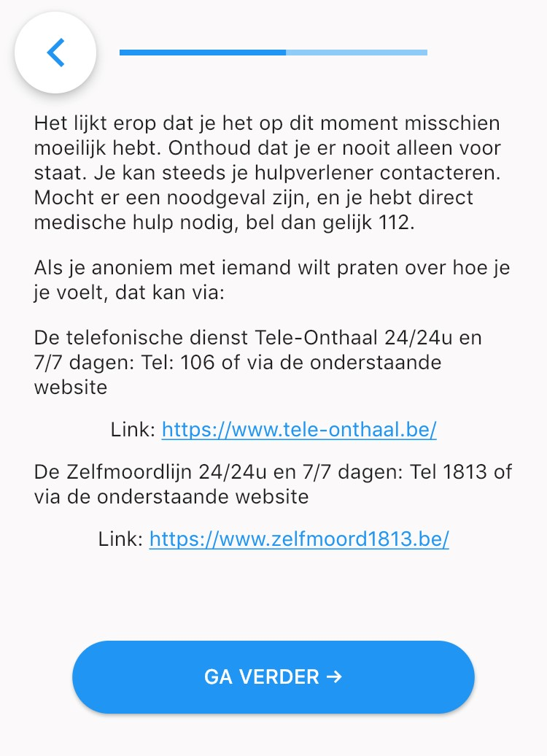

*Tip1: try to reverse engineer what you see (i.e. what does the image consist of?)*

*Tip2: container, advanced options, formatted text*

Solution: <https://www.youtube.com/watch?v=2SEyhLFxggU>

Exercise 1.7

* Save one of the interactions you have made to your library

*Tip:* Using the library: loading and editing interactions from the library

# 2. Using the library: loading and editing interactions from the library

Exercise 2.1

* Load the following interaction from the library:
  + IMPROVE package*
* Test the interaction on your phone

*Tip: use the search bar to find interactions for which you know the name*

*The IMPROVE package is a clinical questionnaire package that was jointly created by the Centre for Contextual Psychiatry (KULeuven) and research group for Quantitative Psychology and Individual Differences (KULeuven). It contains a basic ESM questionnaire as well as add-on modules for measuring symptomatology and more. Additional add-on modules are being developed. For inquiries email [buildingbridges@kuleuven.be](mailto:buildingbridges@kuleuven.be)

Solution: <https://www.youtube.com/watch?v=8Jz5vF30m4U>

Exercise 2.2

* Go into the library and try to edit and overwrite an interaction from another user

***Tip: you will not be able to***

Solution: <https://www.youtube.com/watch?v=_gNhDy1ucEA>

Exercise 2.3

* Go into the library and try to edit the interaction you saved in exercise 1.7:
  + Add another item:
    - How are you doing? (open-ended question)
* Load the interaction you just edited to your user account and test it

*Tip: in the library look for the paper and pencil icon*

Solution: <https://www.youtube.com/watch?v=sgMVU5hbH4M>

Exercise 2.4 (duo exercise)

* Make your saved interaction available to others, ask a colleague to load it in.
* Load in an interaction made by one of your colleagues

*Tip: have a look at the different columns in the library*

Solution: <https://www.youtube.com/watch?v=Lyo6mpSzHxE>

# 3. Scheduling interactions

Exercise 3.1

* Load in a questionnaire
* Schedule a notification to occur 2 minutes from the current time* (do not forget to save!)

*it may take up to 5 minutes for a notification to arrive, this will mainly occur when you have bad connectivity/have your phone in battery saving mode.

*Tip: after clicking in the schedule, click the box again to open the ‘beep properties’*

Solution: <https://www.youtube.com/watch?v=okdtLJe-mpY>

Exercise 3.2

* Randomize a notification (i.e. that it occurs randomly within a block that you create), without opening the ‘beep properties’ window

*Tip: you will need to click on a line*

Solution: <https://www.youtube.com/watch?v=YNg3lgDRzco>

Exercise 3.3

* Load in a second questionnaire
* Create a notification for questionnaire one, afterwards alter this notification to be for questionnaire two.

*Tip: open the ‘beep properties’ window*

Solution: <https://www.youtube.com/watch?v=IhmTDE5_a4E>

Excerise 3.4

* Open the ‘beep properties window’
* In the ‘beep properties window’ you see various options:
  + One time answer
  + Set reminder
  + Install as button
  + Set expiration
  + When creating a baseline schedule, this interaction should be planned at
    - This specific day
    - This day, relative to the starting date
    - The next day of this type (1st Monday, 3rd Tuesday, …), relative to starting date
* Try to figure out what each of these options do. Compare your answers with a colleague.

Solution: <https://www.youtube.com/watch?v=hDbr_BlRJyA>

Exercise 3.5

* Try various fill options
  + Fill with 5 notifications a day for 12 days 🡪 clear schedule
  + Fill with 7 notifications a day for 9 days 🡪 clear schedule
  + Fill with 10 notifications a day for 6 days 🡪 clear schedule
  + Fill morning notification for 6 days 🡪 clear schedule
  + Fill evening notification for 6 days 🡪 clear schedule
* Repeat the exercise above, but now try and schedule using different starting days

Solution: <https://www.youtube.com/watch?v=cgwZtSP_JTw>

Exercise 3.6

* Manually create a schedule for one day:
  + One notification at 9:00
  + One notification at 13:00
  + One notification at 18:00
  + One notification occurring between 9:00 and 13:00
  + One notification occurring between 13:00 and 18:00
* Copy the schedule of this day for 5 days (do not do this by manually planning in each beep)
* Make the planned 6 days schedule repeat for another two weeks

*Tip: open the ‘add to schedule window’ (i.e. the window you have used for filling in exercise 3.5) and go to extend last day/week*

Solution: <https://www.youtube.com/watch?v=BFwwZZXhnWY>

# 4. Adjusting personal settings and utilizing intake interactions and baseline settings

Exercise 4.1

* Navigate to the personal settings menu
* Modify your name
* Click on save

Solution: <https://www.youtube.com/watch?v=4zyMq4aY8xs>

Exercise 4.2

* Plan in a simple intake*:
  + Select: ‘ESM demo’ as your intake questionnaire
* Re-install m-Path and add yourself as a client

*You can also install applets using this feature, this will come back in section 6!

Solution: <https://www.youtube.com/watch?v=USRTp9TyuNQ>

Exercise 4.3

* After re-installing, you will need to change your test device. Try to do this in the personal settings menu.

Solution: <https://www.youtube.com/watch?v=fZdYHi1iRDM>

Exercise 4.4

* Create a simple baseline:
  + Interaction = ESM demo
  + Baseline = 5 notifications per day
  + Check the ‘start baseline schedule automatically when a client adds me’
* Enroll a new participant and check if your baseline was scheduled in

Solution: <https://www.youtube.com/watch?v=rELJ8nwvS4k>

Exercise 4.5

* Set your baseline to match that of a template client*

*This feature may not be available to you if you do not have access to a template client. To get access to a template client, send an email to [buildingbridges@kuleuven.be](mailto:buildingbridges@kuleuven.be)

Solution: <https://www.youtube.com/watch?v=YMnf9upzoc8>

# 5. Extracting data

Exercise 5.1

* Extract data of yourself
* Extract data of all participants registered to your account

NOTE1: to extract data you will need to have filled out notifications.   
NOTE2: extracting data of all participants may not be accessible to your account, to inquire about the extract all feature, send an email to [buildingbridges@kuleuven.be](mailto:buildingbridges@kuleuven.be)

*Tip1: extracting data from single individual? Use the visualize tab  
Tip2: extracting data from multiple individuals? Use the personal settings tab*

Solution: <https://www.youtube.com/watch?v=6LXfbZ5bODA>

Exercise 5.2

* Inspect your data output and see if you understand each column and row
* Ask your tutor for more information if anything is unclear

Solution: <https://www.youtube.com/watch?v=aIBCL756NF4>

# 6. Creating applets

NOTE: please only start with the exercises of this section after you have successfully completed all exercises of sections 1 to 4. Creating applets is an advanced feature of m-Path that requires thorough knowledge of the platform.

Excerise 6.1

* Create an applet that contains a home screen with:
  + 1 main button with a picture
  + 1 divider line
  + X smaller buttons, in rows of 2
* You are completely free to decide what the content of your applet will be. An example of a home screen that meets above requirements is provided below.

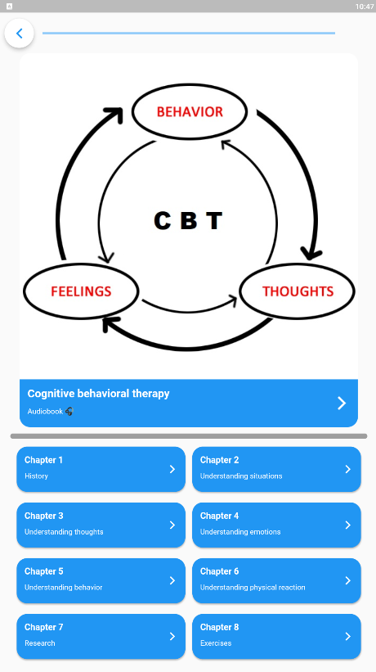

*Tip: containers inside of containers*

Solution: <https://www.youtube.com/watch?v=XI_MWJI6Z9I>

Excersie 6.2

* Going into the applet: content of different windows
  + Add content for one of the buttons in exercise 6.1. (e.g. a video)
  + Make the applet exit to the default m-Path display after pressing the ‘next’ button
  + Customize the next button to say ‘return to home’

*Tip: have a look at the description of various ‘advanced’ items*

Solution: <https://www.youtube.com/watch?v=LI-lsX2z-Yk>

Exercise 6.3

* Making the applet install when participants add you as a researcher, give the applet the title ‘demo applet’

*Tip: think back to an exercise you made earlier!*

Solution: <https://www.youtube.com/watch?v=E70rgTcpLq8>

# 7. Skill test: combination exercise

In this exercise, we will be combining skills learned from some of the exercises you have made so far. By completing this exercise, you will have completed this course. Some bonus exercises are provided in section 8.

Exercise 7.1 - The combination exercise:

What we will create is a study template* that contains:

1. An applet with a morning and evening questionnaire.
2. An ESM questionnaire, scheduled 10 times per day for 6 days
   1. Use containers for item groups (e.g. affect items) and randomize item presentation for or more item containers to decrease repetitiveness of the questionnaire
3. A questionnaire that acts a reminder notification for the morning and evening questionnaire
4. A demo ESM questionnaire that allows clients/participants to get familiarized with the method
5. Curate your applet and questionnaires so that your template can easily and intuitively be used by other researchers
6. OPTIONAL: add a home button for event-contingent sampling

Further we ask you to:

1. Store all elements of your template in the library (i.e. applet, ESM questionnaire, home button content).
2. Choose whether to make the created content available to others.
3. Make it so that when people add you as a clinician/researcher the applet is instantly installed.
4. Make it so that when people add you as a clinician/researcher the ESM schedule + reminders are loaded in on enrollment and start the next day

*This template follows the format of a typical ESM study. We encourage you to try and complete point 1, 2 and 6 of this exercise with your own ESM content.

*Tip1: For ESM content, have a look at the online ESM repository* <https://www.esmitemrepository.com/>

*Tip2: Shorter questionnaires and visual feedback are better for participant compliance!*

Solution:

NOTE: If you do not have access to a study template, you can alternative make the above for a single client/participant.

# 8. Bonus exercises

The exercises below are considered difficult. Try these if you are up for a challenge! No tips are provided. Solutions are available upon request ([buildingbridges@kuleuven.be](mailto:buildingbridges@kuleuven.be))

Exercise 8.1

1. We have 3 stimulus pools, each contains 2 pictures. Each picture in this stimulus pool has a paired stimulus, which is the inverse of that picture. You can find the stimulus pools [here](https://github.com/JeroenDMW/mPathExercises).
2. We want to make a questionnaire which randomly selects one picture out of the 3 stimulus pools.
3. We want the selected picture to be presented together with a Likert scale question that ranges from 1 to 7. We want the data output on this scale to be unique depending on which picture is selected.
4. After presenting the selected picture we want to have the app present the paired inverse picture, with again the same Likert scale question underneath but with output being unique.
5. Make it so that the presentation order can be either picture -> inverse or inverse -> picture

Sketch of app display provided below, arrows indicate bidirectional order of presentation

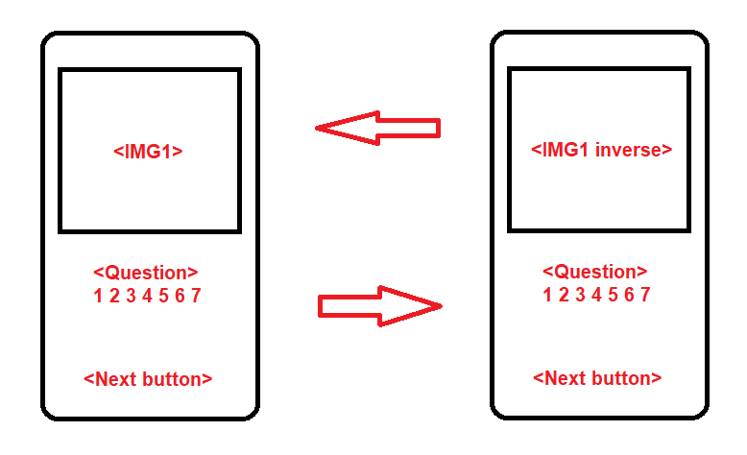

Exercise 8.2

1. create two items:

* ‘I like this company’
  + rated on a scale from 1 (not at all) to 7 (very much so)
  + label = item_like_company
* ‘I would rather be alone’
  + Rated on a scale from 1 (not at all) to 7 (very much so)
  + label = item_rather_alone

1. We want to calculate a composite value based on these two items
2. One item needs to be reverse coded
3. We want to scale the answer so it is neatly displayed on the standard 0 to 100 scale

* Create an item that calculates the mean of the two items above, of which one item needs to reverse coded in your calculation. Finally, scale this answer so that it is neatly displayed on the standard 0 to 100 scale in the visualization tab.