**IP Mobility support for IPv4, revised**

**Abstract**

* Transparent routing of IP datagrams to mobile nodes
* Mobile nodes(MN) 🡪 identified by home address
  + Away from home 🡪 care of address (COA)
* Home Agent (HA)
  + Sends datagrams destined for MN through tunnel to the COA.

1. **Introduction**

A node ‘s IP address 🡪 uniquely identifies its attachment to the internet.

Mobile IP = way to provide node mobility while keeping the node’s IP address

* 1. **Protocol requirements**
* MN must be able to keep communicating while changing its link-layer attachment point to the internet 🡪 no change of MN’s IP address
* No protocol enhancements are needed
* All messages relating updates of the location of a MN must be authenticated (not required for this project)
  1. **Goals**
* Number of administrative messages (sent over a possible wireless link which connects the MN) must be kept to a minimum
* Message size must be as small as possible
  1. **Assumptions**
* Assignment of the MN’s IP address is not constraint by this RFC
* MN will not change their attachment point to the Internet more than once per second
* IP unicast datagrams are routed based on the DEST address in the datagram header (aka not by the SRC address)
  1. **Applicability**
* Mobile IP 🡪 enables nodes to move from one IP subnet to another, Ethernet segment to wireless LAN etc.

🡺 **MN’s IP address must be the same after the movement**

* Mobile IP 🡪 solves macro mobility management
  1. **New architectural entities**
* Mobile node (MN)
  + Host/router that changes it point of attachment from 1 network/subnetwork to another
  + Can change location without changing its IP address
  + Continues communication at different locations using its CONSTANT IP address
* Home agent (HA)
  + Router of the MN’s home network
  + Tunnels datagrams for delivery to the MN (when the MN is not @ home)
  + Maintains current location information of the MN
* Foreign agent (FA)
  + Router of the MN’s visited network
  + Provides routing services when the MN is registered
  + Detunnels and delivers the MN’s datagrams (which were sent through the tunnel coming from the MN’s HA)
  + When MN sends a datagram 🡪 FA functions as default router for the registered MN’s.

MN

🡪 has a long term IP address (given by home network)

🡪 administered same as a permanent IP address provided to a stationary host

🡪 if MN is away from home 🡺 care of address (COA)

🡪 uses its home address as SRC address for **all** sent IP datagrams, except for certain mobility management functions (see section 3.6.1.1)

COA is associated with a MN, reflects MN’s current point of attachment­

* 1. **Terminology**

key words like MUST, SHOULD etc. 🡺 see RFC 2119

* Agent advertisement
  + - Constructed by adding an extension to the Router Advertisement message (see RFC 1256)
* Authentication
  + - The verification of the identity of the originator of the message
    - Not required for this project
* Care-of address (COA)
  + - Tunnel termination point towards the MN, datagrams which were forwarded when MN is away from home
    - 2 types:
      * FA care-of address:
        + Address of the current FA with which the MN is currently registered
      * Co-located care-of address:
        + Externally obtained local address
        + Not required for this project
* Correspondent Node (CN)
  + - Peer with which the MN communicates
    - Mobile / stationary
* Foreign network
  + - Any network which is not the MN’s home network
* ~~Gratuitous ARP~~
  + - ~~ARP packet sent by a node in order to update other nodes their ARP caches 🡪 see section 4.6~~
    - ~~Not required for the project~~
* Home address
  + - IP address which is assigned to the MN for an extended period of time
    - **Remains unchanged regardless the MN’s current location**
* Home network
  + - Network (possibly virtual) with the same network prefix as the MN’s home address
    - Standard IP routing mechanisms will deliver datagrams (with destination the MN) to the MN’s home network
* Link
  + - Facility/medium which enables node communication @ link layer
    - Under the network layer
* Link layer address
  + - Identifies an endpoint of some communication over a physical link
    - Typically an interface’s MAC address
* Mobility agent
  + - Home agent OR foreign agent
* Mobility binding
  + - Association of a home address with the COA
    - Also contains the remaining lifetime of that binding
* Node
  + - Host OR router
* Nonce
  + - Random chosen value
    - Different from previous choices
    - Inserted in a message
* Tunnel
  + - The followed path of an encapsulated datagram
    - Datagram is routed to a decapsulator 🡺 decapsulation + delivered to the correct destination
* Virtual network
  + - No physical instantiation beyond a router
    - Router (HA) advertises reachability to the virtual network using conventional routing protocols
* Visited network
  + - Network different than the home network
    - Currently connected to the MN
* Visitor list
  + - List of the FA’s currently visiting MN’s
  1. **Protocol overview**

Agent discovery

HA and FA 🡪 advertise their availability on each service link

MN can ask for prospective agents with a **solicitation message**

Registration

MN is away 🡪 registers its COA with the HA

Depending the attachment method this registration can occur in 2 ways:

1. Directly with the HA
2. Via a FA which forwards the message to the HA

Silently discard

Implementation

- Discards the datagram without further processing

- Should provide logging capabilities

- Record event in a statistics counter

**Mobile IP operations steps**

* HA and FA advertise their presence with Agent Advertisement messages (AAM, see section 2), MN can solicit (on any locally attached mobility agent) such messages with an Agent Solicitation message
* MN receives these AAM 🡪 determine if its home or a foreign network
* MN = home 🡪 operate without mobility services

MN = returning home ,after being registered on a foreign network 🡪 Deregister with HA using an exchange of a Registration request and reply

* MN detects it’s has moved to a foreign network 🡪 receives COA on the foreign network. This COA = determined from FA’s advertisements (foreign COA) or collocated COA (not required)
* MN (away from home) 🡪 registers new COA with HA 🡪 registration request – reply exchange with HA (via FA, section 3)
* Datagrams sent to the MN’s home address 🡪 received by the HA 🡪 tunneled by the HA to the MN’s COA, received at the tunnel end (or the MN itself) 🡪 delivered to the MN
* Reverse direction 🡪 MN sends the datagrams through normal IP routing mechanisms (not necessarily through HA)

Mobile IP uses tunneling (conventional IP routing), the tunnel end @ the MN’s COA. COA 🡪 detunnels the datagram 🡪delivered to the MN

Two ways to acquire a COA:

1. Foreign agent COA

🡪 provided through agent advertisement messages

🡪 COA = FA’s IP address

🡪 FA = tunnel end point, decapsulates tunneled datagrams + sends the inner datagrams to the MN

1. Co-located COA

🡪 not required for this project

Difference between FA and COA, COA = the FA’s IP address (in case 1) and the FA = a mobility agent which provides services to MN’s

MN and FA must be able to communicate without relying on standard IP routing mechanisms.

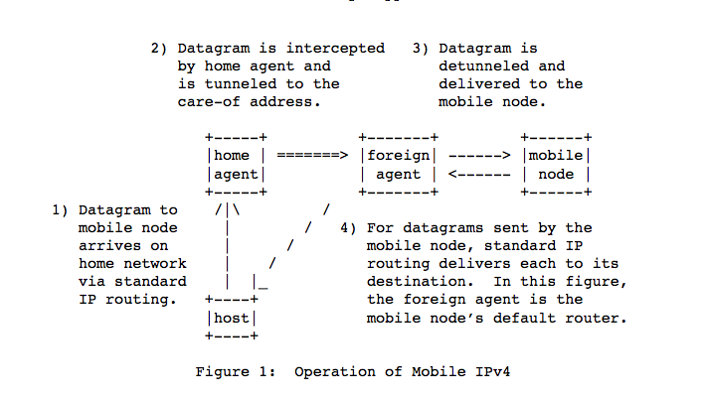

figure 1 = situation after MN has registered with its HA

host = Correspondent node

* 1. **Message format and protocol extensibility**

Control messages 🡪 sent with UDP, port 434

2 message types:

1. Registration request

3- Registration reply

Agent discovery messages (see RFC 1256):

- Router advertisement

- Router solicitation

General extension mechanism 🡪 allows optional info carried by Mobile IP and ICMP router discovery messages 🡪 see section 1.9

End of extension list 🡪 indicated by the total length of the IP datagram

2 separately maintained sets of numbering spaces:

1) Extensions that may appear in Mobile IP control messages (sent to and from UDP 434)

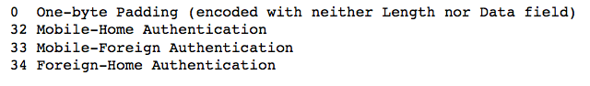

2) Extensions that may appear in ICMP router discovery messages

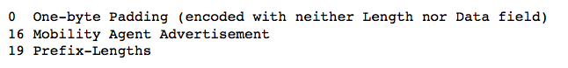

Extension numbered in either of the 2 above set (range 0-127) is encountered but not recognized 🡪 message containing that extension 🡪 discarded

Extension with range (128-255) is encountered but not recognized 🡪 that extension is ignored but the rest of the extensions and the message MUST be processed

Length field of the extension is used to skip the data field in order to find the next extension.

🡺 extensions are aggregated

3 distinct structures for Mobile IP extensions:

1) Simple extension format

2) Long extension format

3) Short extension format

* 1. **Type-length-value extension format for Mobile IP extensions**

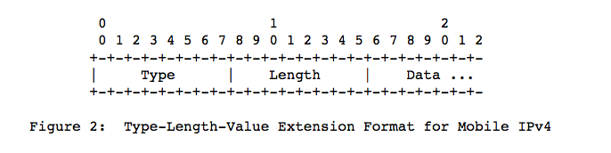

🡪 not the most efficient use of the extension type space

Type = type of the extension

Length = length in bytes of the data field, not including the type and length part

Data = can be 0 or more bytes, its format and length is determined by the length and type part

* 1. **Long extension format**

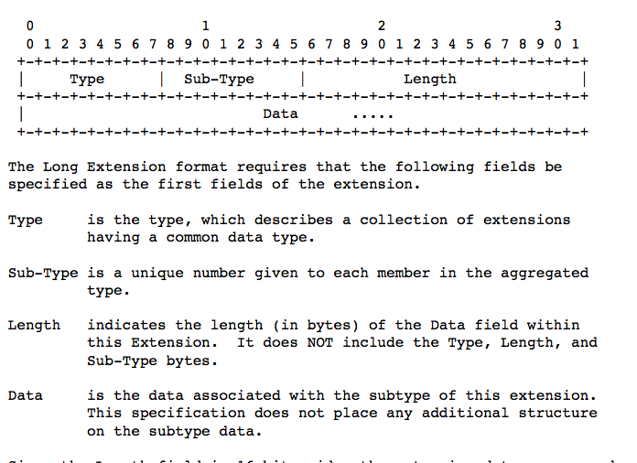

For not-skippable extensions with information > 256 bytes

* 1. **Short extension format**

For skippable extensions with information <= 256 bytes

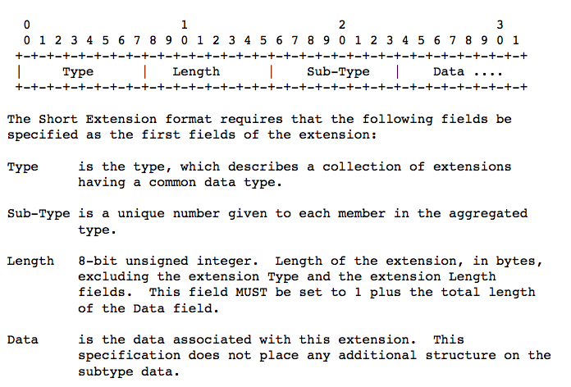

1. **Agent discovery**

This method allows the MN to determine if he is connected to its home network or a foreign network + if it has moved from one network to another

MN (connected to foreign network), method of this section determine the offered FA’s COA by each FA on the foreign network

Agent advertisement

= ICMP router advertisement message + Mobility agent advertisement extension

Agent solicitation

= ICMP router solicitation with TTL = 1

* 1. **Agent advertisement(AA)**

Agent advertisement

Transmitted by mobility agents

ICMP router advertisement that has been extended to carry a mobility agent advertisement extension (see 2.1.1)

MN 🡪 use AA to determine current attachment to the Internet

ICMP router advertisement fields of the message must be set as follows:

Link layer fields:

Destination address

In case of unicast AA 🡺 DEST = SRC link layer address of the agent solicitation that prompted the advertisement

IP fields:

TTL = 1 (for all advertisements)

DEST = 255.255.255.255 (for all multicast agent advertisements)

[DEST = IP home address of the MN (unicast agent advertisement)]

ICMP fields:

Code = 0 OR 16

0: Mobility agents is also a router for IP traffic not relating to MN (common traffic)

16: No common traffic routing

Lifetime

Max length of time that the advertisement is considered valid

Router addresses

See section 2.3.1

Num addrs

Number of router addresses advertised in this message

AA message 🡪 num addrs may be set to 0, see section 2.3.1

Periodically 🡺nominal interval AA are sent = max 1/3 advertisement life (ICMP header) + randomized != registration lifetime (mobility agent advertisement extension)

**2.1.2 Mobility agent advertisement extension**

MAAE 🡪 follows the ICMP router advertisement fields

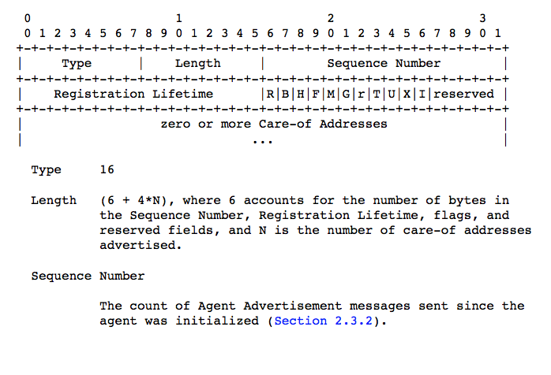

Registration lifetime (seconds)

longest lifetime an agent will accept in a registration request

0xffff == infinity

No relation to the lifetime field of ICMP advertisement

R

Registration required (only with FA)

B

Busy, FA will not accept incoming registration request

H

Home agent, the agent offers service as a HA on the link on which the AA is sent

F

Foreign agent, the agent offers service as a FA on the link on which the AA is sent

M

Minimal encapsulation, this agent implements receiving datagrams with minimal encapsulation

G

Generic encapsulation

r

sent as 0, ignored on reception

T

FA supports reverse tunneling

U

Mobility agent supports UDP tunneling

X

Mobility agents supports Registration revocation

I

FA supports regional registration

reserved

sent as 0, ignored on reception

CAO

CAO address provided by the FA. AA must include 1 CAO if the F bit is set

AA message can’t have bot F = 1 and B = 1.

AA message must have at least F = 1 or H = 1 set in any message

FA wishes to require registration 🡺 set R bit to 1

Agent must not set R to 1 unless F bit = 1

* 1. **Agent solicitation**

🡪 identical to ICMP router solicitation with TTL = 1

* 1. **FA and HA considerations**

Advertisements need not to be sent, except when the R bit is 1 or as a response a specific agent solicitation.

All MA must process packets with DEST 255.255.255.255 + should respond to these solicitations.

All defaults for advertisement and solicitations are the same as ICMP router advertisements except:

-) MA must limit the rate of broadcast and multicast AA.

-) MA that receives a router solicitation must not require that the IP address is a neighboring address

Home network = not a virtual network

Any AA sent by the HA 🡺 sent with bit H = 1

MA can use different combinations of R, H, F bits

Home network = virtual network

All MN are always treated as away from home

* + 1. **Advertised router addresses**

ICMP router advertisement part of the AA may contain 1 or more router addresses

Agent should only put his own addresses there

FA must route datagrams must route datagrams it receives from registered MN’s

* + 1. **Sequence numbers and rollover handling**

range:0-0xffff

Agent must use 0 for its first advertisement

Subsequent advertisement 🡪 sequence number + 1

*?Each subsequent advertisement MUST use the sequence*

*number one greater, with the exception that the sequence number 0xffff MUST be followed by sequence number 256. In this way, mobile nodes can distinguish a reduction in the sequence number that occurs after a reboot from a reduction that results in rollover of the sequence number after it attains the value 0xffff.?*

* 1. **MN considerations**

MN must process incoming advertisements

More than 1 advertised address 🡪 pick the first

if it is rejected 🡪 use the next advertised address

When multiple methods of agent discovery are in place 🡪 MN should first attempt the registration with agents including MAA extension in their messages.

MN 🡪 ignore reserved bits in AA, DON’t discard!

* + 1. **Registration required**

MN receives AA with R = 1 🡪 register with this FA

* + 1. **Move detection**

When MN’s detects it has moved 🡪 should register (see section 3) with a suitable COA on the foreign network (But no more than once a second)

* + - 1. **Algorithm 1**

🡪 based upon lifetime field of the ICMP router advertisement of the AA

MN 🡪 records lifetime received in received AA, until that expires

MN doesn’t receive another AA from that agent in the specified lifetime 🡪 assume it has lost contact

If MN has received AA from other agent which lifetime is not yet expired 🡪 attempt registration with that agent

otherwise 🡪 attempt discovery of new agent

* + 1. **Returning home**

MN 🡪 detects it is home when receiving AA of the HA

if so 🡪 deregister with HA (section 3)

Before deregistering 🡪 MN should configure its home network(section 4.2.1)

* + 1. **Sequence numbers and rollover**

MN 🡪 detects 2 successive values of the sequence number in the AA from the FA (to which it is registered)

1. the second seq number (and range 0-255) < the first seq number 🡺 MN registers again
2. Second seq number (>=256)< the first seq number:

rolled over the max val (0xffff) 🡺 don’t re-register

1. **Registration**

Mobile IP registration 🡪 enables MN to:

* request forwarding services (MN visiting foreign network)
* Inform HA of the current COA
* Renew an expiring registration
* deregister when returning home

Registration creates/modifies a mobility binding @ the HA, associating the MN’s home address with its COA for a specified lifetime

Other capabilities thanks to registration:

* Discover home address
* multiple simultaneous registrations (not required)
* deregister specific COA
* discover HA’s address
  1. **Registration overview**

🡺 2 registration procedures (one with the FA that relays it to the HA, one with the HA)

* If MN registers via a FA’s COA 🡪 MN must register via FA
* MN using collocated COA 🡪 not required for this project
* If MN returned to home network + (de) registering with HA 🡪 MN must register directly with the HA

Both procedures require exchange of registration request-reply messages:

Registering via FA 🡺 4 messages

* MN sends reg request to the FA
* FA processes it and relays it to the HA
* HA sends reg reply to the FA (grant-deny)
* FA processes the reg reply and relays it to the MN

Registering directly with the HA 🡺 2 messages

* MN sends req request to the HA
* HA sends req reply to the MN (grant-deny)

Registration request and reply messages 🡺 UDP

nonzero UDP checksum 🡪 must be checked by recipient

zero UDP checksum 🡪 should be accepted by the recipient

* 1. **Registration request**

MN registers with HA using a registration request (HA will then create/modify the mobility binding for that MN)

IP fields (see sections 3.6.1.1 and 3.7.2.2)

SRC address

Interface from which the message is sent

DEST address

Address of FA or HA

UDP fields

SRC port 🡪 variable

DEST port 🡪 434

UDP header

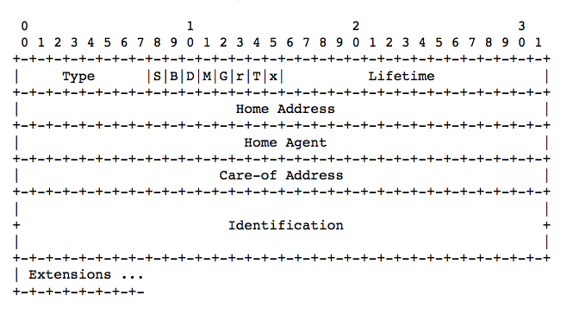

Type = 1

S = simultaneous binding (not required)

B = broadcast datagrams, if B = 1 🡪MN requires HA to forward all incoming datagrams (see section 4.3)

D = decapsulation by MN, if D = 1 using collocated COA (not required)

M = minimal encapsulation, if M = 1 🡪 HA must use minimal encap

G = GRE encap, if G = 1🡪 HA must use GRE encap

r = sent as 0, ignored on reception

T = reverse tunneling

x = sent as 0, ignored on reception

Lifetime = number of seconds before registration expires

= 0 (request for deregistration)

= 0xffff (infinite lifetime)

Home address = IP address of MN

HA = IP address of MN’s HA

COA = IP address of tunnel endpoint

Identification = 64bit number (constructed by MN), used for matching registration request with their replies

Extensions = not required

* 1. **Registration reply**

Mobility agent returns a registration reply to a MN which has sent and registration request (if MN is away from home, reply is sent to the FA, FA then relays it to the MN), reply contains information (lifetime which may be smaller than lifetime in the request itself)

if lifetime in reply > lifetime in request 🡺 MN uses request lifetime

if lifetime reply < lifetime request 🡺 MN uses reply lifetime

IP fields

SRC address = DEST address of the incoming registration request

DEST address = SRC address of the incoming registration request

🡪 see sections 3.7.2.3 and 3.8.3.2

UDP fields

SRC port = copied from UDP DEST port of corresponding registration request

DEST port = copied from UDP SRC port of corresponding registration request (section 3.7.1)

UDP header

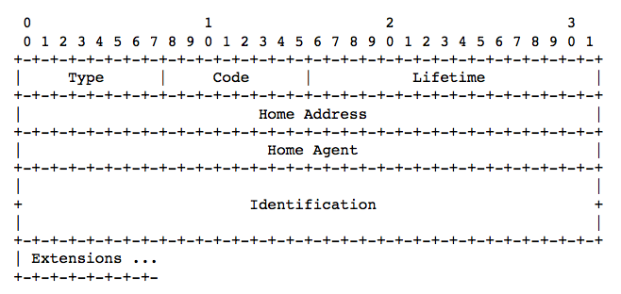

Type = 3

Code = value indicating result of the request, see further

Lifetime = if code field indicates registration was accepted, this field will contain number of seconds before expiration

= 0 🡪 MN has been deregistered

= 0xffff 🡪 infinite

if code indicates the request was denied 🡪 ignore lifetime field

Home address = IP address MN

HA = IP address of MN’s HA

Identification = 64bit number (based on registration request sent by MN) used for matching registration request with their replies

Extensions = not required

Values of code field

Registration successful:

0 🡪 registration accepted

1 🡪 reg accepted, but no simultaneous bindings allowed

Registration denied by FA:

(the yellow marked codes MUST be supported at least)

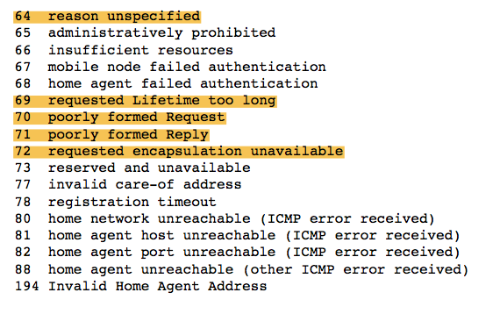

Registration denied by HA:

(the yellow marked codes MUST be supported at least)

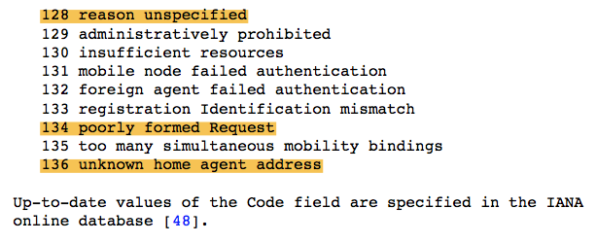

* 1. **Not required**
  2. **MN considerations**

MN must be configured with network mask (static or dynamic)

MN = configured with valid IP address (given in the project)

For each pending registrations, MN maintains the following data:

* Link layer address (of FA) on which the req was sent
* COA used in the reg
* Identification value of req
* Originally requested lifetime
* remaining lifetime of the pending registration

MN should initiate registration whenever it detects network activity change (detection methods 🡪 see section 2.4.2)

MN (away from home) 🡪MN’s registration request allows HA to create-modify MN’s mobility binding

MN (@ home) 🡪MN’s (de)registration request allows HA delete MN’s previous mobility bindings

MN should (re)register with FA when it has detected that FA has rebooted (section 2.4.4) + when the current registration lifetime is almost expiring

AA of new agents should not cause a new registration by the MN (if the current registration is not expiring and MN still receives AA from the current FA to which it is registered), MN must not attempt to register more than once per second

??~~A mobile node MAY register with a different agent when transport-layer protocols indicate excessive retransmissions. A mobile node MUST NOT consider reception of an ICMP Redirect from a foreign agent that is currently providing service to it as reason to register with~~

~~a new foreign agent. Within these constraints, the mobile node MAY register again at any time.~~

See appendix C for examples of registration messages

* + 1. **Sending registration requests**
       1. **IP fields**

IP SRC address

= care-of address (when MN registers with collocated COA)

= 0.0.0.0 (MN has no home address)

= MN’s home address (all other cases)

IP DEST address

= 255.255.255.255 (MN doesn’t know the agents IP address)

= IP SRC address of the incoming AA (MN registering with FA) + MN must use the link layer SRC address copied from the received AA

= IP address HA (if MN is registering directly with HA)

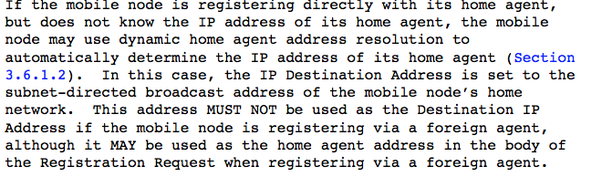

IP TTL

= 1 (if IP DEST == 255.255.255.255)

= suitable value (other cases)

* + - 1. **Registration request fields**

No support needed for simultaneous bindings!!

D bit = 0(for this project)

B bit = 1(if MN wants to receive broadcast datagrams when he is away)

if D = 1 (not relevant I think, check RFC page 45)

Alternative forms of encapsulation by setting the G/M bits (if MN is using a collocated COA or if FA has indicated it in the Mobility AA extension of the AA message), otherwise G = 0 and M = 0

Lifetime field

1. MN registers with FA 🡪 lifetime < registration lifetime field of AA message (sent by FA)

If method of which the COA is learned doesn’t include a lifetime 🡺 1800 seconds OR choose one (must be configurable)

1. MN may ask HA to delete a mobility binding by sending a registration request with COA for this binding with lifetime field set to 0
2. Lifetime = 0 when MN deregisters all COA (upon returning home)

Home address

= MN’s home address (information is known)

= 0.0.0.0 (unknown)

Home agent field

= HA’s IP address (if known)

= subnet directed broadcast of MN’s home network, Each HA receiving such request must reject it and reply with a rejection indicating its unicast IP address (for future reg attempts)

COA

= value of particular COA that the MN wishes to (de)register

= home address (when MN wants to deregister all COA)

Identification field

= not required?

* + - 1. **Extensions**

Ordering of mandatory-optional extensions that a MN adds to the registration request:

Required ordering:

1. IP header + UDP header + fixed portion of registration request
2. Non authentication extensions (optional)
3. ~~All authorization enabling extensions~~
4. non authentication extensions (optional)
5. Mobile foreign authentication (optional)
   * 1. **Receiving registration replies**

3 kinds:

1. Registration accepted
2. Registration denied by FA
3. Registration denied by HA
   * + 1. **Validity checks**

Replies with invalid, nonzero checksum 🡪 discard

+ low order 32 bit of identification field (reg reply) must be compared to the low order 32 bit of identification field of the most recent reg request sent to the replying agent 🡪 if mismatch 🡺 discard reply

* + - 1. **Registration request accepted**

🡺 MN should configure its routing appropriately (see section 4.2.1)

if MN register on foreign network 🡪 should reregister before expiration of reg lifetime

MN must maintain info (remaining lifetime pending registration and lifetime of original reg request), when MN received reply 🡺 MN must decrease remaining lifetime with (lifetime original request – lifetime reply)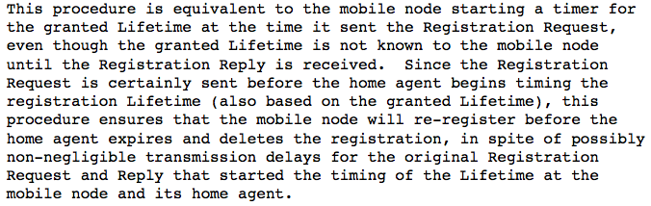

* + - 1. **Registration request denied**

code field in reply indicates denial 🡪 MN should log the error + in some cases repair the error

Code 69(denied by FA, requested lifetime too long)

Lifetime field in reply will contain the maximum allowed lifetime value (by the FA)🡺MN may attempt to reregister with a lifetime value <= max value specified in the reply

Code 133(denied by HA,regidentification mismatch)

not required?

Code 136(denied by HA, unknown HA address)

see sections 3.6.1.1 and 3.6.1.2

* + 1. **Registration retransmission**

No reg reply received in reasonable time 🡺 send another reg request

Use of timestamps 🡪 create new registration! (new identification number)

Use of nonces 🡪 retransmit unanswered request

Max retransmission time < requested lifetime of the reg request

Min retransmission time > 2 x RTT (to HA) + 100 milliseconds, must be larger than 1

Each successive retransmission timeout period must be 2X the timeout of the previous period, but smaller than max retransmission time (see above)

* 1. **Foreign Agent considerations**

mostly passive role:

* Relays registration messages between HA and FA
* Decapsulates datagrams for MN
* Send periodic agent advertisements
  + 1. **Configuration and Registration Tables**

Each FA needs to be configured with a Care-of address.

For each pending or current registration,

visitor list entry (info from Registration request):

* Link-layer address of MN
* MN’s home address
* IP destination address
* UDP source Port
* Home agent address
* Identification field
* Requested registration lifetime
* Remaining lifetime

FA may configure a max #pending registrations (default: 5)

Additional registration: reject with code 66

FA may Delete pending registration after 7 seconds with code 78

* + 1. **Receiving Registration Requests**

Check home agent address is not interface of foreign agent

Ok: Forward to HA

Not Ok: Reg. reply to MN with denial code (except > 1 per second)

If interface of FA is mobile node’s HA address:

If FA serves as HA of MN 🡪 Follow 3.8.2

If FA does not serve as HA of MN 🡪 Reject w/ code 194

If registration request from MN already in visitor list:

Existing entry should not be deleted or modified until valid reply received with a code indicating success.

Must record new request as separate part of entry.

If deregistration

Don’t delete entry until successful reply

If reply indicates request denied

Entry must not be modified

* + - 1. **Validity Checks**

Silently Discard:

Invalid, non-zero UDP checksum

Reject with code 70:

Non-zero bits in reserved fields

Reject with code 77:

‘D’ bit set to 0, nonzero Lifetime, and a care-of address not offered by FA

* + - 1. **Forwarding a Valid Request to the Home Agent**

FA operations when valid request:

* Must process and remove extensions that do not precede authorization extensions
* May append own non-authentication extensions
* Set fields:
  + IP Source Address
    - Care-of address
  + IP Destination Address
    - Copied from Home Agent field
  + UDP Source Port
    - Variable
  + UDP Destination Port
    - 434
* Begin timing remaining lifetime of pending registration

If expires before reply: delete entry.

* + - 1. **Denying Invalid Requests**

Reply to MN with suitable denial code.

Home address, Home Agent, and Identification fields in reply are copied from request.

Reject with code 70:

Reserved field is nonzero

Reject with code 60 and set lifetime to max:

Lifetime is too long

Set fields in IP and UDP header:

* IP Source Address
  + Copied from IP Dest Address of request
  + Unless multicast was used: use interface address
* IP Destination Address
  + FA denies
    - Copy from Home address field of request
  + HA denies
    - Copy from Home address field of reply
  + Otherwise
    - 255.255.255.255
* UDP Source Port
  + 434
* UDP Destination Port
  + Copy from Source Port of request
    1. **Receiving Registration Replies**

Valid reply from HA:

* Update visitor list
* Relay reply to mobile node
  + - 1. **Validity Checks**

Silently Discard:

Invalid, non-zero UDP checksum

If no pending request with home address in visitor list

Low-order 32 bits of Identification field do not match request

* + - 1. **Forwarding Replies to the Mobile Node**
* If code indicates HA has accepted registration + lifetime = nonzero:

Set lifetime in visitor list entry to the minimum of:

* Lifetime value from reply
* FA’s own max lifetime value
* If code indicates that lifetime field is zero:
  + - * Delete visitor list entry
* If code indicates registration denied:
  + - * Delete pending registration list entry but not visitor list entry

FA should perform procedures when forwarding replies:

* Must process and remove extensions not covered by any authorization-enabling extension
* May append its own non-authentication extensions

Fields in IP and UDP header: Same rules as 3.7.2.3

After forwarding valid reply:

Must Update visitor list entry as follows:

* If reply indicates accepted by HA
  + Reset timer to lifetime granted in reply
* If reply indicates rejected by HA
  + Delete visitor list entry
  1. **Home Agent considerations**

Reactive role:

* Receive registration requests from MN
* Update record of mobility bindings for MN
* Issue a suitable reply.

No reply to indicate lifetime has expired

* + 1. **Configuration and Registration Tables**

Each HA must be configured with IP Address + prefix size for home network.

HA must be configured with mobility security association of each MN.

When accept valid registration request:

* Create or modify entry for MN in mobility binding list
  + MN’s home address
  + MN’s Care-of address
  + Identification field from registration reply
  + Remaining lifetime
    1. **Receiving Registration Requests**

If HA accepts request it:

* + Must Update record of MN’s mobility binding(s)
  + Should send a reply with a suitable code

If HA denies request it:

* + Should send a reply with code

If HA does not support broadcasts

* + It must ignore the ‘B’ bit (instead of rejecting request)
    - 1. **Validity Checks**

Reply with code 136:

Requests sent to subnet-directed broadcast address of home network. Reply contains HA’s unicast address for MN.

* + - 1. **Accepting a Valid Request**

When request is valid, the HA:

* + Must update mobility binding list
    - If lifetime = 0 and Care-of address = MN’s home address
      * Delete all entries in list for MN
    - If lifetime 0 and Care-of address != MN’s home address
      * Delete entry w/ care-of address for MN
    - If lifetime != 0
      * Add entry w/ requested care-of address
      * Remove all previous entries for MN
  + Must return a reply
    - Code 0 if HA supports simultaneous mob. Bindings
    - Code 1 if it does not
  + ~~Mobility security association, reply to multiple FA’s~~
  + ~~Relay deregristration w/ care-of address that it does not own, no Foreign-Home Authentication extension.~~
* Reduce lifetime if over max + return this value in reply
* After expiration of lifetime, delete entry
* If registration request duplicates accepted requests (Home address, COA and Identification field are the same)
* New lifetime must <= original lifetime
  + - 1. **Denying an Invalid Request**

Reject with code 135:

Limit of simultaneous registrations for a MN is exceeded

Reject with code 129:

MN has entered unauthorized service areas

Reject with code 134:

Non-zero bits in reserved fields

* + 1. **Sending Registration Replies**

If HA accepts request:

* Must update MN’s entry in mobility bindings list
* Send reply with suitable code

If HA does not accept request:

* Send reply with appropriate code
  + - 1. **IP/UDP Fields**
* IP Source Address
  + Copied from IP Destination of request
    - If request was multicast: use HA’s IP address
* IP Destination Address
  + Copied from IP Source Address of request
* UDP Source Port
  + Copied from UDP Destination port of request
* UDP Destination Port
  + Copied from UDP Source port of request

If registration request for deregistration:

(lifetime = 0, COA = MN’s home address)

* IP Destination Address of reply = MN’s home address
* Transmit on home network
* If reply indicates rejection, also on home network
  + - 1. **Registration Reply Fields**
* Code
  + Accepted, but no simultaneous registrations: 1
* Lifetime
  + Max(Lifetime from request, max lifetime HA supports)
* Home Address
  + If can support home address from request
    - Copied from request
  + If it can’t support
    - Reject with code 129
  + If Zero
    - Not implemented for project
* Home Agent
  + If a unicast address of this HA
    - Copy field from request
  + Otherwise
    - Use own unicast address
    - Reject with suitable code (e.g., code 136)
      1. **Extensions**

The following ordering must be followed:

1. The IP header, followed by UDP header, followed by fixed-length portion of the reply
2. If present, any non-authentication extensions
3. Mobile-Home Authentication Extension
4. If present, any non-authentication Extensions only for FA
5. If present, the Foreign-Home Authentication Extension
6. **Routing Considerations**
   1. **Encapsulation Types**

HA’s and FA’s must support IP in IP encapsulation.

* 1. **Unicast Datagram Routing**
     1. **Mobile Node Considerations**

When on foreign network, MN chooses a default router via:

* If MN registered using a FA COA, it may use FA as first-hop router
  + FA MAC address from Advertisement
* Otherwise
  + Default router from ICMP Router Advertisement portion of Agent Advertisement message

While away from home network, MN’s must not broadcast ARP packets

If no mechanism for obtaining MAC address on foreign networks:

MN must ignore redirects to other routers

* + 1. **Foreign Agent Considerations**

Receiving encapsulated datagram:

* Compare inner Destination Address to visitor list
  + No match = silently discard
  + Match = forward to MN
* Don’t advertise the presence of MN in visitor list to other routers
* Must route datagrams from registered MN
  + At a minimum:
    - Verify IP Header Checksum
    - Decrement IP Time to Live
    - Recompute IP Header Checksum
    - Forward
* Must not broadcast ARP for MN’s MAC address on a foreign network
  + May obtain by copying info from Agent solicitation or request
* ARP cache for MN’s IP address must not expire before visitor list entry
  + 1. **Home Agent Considerations**

Must be able to intercept datagrams on home network addressed to MN while MN is registered away from home.

* Must compare dest. address of datagram to registered MN
  + If match:
    - Tunnel datagram to COA
* If MN has no mobility bindings
  + Assume at home, forward to home network
* Source address of reply must equal Home Agent field
  + Can’t use address of other interface
* Must decapsulate packets addresses to themselves (location privacy)
* If Lifetime of mobility binding expires before new valid request
  + Delete binding
  1. **~~Broadcast Datagrams~~**
  2. **~~Multicast Datagram Routing~~**
  3. **Mobile Routers**

Ex. Airplane, ship, train, …

Mobile router may act as FA, typical case example:

1. Laptop attached to mobile network, uses mobileIP
2. When in flight, router (FA of laptop) registers from time to time with a router on the ground (FA of router).
3. Datagram to laptop:

Datagram to laptops HA, forwards to routers HA (Airplane HQ), forwards to router COA on ground under airplane, forwards to router, forwards to laptop.

If the mobile network is the node’s home network:

* HA may use permanent registration in mobility binding with COA = MN’s home address
* Or it may advertise connectivity to the mobile network using normal IP routing protocols
  1. **~~ARP, Proxy ARP, and Gratuitous ARP~~**

1. **~~Security Considerations~~**
2. **IANA Considerations**

New number spaces:

* Mobile IP Messages sent to UDP port 434
* Types of extensions for request and reply
* Values for code in reply
* Agent Solicitation/Advertisement = Router Discovery with extensions
  1. **Mobile IP Message Types**

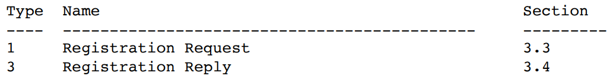

* 1. **Extensions to RFC 1256 Router Advertisement**

**~~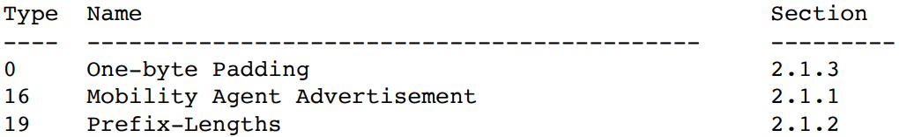~~**

* 1. **Extensions to Mobile IP Registration Messages**

**~~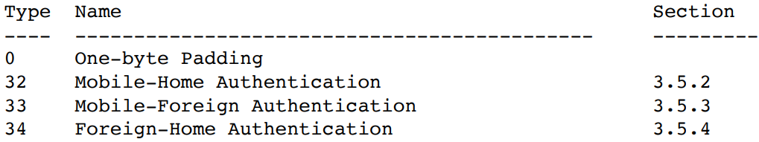~~**

* 1. **Code Values for Mobile IP Registration Reply Messages**

**~~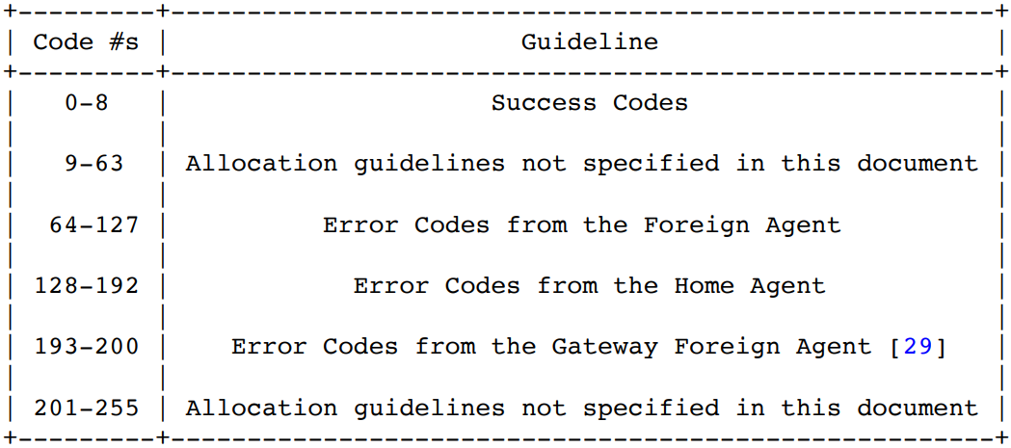~~**

**Appendix C. Example Scenarios**

**C.1. Registering with a Foreign Agent Care-of Address**

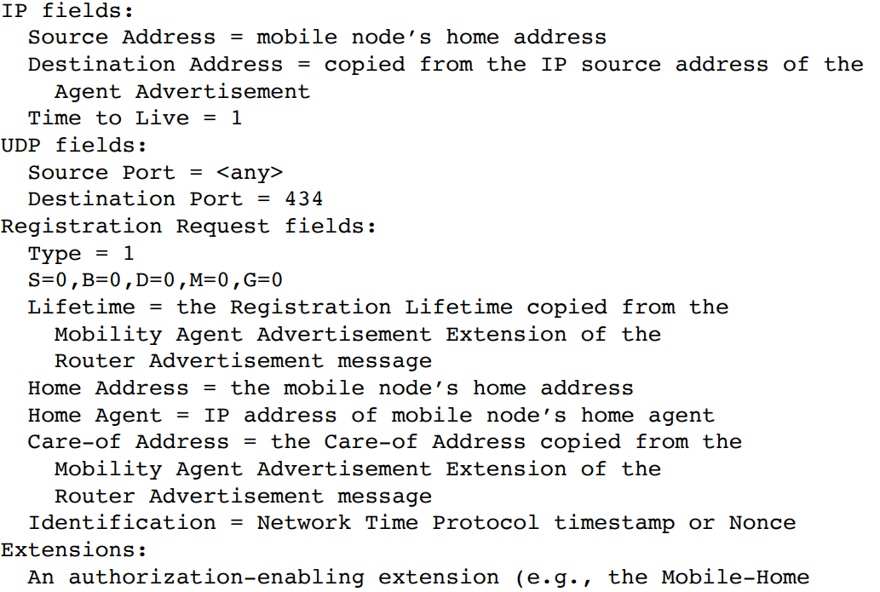

**C.2. Registering with a Co-Located Care-of Address**

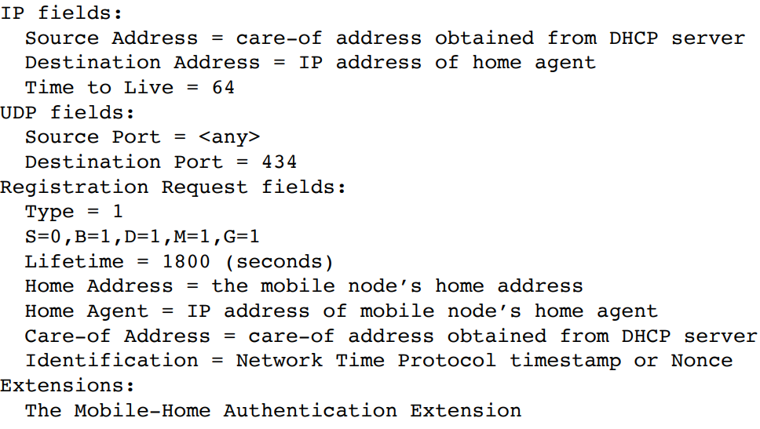

**C.3. Deregistration**

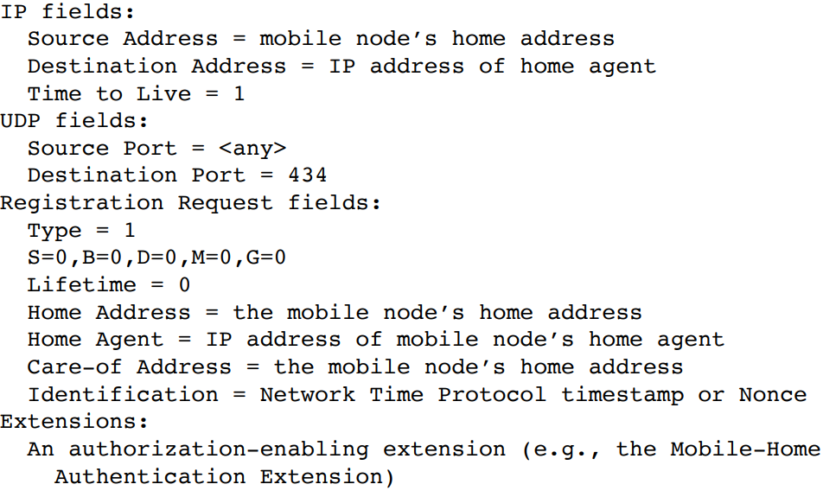

**Appendix G. Example Messages**

**G.1. Example ICMP Agent Advertisement Message Format**

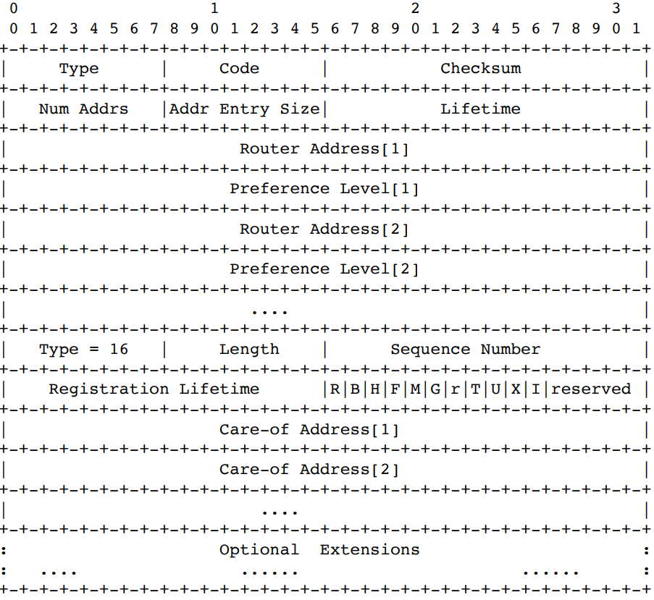

**G.2. Example Registration Request Message Format**

UDP Header if followed by the Mobile IP fields shown below:

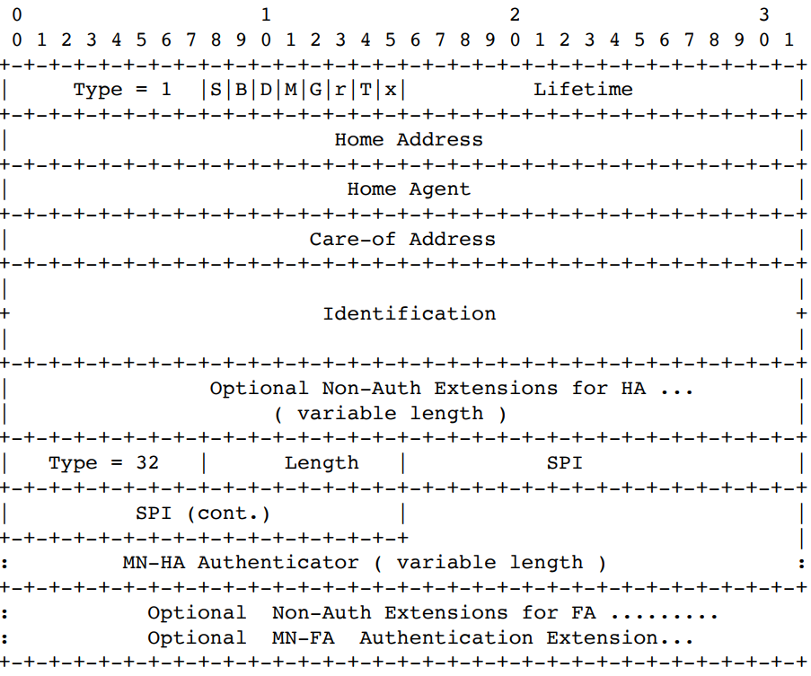

**G.3. Example Registration Reply Message Format**

UDP Header if followed by the Mobile IP fields shown below:

