**IP Mobility support for IPv4, revised**

**Abstract**

* Transparent routing of IP datagrams to mobile nodes
* Mobile nodes(MN) 🡪 identified by home address
  + Away from home 🡪 care of address (COA)
* Home Agent (HA)
  + Sends datagrams destined for MN through tunnel to the COA.

1. **Introduction**

A node ‘s IP address 🡪 uniquely identifies its attachment to the internet.

Mobile IP = way to provide node mobility while keeping the node’s IP address

* 1. **Protocol requirements**
* MN must be able to keep communicating while changing its link-layer attachment point to the internet 🡪 no change of MN’s IP address
* No protocol enhancements are needed
* All messages relating updates of the location of a MN must be authenticated (not required for this project)
  1. **Goals**
* Number of administrative messages (sent over a possible wireless link which connects the MN) must be kept to a minimum
* Message size must be as small as possible
  1. **Assumptions**
* Assignment of the MN’s IP address is not constraint by this RFC
* MN will not change their attachment point to the Internet more than once per second
* IP unicast datagrams are routed based on the DEST address in the datagram header (aka not by the SRC address)
  1. **Applicability**
* Mobile IP 🡪 enables nodes to move from one IP subnet to another, Ethernet segment to wireless LAN etc.

🡺 **MN’s IP address must be the same after the movement**

* Mobile IP 🡪 solves macro mobility management
  1. **New architectural entities**
* Mobile node (MN)
  + Host/router that changes it point of attachment from 1 network/subnetwork to another
  + Can change location without changing its IP address
  + Continues communication at different locations using its CONSTANT IP address
* Home agent (HA)
  + Router of the MN’s home network
  + Tunnels datagrams for delivery to the MN (when the MN is not @ home)
  + Maintains current location information of the MN
* Foreign agent (FA)
  + Router of the MN’s visited network
  + Provides routing services when the MN is registered
  + Detunnels and delivers the MN’s datagrams (which were sent through the tunnel coming from the MN’s HA)
  + When MN sends a datagram 🡪 FA functions as default router for the registered MN’s.

MN

🡪 has a long term IP address (given by home network)

🡪 administered same as a permanent IP address provided to a stationary host

🡪 if MN is away from home 🡺 care of address (COA)

🡪 uses its home address as SRC address for **all** sent IP datagrams, except for certain mobility management functions (see section 3.6.1.1)

COA is associated with a MN, reflects MN’s current point of attachment­

* 1. **Terminology**

key words like MUST, SHOULD etc. 🡺 see RFC 2119

* Agent advertisement
  + - Constructed by adding an extension to the Router Advertisement message (see RFC 1256)
* Authentication
  + - The verification of the identity of the originator of the message
    - Not required for this project
* Care-of address (COA)
  + - Tunnel termination point towards the MN, datagrams which were forwarded when MN is away from home
    - 2 types:
      * FA care-of address:
        + Address of the current FA with which the MN is currently registered
      * Co-located care-of address:
        + Externally obtained local address
        + Not required for this project
* Correspondent Node (CN)
  + - Peer with which the MN communicates
    - Mobile / stationary
* Foreign network
  + - Any network which is not the MN’s home network
* ~~Gratuitous ARP~~
  + - ~~ARP packet sent by a node in order to update other nodes their ARP caches 🡪 see section 4.6~~
    - ~~Not required for the project~~
* Home address
  + - IP address which is assigned to the MN for an extended period of time
    - **Remains unchanged regardless the MN’s current location**
* Home network
  + - Network (possibly virtual) with the same network prefix as the MN’s home address
    - Standard IP routing mechanisms will deliver datagrams (with destination the MN) to the MN’s home network
* Link
  + - Facility/medium which enables node communication @ link layer
    - Under the network layer
* Link layer address
  + - Identifies an endpoint of some communication over a physical link
    - Typically an interface’s MAC address
* Mobility agent
  + - Home agent OR foreign agent
* Mobility binding
  + - Association of a home address with the COA
    - Also contains the remaining lifetime of that binding
* Node
  + - Host OR router
* Nonce
  + - Random chosen value
    - Different from previous choices
    - Inserted in a message
* Tunnel
  + - The followed path of an encapsulated datagram
    - Datagram is routed to a decapsulator 🡺 decapsulation + delivered to the correct destination
* Virtual network
  + - No physical instantiation beyond a router
    - Router (HA) advertises reachability to the virtual network using conventional routing protocols
* Visited network
  + - Network different than the home network
    - Currently connected to the MN
* Visitor list
  + - List of the FA’s currently visiting MN’s
  1. **Protocol overview**

Agent discovery

HA and FA 🡪 advertise their availability on each service link

MN can ask for prospective agents with a **solicitation message**

Registration

MN is away 🡪 registers its COA with the HA

Depending the attachment method this registration can occur in 2 ways:

1. Directly with the HA
2. Via a FA which forwards the message to the HA

Silently discard

Implementation

- Discards the datagram without further processing

- Should provide logging capabilities

- Record event in a statistics counter

**Mobile IP operations steps**

* HA and FA advertise their presence with Agent Advertisement messages (AAM, see section 2), MN can solicit (on any locally attached mobility agent) such messages with an Agent Solicitation message
* MN receives these AAM 🡪 determine if its home or a foreign network
* MN = home 🡪 operate without mobility services

MN = returning home ,after being registered on a foreign network 🡪 Deregister with HA using an exchange of a Registration request and reply

* MN detects it’s has moved to a foreign network 🡪 receives COA on the foreign network. This COA = determined from FA’s advertisements (foreign COA) or collocated COA (not required)
* MN (away from home) 🡪 registers new COA with HA 🡪 registration request – reply exchange with HA (via FA, section 3)
* Datagrams sent to the MN’s home address 🡪 received by the HA 🡪 tunneled by the HA to the MN’s COA, received at the tunnel end (or the MN itself) 🡪 delivered to the MN
* Reverse direction 🡪 MN sends the datagrams through normal IP routing mechanisms (not necessarily through HA)

Mobile IP uses tunneling (conventional IP routing), the tunnel end @ the MN’s COA. COA 🡪 detunnels the datagram 🡪delivered to the MN

Two ways to acquire a COA:

1. Foreign agent COA

🡪 provided through agent advertisement messages

🡪 COA = FA’s IP address

🡪 FA = tunnel end point, decapsulates tunneled datagrams + sends the inner datagrams to the MN

1. Co-located COA

🡪 not required for this project

Difference between FA and COA, COA = the FA’s IP address (in case 1) and the FA = a mobility agent which provides services to MN’s

MN and FA must be able to communicate without relying on standard IP routing mechanisms.

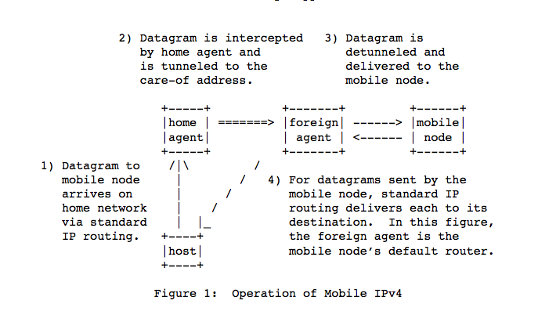

figure 1 = situation after MN has registered with its HA

host = Correspondent node

* 1. **Message format and protocol extensibility**

Control messages 🡪 sent with UDP, port 434

2 message types:

1. Registration request

3- Registration reply

Agent discovery messages (see RFC 1256):

- Router advertisement

- Router solicitation

General extension mechanism 🡪 allows optional info carried by Mobile IP and ICMP router discovery messages 🡪 see section 1.9

End of extension list 🡪 indicated by the total length of the IP datagram

2 separately maintained sets of numbering spaces:

1) Extensions that may appear in Mobile IP control messages (sent to and from UDP 434)

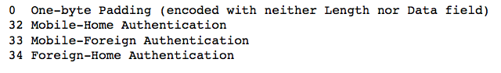

2) Extensions that may appear in ICMP router discovery messages

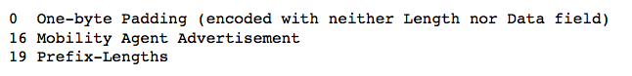

Extension numbered in either of the 2 above set (range 0-127) is encountered but not recognized 🡪 message containing that extension 🡪 discarded

Extension with range (128-255) is encountered but not recognized 🡪 that extension is ignored but the rest of the extensions and the message MUST be processed

Length field of the extension is used to skip the data field in order to find the next extension.

🡺 extensions are aggregated

3 distinct structures for Mobile IP extensions:

1) Simple extension format

2) Long extension format

3) Short extension format

* 1. **Type-length-value extension format for Mobile IP extensions**

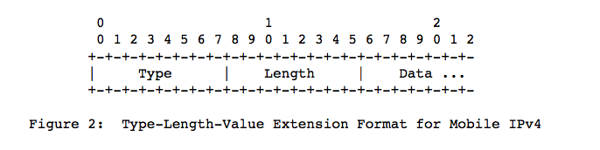

🡪 not the most efficient use of the extension type space

Type = type of the extension

Length = length in bytes of the data field, not including the type and length part

Data = can be 0 or more bytes, its format and length is determined by the length and type part

* 1. **Long extension format**

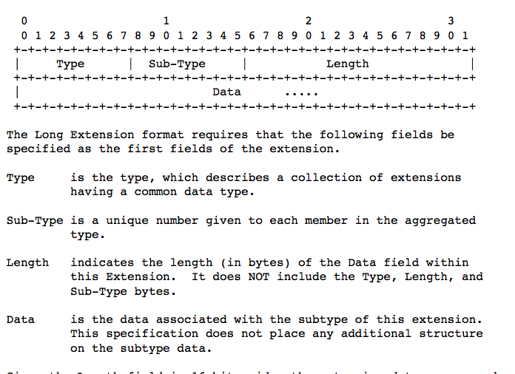

For not-skippable extensions with information > 256 bytes

* 1. **Short extension format**

For skippable extensions with information <= 256 bytes

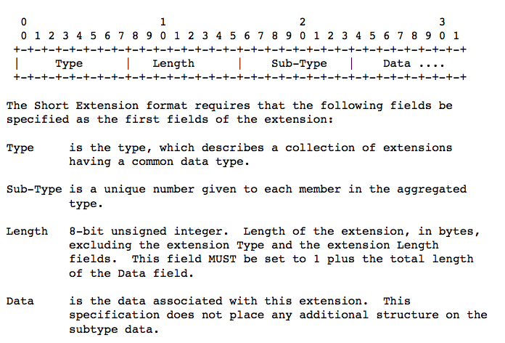

1. **Agent discovery**

This method allows the MN to determine if he is connected to its home network or a foreign network + if it has moved from one network to another

MN (connected to foreign network), method of this section determine the offered FA’s COA by each FA on the foreign network

Agent advertisement

= ICMP router advertisement message + Mobility agent advertisement extension

Agent solicitation

= ICMP router solicitation with TTL = 1

* 1. **Agent advertisement(AA)**

Agent advertisement

Transmitted by mobility agents

ICMP router advertisement that has been extended to carry a mobility agent advertisement extension (see 2.1.1)

MN 🡪 use AA to determine current attachment to the Internet

ICMP router advertisement fields of the message must be set as follows:

Link layer fields:

Destination address

In case of unicast AA 🡺 DEST = SRC link layer address of the agent solicitation that prompted the advertisement

IP fields:

TTL = 1 (for all advertisements)

DEST = 255.255.255.255 (for all multicast agent advertisements)

[DEST = IP home address of the MN (unicast agent advertisement)]

ICMP fields:

Code = 0 OR 16

0: Mobility agents is also a router for IP traffic not relating to MN (common traffic)

16: No common traffic routing

Lifetime

Max length of time that the advertisement is considered valid

Router addresses

See section 2.3.1

Num addrs

Number of router addresses advertised in this message

AA message 🡪 num addrs may be set to 0, see section 2.3.1

1. **Registration**
2. **Routing considerations**