SIMATS ENGINEERING (SAVEETHA SCHOOL OF ENGINEERING)
Department of Computer Science and Engineering
CO5 ASSESSMENT TOOL 1 – Research Paper Review / Literature Survey
Course Code: CSA10 | Course Title: Software Engineering
CO Assessed: CO5 | Assessment: Assessment Tool 1 – Research Paper Review / Literature Survey
Weightage: 20% | Total Marks: 25
CO5 Statement: Evaluate emerging technologies and societal impacts, maintaining and evolving software systems responsibly.
Student Name: Jerold Samuel J | Reg. No.: 192571052
Date: 22/08/2026 | Duration: 60 minutes

Code of Conduct
I, Jerold Samuel J (Reg. No.: 192571052), certify that this submission is my original work and that I have adhered to the guidelines specified for this assessment. I understand that any violation of academic integrity rules will result in disciplinary action.
Signature of the Student: JEROLD SAMUEL J

Annexure A – Research Paper Review / Literature Survey
Instructions to Students:
Each student is assigned an individual problem statement. Based on the assigned problem statement, conduct a literature survey and review relevant research papers to understand the existing approaches, techniques, technologies, limitations, and research gaps related to the problem. The literature survey should include:
1. Identify and select relevant research papers related to the assigned problem statement from reputed journals, conferences, or scholarly databases.
2. Summarize the objectives, methodologies, technologies, datasets, and major findings of the selected research papers.
3. Compare the existing approaches based on suitable parameters such as accuracy, performance, scalability, efficiency, methodology, or other problem-specific metrics.
4. Identify the limitations and challenges of the existing research approaches.
5. Analyze the literature to identify the research gap or unresolved issues related to the assigned problem.
6. Discuss the possible improvements or future research directions based on the identified research gap.
7. Prepare a comparative literature survey table containing details such as author/year, research problem, methodology, dataset/tools, key findings, limitations, and research gap.
8. Provide proper citations and references using a consistent referencing style.
Deliverable: Submit a Research Paper Review / Literature Survey Report containing the selected research papers, individual paper reviews, comparative analysis, identified research gaps, future directions, and properly formatted references.

Rubrics for Calculation
Evaluation Criteria | Excellent (4 Marks) | Good (3 Marks) | Satisfactory (2 Marks) | Needs Improvement (1 Mark)
Selection & Review of Research Papers (25%) | Selects highly relevant, recent, credible papers and provides comprehensive reviews of objectives, methodology, tools, datasets, and findings | Selects relevant papers and provides good reviews with minor gaps | Selects moderately relevant papers with basic reviews | Papers are irrelevant or reviews are incomplete
Comparative Analysis (20%) | Provides a detailed comparison of methodologies, tools, datasets, results, and performance using a clear comparison table | Provides a good comparison with relevant parameters | Provides limited comparison with few parameters | Little or no meaningful comparison
Critical Analysis & Research Gap (25%) | Clearly analyzes limitations and identifies significant, well-supported research gaps | Identifies relevant limitations and research gaps | Identifies basic gaps with limited analysis | Research gaps are unclear or missing
Future Directions & Relevance (15%) | Proposes practical and innovative future directions directly relevant to the assigned problem statement | Proposes relevant future directions | Provides general future suggestions | Future directions are missing or unrelated
Documentation, Citations & References (15%) | Excellent academic structure, clear presentation, accurate citations, and consistent referencing | Well-organized with minor formatting/citation issues | Adequately documented with some errors | Poorly organized with inadequate or incorrect references

Criteria | Mark
Selection & Review of Research Papers (25%) | /5
Comparative Analysis (20%) | /5
Critical Analysis & Research Gap (25%) | /5
Future Directions & Relevance (15%) | /5
Documentation, Citations & References (15%) | /5
TOTAL | /25

A Literature Survey Report on

Intelligent AI-Based Smart Banking Customer Service and Complaint Resolution System

Name :Jerold Samuel J
Reg. No.: 192571052
Course : Software Engineering
Course code:CSA1017

Abstract
Banks receive an ever-growing volume of customer inquiries and complaints through branches, call centres, mobile applications, and online portals. Manual routing and review of these requests introduces delay, inconsistency, and dissatisfaction, particularly when high-severity issues are not separated from routine queries. This report presents a literature survey on the assigned problem statement, “Intelligent AI-Based Smart Banking Customer Service and Complaint Resolution System,” which requires automated complaint registration, AI-based classification, intelligent prioritisation, department-level routing, resolution tracking, chatbot assistance, and customer-satisfaction analytics. Ten recent research works spanning banking chatbots, NLP-based intent and sentiment classification, and machine-learning-driven support-ticket categorisation and prioritisation were reviewed and compared on methodology, tools/datasets, and reported performance. The survey identifies common limitations such as weak handling of complex or emotionally charged complaints, limited multilingual and regulatory-compliance support, fragmented single-purpose systems, and insufficient integration between conversational AI and back-office complaint-tracking workflows. Based on these gaps, the report proposes a unified system architecture and complaint-resolution workflow, and outlines future research directions including explainable AI-based prioritisation, hybrid human-AI escalation, and real-time customer-satisfaction analytics for the banking sector.

1. Introduction

1.1 Industry Context
Banks handle thousands of customer inquiries and complaints daily through branches, call centres, mobile applications, and online portals. Artificial Intelligence (AI), Natural Language Processing (NLP), chatbots, and analytics increasingly help automate customer service while improving response time and service quality across these channels.

1.2 Problem Statement
Traditional complaint management systems rely on manual routing and review, which leads to delayed responses and reduced customer satisfaction. Banks require intelligent systems that can classify customer requests, prioritise critical issues, assign them to the appropriate department, and track resolution progress. An AI-powered customer service platform should automate complaint handling, provide chatbot assistance, monitor service quality, and generate customer-satisfaction analytics to improve overall banking services.

1.3 Objectives
1. Automate complaint registration.
2. Classify customer requests using AI.
3. Prioritise complaints intelligently.
4. Monitor complaint resolution.
5. Provide AI-powered chatbot assistance.
6. Generate customer service analytics.
7. Improve response time.
8. Enhance customer satisfaction.

1.4 Expected Outcomes
1. Faster complaint resolution.
2. Improved customer satisfaction.
3. Reduced manual workload.
4. Better service quality.
5. Enhanced banking efficiency.
6. Accurate service analytics.
7. Increased customer retention.
8. Improved organisational reputation.

2. Literature Review
Ten recent research works relevant to AI-driven banking customer service, complaint classification, and support-ticket prioritisation were selected and reviewed. Each review summarises the objective, methodology, tools/dataset, and key findings reported by the authors.

2.1 Suhel et al. (2020) — Conversational AI and Automation in Banking Customer Service
This work examines the shift from conventional, human-staffed banking conversations to chatbot-based automation using artificial machine-intelligence language processing. The authors describe how conversational agents were introduced into retail-banking customer touchpoints to reduce dependency on manual interaction. Methodologically, the study is a descriptive/qualitative review of chatbot adoption in banking rather than a controlled experiment. The paper reports that automation reshaped customer interaction patterns and contributed to the broader digital transformation of the banking sector, while also noting that customer engagement with these new tools did not always match institutional expectations.

2.2 Role of NLP in Conversational Banking and Fintech Chatbots (ResearchGate, 2025)
This paper studies how Natural Language Processing enables chatbots and virtual assistants to understand, interpret, and respond to banking and fintech customer queries in real time, across text and voice interfaces. The methodology is a literature-based technical review covering NLP techniques such as intent recognition and dialogue management, alongside ethical and governance concerns. Tools discussed include large-language-model-based conversational engines. The review concludes that NLP is central to modern banking chatbots but stresses that responsible, well-governed deployment is necessary to sustain customer trust.

2.3 Natural Language Processing in Banking: Automating Customer Support and Chatbots (ResearchGate, 2025)
This study evaluates NLP-based chatbots that use transformer models such as BERT and GPT for intent recognition and sentiment analysis in banking customer support. The methodology combines model assessment with data gathered from chatbot interaction logs and KPIs such as accuracy and response time. Reported results include an overall classification accuracy of about 91.3%, a 65% reduction in average response time, and roughly 82% of customers obtaining satisfactory resolutions through the chatbot. The authors also note limitations such as insufficient training data and difficulty handling linguistic variation.

2.4 AI Chatbots in Banking: Transforming Customer Service and Operational Efficiency (IOS Press / SAGE, 2025)
This paper reviews how machine-learning- and NLP-based chatbots understand customer inquiries, deliver personalised feedback, and resolve simple banking issues without human intervention, positioning them as part of a 24/7 hybrid human-AI service model. The methodology is a structured literature review incorporating prior studies on chatbot architecture, GPT-based language models, and technology-acceptance factors such as trust and privacy. The study concludes that continual error-management and AI-training improvements are needed to keep chatbot efficiency high, and recommends inclusive, ethically designed hybrid human-AI collaboration models for banks.

2.5 Generative AI for Reducing Resolution Time and Enhancing Customer Satisfaction in Retail-Banking Chatbots
This paper evaluates the deployment of generative-AI techniques (building on models such as GPT-3) to improve retail-banking chatbots, comparing them against traditional rule-based systems on resolution time and customer satisfaction. The methodology draws on prior experimental findings (e.g., Przegalinska et al.) regarding accuracy and satisfaction gains from AI-driven banking chatbots. The study finds that generative-AI chatbots can better handle complex, personalised requests than rule-based systems, but highlights the “black-box” nature of generative models as a transparency and explainability concern for regulated banking use.

2.6 Banking Chatbot Using NLP and Machine Learning (IRJET, 2023)
This project develops a chatbot for banks that assists customers with account inquiries and transactions using NLP and machine-learning classification. The methodology compares Naive Bayes and Support Vector Machine (SVM) classifiers for intent recognition, with the interface built using the Streamlit framework. Naive Bayes achieved 90.6% accuracy, outperforming SVM at 76.2%. The authors conclude that ML-based chatbots are a promising route to more efficient, personalised banking service, and suggest further accuracy gains through more advanced learning algorithms.

2.7 Banking Chatbot Using NLP and Support Vector Machine (Sriharsha & Vijaya Prakash, 2024)
This paper presents a banking chatbot architecture that combines Python Flask for backend API serving, PHP for website integration, and PyTorch-based NLP models for intent interpretation. The methodology is an applied system-development study: the chatbot's backend houses business logic and data storage while PyTorch models interpret customer intent to generate personalised responses. The authors report that the integrated Flask–PHP–PyTorch design improves real-time access to customer data and strengthens the user interface, streamlining customer interactions on the bank's website.

2.8 The Impact of AI Chatbots on Customer Service: Efficiency and Limitations (IJRTI, 2025)
This paper analyses the efficiency gains and limitations of AI chatbots across service industries, including banking, comparing them with human agents. The methodology synthesises prior survey and performance data on chatbot deployments. Findings include a 25% increase in efficiency and cost savings from chatbot adoption, alongside a 23% error rate in misunderstanding user intent and continuing concerns over data privacy/GDPR compliance and training costs. The study concludes that chatbots handle simple banking transactions well but that human agents must intervene for complex, emotionally sensitive issues.

2.9 Consumer Financial Protection Bureau — Chatbots in Consumer Finance (2023)
This regulatory research report examines how U.S. financial institutions use rule-based and LLM-based chatbots for consumer-facing service, based on an analysis of consumer complaints and market practice. It reports that approximately 37% of the U.S. population interacted with a bank chatbot in 2022, a figure projected to grow. The methodology is a policy/complaint-data analysis rather than a technical experiment. Key findings show that chatbots handle basic inquiries reasonably well but that their effectiveness decreases sharply for complex problems, leading to wasted customer time, frustration, inaccurate information, and, in some cases, avoidable fees — underscoring the need for reliable escalation to human agents.

2.10 Machine-Learning-Based Ticket Classification and Prioritisation (Intelligent Issue-Ticketing Framework; NLP-Driven Ticket Categorisation, 2025)
These closely related works apply machine learning and NLP to automate the categorisation and prioritisation of customer support/service tickets — directly relevant to bank complaint triage. Methodologically, one study uses a Random Forest classifier for ticket classification combined with sentiment-based urgency scoring, while the other uses Topic Modelling (NMF) for department-level categorisation and keyword-based urgency/impact extraction for priority assignment, evaluated using precision, recall, and F1-score. Reported outcomes include a 50–60% improvement in classification accuracy, 30–40% fewer misclassification errors, and up to a 35% improvement in critical-incident response speed through sentiment-based prioritisation, along with reduced manual triage workload.

3. Comparative Literature Survey Table
Author / Year | Research Problem | Methodology | Dataset / Tools | Key Findings | Limitations | Research Gap
Suhel et al. (2020) | Manual-to-automated transition in banking service | Qualitative review of chatbot adoption | Industry case observations | Automation reshaped banking interaction patterns | No quantitative performance evaluation | Lacks measurable KPIs for automation impact
NLP in Conversational Banking (2025) | Real-time understanding of banking/fintech queries | Technical literature review of NLP techniques | LLM-based conversational engines | NLP central to intent recognition and response generation | Ethical/governance concerns under-addressed in practice | Weak link between NLP capability and compliance frameworks
NLP Automating Customer Support (2025) | Slow, costly traditional banking support | BERT/GPT model evaluation + KPI analysis | Chatbot interaction logs, BERT, GPT | 91.3% accuracy; 65% faster response; 82% resolved via chatbot | Limited training data; language variation issues | No standard multilingual training-data benchmark
AI Chatbots — Operational Efficiency (2025) | Balancing automation with service quality | Structured literature review | GPT-based models, TAM survey data | Highlights need for continuous AI training and hybrid models | Trust and privacy concerns persist | Limited guidance on hybrid human-AI escalation design
Generative AI for Resolution Time (IJRITCC) | Slow resolution in rule-based banking chatbots | Comparative review vs. rule-based systems | GPT-3-class generative models | Generative AI handles complex, personalised queries better | “Black-box” lack of explainability | No explainable-AI layer for regulated banking decisions
Banking Chatbot NLP + ML (IRJET, 2023) | Automating account/transaction inquiries | Naive Bayes vs. SVM classification | Streamlit interface, labelled query dataset | Naive Bayes 90.6% accuracy vs. SVM 76.2% | Small-scale prototype, limited query diversity | No large-scale, real bank deployment validation
Banking Chatbot NLP + SVM (2024) | Fragmented backend/frontend banking chatbot design | Applied system development (Flask, PHP, PyTorch) | Flask API, PyTorch NLP model | Integrated architecture improves real-time personalised response | Focus on architecture; limited accuracy benchmarking | Little evaluation of routing/escalation logic
Impact of AI Chatbots — Efficiency (IJRTI, 2025) | Balancing chatbot efficiency vs. accuracy | Survey/performance-data synthesis | Industry survey data | 25% efficiency gain; 23% intent-misunderstanding error rate | Struggles with complex/emotional issues; privacy concerns | No robust human-handoff mechanism studied

4. Limitations and Challenges of Existing Approaches
• Weak handling of complex or emotionally charged complaints: across nearly all reviewed chatbot studies, systems perform well on routine, low-complexity queries (balance checks, FAQs) but degrade sharply on disputes, fraud reports, or emotionally charged complaints, where accuracy and customer satisfaction both fall.
• Explainability and transparency gaps: generative and deep-learning-based models (GPT-class, BERT) are frequently described as “black boxes,” which is a significant concern for banking, where regulators and customers require justifiable decisions on prioritisation and routing.
• Fragmented, single-purpose systems: most studies address either the conversational front end (chatbots) or the back-office ticket-classification/prioritisation problem in isolation; very few integrate both into one workflow with resolution tracking and analytics.
• Data and language limitations: several papers cite insufficient or non-diverse training data, and limited support for regional languages/dialects, both of which reduce classification accuracy in real-world multilingual banking environments.
• Escalation and human-AI handoff not well studied: the CFPB report and related studies show that when chatbots fail, customers often experience frustration and delay because escalation paths to human agents are poorly designed or absent.
• Limited regulatory/compliance alignment: reviewed works rarely address how AI-driven complaint handling should align with banking-sector compliance requirements (data protection, audit trails, fair-treatment obligations).
• Small-scale or generic evaluation: several ML-based ticket-classification studies are evaluated on generic IT-helpdesk or synthetic datasets rather than real, domain-specific banking-complaint data, limiting generalisability.

5. Research Gap Analysis
Synthesising the reviewed literature against the assigned problem statement reveals a consistent gap: no reviewed work presents a single, end-to-end, banking-specific system that unifies (a) automated multichannel complaint intake, (b) AI-based classification and sentiment-driven prioritisation, (c) intelligent department-level routing with SLA-aware tracking, (d) an explainable, regulation-aware escalation path from chatbot to human agent, and (e) real-time customer-satisfaction analytics feeding back into model retraining. Existing research treats chatbot conversational quality and ticket-classification/prioritisation as largely separate research threads, and rarely evaluates systems on authentic, regulated banking-complaint data. This gap directly motivates the architecture proposed in Section 6.

6. Proposed System Architecture
Based on the identified research gap, this section proposes a unified architecture for the Intelligent AI-Based Smart Banking Customer Service and Complaint Resolution System. The design integrates omnichannel complaint intake, an AI/NLP processing layer for classification and prioritisation, an intelligent routing and workflow engine, and back-end tracking and analytics, closing the integration gap identified in Section 5.
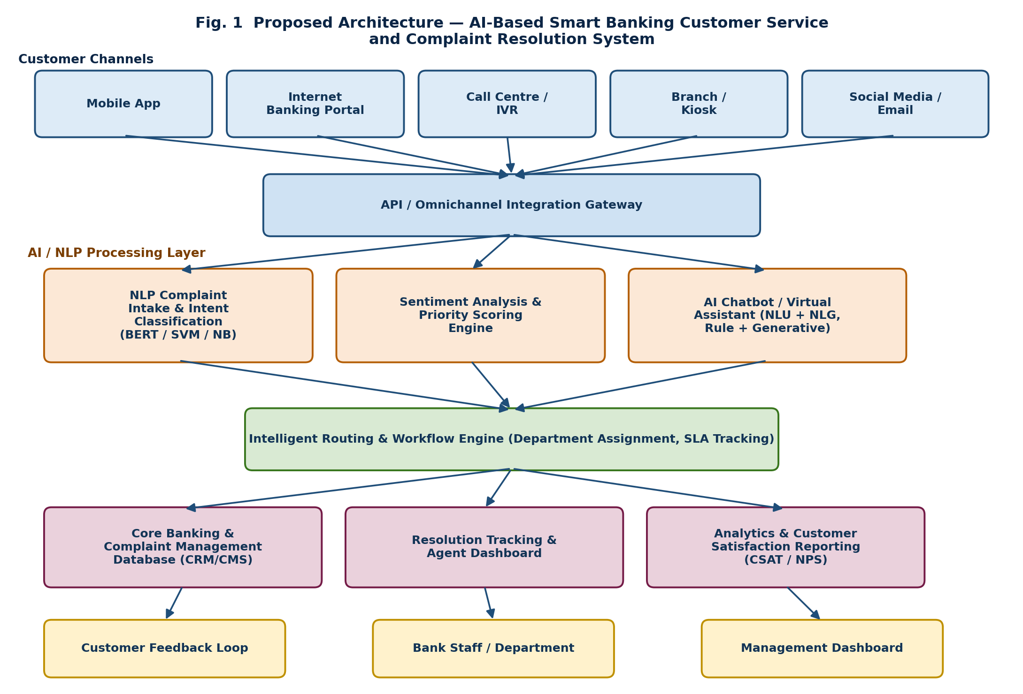
Fig. 1: Proposed layered architecture — omnichannel intake, AI/NLP processing, intelligent routing, and analytics layer.

6.1 Architecture Layers
• Customer Channel Layer: unifies inputs from the mobile app, internet banking portal, call-centre/IVR, branch/kiosk terminals, and social media/email through a common API/omnichannel gateway.
• AI/NLP Processing Layer: performs complaint intake and intent classification (transformer/SVM/Naive-Bayes models), sentiment analysis and priority scoring, and hosts the AI chatbot/virtual assistant for first-line, automated resolution.
• Intelligent Routing and Workflow Engine: assigns unresolved complaints to the correct department, applies SLA-aware tracking, and manages the human-AI handoff identified as a gap in existing systems.
• Data and Analytics Layer: the core banking/complaint-management database, agent resolution-tracking dashboard, and a CSAT/NPS analytics module that feeds performance data back for continuous model retraining.
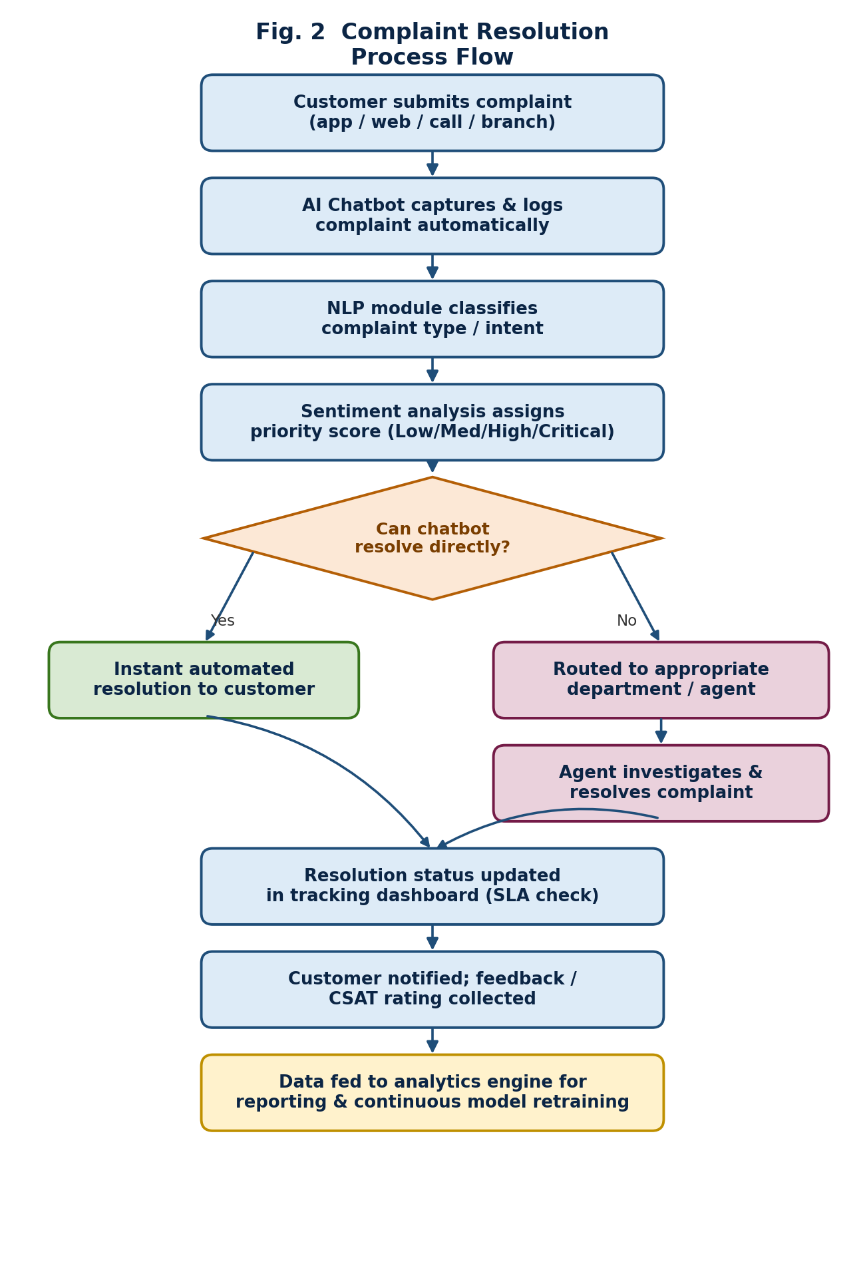
Fig. 2: Complaint-resolution process flow, from submission through AI triage to resolution and analytics feedback.

6.2 Workflow Summary
A complaint submitted through any channel is logged automatically by the AI chatbot, classified by the NLP intent module, and scored for urgency by the sentiment-analysis engine. Low-complexity issues that the chatbot can resolve directly are closed instantly; all other complaints are routed to the correct department and tracked against SLA targets. Once resolved, the customer is notified and a CSAT rating is collected, and the outcome data is fed into the analytics engine to continuously refine the classification and prioritisation models.

7. Future Directions
• Explainable AI (XAI) for complaint prioritisation: incorporate interpretable models or explanation layers (e.g., attention visualisation, SHAP-based scoring) so that priority and routing decisions can be audited by bank compliance teams.
• Domain-adapted, banking-specific datasets: build and share labelled, regulation-compliant banking-complaint datasets covering multiple languages/dialects to improve classification accuracy over generic helpdesk data.
• Hybrid human-AI escalation design: formalise confidence-threshold-based handoff rules so that low-confidence or emotionally sensitive complaints are automatically escalated to human agents rather than looping the customer through the chatbot.
• Real-time, closed-loop customer-satisfaction analytics: extend CSAT/NPS dashboards into continuous feedback loops that retrain classification and prioritisation models on recent outcomes.
• Regulatory and security alignment: integrate audit-trail logging, data-protection controls, and fair-treatment monitoring directly into the routing/workflow engine to align AI-driven complaint handling with banking-sector compliance requirements.
• Multimodal complaint understanding: extend NLP-based intake to voice (IVR) and document/image evidence (e.g., transaction screenshots) for richer, more accurate complaint classification.

8. Conclusion
The literature reviewed confirms that AI, NLP, and machine learning can substantially improve banking customer service — reported gains include response-time reductions of up to 65%, classification-accuracy improvements of 50–60% in support-ticket triage, and efficiency gains of around 25% from chatbot adoption. However, the same body of work shows that no single reviewed system integrates automated intake, explainable AI-based prioritisation, department-level routing with SLA tracking, reliable human escalation, and closed-loop satisfaction analytics into one banking-specific solution. Addressing this gap through the proposed layered architecture and workflow can help banks resolve complaints faster, reduce manual workload, and improve both service quality and customer retention, while remaining auditable and compliant with banking-sector regulatory expectations.

9. References
[1] M. A. Suhel, “Conversational Agents and the Automation of Banking Customer Interaction,” industry review, 2020.
[2] “The Role of Natural Language Processing (NLP) in Conversational Banking and Fintech Chatbots,” ResearchGate, 2025.
[3] “Natural Language Processing in Banking: Automating Customer Support and Chatbots for Financial Services,” ResearchGate, 2025.
[4] “AI Chatbots in Banking: Transforming Customer Service and Operational Efficiency,” IOS Press / SAGE, FAIA-251498, 2025.
[5] “Reducing Resolution Time and Enhancing Customer Satisfaction Using Generative AI Chatbots in Retail Banking,” Int. J. Recent Innov. Trends Comput. Commun. (IJRITCC), 2025.
[6] S. Mohamed, A. F. A. Jalil, et al., “Banking Chatbot Using NLP and Machine Learning,” Int. Res. J. Eng. Technol. (IRJET), vol. 10, no. 5, 2023.
[7] T. Sriharsha and R. Vijaya Prakash, “Banking Chatbot Using NLP and Support Vector Machine,” Educational Administration: Theory and Practice, vol. 30, no. 5, pp. 1958–1964, 2024.
[8] “The Impact of AI Chatbots on Customer Service: Efficiency and Limitations,” Int. J. Res. Trends Innov. (IJRTI), vol. 10, no. 3, 2025.
[9] Consumer Financial Protection Bureau, “Chatbots in Consumer Finance,” CFPB Research Report, 2023.
[10] S. Qamili et al., “An Intelligent Framework for Issue Ticketing System Based on Machine Learning,” ResearchGate, 2018.
[11] “Customer Support Ticket Categorization and Prioritization Using NLP and Deep Learning,” SCITEPRESS, 2025.
[12] L. S. Benitez Pereira et al., “Machine Learning for Classification of IT Support Tickets,” ResearchGate, 2023.

