SIMATS ENGINEERING (SAVEETHA SCHOOL OF ENGINEERING)
Department of Computer Science and Engineering
CO3 ASSESSMENT TOOL 1 – Git & Docker Technical Assignment
Course Code: CSA10 | Course Title: Software Engineering
CO Assessed: CO3 | Assessment: Assessment Tool 1 – Git & Docker Technical Assignment
Weightage: 20% | Total Marks: 25
Student Name: Jerold Samuel J | Reg. No.: 192571052
Date: 13-08-2026 | Duration: 60 minutes

CO3 Statement: Build full-stack applications with an emphasis on containerization, version control, and collaborative development.

Code of Conduct
I, Jerold Samuel J (Reg. No. 192571052), certify that this submission is my original work and that I have adhered to the guidelines specified for this assessment. I understand that any violation of academic integrity rules will result in disciplinary action.
Signature of the Student:
JEROLD SAMAUEL J

Annexure A – Git & Docker Technical Assignment

Instructions to Students
Each student has been assigned an individual problem statement. Based on the assigned problem statement, prepare a Git & Docker Technical Assignment by applying version control and containerization concepts. The report includes appropriate diagrams, screenshots, commands, and explanations wherever applicable.

Assignment Questions
- Problem Analysis – Explain the assigned problem statement and identify the project objectives, functional requirements, and expected outcomes.
- Project Structure Design – Design and explain the folder structure of the project repository; justify the purpose of each major folder and file.
- Git Repository Initialization – Create a Git repository for the project; explain repository initialization and the purpose of essential Git files.
- Git Branching Strategy – Design a suitable branching strategy (Main, Development, Feature, Release, Hotfix) and justify why it is appropriate.
- Version Control Workflow – Demonstrate meaningful commits, branch creation, merging, conflict resolution, and synchronization.
- Commit History Analysis – Present the commit history and explain how commit messages follow good version control practices.
- Docker Environment Design – Explain why Docker is suitable for the project and identify components requiring containerization.
- Dockerfile Development – Design and explain the Dockerfile required to containerize the application.
- Docker Compose Design – Develop a Docker Compose configuration; explain services, networking, volumes, environment variables, and dependencies.
- Container Deployment and Testing – Demonstrate execution using Docker containers and provide evidence of successful running.
- Benefits of Git and Docker – Discuss how Git and Docker improve collaboration, version management, portability, deployment, scalability, and maintainability.
- Challenges and Improvements – Identify challenges encountered and suggest improvements/future enhancements.

Expected Deliverables
- Technical report (10 pages)
- Git repository with complete commit history
- Source code of the assigned project
- Dockerfile
- Docker Compose file (docker-compose.yml)
- Screenshots of Git operations and Docker execution
- Architecture and workflow diagrams

Rubrics for Calculation
Evaluation Criteria | Excellent (4) | Good (3) | Satisfactory (2) | Needs Improvement (1)
Problem Analysis & Project Design (20%) | Clearly explains problem statement, objectives, requirements, expected outcomes, and well-organized project structure with justification. | Good analysis and project structure with minor omissions. | Basic analysis and repository structure with limited justification. | Incomplete or unclear analysis and project organization.
Git Repository & Branching Strategy (20%) | Repository initialized correctly with appropriate branching strategy, clear workflow, and proper organization. | Repository and branching strategy are mostly correct. | Basic Git setup with limited branching implementation. | Incorrect or incomplete Git repository and branching strategy.
Version Control Workflow & Commit History (10%) | Demonstrates meaningful commits, branching, merging, synchronization, conflict resolution, and professional commit messages. | Most Git operations demonstrated correctly with good commit history. | Limited Git workflow and commit practices. | Poor workflow and inadequate commit history.
Docker Implementation (20%) | Well-designed Docker environment, Dockerfile, and Compose configuration with clear explanation of services, networking, volumes, dependencies. | Functional Docker implementation with minor issues. | Basic Docker implementation with limited explanation. | Incomplete or incorrect Docker implementation.
Deployment, Testing & Results (15%) | Application successfully deployed and tested with appropriate screenshots and evidence of successful execution. | Deployment completed with minor issues. | Partial deployment and testing demonstrated. | Deployment unsuccessful or insufficient evidence.
Documentation, Challenges & Future Enhancements (15%) | Professional report with diagrams, screenshots, references, discussion of benefits, challenges, and future improvements. | Good documentation with minor omissions. | Basic documentation with limited discussion. | Poor documentation and insufficient analysis.

Criteria | Mark
System Requirement Analysis (30%) | /5
Selection of Software Architecture (25%) | /5
Architecture Diagram and Component Design (20%) | /5
Component Interaction and Quality Attribute Analysis (15%) | /5
Architectural Justification and Technical Presentation (10%) | /5
TOTAL | /25

Intelligent AI-Based Smart Banking Customer Service and Complaint Resolution System

Git Version Control & Docker Containerization Implementation

Submitted by
Jerold Samuel J
Reg. No.: 192571052
CSA10 – Software Engineering
| CO3 Assessment Tool 1
1. Problem Analysis

1.1 Problem Statement
Banks handle thousands of customer inquiries and complaints every day through branches, call centres, mobile applications, and online portals. Traditional complaint management systems rely on manual routing and review, which causes delayed responses, inconsistent prioritization, and reduced customer satisfaction. There is a clear need for an intelligent, AI-driven platform that can automatically classify customer requests, prioritize critical issues, assign them to the appropriate department, and track resolution progress end-to-end, while also providing conversational chatbot assistance and generating actionable service-quality analytics.

1.2 Project Objectives
- Automate complaint registration through web, mobile, and chatbot channels.
- Classify customer requests using Natural Language Processing (NLP) models.
- Prioritize complaints intelligently based on severity, sentiment, and customer profile.
- Route and assign complaints automatically to the correct department.
- Monitor and track complaint resolution status in real time.
- Provide AI-powered chatbot assistance for first-line customer support.
- Generate analytics dashboards for customer service quality and satisfaction.
- Reduce average response time and manual workload for support staff.

1.3 Functional Requirements
- FR1: The system shall allow customers to register complaints via web portal, mobile app, or chatbot.
- FR2: The system shall use an NLP classification engine to categorize each complaint (e.g., transaction dispute, login/authentication, card services, loan queries).
- FR3: The system shall assign a priority score (Low / Medium / High / Critical) using rule-based and ML-based scoring.
- FR4: The system shall auto-route complaints to the responsible department queue.
- FR5: The system shall allow staff to update complaint status and shall notify customers of progress.
- FR6: The system shall provide a chatbot capable of answering FAQs and logging complaints conversationally.
- FR7: The system shall generate analytics on resolution time, satisfaction score, and complaint volume by category.
- FR8: The system shall maintain an audit trail of all actions performed on a complaint.

1.4 Expected Outcomes
- Faster complaint resolution and reduced turnaround time.
- Improved customer satisfaction and retention.
- Reduced manual workload for support staff.
- Better, more consistent service quality across channels.
- Enhanced overall banking operational efficiency.
- Accurate, data-driven service analytics for management decision-making.
- Improved organizational reputation through responsive service.

1.5 System Architecture Overview
The platform follows a microservices architecture in which each functional capability (complaint registration, NLP classification, routing, chatbot, analytics, notifications) is implemented as an independently deployable, containerized service. Services communicate through a REST API gateway and share data through dedicated relational and NoSQL data stores, as shown in Figure 1.
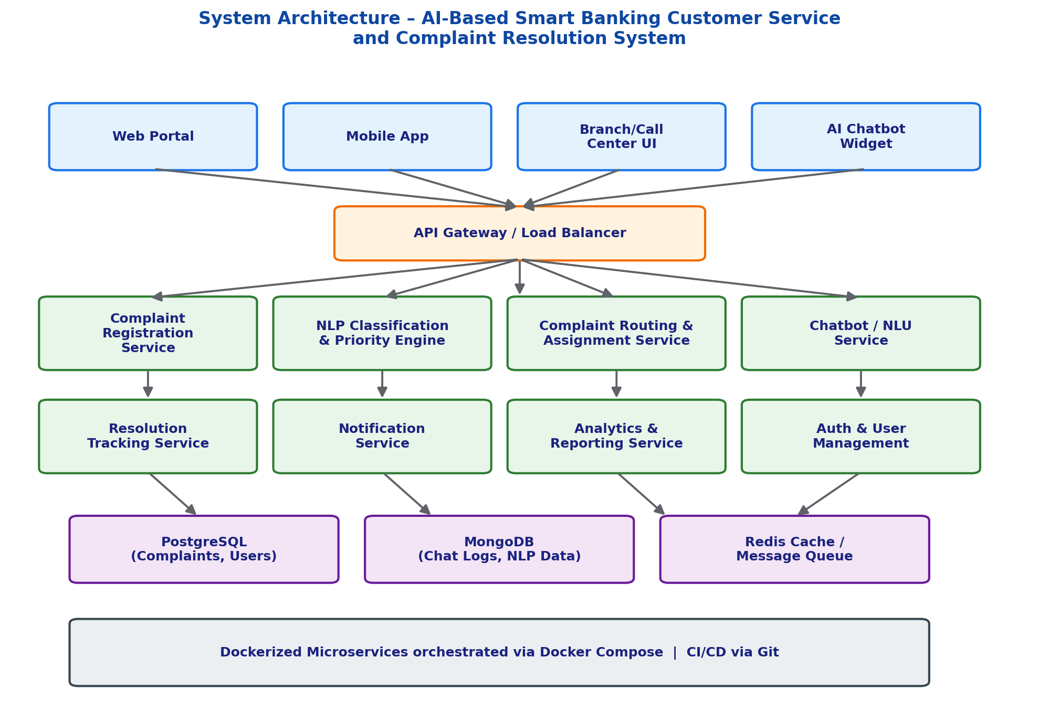
Figure 1: High-level system architecture of the Smart Banking Customer Service and Complaint Resolution System

2. Project Structure Design
The repository is organized around the microservices identified in the architecture, with a clear separation between application source code, infrastructure configuration, and documentation. This structure keeps each service independently buildable and testable while allowing Docker Compose to orchestrate them together.
smart-banking-crs/
├── frontend/ # React web client
│ ├── src/
│ ├── public/
│ ├── package.json
│ └── Dockerfile
├── backend-api/ # Node.js/Express core API (complaints, routing, auth)
│ ├── src/
│ │ ├── controllers/
│ │ ├── models/
│ │ ├── routes/
│ │ └── services/
│ ├── tests/
│ ├── package.json
│ └── Dockerfile
├── nlp-service/ # Python/FastAPI classification & priority engine
│ ├── app/
│ │ ├── classifier.py
│ │ ├── priority_engine.py
│ │ └── main.py
│ ├── requirements.txt
│ └── Dockerfile
├── chatbot-service/ # NLU-based chatbot microservice
│ ├── app/
│ ├── requirements.txt
│ └── Dockerfile
├── analytics-service/ # Reporting & dashboards
│ ├── src/
│ └── Dockerfile
├── docs/ # Architecture & workflow diagrams, ERD
├── .github/workflows/ # CI pipeline definitions
├── .gitignore
├── README.md
├── docker-compose.yml
└── .env.example

2.1 Purpose of Major Folders and Files
Folder / File | Purpose
frontend/ | React single-page application used by customers and staff to submit and track complaints.
backend-api/ | Core REST API handling complaint registration, routing, authentication, and orchestration of downstream services.
nlp-service/ | Independent Python microservice hosting the NLP classification model and priority-scoring logic.
chatbot-service/ | Handles conversational intents, chatbot dialogue flow, and hands off structured complaints to backend-api.
analytics-service/ | Aggregates data and exposes endpoints/dashboards for customer service KPIs.
docs/ | Architecture diagrams, ER diagrams, and workflow documentation referenced in this report.
.github/workflows/ | CI/CD pipeline definitions that run tests and build Docker images on every push.
.gitignore | Excludes node_modules, .env, build artefacts, and other non-versioned files from Git tracking.
README.md | Project overview, setup instructions, and usage guide for new contributors.
docker-compose.yml | Defines and orchestrates all containers, networks, and volumes for local/staging deployment.
.env.example | Template of required environment variables without exposing actual secrets.

3. Git Repository Initialization

3.1 Repository Initialization Steps
- Create the project root folder and navigate into it (mkdir smart-banking-crs && cd smart-banking-crs).
- Run git init to initialize a new local Git repository.
- Create a .gitignore file to exclude node_modules, __pycache__, .env, and build output.
- Add all initial files with git add . and create the first commit.
- Create a remote repository on GitHub and link it using git remote add origin <url>.
- Push the initial commit with git push -u origin main.
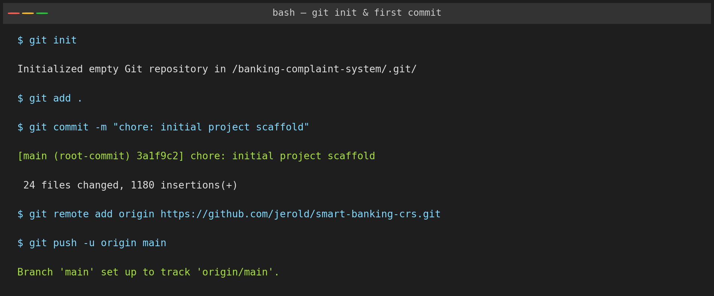
Figure 2: Terminal output of repository initialization and first commit/push

3.2 Purpose of Essential Git Files
File | Purpose
.git/ | Hidden directory created by git init that stores the entire object database, refs, and history of the repository.
.gitignore | Specifies intentionally untracked files (dependencies, secrets, build output) that Git should ignore.
README.md | Documents project purpose, setup, and usage for collaborators.
.env.example | Provides a safe template for environment variables without leaking credentials into version control.
package.json / requirements.txt | Declares dependencies per service so any collaborator can reproduce the environment.

4. Git Branching Strategy
The project adopts a Gitflow-inspired branching model, which suits a multi-microservice banking application that needs stable releases, parallel feature development, and rapid production hotfixes.
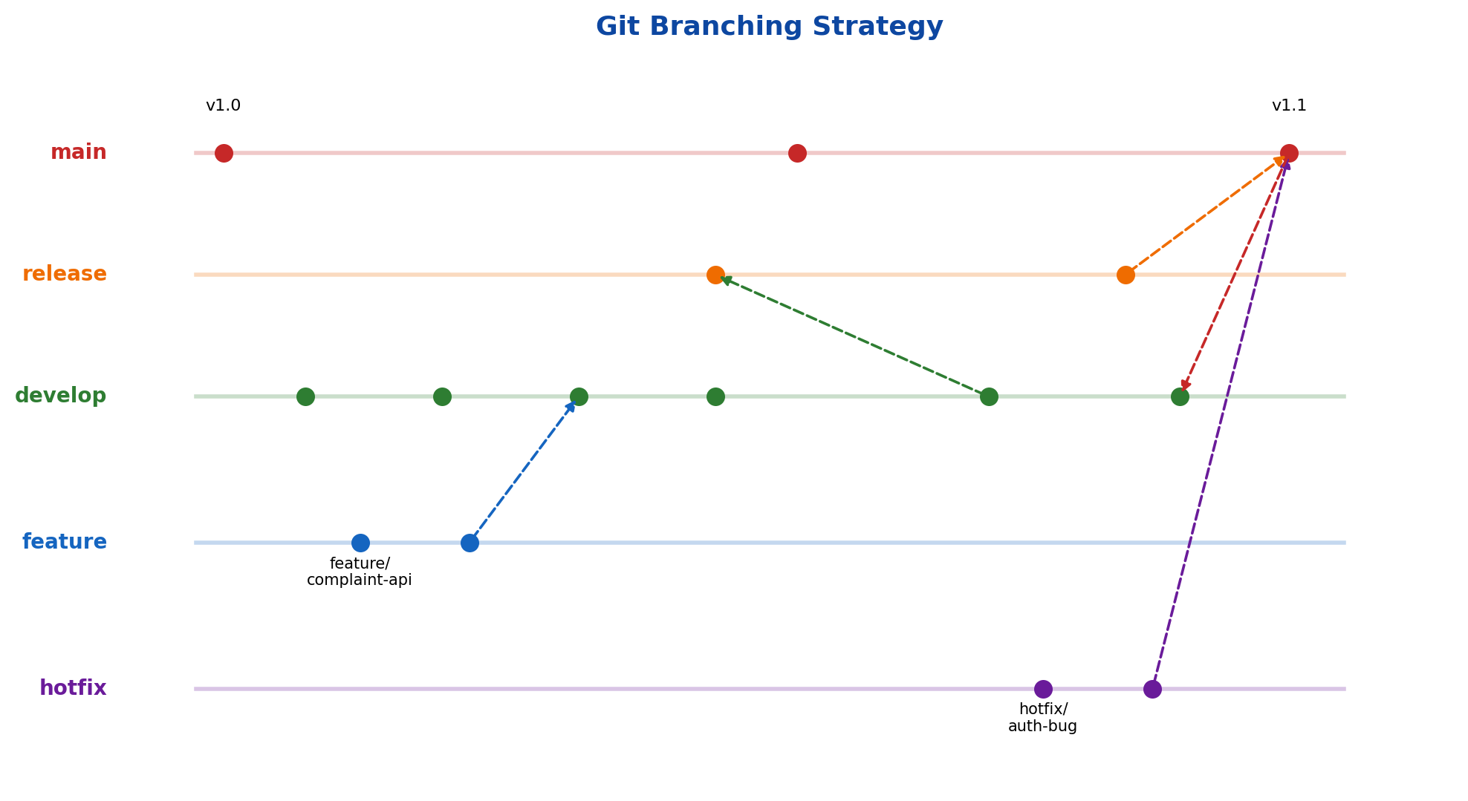
Figure 3: Git branching strategy used for the project
Branch | Purpose
main | Always reflects the current production-ready state of the application; only release and hotfix branches merge here.
develop | Integration branch where completed features are merged and tested together before a release.
feature/* | Short-lived branches created from develop for individual features, e.g. feature/complaint-classification.
release/* | Created from develop when preparing a new production release; used for final QA, versioning, and bug fixes.
hotfix/* | Created from main to urgently patch a production issue, then merged back into both main and develop.

4.1 Justification
A banking application must maintain a highly stable production branch at all times because downtime or defects can directly affect financial operations and customer trust. Gitflow's separation of develop and main allows the team to continuously integrate features such as the NLP classifier, chatbot, and analytics dashboard on develop, while main is only updated through controlled releases. The dedicated hotfix/* branches allow critical banking-related defects (e.g., an authentication bug) to be patched and deployed within minutes without waiting for the next scheduled release, which is essential in a regulated banking environment.

5. Version Control Workflow
The Git workflow below demonstrates feature branching, meaningful commits, merging, and synchronization, mirroring how the complaint-classification feature was developed and integrated.
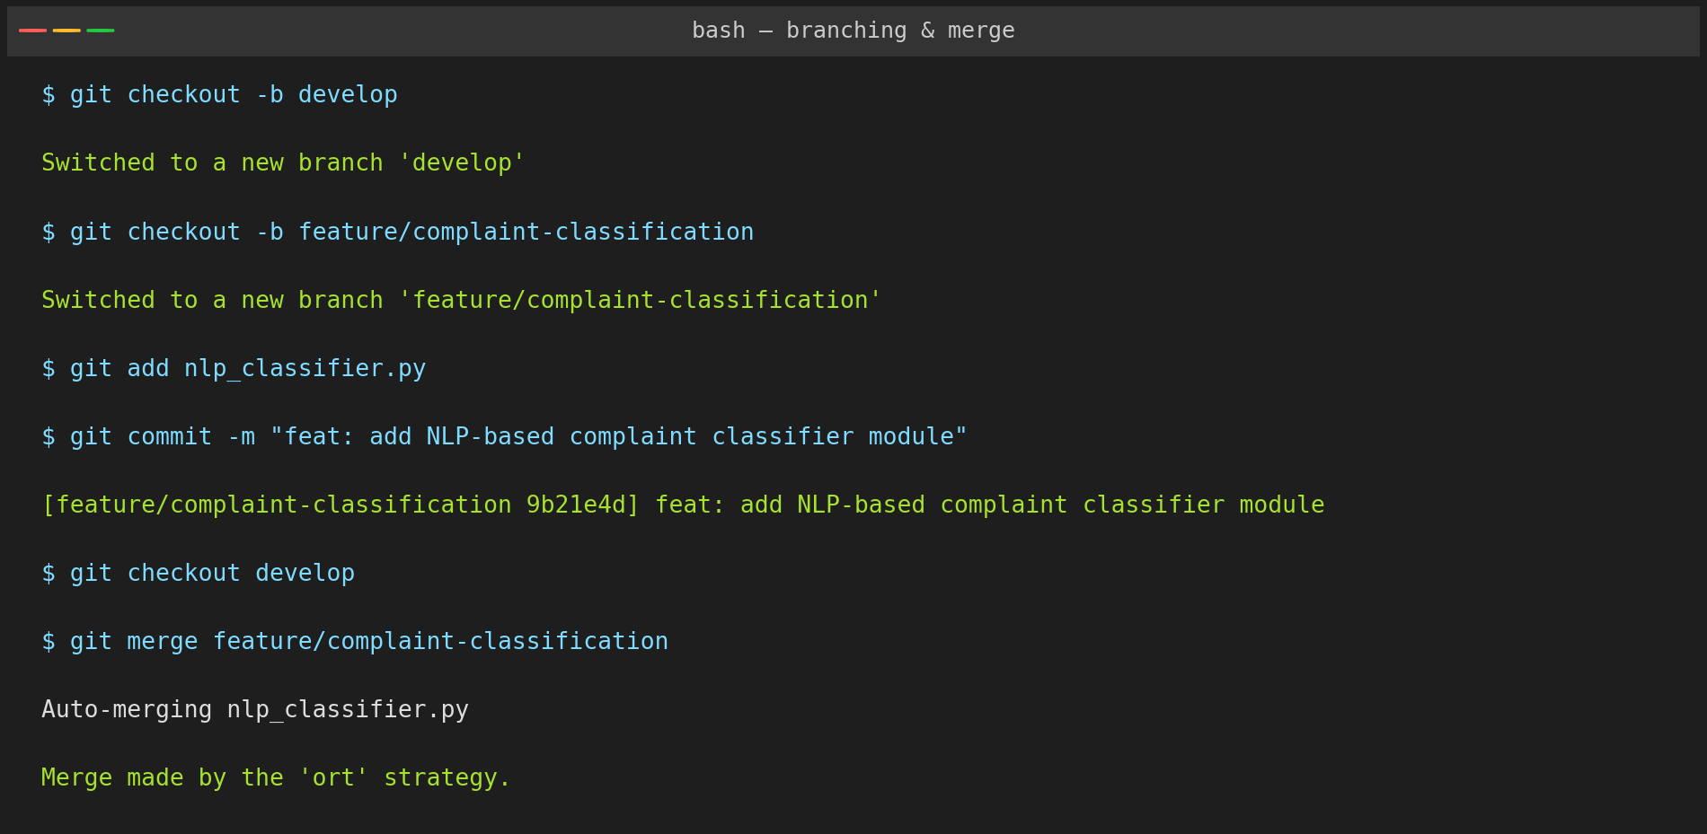
Figure 4: Creating a feature branch, committing changes, and merging into develop

5.1 Purpose of Each Git Operation
Operation | Purpose in this project
git checkout -b develop | Creates the shared integration branch off main.
git checkout -b feature/complaint-classification | Isolates development of the NLP classification module from other work.
git add / git commit | Records a meaningful, reviewable snapshot of the classifier implementation.
git checkout develop && git merge feature/... | Integrates the completed feature back into the shared develop branch.
git pull / git fetch | Synchronizes the local repository with the latest changes pushed by teammates.
git push | Publishes local commits to the shared remote (GitHub) repository.

5.2 Conflict Resolution
When two branches modify the same lines of nlp_classifier.py (for example, one branch tuning the priority thresholds while another adds a new complaint category), Git flags a merge conflict during git merge. The conflict markers (<<<<<<<, =======, >>>>>>>) are reviewed manually, the correct combined logic is retained, the file is re-staged with git add, and the merge is finalized with git commit. This ensures no teammate's work is silently overwritten during integration.

6. Commit History Analysis
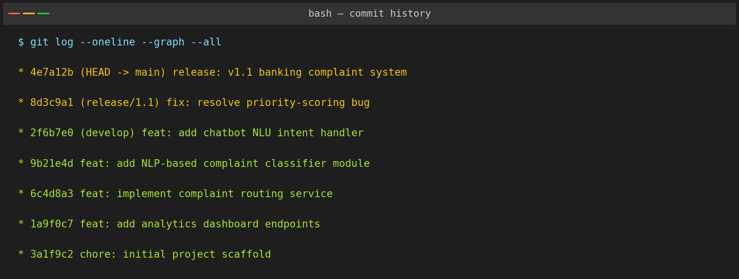
Figure 5: Commit history shown with git log --oneline --graph --all

6.1 Commit Message Conventions
Commits follow the Conventional Commits style (type: short description), which makes the project history self-documenting and easy to scan:
Prefix | Meaning
feat: | A new feature, e.g. feat: add NLP-based complaint classifier module
fix: | A bug fix, e.g. fix: resolve priority-scoring bug
chore: | Maintenance work not affecting application behaviour, e.g. chore: initial project scaffold
docs: | Documentation-only changes
release: | A tagged production release, e.g. release: v1.1 banking complaint system
Each commit message is written in the imperative mood, kept under ~70 characters for the summary line, and scoped to a single logical change. This practice makes it straightforward to generate changelogs, perform git bisect debugging, and understand the intent behind each change without inspecting the diff, which is especially valuable for auditability in a banking-domain project.

7. Docker Environment Design

7.1 Why Docker is Suitable
- Consistency: Every developer and environment (dev, staging, production) runs the identical containerized stack, eliminating "works on my machine" issues across the NLP, chatbot, and API services.
- Isolation: Each microservice (Node.js API, Python NLP engine, chatbot, databases) runs in its own container with its own dependencies, avoiding version conflicts.
- Portability: The system can be deployed on any cloud provider or on-premise bank data-centre that supports containers.
- Scalability: Individual services (e.g., nlp-service during peak complaint volume) can be scaled independently using Docker Compose or an orchestrator such as Kubernetes.
- Faster onboarding and CI/CD: New contributors and pipelines can bring up the full stack with a single docker compose up command.

7.2 Components Requiring Containerization
Component | Reason for Containerization
frontend (React) | Isolated build/runtime environment; served independently via its own web server.
backend-api (Node.js) | Core service with its own Node runtime and package dependencies.
nlp-service (Python/FastAPI) | Requires Python, ML/NLP libraries distinct from the Node.js stack.
chatbot-service (Python) | Separate NLU dependencies and independent scaling needs during peak chat traffic.
postgres-db | Persistent relational store for complaints and user data, isolated with a named volume.
mongo-db | Stores unstructured chat logs and NLP training/inference artefacts.
redis-cache | In-memory cache and message broker between services.
nginx-gateway | Reverse proxy / API gateway routing external traffic to the correct service.

8. Dockerfile Development
The backend-api service uses a multi-stage Dockerfile to keep the final production image small and secure:
# ---- Stage 1: install dependencies ----
FROM node:18-alpine AS builder
WORKDIR /app
COPY package*.json ./
RUN npm install --production

# ---- Stage 2: build runtime image ----
FROM node:18-alpine
WORKDIR /app
COPY --from=builder /app/node_modules ./node_modules
COPY . .
ENV NODE_ENV=production
EXPOSE 5000
HEALTHCHECK --interval=30s --timeout=5s CMD wget -qO- http://localhost:5000/health || exit 1
CMD ["node", "src/server.js"]

8.1 Purpose of Each Instruction
Instruction | Purpose
FROM node:18-alpine | Selects a lightweight official Node.js base image to minimize image size.
WORKDIR /app | Sets the working directory inside the container for subsequent commands.
COPY package*.json ./ | Copies only dependency manifests first to leverage Docker layer caching.
RUN npm install --production | Installs only production dependencies, keeping the image lean.
COPY --from=builder ... | Copies pre-installed node_modules from the builder stage (multi-stage build).
COPY . . | Copies the remaining application source code into the image.
ENV NODE_ENV=production | Configures the Node.js runtime for production behaviour.
EXPOSE 5000 | Documents the port the container listens on.
HEALTHCHECK | Allows Docker/Compose to detect and report an unhealthy container automatically.
CMD | Defines the default command executed when the container starts.
The nlp-service and chatbot-service use an equivalent Python-based Dockerfile (FROM python:3.11-slim, pip install -r requirements.txt, CMD ["uvicorn", "app.main:app", "--host", "0.0.0.0", "--port", "8001"]), following the same layered-caching and minimal-image principles.
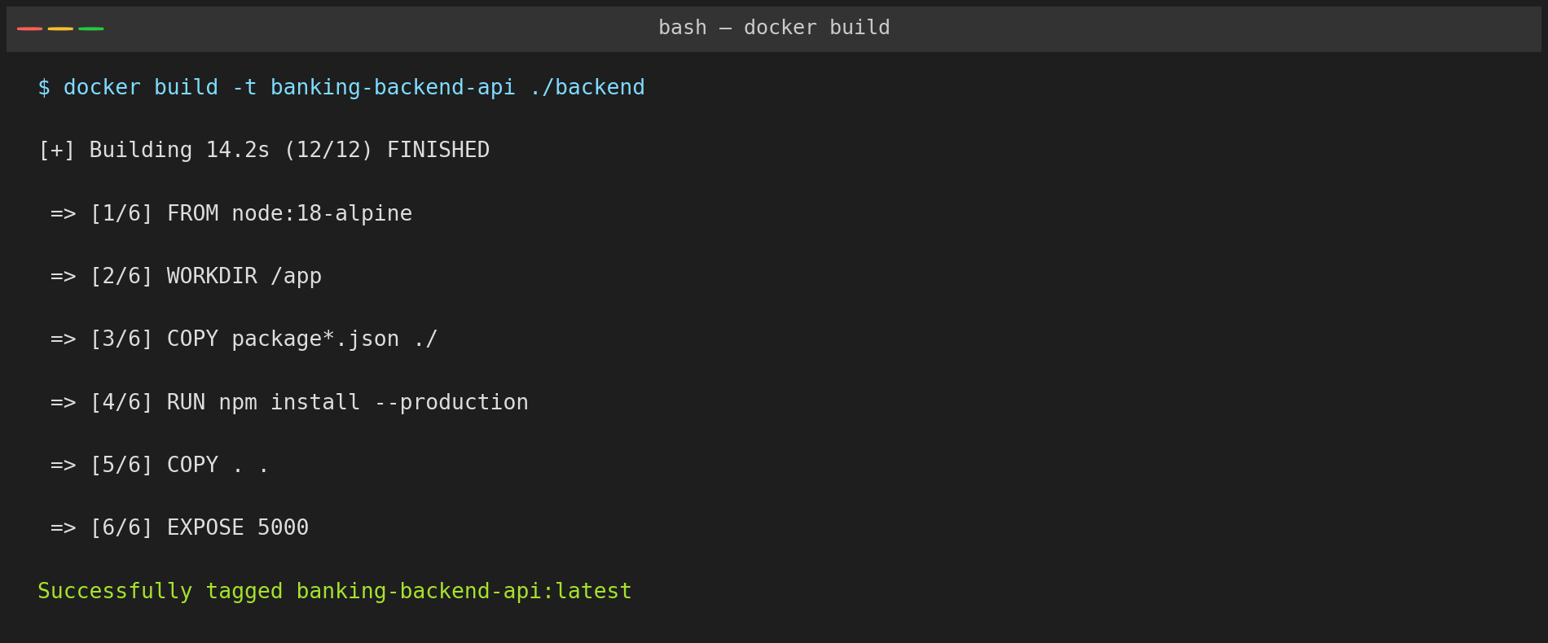
Figure 6: Building the backend-api image with docker build

9. Docker Compose Design
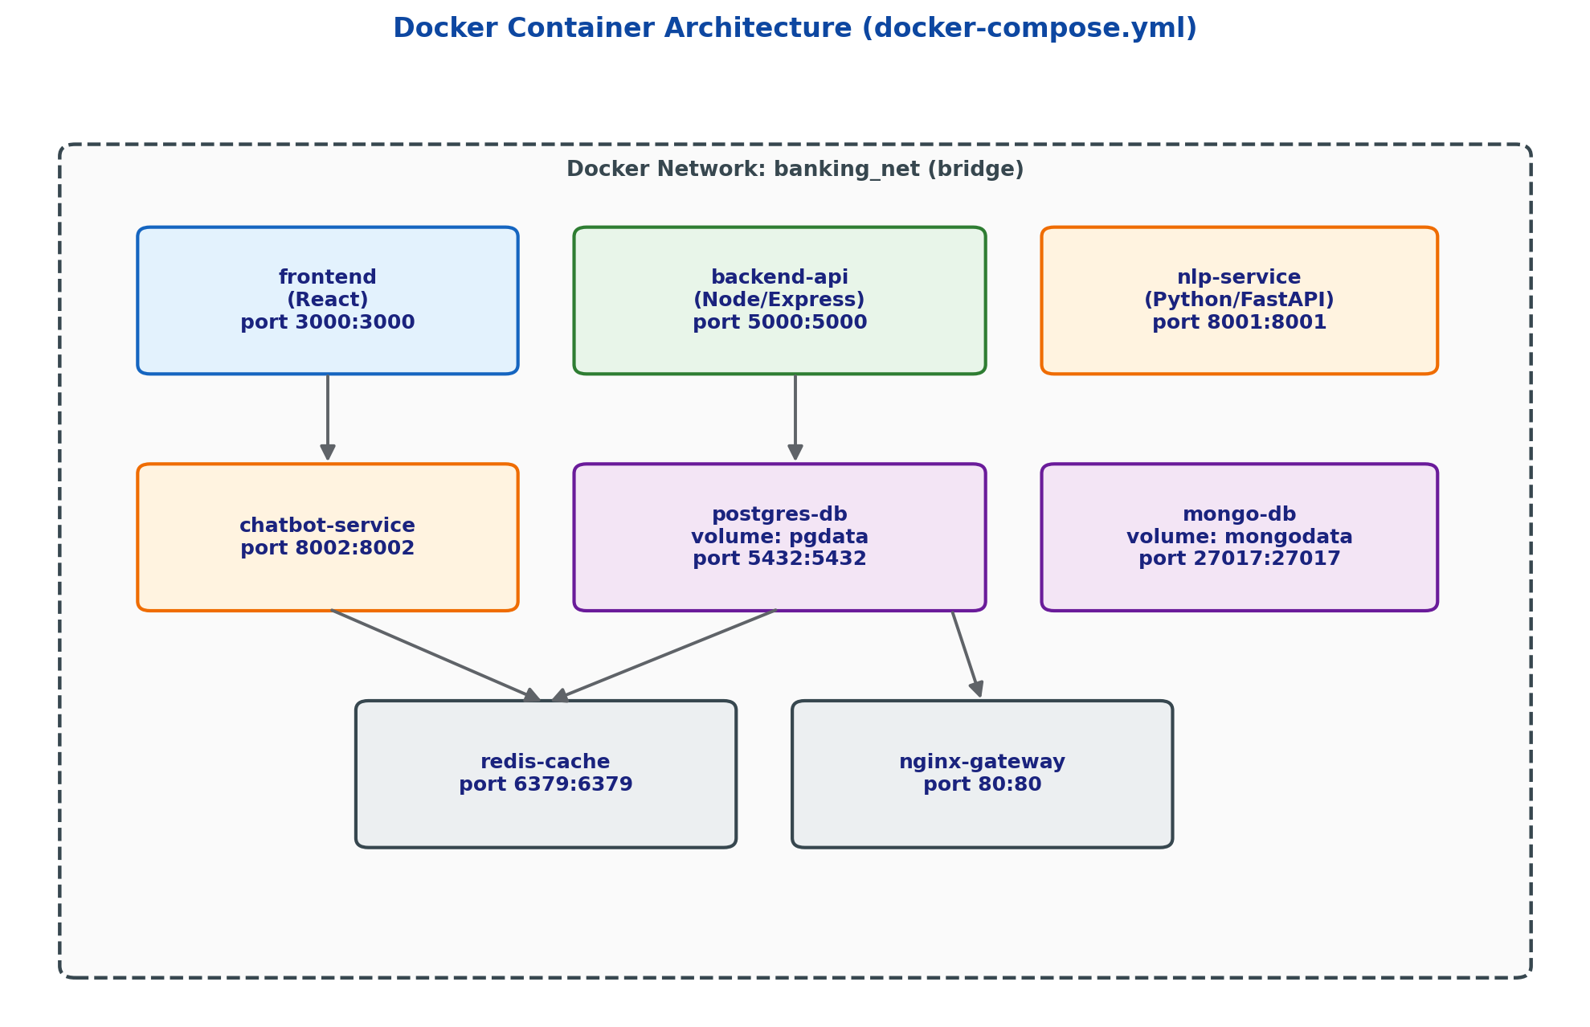
Figure 7: Container architecture defined in docker-compose.yml
version: "3.9"
services:
frontend:
build: ./frontend
ports: ["3000:3000"]
depends_on: [backend-api]
networks: [banking_net]

backend-api:
build: ./backend-api
ports: ["5000:5000"]
environment:
- DB_HOST=postgres-db
- REDIS_HOST=redis-cache
- NLP_SERVICE_URL=http://nlp-service:8001
depends_on: [postgres-db, redis-cache, nlp-service]
networks: [banking_net]

nlp-service:
build: ./nlp-service
ports: ["8001:8001"]
networks: [banking_net]

chatbot-service:
build: ./chatbot-service
ports: ["8002:8002"]
depends_on: [nlp-service]
networks: [banking_net]

postgres-db:
image: postgres:15
volumes: ["pgdata:/var/lib/postgresql/data"]
environment:
- POSTGRES_DB=banking_crs
- POSTGRES_PASSWORD=${DB_PASSWORD}
networks: [banking_net]

mongo-db:
image: mongo:6
volumes: ["mongodata:/data/db"]
networks: [banking_net]

redis-cache:
image: redis:7-alpine
networks: [banking_net]

nginx-gateway:
image: nginx:alpine
ports: ["80:80"]
depends_on: [frontend, backend-api]
networks: [banking_net]

networks:
banking_net:
driver: bridge

volumes:
pgdata:
mongodata:

9.1 Services, Networking, Volumes, Environment Variables, and Dependencies
Aspect | Explanation
Services | Eight services corresponding to each microservice/data store identified in the architecture (frontend, backend-api, nlp-service, chatbot-service, postgres-db, mongo-db, redis-cache, nginx-gateway).
Networking | All services join a single custom bridge network, banking_net, so containers can resolve each other by service name (e.g., http://nlp-service:8001).
Volumes | Named volumes pgdata and mongodata persist database contents across container restarts and rebuilds.
Environment variables | Configuration such as DB_HOST, REDIS_HOST, and NLP_SERVICE_URL is injected at runtime, keeping the images environment-agnostic; secrets like DB_PASSWORD are supplied via a .env file, never hard-coded.
Dependencies (depends_on) | Ensures databases and the NLP service start before backend-api, and backend-api starts before the gateway, so the application boots in the correct order.

10. Container Deployment and Testing

10.1 Deployment
The full stack is brought up locally with a single command, which builds each image and starts all containers on the shared banking_net network:
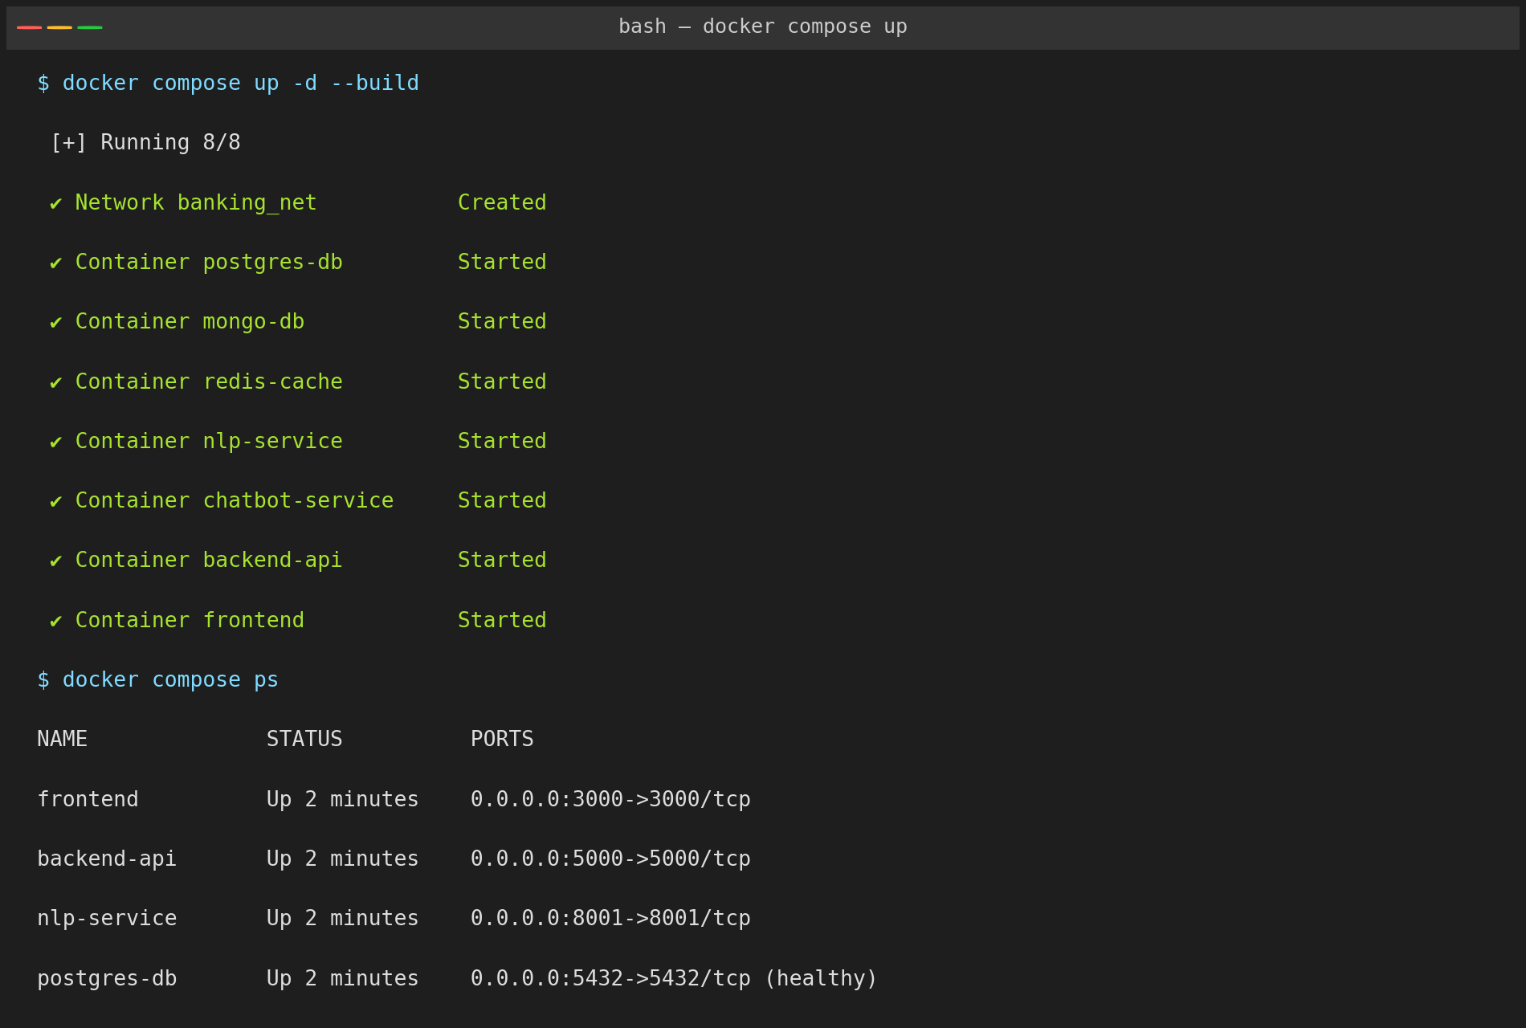
Figure 8: docker compose up -d --build bringing all eight containers online, and docker compose ps confirming healthy status

10.2 Testing Procedure
- Verify all containers report an "Up"/"healthy" status using docker compose ps.
- Exercise the complaint-registration endpoint directly with a REST client (curl/Postman) to confirm end-to-end connectivity between backend-api, nlp-service, and postgres-db.
- Verify the NLP classifier returns a category and priority for a sample complaint.
- Load the frontend at http://localhost:3000 and submit a complaint through the UI to confirm the full user flow.
- Interact with the chatbot to confirm it can log a complaint conversationally via chatbot-service.
- Check the analytics dashboard reflects the newly created complaint in real time.
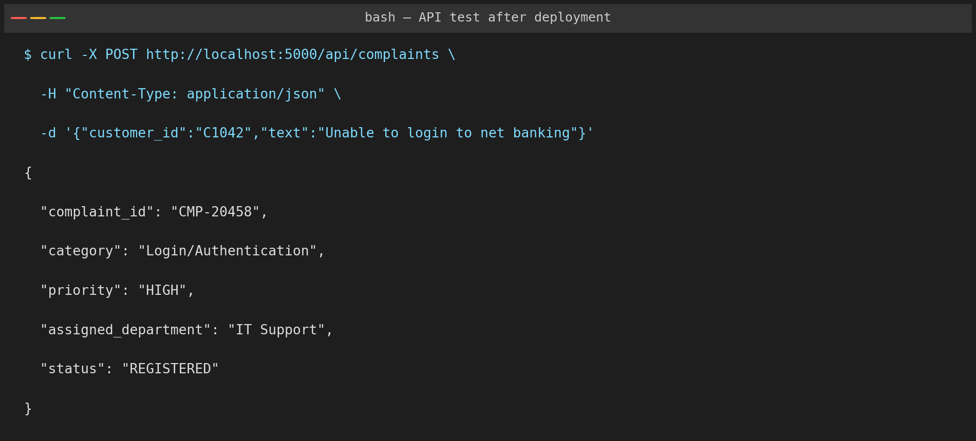
Figure 9: Sample POST request to /api/complaints and the classified, prioritized, and routed response
The response confirms the complaint was registered, automatically classified as "Login/Authentication", scored as HIGH priority, and routed to the IT Support department — demonstrating that the containerized services communicate correctly end-to-end.

11. Benefits of Git and Docker
Dimension | Benefit to this Project
Collaboration | Gitflow branching lets multiple contributors work on the NLP engine, chatbot, and frontend in parallel without interfering with a stable main branch.
Version management | Every change to complaint-classification logic or Dockerfiles is tracked, reviewable, and reversible through commit history and tags.
Portability | Docker images run identically on a developer laptop, a CI runner, or the bank's production servers, regardless of underlying OS.
Deployment | docker compose up automates multi-service deployment that would otherwise require manually installing Node.js, Python, PostgreSQL, MongoDB, and Redis on every environment.
Scalability | High-load services such as nlp-service and chatbot-service can be scaled horizontally (multiple container replicas) independently of the rest of the stack.
Maintainability | Clear branch history plus isolated, versioned containers make it easy to trace, reproduce, and fix defects, which is critical in a regulated banking system.

12. Challenges and Improvements

12.1 Challenges Encountered
- Coordinating inter-service dependencies in Docker Compose (e.g., backend-api starting before postgres-db was fully ready) required adding health checks and startup ordering.
- Merge conflicts arose when multiple feature branches modified shared configuration files such as docker-compose.yml.
- Keeping the NLP model's dependencies (Python) isolated from the Node.js backend added initial complexity to the container network design.
- Managing environment-specific secrets (database passwords, API keys) securely across development and production required careful use of .env files and .gitignore.
- Ensuring consistent commit-message discipline across contributors needed an agreed convention and periodic review.

12.2 Suggested Improvements and Future Enhancements
- Introduce Kubernetes for production-grade orchestration, auto-scaling, and self-healing beyond what Docker Compose offers.
- Add automated CI/CD pipelines (GitHub Actions) that run tests and security scans before every merge to develop, and auto-deploy release branches.
- Adopt pull-request-based code review with mandatory approvals before merging into develop or main.
- Integrate a secrets manager (e.g., HashiCorp Vault or a cloud KMS) instead of local .env files for production credentials.
- Enhance the NLP model with continuous learning from agent feedback to improve classification and priority-scoring accuracy over time.
- Add distributed tracing and centralized logging (e.g., ELK stack) across all microservices for easier debugging in production.

