CO2 ASSESSMENT TOOL - 2
Architecture Design Assignment

Student Name | JEROLD SAMUEL J
Register Number | 192571052
Course Code | CSA1017
Course Title | Software Engineering
CO Assessed | CO2 AT2
Assessment | Assessment Tool 2 – Architecture Design Assignment
Assigned Problem No. | 37 – Intelligent AI-Based Smart Banking Customer Service and Complaint Resolution System
Weightage / Total Marks | 20% / 25 Marks

Rubrics for Evaluation
Evaluation Criteria | Excellent (4 Marks) | Good (3 Marks) | Satisfactory (2 Marks) | Needs Improvement (1 Mark)
System Requirement Analysis | Thoroughly analyzes the problem statement, accurately identifies functional and non-functional requirements, and clearly explains quality attributes influencing the architecture. | Analyzes most requirements with minor omissions or limited explanation. | Identifies only basic requirements with partial analysis. | Requirement analysis is incomplete, inaccurate, or lacks clarity.
Selection of Software Architecture | Selects the most appropriate architectural style with strong technical justification aligned to system requirements. | Selects a suitable architecture with reasonable justification. | Architecture is partially suitable with limited justification. | Inappropriate architecture selected or justification is missing.
Architecture Diagram and Component Design | Produces a clear, complete, and well-structured architecture diagram with all major components, interfaces, and interactions accurately represented. | Diagram is mostly complete with minor omissions or notation issues. | Diagram includes only essential components and lacks sufficient detail. | Diagram is incomplete, unclear, or technically incorrect.
Component Interaction and Quality Attribute Analysis | Clearly explains component responsibilities, interactions, and thoroughly discusses scalability, security, performance, reliability, maintainability, and availability. | Explains most components and quality attributes with minor gaps. | Provides limited explanation of interactions and addresses only some quality attributes. | Component interactions and quality attributes are poorly explained or missing.
Architectural Justification and Technical Presentation | Provides strong justification for architectural decisions, discusses trade-offs and future enhancements, and presents a well-organized, professional report. | Provides adequate justification with minor gaps; report is well organized. | Limited justification with minimal discussion of trade-offs or future scope; report needs improvement. | Justification is weak or absent; report lacks organization and technical clarity.

Criteria | Marks
System Requirement Analysis | /5
Selection of Software Architecture | /5
Architecture Diagram and Component Design | /5
Component Interaction and Quality Attribute Analysis | /5
Architectural Justification and Technical Presentation | /5
TOTAL | /25

Intelligent AI-Based Smart Banking Customer Service and Complaint Resolution System

Industry Context
Banks handle thousands of customer inquiries and complaints daily through branches, call centers, mobile applications, and online portals.
AI, Natural Language Processing (NLP), chatbots, and analytics help automate customer service while improving response time and service quality.

Problem Statement
Traditional complaint management systems involve manual routing and delayed responses, leading to customer dissatisfaction.
Banks require intelligent systems capable of classifying customer requests, prioritizing critical issues, assigning them to the appropriate departments, and tracking resolution progress.
An AI-powered customer service platform should automate complaint handling, provide chatbot assistance, monitor service quality, and generate customer satisfaction analytics to improve banking services.

Architecture Design Analysis Report

This report presents a complete architecture design analysis for the Intelligent AI-Based Smart Banking Customer Service and Complaint Resolution System, prepared in accordance with the CO2 Architecture Design Assignment guidelines.

1. Analyze System Requirements

1.1 System Objectives

The core objective of the system is to replace slow, manual, and error-prone complaint handling with an intelligent, automated platform that can register, classify, prioritize, route, track, and resolve customer complaints across all banking channels, while continuously learning from customer feedback to improve service quality.

1.2 Functional Requirements
- Allow customers to register complaints through mobile app, internet banking portal, branch terminal, IVR/SMS, and an AI chatbot.
- Automatically classify each complaint into a category (e.g., card issue, loan, fraud, account, digital banking) using an NLP engine.
- Perform sentiment analysis to detect customer frustration or urgency from the complaint text.
- Assign a priority level (Critical, High, Medium, Low) based on classification, sentiment, and customer profile (e.g., fraud complaints are always Critical).
- Automatically route the complaint to the correct department or available agent queue.
- Provide a chatbot capable of answering FAQs, guiding complaint registration, and reporting live case status.
- Track the complaint lifecycle in real time and enforce Service Level Agreement (SLA) timers with escalation on breach.
- Send proactive notifications (SMS, e-mail, push) at every stage of resolution.
- Collect a post-resolution customer satisfaction survey.
- Generate analytical dashboards for management on complaint volume, turnaround time (TAT), agent performance, and satisfaction trends.
- Integrate with the Core Banking System (CBS) to verify customer and transaction details during complaint handling.
- Maintain a complete, tamper-evident audit trail of every action for regulatory compliance.

1.3 Non-Functional Requirements & Quality Attributes
Because the system operates within a regulated, high-volume banking environment, the following quality attributes strongly influence the architecture:
Quality Attribute | Why It Matters for This System
Scalability | Complaint volume spikes sharply during salary days, festive offers, or outages; the system must scale specific services (e.g., NLP classification) independently without over-provisioning the entire platform.
Security | The system processes sensitive financial and personal data, so it must enforce encryption, authentication, role-based access control, and compliance with banking data-protection regulations.
Performance | Chatbot responses and complaint classification must occur within seconds to keep the customer engaged and avoid channel abandonment.
Reliability | A complaint must never be lost or duplicated; the platform needs guaranteed message delivery and fault-tolerant processing.
Availability | Banking customer service is expected to be available 24/7, including during partial component failures or maintenance windows.
Maintainability | New complaint categories, languages, and AI models must be added or updated frequently without disrupting the live system.

2. Select a Suitable Software Architecture

2.1 Selected Architectural Style
The proposed system adopts a Microservices Architecture combined with an Event-Driven Architecture (EDA) backbone, fronted by an API Gateway. This hybrid style is best suited to the scale, heterogeneity, and continuous-evolution needs of an AI-powered banking customer service platform.

2.3 Justification of Selection
- Independent scalability: The AI/NLP classification and chatbot services experience unpredictable, bursty load and can be scaled horizontally on their own, without over-provisioning simpler services such as notifications.
- Fault isolation: A failure in the chatbot or analytics service does not bring down complaint registration or case tracking, which are the most business-critical functions.
- Technology flexibility: NLP/AI models are best built in Python with ML frameworks, while transaction-critical services can remain in Java/.NET — microservices allow each to use the most suitable stack.
- Asynchronous, decoupled processing: The event bus (Kafka) allows classification, routing, notification, and analytics to react to a single 'complaint registered' event independently and asynchronously, improving responsiveness for the customer.
- Continuous delivery: New complaint categories, languages, or improved AI models can be deployed to a single microservice without redeploying the entire platform, supporting rapid iteration.
- Compared to a monolithic layered architecture, which would tightly couple the AI engine with core banking logic and be difficult to scale selectively, or a pure client-server model, which lacks the modularity needed for independent AI model updates, the microservices plus event-driven hybrid offers the best balance of scalability, resilience, and agility for this problem.

3. Software Architecture Diagram
The diagram below illustrates the complete layered structure of the proposed system — from client channels through the API gateway, the microservices layer, the Kafka-based event backbone, the polyglot data persistence layer, down to external system integrations.
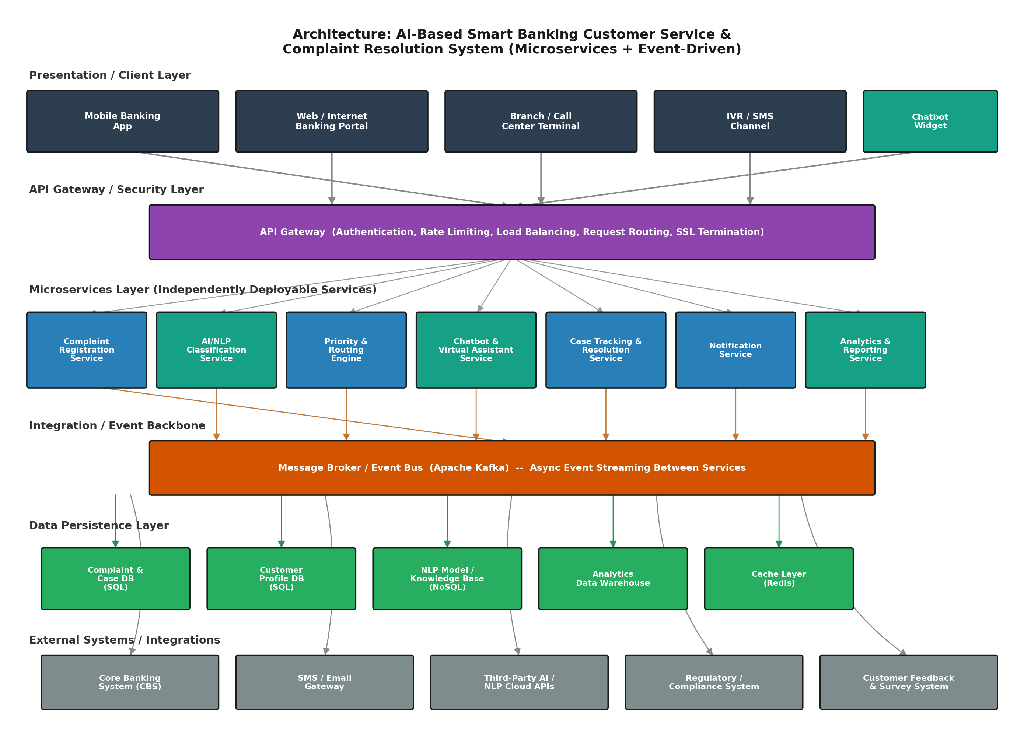
Figure 1: Proposed Microservices + Event-Driven Architecture for the AI-Based Smart Banking Customer Service and Complaint Resolution System

3.1 Layer Summary
- Presentation / Client Layer – Mobile app, internet banking portal, branch/call-center terminal, IVR/SMS, and chatbot widget through which customers raise and track complaints.
- API Gateway / Security Layer – Single entry point that performs authentication, rate limiting, load balancing, request routing, and SSL termination for all client requests.
- Microservices Layer – Independently deployable services: Complaint Registration, AI/NLP Classification, Priority & Routing Engine, Chatbot & Virtual Assistant, Case Tracking & Resolution, Notification, and Analytics & Reporting.
- Integration / Event Backbone – Apache Kafka message broker enabling asynchronous, loosely coupled communication between microservices.
- Data Persistence Layer – Polyglot persistence with a Complaint/Case SQL database, Customer Profile SQL database, NoSQL store for the NLP model and knowledge base, an analytics data warehouse, and a Redis cache for low-latency lookups.
- External Systems – Core Banking System (CBS), SMS/e-mail gateway, third-party AI/NLP cloud APIs, regulatory/compliance systems, and the customer feedback and survey system.

4. Explain Components and Their Interactions
Component | Responsibility | Key Interactions
API Gateway | Authenticates requests, applies rate limits, and routes traffic to the correct backend microservice. | Receives all client calls; forwards to microservices over REST/HTTPS.
Complaint Registration Service | Captures complaint details, attachments, and customer/account references; creates the initial case record. | Publishes a 'ComplaintRegistered' event to Kafka; writes to Complaint DB.
AI/NLP Classification Service | Analyzes complaint text/voice to detect category, intent, and sentiment using trained NLP models. | Consumes registration events; calls third-party AI APIs when needed; publishes 'ComplaintClassified' event.
Priority & Routing Engine | Assigns a priority level and routes the case to the correct department/agent queue. | Consumes classification events; updates Case Tracking Service; may query Customer Profile DB.
Chatbot & Virtual Assistant | Provides conversational self-service for FAQs, guided complaint filing, and live status queries. | Calls Complaint Registration and Case Tracking services synchronously via the gateway; uses NLP service for intent detection.
Case Tracking & Resolution Service | Maintains case state, enforces SLA timers, and manages escalation workflow until resolution. | Reads/writes Complaint DB; publishes status-change events consumed by Notification and Analytics services.
Notification Service | Sends SMS, e-mail, and push notifications at each stage of the complaint lifecycle. | Subscribes to status-change events; calls external SMS/e-mail gateway.
Analytics & Reporting Service | Aggregates operational data into dashboards — volumes, TAT, satisfaction, agent performance. | Consumes all lifecycle events asynchronously; writes to the analytics data warehouse.

4.1 Overall Workflow
The diagram below traces a single complaint end-to-end through the six major processing stages, showing how the microservices collaborate via the event backbone, and how feedback from later stages continually improves the AI classification model.
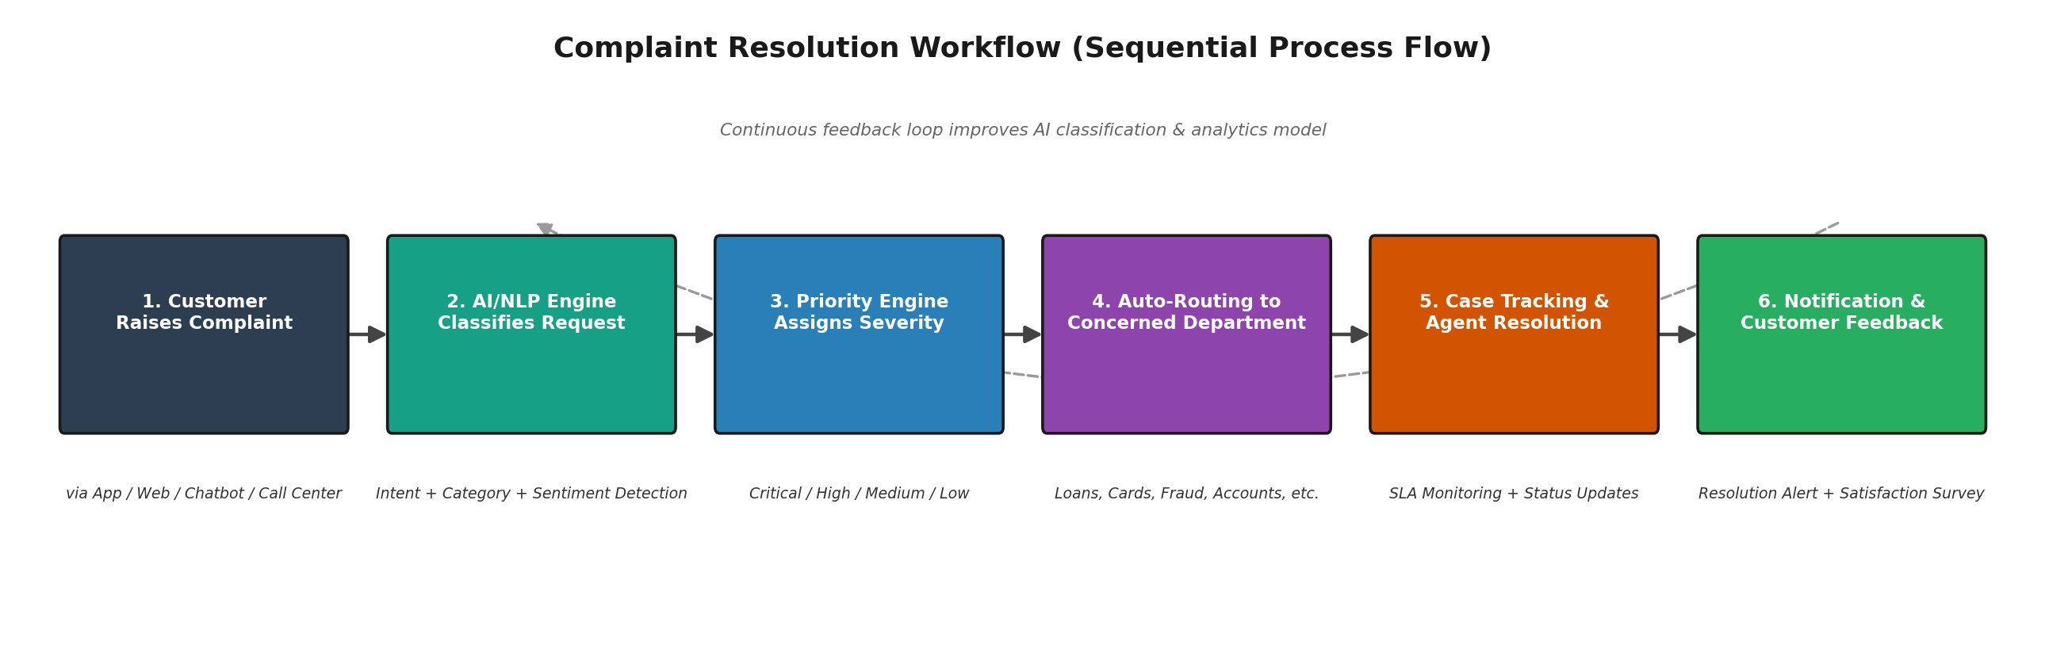
Figure 2: Complaint Resolution Workflow across Microservices

5. Discuss Quality Attributes
The chosen microservices and event-driven architecture directly addresses each of the required quality attributes, summarized visually below and explained in detail thereafter.
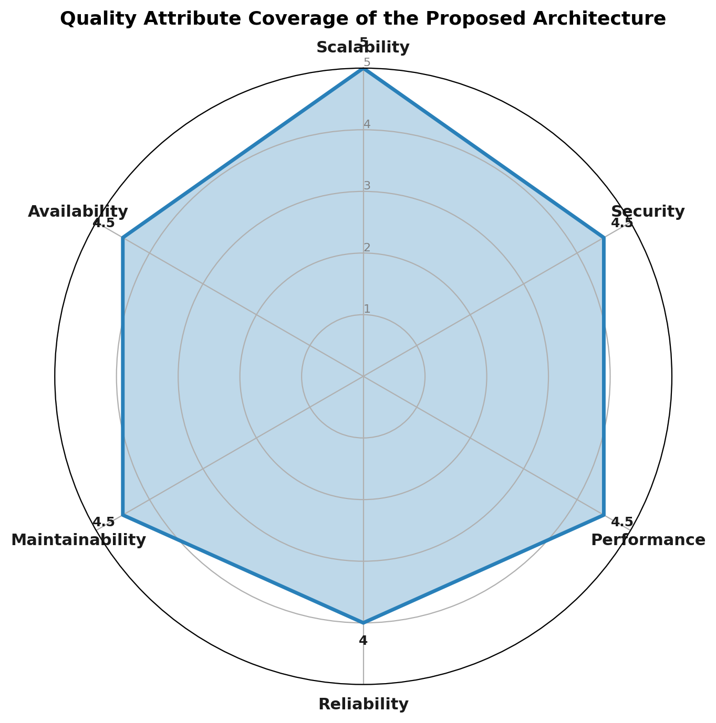
Figure 3: Illustrative Quality Attribute Coverage of the Proposed Architecture
Scalability: Each microservice, especially the AI/NLP Classification and Chatbot services, can be scaled horizontally and independently using container orchestration (e.g., Kubernetes) to absorb sudden spikes in complaint volume without over-provisioning the entire system.
Security: The API Gateway centralizes authentication (OAuth2/JWT), role-based access control, and SSL termination; sensitive data is encrypted in transit and at rest, and every action is logged for regulatory audit.
Performance: Redis caching, an asynchronous event backbone, and dedicated scaling of latency-sensitive services (chatbot, classification) together keep customer-facing response times low even under load.
Reliability: Kafka guarantees durable, at-least-once event delivery between services, and the database-per-service pattern combined with retry/idempotency logic ensures no complaint is lost or processed twice.
Maintainability: Loose coupling between microservices allows any single service — such as the NLP model — to be updated, tested, and redeployed independently without touching the rest of the system.
Availability: Redundant service instances behind the API Gateway, combined with asynchronous processing that tolerates temporary downstream slowdowns, support the 24/7 availability banking customers expect.

6. Justify Architectural Decisions

6.1 Rationale
The architecture was chosen to directly map system objectives (automation, AI-based classification, intelligent routing, tracking, and analytics) onto independently scalable and deployable services, connected by an event backbone that keeps the customer-facing path fast while heavier processing (classification, analytics) happens asynchronously in the background.

6.2 Trade-offs Considered
- Operational complexity: A distributed microservices system requires container orchestration, service discovery, and centralized logging/monitoring, adding DevOps overhead compared to a simpler monolith.
- Eventual consistency: Because services communicate asynchronously via events, there can be a brief delay before all services (e.g., analytics) reflect the latest complaint status — acceptable here since core case status is still updated synchronously and reliably.
- Increased infrastructure cost: Running many small services and a message broker costs more at small scale than a monolith, but this is justified by the scalability and agility needed at banking scale.
- Network latency: Inter-service calls introduce some latency versus in-process calls in a monolith; this is mitigated using asynchronous events and caching for latency-sensitive paths.

6.3 Support for Future Enhancements
Because each capability is isolated as its own service behind the event backbone, the platform can evolve without disrupting existing functionality. For example, a voice-bot channel, a dedicated fraud-detection microservice, multilingual NLP models, or a blockchain-based audit trail can each be introduced as a new service that simply publishes and subscribes to existing Kafka topics. Containerized deployment (Docker/Kubernetes) and independent CI/CD pipelines per service further support long-term maintainability, allowing the bank to continuously improve AI accuracy and customer experience with minimal risk to the live system.

6.4 Conclusion
The proposed Microservices and Event-Driven Architecture, fronted by an API Gateway, satisfies the functional and non-functional requirements of the Intelligent AI-Based Smart Banking Customer Service and Complaint Resolution System. It delivers the scalability, security, performance, reliability, availability, and maintainability that a modern banking customer service platform demands, while remaining flexible enough to support future AI-driven enhancements and long-term system growth.

