CO2-ASSESMENT TOOL 1

CSA1017-SOFTWARE ENGINEERING

AI-Based Smart Banking Customer Service and Complaint Resolution System

NAME | JEROLD SAMUEL J
REGISTRATION NO | 192571052
DEPARTMENT NAME | B.TECH CS BS

Problem Statement
Banks receive thousands of customer inquiries and complaints every day through branches, call centers, mobile applications, and online banking platforms. Traditional complaint management systems rely heavily on manual processes, making it difficult to classify complaints, assign them to the appropriate departments, and track their resolution efficiently. These delays often result in poor customer experiences, increased operational workload, and reduced service quality.
To overcome these challenges, an Intelligent AI-Based Smart Banking Customer Service and Complaint Resolution System is proposed. The system uses Artificial Intelligence (AI), Natural Language Processing (NLP), and chatbot technology to automate complaint registration, classify customer requests, prioritize critical issues, assign complaints to the appropriate departments, monitor resolution progress, and provide real-time updates. This intelligent approach improves response time, enhances customer satisfaction, reduces manual effort, and enables banks to deliver faster, more reliable, and customer-centric services.
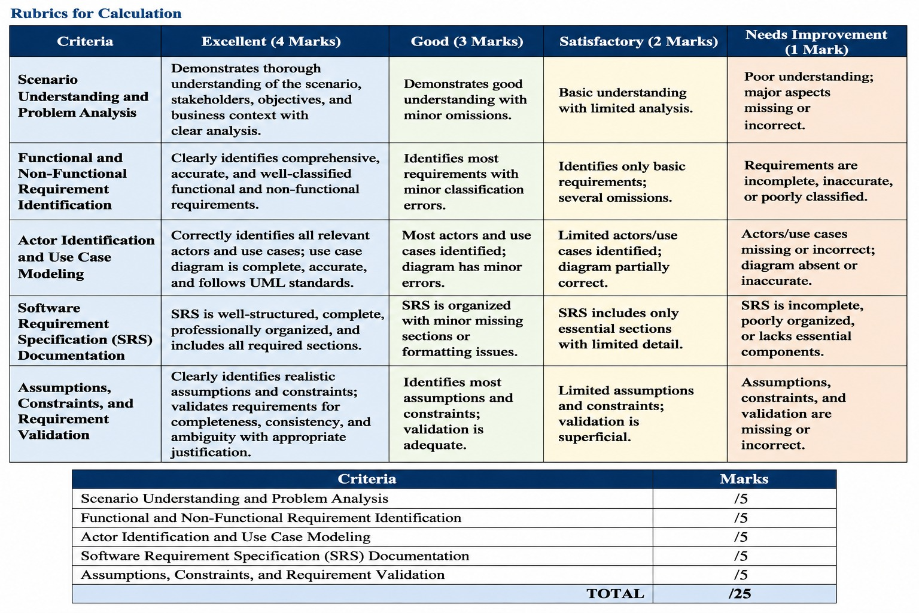

Introduction
The Intelligent AI-Based Smart Banking Customer Service and Complaint Resolution System is a software solution designed to improve the efficiency and quality of customer service in the banking sector by using Artificial Intelligence (AI), Natural Language Processing (NLP), chatbots, and data analytics. As digital banking services continue to expand, banks receive a large number of customer inquiries and complaints through branches, call centers, mobile applications, internet banking, and online portals. Managing these requests manually often leads to delayed responses, incorrect complaint routing, increased workload, and reduced customer satisfaction.
Traditional complaint management systems rely heavily on human intervention for registering, categorizing, assigning, and tracking customer complaints. This process is time-consuming and may result in errors, inconsistent service quality, and longer resolution times. Customers today expect quick responses, real-time updates, and seamless support across multiple communication channels. Therefore, banks require an intelligent system that can automate routine tasks while ensuring that critical complaints are handled promptly.
The proposed system uses AI to automatically classify customer complaints, determine their priority, and assign them to the appropriate department for resolution. It also provides an AI-powered chatbot that offers 24/7 assistance by answering common customer queries, helping users register complaints, and providing complaint status updates. If a customer's issue cannot be resolved automatically, the system forwards it to the appropriate customer service representative for further action.
In addition to complaint management, the system includes dashboards and analytical reports that help bank management monitor complaint trends, response times, service quality, and customer satisfaction. These insights support better decision-making and enable banks to continuously improve their customer service processes. The system also incorporates secure authentication, role-based access control, and data protection mechanisms to ensure the privacy and security of customer information.
The main objective of this project is to automate complaint handling, reduce manual workload, improve response time, enhance customer satisfaction, and provide efficient banking customer support through intelligent technologies. This Software Requirement Specification (SRS) document presents the functional requirements, non-functional requirements, stakeholders, system features, use cases, data requirements, and other essential specifications required for the successful development and implementation of the proposed system.

Problem Description
The banking industry handles thousands of customer inquiries and complaints every day through branches, call centers, mobile banking applications, internet banking, and online portals. Traditional complaint management systems rely heavily on manual processes for registering, categorizing, assigning, and tracking customer complaints. This often results in delayed responses, incorrect complaint routing, increased workload for customer service representatives, and inconsistent service quality. Customers frequently experience long waiting times, limited visibility into the status of their complaints, and delays in resolving critical issues, leading to dissatisfaction and reduced trust in banking services.
To address these challenges, banks require an intelligent and automated customer service platform that uses Artificial Intelligence (AI), Natural Language Processing (NLP), and chatbot technology to improve complaint management. The proposed Intelligent AI-Based Smart Banking Customer Service and Complaint Resolution System automatically registers customer complaints, classifies requests, prioritizes urgent issues, assigns them to the appropriate departments, and continuously monitors the resolution process. It also provides 24/7 AI-powered chatbot assistance, real-time complaint tracking, automated notifications, and analytical reports to support decision-making. By automating routine tasks and improving service efficiency, the proposed system reduces response time, enhances customer satisfaction, minimizes manual effort, and improves the overall quality of banking customer service.

Scope of the System
The Intelligent AI-Based Smart Banking Customer Service and Complaint Resolution System is designed to automate and improve the customer service and complaint handling process within the banking sector. The system allows customers to register complaints through multiple digital channels, including web portals and mobile applications, and provides an AI-powered chatbot to answer common queries and assist users at any time. It automatically classifies complaints using Artificial Intelligence (AI), prioritizes issues based on their urgency, assigns them to the appropriate department, and enables customers to track the progress of their complaints in real time. The system also sends notifications regarding complaint status updates and collects customer feedback after issue resolution.
The scope of the system also includes providing secure user authentication, role-based access for customers, support staff, managers, and administrators, and maintaining a centralized database for complaint records and customer information. It generates dashboards and analytical reports to monitor complaint trends, employee performance, response times, and customer satisfaction levels, helping management make informed decisions. However, the system is limited to customer service and complaint resolution activities and does not perform core banking operations such as fund transfers, account management, loan processing, or financial transactions. It is intended to integrate with existing banking systems to improve service quality, operational efficiency, and overall customer experience.

Stakeholders
The Intelligent AI-Based Smart Banking Customer Service and Complaint Resolution System involves several stakeholders who interact with the system either directly or indirectly. The primary stakeholders include customers, who use the system to register complaints, track complaint status, communicate with the AI chatbot, and provide feedback after their issues are resolved. Customer Support Representatives handle complaints that require human intervention, update complaint statuses, communicate with customers, and ensure timely issue resolution. Complaint Managers monitor complaint progress, assign complaints to appropriate departments, escalate critical issues, and ensure that service-level agreements (SLAs) are met. System Administrators are responsible for managing user accounts, maintaining system security, configuring system settings, and monitoring overall system performance. Bank Management uses the system's dashboards and analytical reports to evaluate service quality, monitor employee performance, identify complaint trends, and make strategic decisions to improve customer service.
In addition to the primary stakeholders, the system also involves several secondary stakeholders. The AI and NLP Engine automatically classifies customer complaints, determines complaint priority, and supports chatbot interactions. The Notification Service sends email, SMS, or mobile notifications to customers regarding complaint registration, status updates, and resolution. Database Administrators ensure secure storage, backup, and maintenance of customer and complaint data. Regulatory Authorities and Auditors verify that the system complies with banking regulations, data privacy laws, and security standards. Together, these stakeholders contribute to the successful operation of the system by ensuring efficient complaint handling, secure information management, improved customer satisfaction, and enhanced banking service quality.
Secondary stakeholders include the AI and NLP Engine, Notification Service, Database Administrators, and Regulatory Authorities. The AI engine automatically classifies customer complaints, predicts complaint priority, and supports chatbot interactions. The Notification Service sends email, SMS, or in-app alerts to customers regarding complaint registration, status updates, and resolution. Database Administrators ensure secure storage, backup, and maintenance of customer and complaint data. Regulatory authorities and auditors ensure that the banking system complies with financial regulations, data privacy laws, and security standards. Together, all stakeholders contribute to delivering an efficient, secure, reliable, and customer-centric banking service.

Functional Requirements
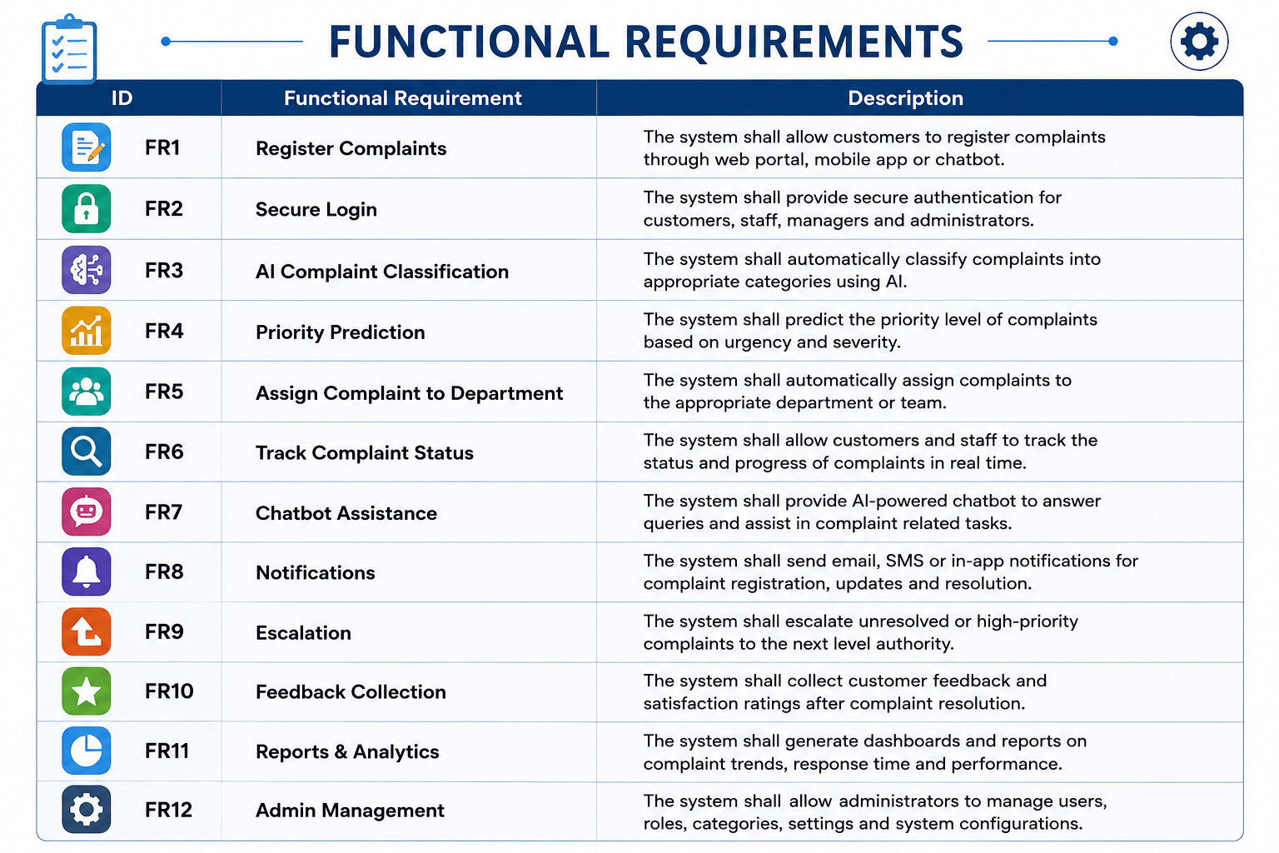

Non-Functional Requirements
Performance: response <3 seconds.
Security: encryption, RBAC, MFA.
Reliability: 99.9% availability.
Usability: simple responsive UI.
Scalability: support growing users.
Maintainability: modular architecture.
Availability: 24/7 service.
In addition to the core functional features, the proposed system must satisfy several non-functional requirements to ensure high-quality performance and reliability. The system should provide fast response times, secure user authentication, and continuous availability to support banking services at all times. It should be designed with a user-friendly and responsive interface that enables customers and bank employees to perform tasks efficiently across different devices. Furthermore, the system must be scalable to handle increasing numbers of users and complaints without performance degradation, maintainable through a modular architecture for easy updates, and compliant with banking security and data privacy standards to protect sensitive customer information and ensure reliable service delivery.

Actors and Use Cases
The Intelligent AI-Based Smart Banking Customer Service and Complaint Resolution System involves several primary and secondary actors who interact with the system to perform different operations. The primary actors include Customers, Customer Support Representatives, Complaint Managers, and System Administrators. Customers use the system to register complaints, track complaint status, communicate with the AI chatbot, and submit feedback after issue resolution. Customer Support Representatives handle customer complaints, update complaint status, resolve issues, and communicate with customers. Complaint Managers monitor complaint progress, assign complaints to appropriate departments, escalate critical issues, and ensure that complaints are resolved within the specified Service Level Agreement (SLA). System Administrators manage user accounts, system settings, security, and overall system maintenance.
The major use cases of the system include User Login, Register Complaint, AI-Based Complaint Classification, Priority Prediction, Assign Complaint to Department, Track Complaint Status, Chatbot Assistance, Send Notifications, Escalate Complaint, Update Complaint Status, Collect Customer Feedback, Generate Reports and Analytics, and Manage Users. These use cases ensure that customer complaints are processed efficiently from registration to resolution while providing real-time updates, intelligent automation, and analytical insights to improve service quality and customer satisfaction
The Intelligent AI-Based Smart Banking Customer Service and Complaint Resolution System involves several actors who interact with the system to perform different tasks. The primary actors include the Customer, Customer Support Representative, Complaint Manager, and System Administrator, while the AI Engine and Notification Service act as supporting actors. Customers can register complaints, track complaint status, interact with the AI chatbot, receive notifications, and submit feedback. Customer support representatives manage and resolve complaints, complaint managers assign and monitor complaints, and system administrators manage users and system settings. The AI engine automatically classifies complaints and predicts their priority, while the notification service sends timely updates to customers, ensuring an efficient and automated complaint management process.

Use Case Descriptions

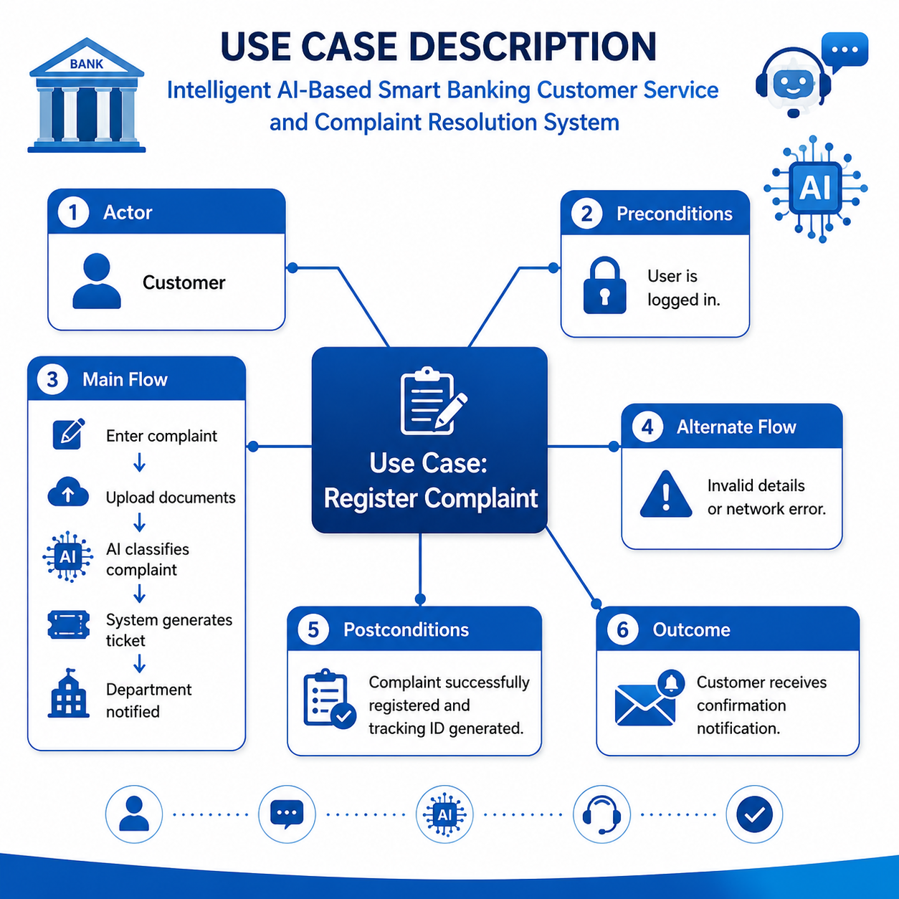

Data Requirements

The Intelligent AI-Based Smart Banking Customer Service and Complaint Resolution System stores and manages all essential data required for efficient complaint handling. Customer data includes basic information such as customer ID, name, contact details, and account information. Complaint data contains details such as complaint ID, category, description, priority level, date of submission, and the assigned department. The system also maintains ticket status information to track the progress of each complaint from registration to resolution.
In addition, the system stores customer feedback after complaint resolution to measure satisfaction and improve service quality. Analytics data is maintained to generate reports on complaint trends, response times, and overall system performance. Audit logs record user activities, login details, and system events to ensure security, transparency, and compliance with banking regulations. All data is securely stored and managed to support reliable, accurate, and efficient banking customer service.

External Interface Requirements
The Intelligent AI-Based Smart Banking Customer Service and Complaint Resolution System provides a user-friendly web application and mobile application that allow customers to register complaints, check complaint status, interact with the AI chatbot, and submit feedback. The interfaces are designed to be simple, responsive, and accessible across different devices and web browsers.
Customer Support Representatives, Complaint Managers, and System Administrators access the system through a secure administrative dashboard. This dashboard enables them to manage complaints, update complaint status, assign complaints to departments, monitor service performance, and generate reports for decision-making.
The system integrates with external services such as Artificial Intelligence (AI) and Natural Language Processing (NLP) engines to classify complaints, predict priority levels, and provide chatbot assistance. It also connects with email, SMS, and push notification services to send complaint acknowledgements, status updates, and resolution notifications to customers.
The system communicates with the bank's existing customer database and authentication services to verify customer information and securely store complaint records. All external interfaces use secure communication protocols to ensure data confidentiality, integrity, and reliable information exchange while complying with banking security and privacy standards.

System Features
The Intelligent AI-Based Smart Banking Customer Service and Complaint Resolution System uses Artificial Intelligence (AI) to automatically classify customer complaints into appropriate categories and determine their priority based on urgency and severity. This intelligent classification helps reduce manual effort, ensures accurate complaint routing, and speeds up the resolution process. The system also includes an NLP-based chatbot that provides 24/7 assistance by answering customer queries, helping users register complaints, and providing real-time complaint status updates.
The system supports workflow automation, which automatically assigns complaints to the appropriate department, tracks complaint progress, and escalates unresolved or high-priority issues when necessary. Customers receive instant notifications through email, SMS, or in-app alerts whenever there is a change in the complaint status. This automated workflow improves operational efficiency, minimizes response time, and enhances the overall customer experience.
The system also provides interactive dashboards and analytics for bank management and customer support teams. These dashboards display complaint trends, response times, resolution rates, employee performance, and customer satisfaction levels. The generated reports help management identify service improvements, monitor key performance indicators (KPIs), and make informed decisions to enhance the quality and efficiency of banking customer service.

Assumptions

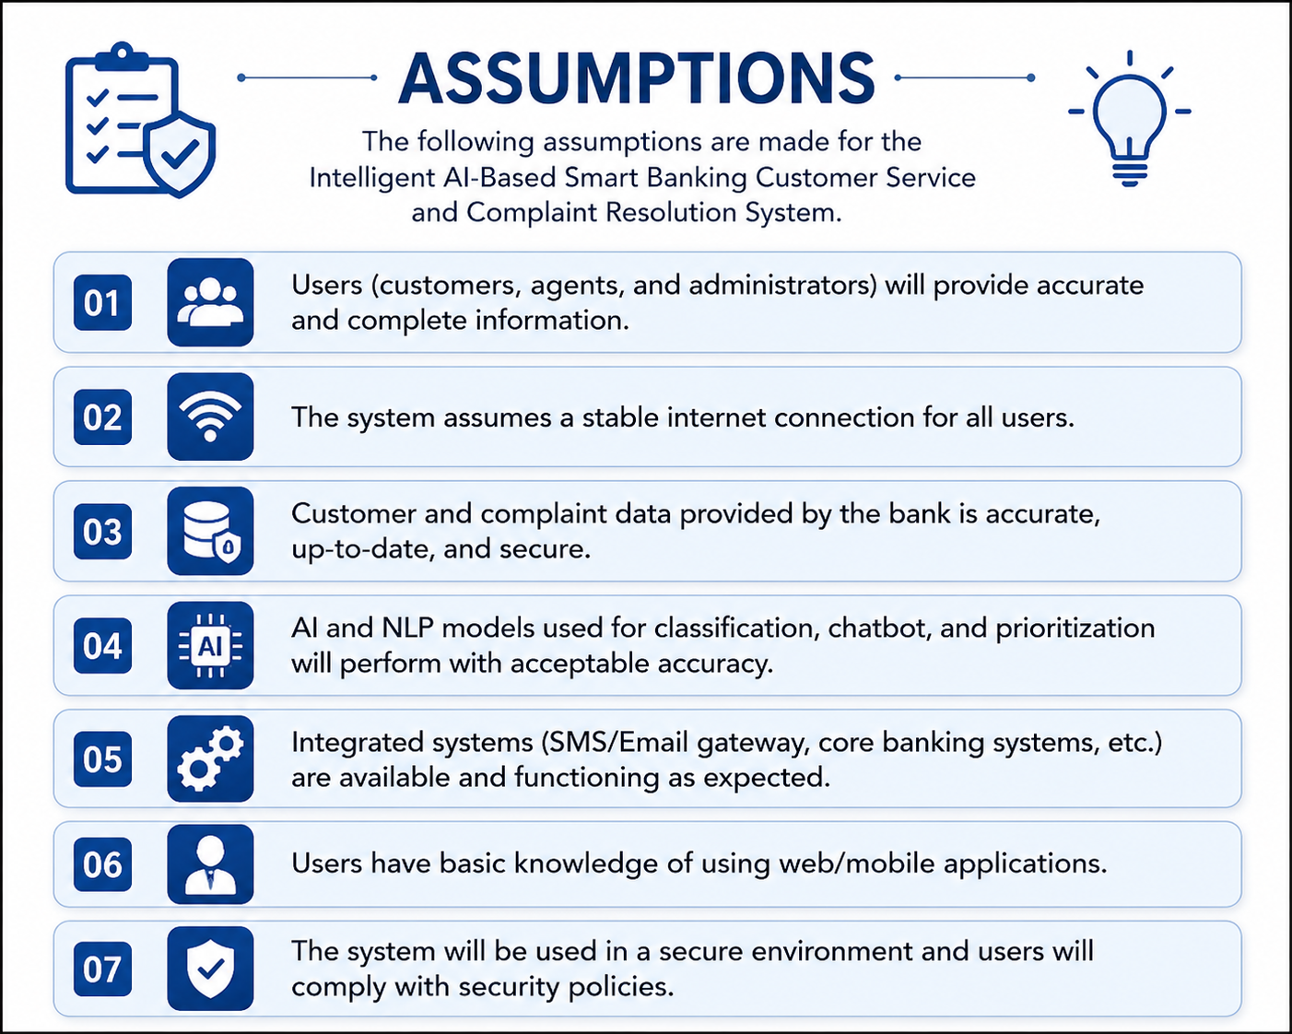

Constraints
Technical: API integration. Operational: staff adoption. Economic: budget. Legal: banking/privacy regulations. Time: academic schedule.

Requirement Validation
The requirements of the Intelligent AI-Based Smart Banking Customer Service and Complaint Resolution System are validated to ensure they are complete, clear, consistent, and feasible. All functional and non-functional requirements are reviewed with stakeholders to verify that they meet the business objectives and customer needs. Each requirement is written in a clear and unambiguous manner to avoid misunderstandings during system development.
The validation process also checks that there are no duplicate or conflicting requirements and that every requirement can be implemented and tested successfully. Stakeholder feedback, requirement reviews, and prototype demonstrations are used to confirm that the system satisfies user expectations. This process helps improve the quality of the Software Requirement Specification (SRS) and ensures the development of a reliable, secure, and efficient banking customer service system.

Use Case Diagram (Text)
The Use Case Diagram illustrates the interactions between the different actors and the Intelligent AI-Based Smart Banking Customer Service and Complaint Resolution System. The primary actors are Customer, Customer Support Representative, Complaint Manager, and System Administrator. Secondary actors include the AI Engine and Notification Service, which support the system by automating complaint classification, priority prediction, chatbot responses, and customer notifications. These actors work together to ensure efficient complaint handling and improved customer service.
The Customer can register complaints, securely log in, communicate with the AI chatbot, track complaint status, receive notifications, and submit feedback after the complaint is resolved. The Customer Support Representative views assigned complaints, updates complaint status, communicates with customers, and resolves issues. The Complaint Manager assigns complaints to appropriate departments, monitors complaint progress, escalates unresolved issues, and generates reports to ensure timely resolution and compliance with service-level agreements (SLAs).
The System Administrator manages user accounts, complaint categories, and system configurations while maintaining overall system security. The AI Engine automatically classifies complaints, predicts their priority, and assists the chatbot in responding to customer queries. The Notification Service sends email, SMS, or in-app notifications regarding complaint registration, status updates, and resolution. Together, these actors and use cases provide a secure, intelligent, and efficient banking customer service and complaint resolution process.
The Use Case Diagram represents the interactions between the users and the Intelligent AI-Based Smart Banking Customer Service and Complaint Resolution System. It identifies the primary actors, including the Customer, Customer Support Representative, Complaint Manager, and System Administrator, along with supporting actors such as the AI Engine and Notification Service. Customers can register complaints, track complaint status, interact with the AI chatbot, receive notifications, and submit feedback. Customer support staff manage and resolve complaints, while complaint managers monitor progress, assign tasks, and generate reports. The system administrator manages users and system settings, whereas the AI engine classifies complaints and predicts priorities, and the notification service sends updates to customers. This use case diagram clearly illustrates how each actor interacts with the system to ensure efficient, secure, and
automated complaint management.

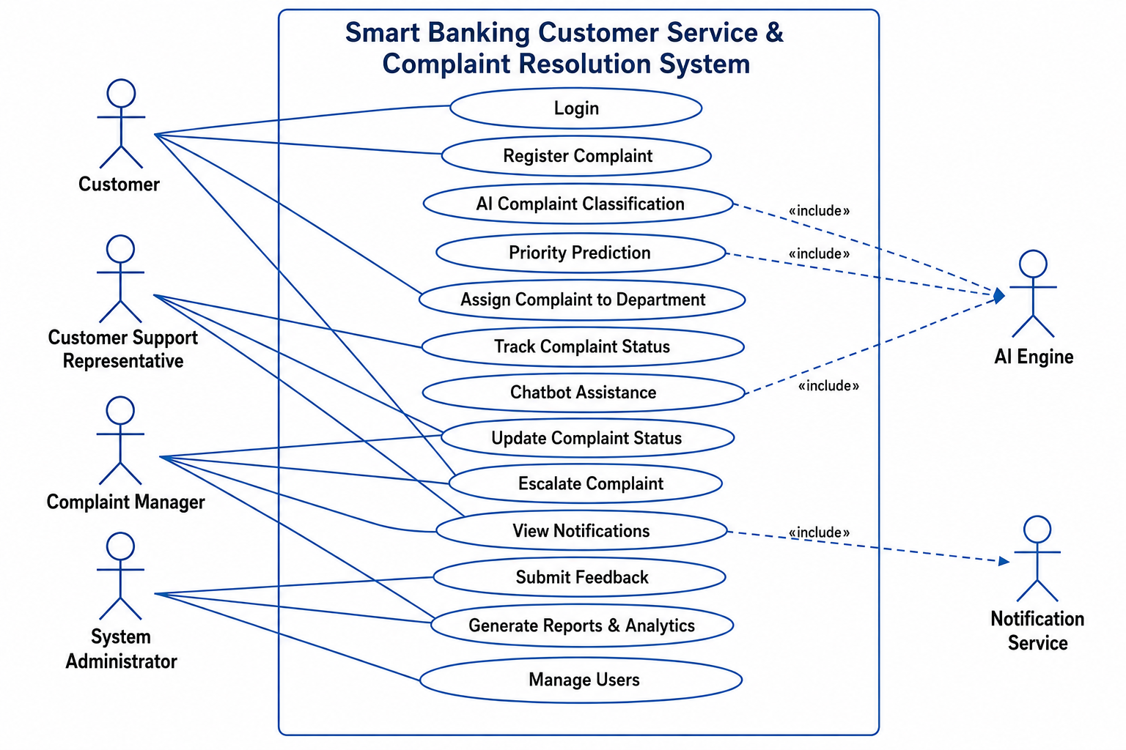

Expected Outcomes
The proposed Intelligent AI-Based Smart Banking Customer Service and Complaint Resolution System is expected to improve the overall complaint management process by automating complaint registration, classification, and routing. This will reduce manual effort and enable faster handling of customer requests.
The system will significantly reduce complaint resolution time by using Artificial Intelligence to classify complaints and assign them to the appropriate department. This ensures that urgent issues receive immediate attention, improving the efficiency of customer service operations.
Customers will benefit from real-time complaint tracking, AI-powered chatbot support, and instant notifications throughout the complaint resolution process. These features will increase customer satisfaction by providing timely updates, transparency, and quick responses to their queries.
The system will also improve the productivity of bank employees by minimizing repetitive manual tasks and streamlining complaint management. Interactive dashboards and analytics will help managers monitor performance, identify complaint trends, and make informed business decisions to enhance service quality.
Overall, the system will increase operational efficiency, strengthen customer trust, improve customer retention, and enhance the bank's reputation. By providing secure, intelligent, and reliable customer service, the proposed solution will support the bank in delivering a better customer experience and achieving long-term business success.

Conclusion
The Intelligent AI-Based Smart Banking Customer Service and Complaint Resolution System is a modern solution developed to improve the efficiency of banking customer service through Artificial Intelligence (AI), Natural Language Processing (NLP), chatbot technology, and workflow automation. The system simplifies the complaint management process by enabling faster complaint registration, intelligent classification, automatic prioritization, and real-time complaint tracking, resulting in improved service quality.
This Software Requirement Specification (SRS) document presents the complete analysis of the proposed system, including the problem description, scope, stakeholders, functional and non-functional requirements, actors, use cases, data requirements, external interface requirements, system features, assumptions, constraints, and requirement validation. These specifications provide a clear foundation for the successful design, development, testing, and deployment of the system.
The proposed system is expected to reduce manual workload, improve operational efficiency, and enhance communication between customers and bank staff. Features such as AI-powered chatbots, automated notifications, complaint analytics, and performance dashboards enable faster decision-making and ensure that customer complaints are handled effectively and transparently.
In conclusion, the implementation of this intelligent banking customer service system will improve customer satisfaction, strengthen customer trust, increase customer retention, and enhance the bank's overall reputation. By providing secure, scalable, reliable, and user-friendly services, the system will support the bank's digital transformation and contribute to long-term business growth and continuous service improvement.

