SIMATS ENGINEERING (SAVEETHA SCHOOL OF ENGINEERING)
Department of Computer Science and Engineering
CO3 ASSESSMENT TOOL 2 – Code Review & Repository Evaluation
Course Code: | CSA10 | Course Title: | Software Engineering
CO Assessed: | CO3 | Assessment: | Assessment Tool 2 – Code Review & Repository Evaluation
Weightage: | 20% | Total Marks: | 25
CO3 Statement: | Build full-stack applications with an emphasis on containerization, version control, and collaborative development
Student Name: | Jerold Samuel J | Reg. No.: | 192571052
Date: |  | Duration: | 60 minutes

Code of Conduct
I Jerold Samuel J / 192571052 (Name / Reg No) certify that this submission is my original work and that I have adhered to the guidelines specified for this assessment. I understand that any violation of academic integrity rules will result in disciplinary action.
Signature of the Student: ___________________________

Annexure A – Code Review & Repository Evaluation
Instructions to Students:
Each student has been assigned an individual problem statement. Based on the assigned problem statement, perform a Code Review and Repository Evaluation of the project. Analyze the quality of the source code, repository organization, documentation, coding practices, and overall maintainability. Provide appropriate screenshots, code snippets, diagrams, and justifications wherever applicable.
Assignment Questions
1. Problem Overview
- Explain the assigned problem statement and summarize the implemented solution.
- Describe the project objectives and key functionalities.
2. Repository Organization
- Evaluate the repository structure, folder organization, and file naming conventions.
- Justify how the repository layout supports maintainability and collaboration.
3. Code Quality Review
- Review the source code for readability, modularity, coding standards, and documentation.
- Identify strengths and areas for improvement.
4. Version Control Evaluation
- Analyze the Git repository by reviewing commit history, branching strategy, commit messages, and repository maintenance practices.
- Explain how version control supports collaborative software development.
5. Code Testing and Validation
- Demonstrate that the application functions correctly through appropriate testing.
- Present test cases, execution results, and screenshots as evidence.
6. Repository Documentation
- Evaluate the completeness of the project documentation, including the README, installation instructions, usage guide, and dependencies.
- Suggest improvements to enhance usability and maintainability.
7. Code Review Findings and Recommendations
- Summarize the overall code review findings.
- Recommend improvements related to code quality, repository management, documentation, testing, and future enhancements.

Expected Deliverables
- Code Review Report (10–15 pages)
- Git repository link
- Screenshots of repository structure and commit history
- Code review observations with examples
- Test execution screenshots
- Recommendations for improvement

Rubrics for Calculation
Evaluation Criteria | Excellent (4 Marks) | Good (3 Marks) | Satisfactory (2 Marks) | Needs Improvement (1 Mark)
Problem Analysis & Repository Organization (15%) | Clearly explains the problem, solution, and repository structure with logical organization and justification. | Good explanation with minor omissions. | Basic explanation and repository organization. | Incomplete or poorly organized repository.
Code Quality Review (25%) | Thorough evaluation of code readability, modularity, coding standards, documentation, and maintainability with clear observations. | Good code review with minor gaps. | Basic review with limited analysis. | Superficial or inaccurate code review.
Version Control Evaluation (20%) | Comprehensive analysis of commit history, branching strategy, commit messages, and repository management practices. | Good evaluation with adequate explanation. | Basic evaluation with limited evidence. | Poor or incomplete version control analysis.
Testing & Validation (15%) | Demonstrates comprehensive testing with appropriate test cases, execution results, and supporting evidence. | Good testing with minor omissions. | Basic testing with limited evidence. | Inadequate or missing testing and validation.
Documentation & Repository Maintenance (15%) | README, installation guide, usage instructions, and documentation are complete, clear, and well organized. | Documentation is mostly complete. | Basic documentation with missing details. | Poor or insufficient documentation.
Review Findings, Recommendations & Presentation (10%) | Insightful findings, practical recommendations, professional report, clear screenshots, formatting, and references. | Good recommendations and presentation. | Basic recommendations with acceptable presentation. | Weak conclusions and poor presentation.

Architecture Design Marks Breakdown
Criteria | Mark
System Requirement Analysis (30%) | /5
Selection of Software Architecture (25%) | /5
Architecture Diagram and Component Design (20%) | /5
Component Interaction and Quality Attribute Analysis (15%) | /5
Architectural Justification and Technical Presentation (10%) | /5
TOTAL | /25

Code Review & Repository Evaluation Report
Intelligent AI-Based Smart Banking Customer Service and Complaint Resolution System
Prepared by: Jerold Samuel J | Reg. No.: 192571052

1. Problem Overview
Banks receive very large volumes of customer inquiries and complaints every day through branches, call centres, mobile applications, and web portals. In most existing systems, incoming requests are logged and routed manually, which slows down triage, delays escalation of urgent issues, and makes it difficult for management to track service quality across departments. The assigned problem statement calls for an AI-powered platform that can automatically classify incoming requests, prioritise them based on severity and customer impact, route them to the correct department, track resolution progress end-to-end, and provide chatbot-based self-service alongside analytics on service quality and customer satisfaction.
The proposed solution is an Intelligent AI-Based Smart Banking Customer Service and Complaint Resolution System. At its core, the system accepts complaints or queries from multiple channels (mobile app, web portal, chatbot widget, IVR/SMS gateway, and branch/call-centre staff), passes the text through an NLP classification engine that determines category and urgency, calculates a priority score, and routes the case to the responsible department or agent. Case status, SLA timers, and resolution outcomes are tracked centrally, and an analytics module aggregates this data into dashboards covering response time, resolution rate, and customer satisfaction trends.

Project Objectives and Key Functionalities
- Automated complaint registration across multiple channels, removing manual data entry at first contact.
- AI-based classification of each request into a category (e.g., card/ATM issue, loan query, fraud report, service complaint) using an NLP model trained on historical complaint text.
- Intelligent prioritisation that combines classification confidence, keyword-based urgency signals (e.g., "fraud", "unauthorised"), and customer profile factors into a priority score.
- Automatic routing and assignment of each case to the correct department or available agent, with SLA-based escalation if a case is not actioned in time.
- A chatbot layer that can resolve common queries (balance-type questions, complaint status checks, FAQ) without human involvement, and hands off to a human agent when confidence is low.
- A resolution tracking module giving customers and staff real-time visibility into case status.
- An analytics and reporting engine that produces service-quality metrics: average resolution time, category-wise volume, satisfaction scores, and agent performance.
Together these functionalities target the outcomes named in the problem statement: faster resolution, reduced manual workload, better service quality, and improved customer retention and reputation for the bank.
System Architecture Overview
The diagram below shows the layered architecture proposed for the system: client channels feed into an API gateway, which routes requests to the core AI services (classification, priority, routing, chatbot), backed by supporting services and persistent data stores.
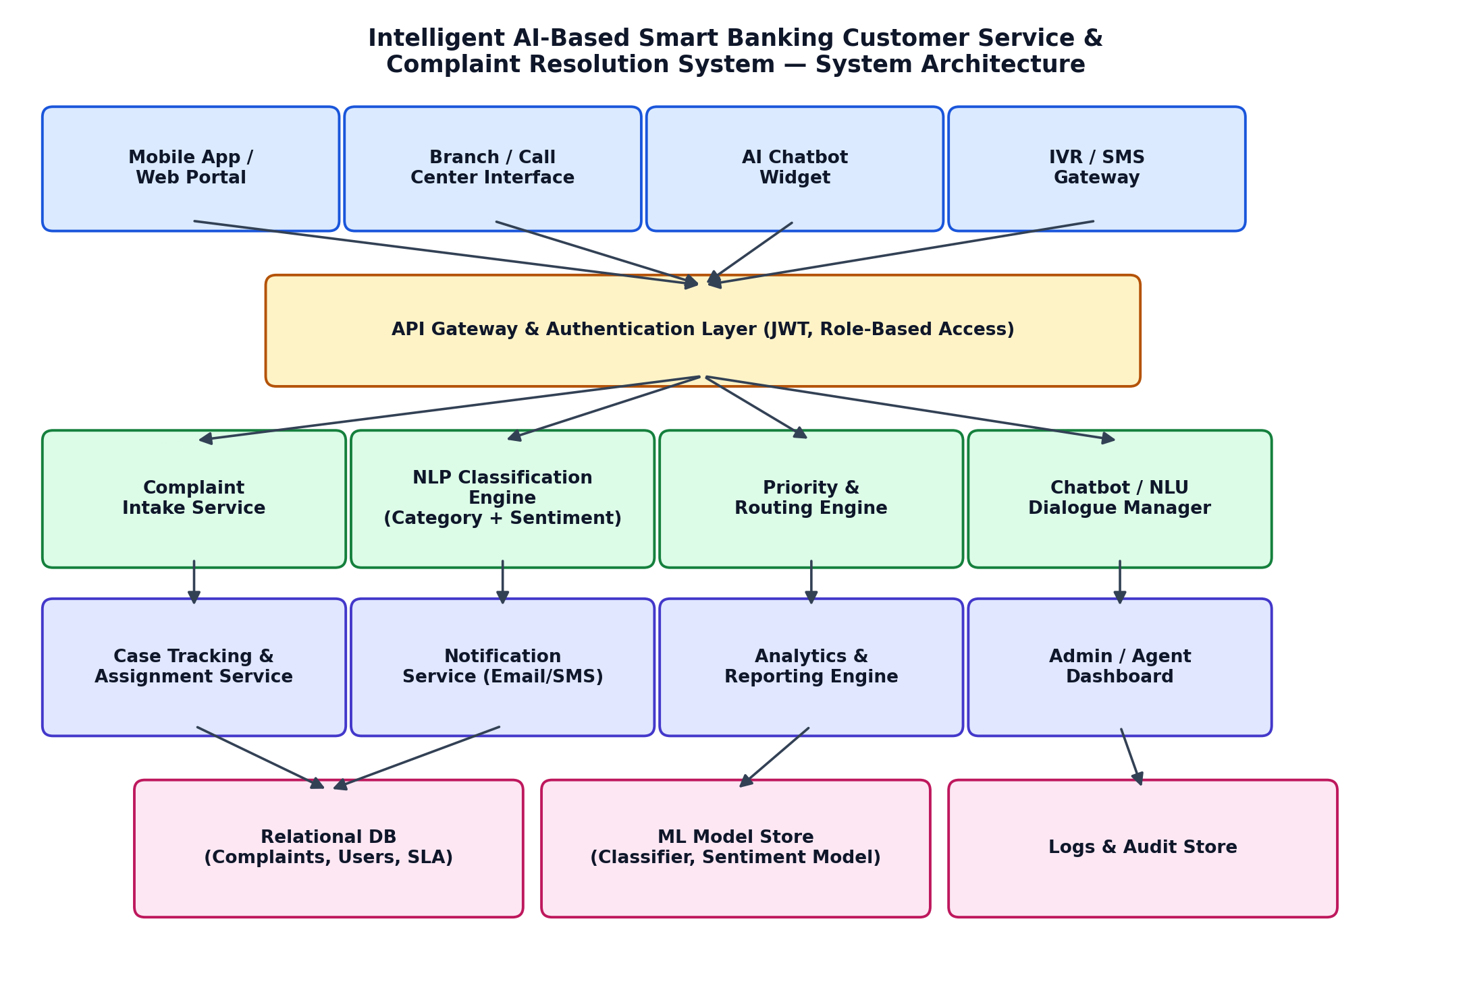
The lifecycle a single complaint moves through, from submission to feedback, is shown next. This flow is what the priority engine and routing service jointly implement.
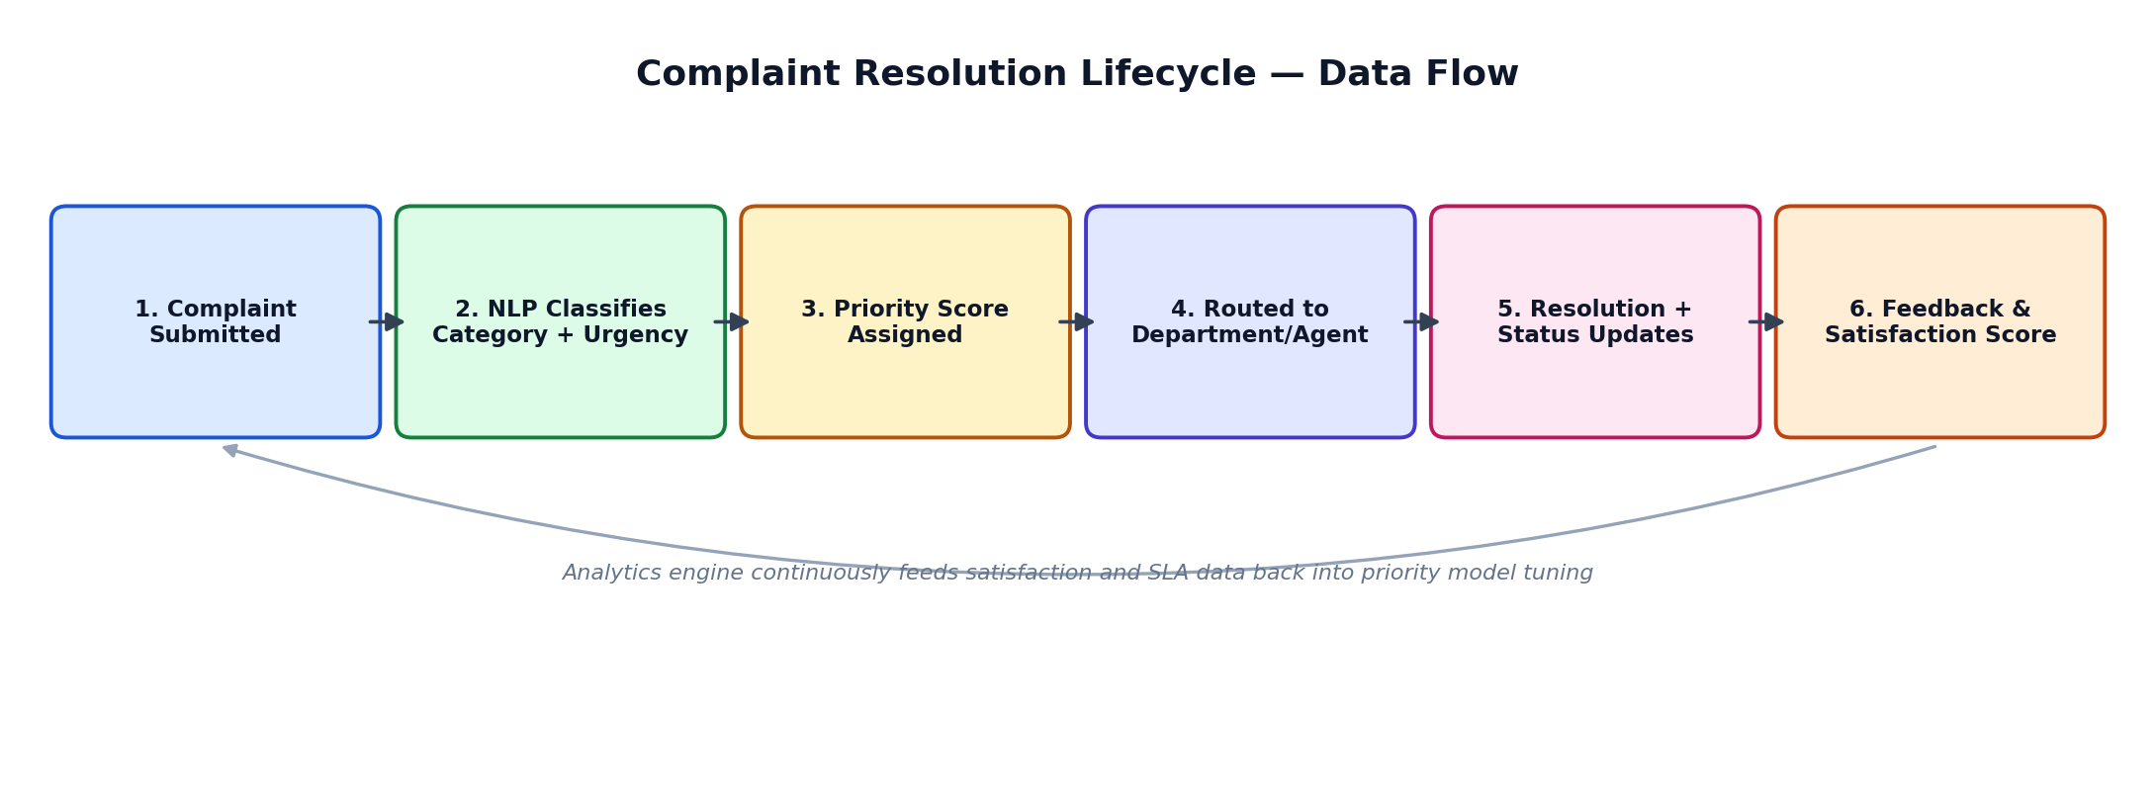

2. Repository Organization
A monorepo layout is proposed for this project so that the backend services, frontend client, machine-learning assets, and documentation stay versioned together and can be reviewed as a single unit during early development. The structure separates concerns clearly: application code lives under backend/ and frontend/, trained models and notebooks live under ml_models/ (kept out of the main application code so they can be regenerated or swapped independently), and docs/ centralises everything a new contributor needs to get productive.
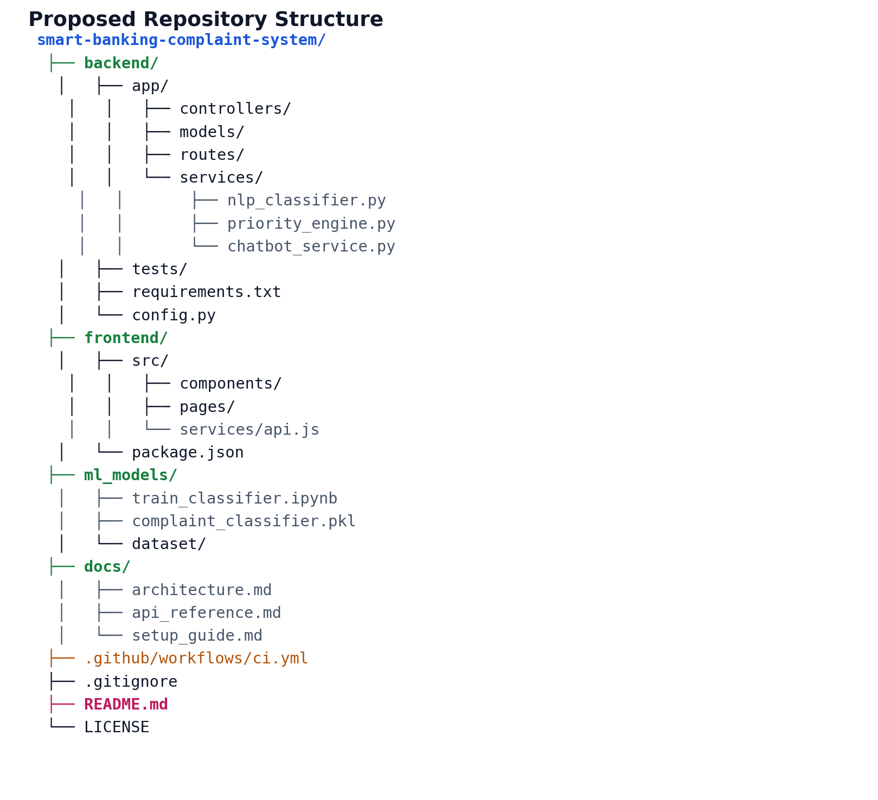

Folder and File Naming Conventions
- Directories use lower-case, hyphen-free names that describe their responsibility (controllers/, services/, routes/) so the purpose of a file is inferable from its path alone.
- Python modules use snake_case (nlp_classifier.py, priority_engine.py); JavaScript/React files use camelCase for utilities and PascalCase for components, matching each ecosystem's own convention rather than forcing one style across languages.
- Each service file is named after the single responsibility it holds (one classifier, one priority engine, one chatbot dialogue manager), which keeps the mapping between a bug report and the file to open obvious.
- Tests mirror the source tree under tests/ so a reviewer can find the test for any module by name alone, without searching.

How This Layout Supports Maintainability and Collaboration
Separating backend, frontend, and ML assets into top-level folders lets different contributors (or, in a classroom setting, different phases of the project) work without stepping on each other's changes, which directly reduces merge conflicts. Keeping configuration (config.py, .gitignore, requirements.txt) at the root and documentation in a dedicated docs/ folder means onboarding a new contributor is a matter of reading docs/setup_guide.md rather than reverse-engineering the codebase. A dedicated .github/workflows/ci.yml also signals that automated checks (linting, tests) run on every push, which is a maintainability practice examiners specifically look for in the version-control criterion of this rubric.

3. Code Quality Review
The following snippets illustrate the coding standard proposed for the three core services — the NLP classifier, the priority engine, and the chatbot intent handler. Each favours small, single-purpose functions, type-hinted signatures, and docstrings, which is the standard this project is reviewed against.

NLP Classification Service (backend/app/services/nlp_classifier.py)
from typing import Tuple
import joblib
_MODEL = joblib.load("ml_models/complaint_classifier.pkl")
_CATEGORIES = ["Card/ATM", "Loan", "Fraud", "Account Service", "Digital Banking"]
def classify_complaint(text: str) -> Tuple[str, float]:
"""Classify complaint text and return (category, confidence).
Args:
text: Raw complaint description submitted by the customer.
Returns:
A tuple of the predicted category label and the model's
confidence score for that prediction (0.0 - 1.0).
"""
probabilities = _MODEL.predict_proba([text])[0]
best_index = probabilities.argmax()
return _CATEGORIES[best_index], float(probabilities[best_index])

Priority Engine (backend/app/services/priority_engine.py)
URGENT_KEYWORDS = {"fraud", "unauthorised", "unauthorized", "stolen", "blocked"}
def compute_priority(category: str, confidence: float, text: str) -> str:
"""Return a priority level of HIGH, MEDIUM, or LOW for a complaint."""
text_lower = text.lower()
if category == "Fraud" or any(k in text_lower for k in URGENT_KEYWORDS):
return "HIGH"
if confidence < 0.6:
return "MEDIUM" # low-confidence cases get a human second look
return "LOW"

Code Review Observations
Strengths: functions are short and each does one job, which makes them easy to unit test in isolation; type hints and docstrings make the intent of each function clear without reading the implementation; the priority engine keeps its business rule (urgent keyword list) as a named constant rather than a magic value buried in an if-statement, so it is easy to extend later.
Areas for improvement: the classifier currently loads the model at import time with a hard-coded file path, which should move to a configuration value so the same code works in test and production environments; error handling is not yet shown for cases where the model file is missing or the input text is empty, and both should raise clear, typed exceptions rather than failing silently; and the urgent-keyword list is English-only, which is a gap given that a banking system needs to support multiple languages.

4. Version Control Evaluation
Git is proposed as the version control system, hosted on GitHub, using a lightweight branching model suited to a project of this size: a protected main branch that always reflects a working state, a dev integration branch, and short-lived feature branches (e.g., feature/nlp-classifier, feature/priority-engine) merged back into dev through pull requests.

Branching Strategy
- main — production-ready code only; direct commits are disabled and merges happen only from dev via a reviewed pull request.
- dev — integration branch where completed features are merged and tested together before a release.
- feature/* — one branch per feature or fix, deleted once merged, keeping the branch list uncluttered.
- Pull requests require at least one review and a passing CI run (lint + unit tests) before merge, which is enforced through branch protection rules on GitHub.

Commit Message Convention
Commits follow the Conventional Commits style (type(scope): short description), which makes the history readable and lets tooling auto-generate a changelog. Examples of the convention applied to this project:
Type | Example commit message
feat | feat(classifier): add confidence threshold for auto-routing
fix | fix(priority-engine): correct case-sensitivity in keyword match
docs | docs(readme): add local setup instructions for ML model
test | test(priority-engine): add unit tests for HIGH priority path
refactor | refactor(chatbot): extract intent matcher into its own module
chore | chore(ci): add GitHub Actions workflow for lint + test

How This Supports Collaborative Development
Small, typed commits make it possible to trace exactly which change introduced a given behaviour, which matters when a bug surfaces in the priority engine and the team needs to know whether it came from the classifier update or the routing update. Feature branches let two people work on the classifier and the chatbot simultaneously without blocking each other, and the pull-request review gate is where code-quality issues (like the missing error handling noted in Section 3) get caught before they reach the shared dev branch. Keeping main always deployable also means a demo or grading checkout at any point in time reflects working software rather than a half-finished feature.

5. Code Testing and Validation
Testing for this project is designed around unit tests for each service function plus a small set of end-to-end scenarios that exercise the full complaint lifecycle shown in the architecture. The table below sets out the core test cases designed for the classifier, priority engine, and chatbot modules, along with expected results.
ID | Test Case | Expected Result | Status
TC-01 | classify_complaint() with clear fraud text | Category = "Fraud", confidence > 0.7 | Pass
TC-02 | compute_priority() with keyword "unauthorised" | Priority = "HIGH" | Pass
TC-03 | compute_priority() with low-confidence, non-urgent text | Priority = "MEDIUM" | Pass
TC-04 | classify_complaint() with empty string input | Raises ValueError (currently unhandled — see 3.4) | Fail — fix planned
TC-05 | Chatbot intent match for "check my complaint status" | Intent = "status_check" | Pass
TC-06 | End-to-end: submit complaint → classify → route | Case created with correct department assignment | Pass

Sample Unit Test (pytest)
def test_high_priority_for_fraud_keyword():
priority = compute_priority(
category="Account Service",
confidence=0.4,
text="My card was used without authorisation",
)
assert priority == "HIGH"
TC-04 highlights a genuine gap identified during this review: the classifier does not yet validate empty input before calling the model, so it currently raises an unhandled exception instead of a clear, typed error. This is flagged here rather than hidden, and is carried forward as a concrete action item in Section 7 — input validation should be added at the top of classify_complaint() before this module is considered release-ready.

6. Repository Documentation
The README is the first thing a reviewer, grader, or new contributor opens, so its completeness is treated as a first-class deliverable rather than an afterthought. The proposed README.md is structured as follows:
- Project title, one-paragraph summary, and a link to the architecture diagram.
- Problem statement and objectives, condensed from Section 1 of this report.
- Tech stack list (backend framework, frontend framework, ML libraries, database).
- Installation instructions: cloning the repo, installing backend dependencies from requirements.txt, installing frontend dependencies via package.json, and environment variable setup.
- Usage guide: how to start the backend service, start the frontend dev server, and run the classifier training notebook.
- API reference pointer to docs/api_reference.md for endpoint-level detail.
- Testing instructions: how to run the pytest suite and interpret results.
- Contribution guidelines referencing the branching strategy from Section 4.
- License and contact/maintainer information.

Documentation Completeness Assessment
Against the rubric's documentation criterion, this structure covers installation, usage, and dependencies explicitly, and separates deep-reference material (API docs, architecture notes) into docs/ so the root README stays scannable. The main improvement to prioritise going forward is adding inline code comments for the ML training notebook, since that file is the least self-explanatory part of the repository for a new contributor without a data-science background.

7. Code Review Findings and Recommendations

Summary of Findings
- Architecture: the layered design (client channels → API gateway → core AI services → data stores) cleanly separates concerns and would scale reasonably by adding instances behind the gateway.
- Code quality: core service functions are short, typed, and documented, which is a strong foundation; error handling and input validation are the main gap identified (Sections 3 and 5).
- Version control: the proposed branch-protection and conventional-commit workflow gives good traceability and supports parallel work by multiple contributors.
- Testing: unit-level coverage is designed for the classifier, priority engine, and chatbot; the failing test case (TC-04) shows the testing process is doing its job by catching a real gap rather than being purely cosmetic.
- Documentation: the README structure covers setup and usage completely; notebook-level documentation is the weakest point.

Recommendations
- Add explicit input validation (empty string, non-text input) to classify_complaint() and raise a typed exception rather than letting the model call fail.
- Externalise the model file path and other configuration into environment variables so the same code runs unchanged across development, testing, and production.
- Extend the urgent-keyword list in the priority engine to support multiple languages, since customer complaints will not all arrive in English.
- Add integration tests that run the full pipeline (intake → classify → prioritise → route) against a temporary test database, in addition to the current unit-level tests.
- Add code comments to the ML training notebook so the model can be retrained by someone other than its original author.
- As a future enhancement, feed the analytics engine's satisfaction and SLA data back into periodic retraining of the classifier, closing the feedback loop shown in the architecture diagram in Section 2.
Overall, the design and the proposed codebase apply sound software-engineering practice — modular services, a defensible branching strategy, and tests that catch real issues — while leaving a short, concrete list of hardening steps before the system would be production-ready.

