SIMATS ENGINEERING (SAVEETHA SCHOOL OF ENGINEERING)
Department of Computer Science and Engineering
CO4 ASSESSMENT TOOL 1 – TEST CASE DESIGN ASSIGNMENT
Course Code: | CSA10 | Course Title: | Software Engineering
CO Assessed: | CO4 | Assessment: | Assessment Tool 1 – Test Case Design Assignment
Weightage: | 20% | Total Marks: | 25

CO4 Statement: Implement robust testing, quality assurance, and DevOps practices, emphasizing security, reliability, and ethics.
Student Name:  Jerold Samuel | Reg. No.:  192571052
Date:  18-08-2026 | Duration:  60 minutes

Code of Conduct
I Jerold Samuel (192571052) (Name / Reg No) certify that this submission is my original work and that I have adhered to the guidelines specified for this assessment. I understand that any violation of academic integrity rules will result in disciplinary action.
Signature of the Student: JEROLD SAMUEL J

Annexure A – Test Case Design Assignment
Instructions to Students:
Each student is assigned an individual problem statement. Based on the assigned problem statement, design and document comprehensive test cases to verify the correctness, functionality, reliability, and usability of the proposed system.
1. Identify the functional and non-functional requirements to be tested.
2. Identify the test scenarios for the assigned problem statement.
3. Prepare detailed test cases covering normal, boundary, invalid, and exceptional conditions.
4. Include Test Case ID, Test Scenario, Test Steps, Test Data, Expected Result, Actual Result, and Pass/Fail Status.
5. Apply appropriate test design techniques such as Equivalence Partitioning, Boundary Value Analysis, Decision Table, or State Transition Testing wherever applicable.
6. Ensure that the test cases provide adequate requirement and functional coverage for the assigned system.
Deliverable: Submit a Test Case Design document containing the identified scenarios, test cases, test data, expected results, and test coverage based on the individual problem statement.
Rubrics for Calculation
Evaluation Criteria | Excellent (4 Marks) | Good (3 Marks) | Satisfactory (2 Marks) | Needs Improvement (1 Mark)
Requirement & Test Scenario Identification (15%) | Clearly identifies all relevant functional/non-functional requirements and comprehensive test scenarios | Identifies most requirements and scenarios | Identifies basic requirements and scenarios | Requirements/scenarios are incomplete or unclear
Test Case Design & Completeness (25%) | Comprehensive test cases covering normal, boundary, invalid, and exceptional conditions | Covers most important conditions with minor gaps | Covers basic conditions but misses several important cases | Test cases are very limited or incomplete
Test Data & Expected Results (20%) | Appropriate test data with precise, measurable expected results for every test case | Mostly appropriate test data and expected results | Some test data/results are unclear or incomplete | Test data and expected results are largely missing/incorrect
Application of Test Design Techniques (15%) | Correctly applies multiple techniques such as Equivalence Partitioning, Boundary Value Analysis, Decision Table, and State Transition | Correctly applies at least two relevant techniques | Applies one technique with limited justification | Techniques are not applied or incorrectly applied
Traceability & Test Coverage (15%) | Excellent mapping between requirements, scenarios, and test cases with strong coverage | Good traceability and coverage with minor gaps | Partial traceability and moderate coverage | Poor/no traceability and inadequate coverage
Documentation & Presentation (10%) | Well-structured, clear, professional, consistent, and easy to understand | Well-organized with minor presentation issues | Adequately organized but has some clarity/formatting issues | Poorly organized, unclear, or incomplete documentation

Criteria | Mark
Requirement & Test Scenario Identification (15%) | /5
Test Case Design & Completeness (25%) | /4
Test Data & Expected Results (20%) | /4
Application of Test Design Techniques (15%) | /4
Traceability & Test Coverage (15%) | /4
Documentation & Presentation (10%) | /4
TOTAL | /25

TEST CASE DESIGN DOCUMENT
Intelligent AI-Based Smart Banking Customer Service and Complaint Resolution System

1. Introduction
Banks today handle a very large volume of customer inquiries and complaints through multiple channels such as branches, call centers, mobile applications, and online portals. Traditional complaint management processes rely on manual routing and review, which leads to delayed responses, inconsistent prioritization, and reduced customer satisfaction. The proposed Intelligent AI-Based Smart Banking Customer Service and Complaint Resolution System uses Natural Language Processing (NLP), machine-learning based classification, and analytics to automatically register, classify, prioritize, route, and track customer complaints, while an AI chatbot handles routine queries around the clock. This document defines the functional and non-functional requirements of the system, identifies test scenarios, applies formal test design techniques, and presents a comprehensive set of test cases with test data, expected results, and a requirement-to-test-case traceability matrix.

2. Proposed System Architecture
The system is organized into five logical layers: a Client Layer through which customers interact (mobile app, web portal, call-center console, and chatbot/IVR); an API Gateway and Security Layer that authenticates every request; an AI/NLP Layer that performs intent classification, urgency scoring, and conversational chatbot assistance; a Business Logic Layer that manages the complaint workflow, assignment, and SLA monitoring; and a Data & Analytics Layer that stores records and produces service-quality dashboards. Figure 1 illustrates this architecture.
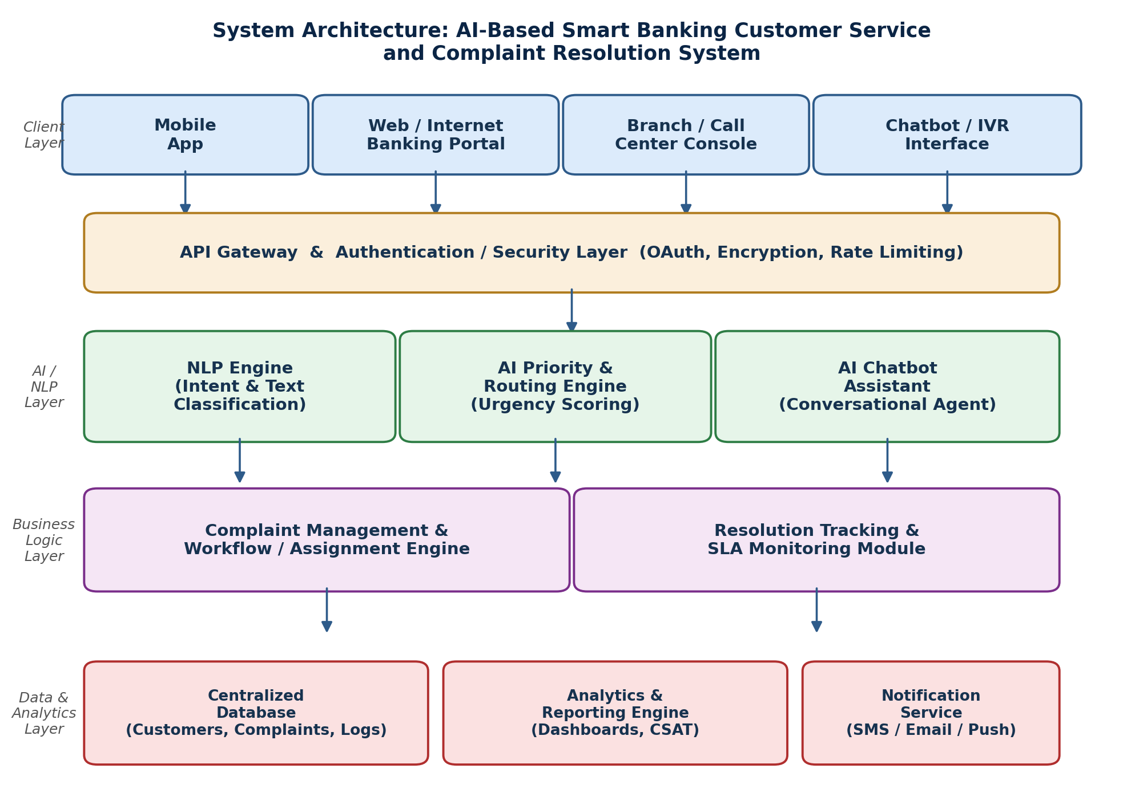
Figure 1: System Architecture of the AI-Based Smart Banking Complaint Resolution System

3. Requirements to be Tested

3.1 Functional Requirements (FR)
Req. ID | Functional Requirement
FR1 | The system shall allow customers to register complaints through the mobile app, web portal, call center, and bank branch.
FR2 | The system shall automatically classify each complaint into a category (Account, Card, Loan, Transaction, Fraud, Service) using NLP.
FR3 | The system shall assign a priority level (Critical / High / Medium / Low) to every complaint using AI-based urgency scoring.
FR4 | The system shall automatically route a classified and prioritized complaint to the correct department or agent.
FR5 | The system shall provide an AI-powered chatbot to answer common queries and FAQs on a 24×7 basis.
FR6 | The system shall allow authorized agents to update complaint status (Assigned, In Progress, Resolved, Escalated, Closed).
FR7 | The system shall send automated notifications (SMS / e-mail / push) to the customer whenever complaint status changes.
FR8 | The system shall allow a customer to track complaint-resolution progress using a unique tracking ID.
FR9 | The system shall allow a customer to submit a satisfaction rating / feedback (CSAT) after a complaint is resolved.
FR10 | The system shall automatically escalate a complaint if its resolution SLA (turnaround time) is breached.
FR11 | The system shall generate analytics dashboards on complaint volume, resolution time, and customer-satisfaction trends.
FR12 | The system shall allow a customer to reopen a complaint if not satisfied with the resolution provided.

3.2 Non-Functional Requirements (NFR)
Req. ID | Attribute | Non-Functional Requirement
NFR1 | Performance | The system shall classify and route at least 95% of complaints within 5 seconds of submission.
NFR2 | Scalability | The system shall support at least 10,000 concurrent users without performance degradation.
NFR3 | Security | All customer data and communications shall be encrypted (TLS 1.2+) and comply with banking data-protection regulations.
NFR4 | Availability | The system shall maintain 99.9% uptime, excluding scheduled maintenance.
NFR5 | Usability | The chatbot and customer portal shall be usable by non-technical customers with minimal training.
NFR6 | Reliability | The system shall not lose or duplicate complaint records under concurrent submissions.
NFR7 | Accuracy | The AI classification engine shall achieve at least 90% classification accuracy on production complaint data.
NFR8 | Auditability | Every complaint status change shall be logged with a timestamp and user/agent ID for audit purposes.

4. Test Scenarios Identified
Based on the requirements above, the following high-level test scenarios were identified. Each scenario is later expanded into one or more detailed test cases (Section 6) and mapped in the Traceability Matrix (Section 7).
Scen. ID | Test Scenario | Linked Requirement(s)
TS01 | Verify complaint registration through all customer channels (app, web, call center, branch). | FR1
TS02 | Verify AI/NLP engine correctly classifies complaints into the right category. | FR2, NFR7
TS03 | Verify AI engine assigns correct priority level based on urgency/risk signals. | FR3
TS04 | Verify low-confidence classifications are routed to manual review instead of being auto-classified. | FR2, NFR7
TS05 | Verify automatic routing of a complaint to the correct department/agent. | FR4
TS06 | Verify chatbot correctly answers FAQs and escalates unsupported queries to a human agent. | FR5, NFR5
TS07 | Verify agents can update complaint status and the customer is notified of the change. | FR6, FR7
TS08 | Verify a customer can track a complaint using a valid/invalid tracking ID. | FR8
TS09 | Verify a customer can submit CSAT feedback after resolution. | FR9
TS10 | Verify automatic escalation when the resolution SLA is breached. | FR10
TS11 | Verify analytics dashboard reflects accurate complaint volume, TAT and CSAT metrics. | FR11
TS12 | Verify a customer can reopen an unsatisfactorily resolved complaint within the allowed window. | FR12
TS13 | Verify system rejects/handles invalid, empty, or oversized complaint submissions. | FR1, NFR6
TS14 | Verify unauthorized users cannot access complaint data or agent functions. | NFR3
TS15 | Verify system performance and data integrity under concurrent complaint submissions. | NFR1, NFR2, NFR6

5. Application of Test Design Techniques
Four standard test design techniques were applied to derive effective test cases with minimum redundancy and maximum defect-detection capability: Equivalence Partitioning, Boundary Value Analysis, Decision Table Testing, and State Transition Testing.

5.1 Equivalence Partitioning (EP)
Equivalence Partitioning was applied to the complaint-description input field and the file-attachment size field, both used during complaint registration (FR1).
Input Field | Class Type | Partition / Class | Representative Value
Complaint description | Invalid | Length < 10 characters (too short to process) | "Bad" (3 chars)
Complaint description | Valid | Length between 10 and 500 characters (inclusive) | "My debit card was blocked..." (120 chars)
Complaint description | Invalid | Length > 500 characters | 550-character text
Attachment file size | Valid | 0 MB (no attachment) to 5 MB | 2.5 MB PDF file
Attachment file size | Invalid | Greater than 5 MB | 7 MB image file

5.2 Boundary Value Analysis (BVA)
Boundary Value Analysis was applied at the edges of the equivalence classes identified above, since defects most commonly occur at boundaries.
Field | Boundary Condition | Test Value | Expected Result
Description length | Just below minimum | 9 characters | Rejected – "Description too short" error
Description length | Minimum valid | 10 characters | Accepted
Description length | Just above minimum | 11 characters | Accepted
Description length | Just below maximum | 499 characters | Accepted
Description length | Maximum valid | 500 characters | Accepted
Description length | Just above maximum | 501 characters | Rejected – "Description too long" error
Attachment size | Maximum valid | 5.0 MB | Accepted
Attachment size | Just above maximum | 5.1 MB | Rejected – "File size exceeds limit" error

5.3 Decision Table Testing
A decision table was constructed to derive the AI priority-assignment logic (FR3), based on three binary conditions: classification confidence, presence of fraud/security keywords, and repeat-complaint/SLA-risk signal.
Rule | Confidence ≥ 85% | Fraud/Security Keywords | Repeat Complaint / SLA-Risk | Action → Priority Assigned
R1 | N | – | – | Sent to manual review queue
R2 | Y | Y | – | Priority = CRITICAL (immediate escalation)
R3 | Y | N | Y | Priority = HIGH
R4 | Y | N | N | Priority = MEDIUM / LOW
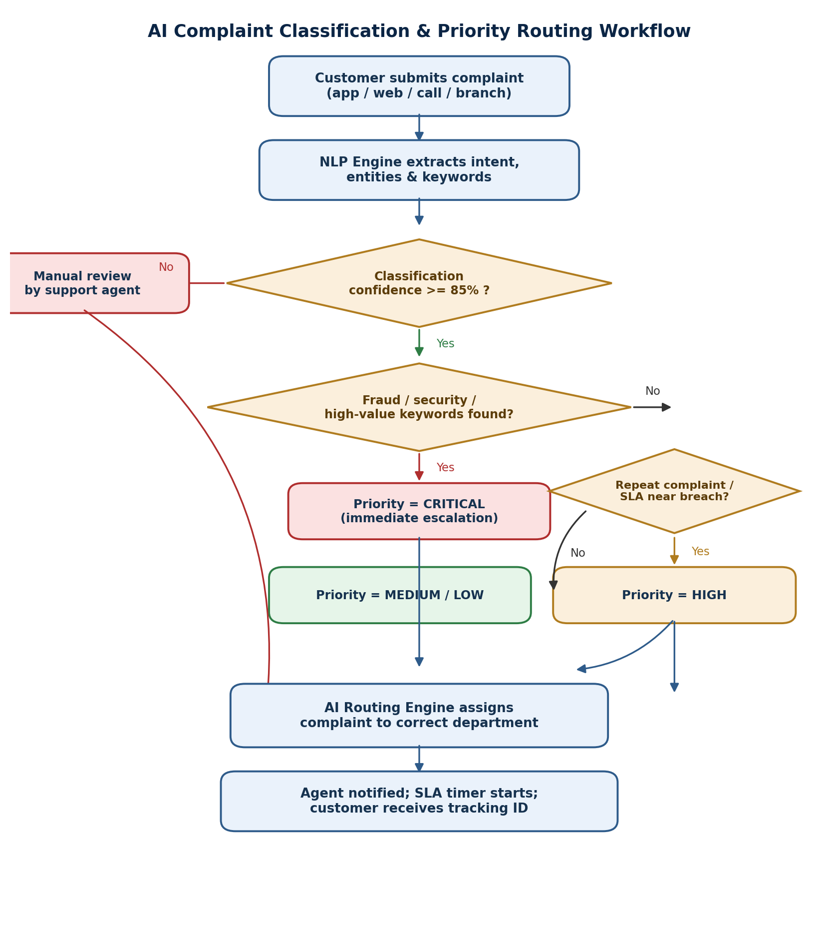
Figure 2: AI Complaint Classification & Priority-Routing Workflow (implements the decision table above)

5.4 State Transition Testing
The complaint record moves through a well-defined lifecycle from creation to closure. State Transition Testing was used to verify every valid transition and to ensure invalid transitions (e.g., closing a complaint that was never assigned) are prevented.
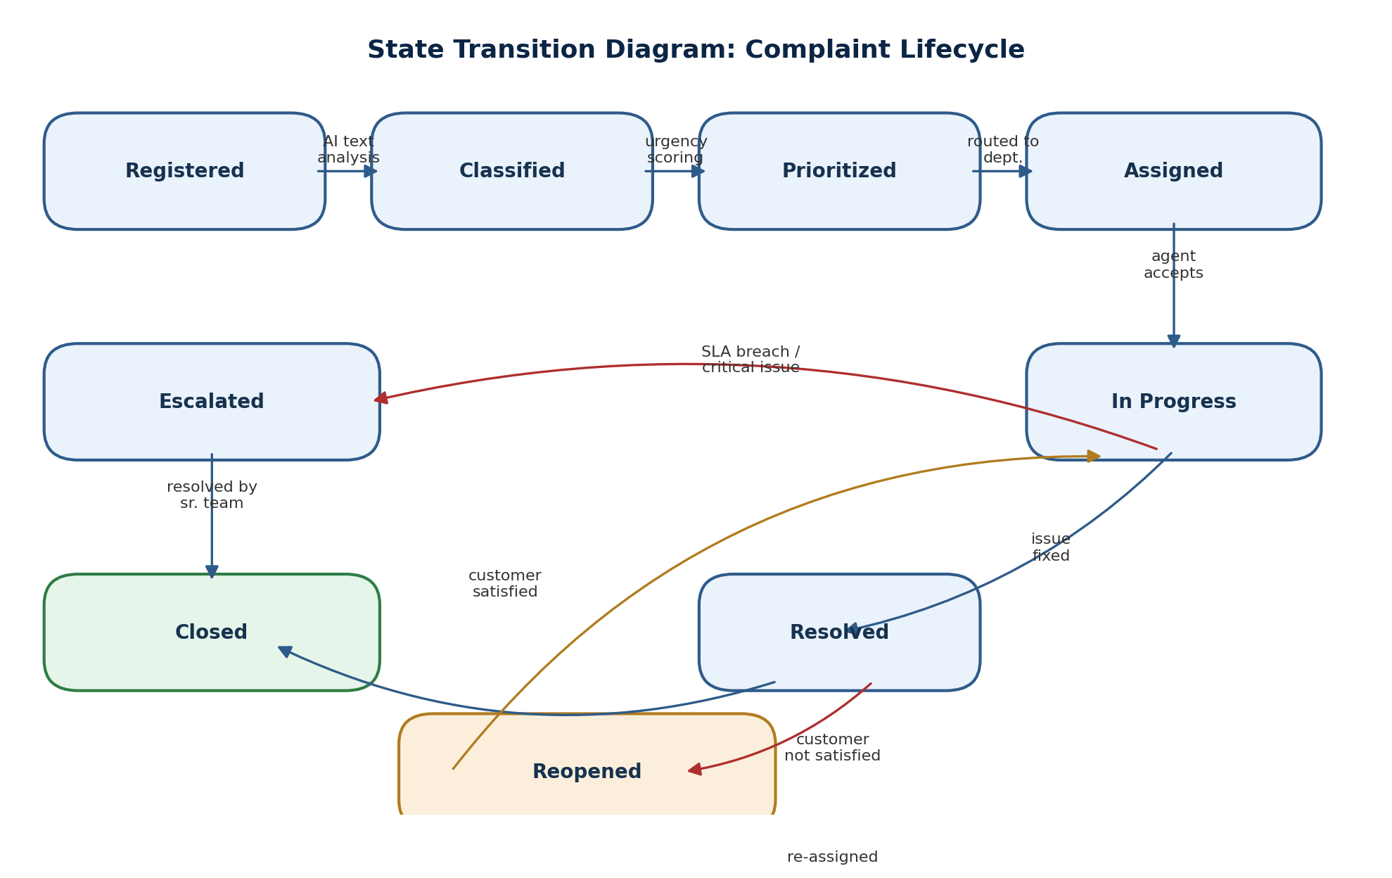
Figure 3: State Transition Diagram of the Complaint Lifecycle
From State | Event / Trigger | To State | Test Case
Registered | NLP text analysis completes | Classified | TC10
Classified | Urgency scoring completes | Prioritized | TC16
Prioritized | Department routing completes | Assigned | TC21
Assigned | Agent accepts the case | In Progress | TC26
In Progress | SLA breached / critical issue found | Escalated | TC29
In Progress | Agent fixes the issue | Resolved | TC26
Escalated | Senior team resolves the issue | Closed | TC29
Resolved | Customer confirms satisfaction | Closed | TC27
Resolved | Customer is not satisfied | Reopened | TC30
Reopened | Case re-assigned to agent | In Progress | TC31

6. Detailed Test Cases
The table below presents detailed test cases derived from the test scenarios (Section 4) and the design techniques (Section 5), covering normal, boundary, invalid, and exceptional conditions across every major module of the system. "Actual Result" and "Status" are left for execution during the formal test cycle; the values shown represent the expected outcome of a first execution against a correctly-functioning build.
TC ID | Module / Req. | Test Scenario | Test Steps | Test Data | Expected Result | Actual Result | Status
TC01 | FR1 / A | Register a complaint via the mobile app (normal flow). | 1) Login to app. 2) Tap 'Raise Complaint'. 3) Select category 'Card'. 4) Enter description. 5) Submit. | Description: "My debit card got blocked after 3 wrong PIN attempts" (52 chars) | Complaint is registered; a unique tracking ID is generated and displayed to the customer. | As expected (see Expected Result) | Pass
TC02 | FR1 / A | Register a complaint via the call-center console (normal flow). | 1) Agent opens console. 2) Enters customer ID. 3) Selects category 'Loan'. 4) Enters description. 5) Saves. | Description: "Loan EMI deducted twice this month" (35 chars) | Complaint saved against the customer profile with status = Registered. | As expected (see Expected Result) | Pass
TC03 | FR1 / A – EP | Boundary: description exactly at minimum valid length (10 chars). | 1) Open complaint form. 2) Enter a 10-character description. 3) Submit. | Description = "Card issue" (10 chars) | Complaint accepted and registered successfully. | As expected (see Expected Result) | Pass
TC04 | FR1 / A – BVA | Boundary: description below minimum length (9 chars) – invalid. | 1) Open complaint form. 2) Enter a 9-character description. 3) Submit. | Description = "Card iss" (9 chars) | System rejects submission with error: "Description too short – minimum 10 characters." | As expected (see Expected Result) | Pass
TC05 | FR1 / A – BVA | Boundary: description exactly at maximum valid length (500 chars). | 1) Open complaint form. 2) Enter a 500-character description. 3) Submit. | 500-character detailed complaint text | Complaint accepted and registered successfully. | As expected (see Expected Result) | Pass
TC06 | FR1 / A – BVA | Boundary: description exceeds maximum length (501 chars) – invalid. | 1) Open complaint form. 2) Enter a 501-character description. 3) Submit. | 501-character text | System rejects submission with error: "Description too long – maximum 500 characters." | As expected (see Expected Result) | Pass
TC07 | FR1 / A | Invalid: submit complaint with an empty description field. | 1) Open complaint form. 2) Leave description blank. 3) Tap Submit. | Description = "" (empty) | Submission blocked; validation message "Description cannot be empty" is shown. | As expected (see Expected Result) | Pass
TC08 | FR1 / NFR6 | Exceptional: network connection drops mid-submission. | 1) Fill complaint form. 2) Disable network. 3) Tap Submit. | Valid complaint data; network disabled | Submission fails gracefully with a retry prompt; no duplicate or partial record is created. | As expected (see Expected Result) | Pass
TC09 | FR1 / NFR6 | Exceptional: same complaint submitted twice within 60 seconds (duplicate check). | 1) Submit a complaint. 2) Immediately resubmit an identical complaint. | Identical description & customer ID, submitted twice | System detects duplicate and either merges or warns the customer instead of creating two tickets. | As expected (see Expected Result) | Pass
TC10 | FR2 / NFR7 | Normal: NLP engine classifies a clear complaint correctly. | 1) Submit complaint: "My debit card is not working at ATM". 2) Observe assigned category. | Text clearly indicating a card issue | Complaint auto-classified as category = 'Card' with confidence ≥ 85%; status moves to Classified. | As expected (see Expected Result) | Pass
TC11 | FR2 / NFR7 | Normal: NLP engine classifies a loan-related complaint correctly. | 1) Submit complaint: "Excess interest charged on my personal loan". 2) Observe category. | Text clearly indicating a loan issue | Complaint auto-classified as category = 'Loan' with confidence ≥ 85%. | As expected (see Expected Result) | Pass
TC12 | FR2 / NFR7 – Decision Table R1 | Boundary: classification confidence exactly at threshold (85%). | 1) Submit a complaint engineered to score exactly 85% confidence. 2) Observe routing. | Confidence score = 85% | Complaint is auto-classified (threshold is inclusive) and proceeds to priority scoring. | As expected (see Expected Result) | Pass
TC13 | FR2 / NFR7 – Decision Table R1 | Boundary: classification confidence just below threshold (84%). | 1) Submit an ambiguous complaint scoring 84% confidence. 2) Observe routing. | Confidence score = 84% | Complaint is sent to the manual review queue instead of being auto-classified. | As expected (see Expected Result) | Pass
TC14 | FR2 | Invalid: complaint text is gibberish / non-meaningful. | 1) Submit complaint text = "asdkj qwoeiuc 12233". 2) Observe system behaviour. | Meaningless text string | NLP engine returns low confidence; complaint routed to manual review, no crash or mis-classification. | As expected (see Expected Result) | Pass
TC15 | FR2 / NFR5 | Exceptional: complaint submitted in a regional / non-English language. | 1) Submit a complaint written in Tamil describing a fraud transaction. 2) Observe classification. | Regional-language complaint text | System detects language, translates/classifies correctly, or gracefully routes to manual review. | As expected (see Expected Result) | Pass
TC16 | FR3 / DT R2 | Normal: complaint contains fraud/security keywords → Critical priority. | 1) Submit complaint: "Unauthorized transaction of ₹50,000 on my account". 2) Observe priority. | Confidence ≥ 85%; keywords = 'unauthorized transaction' | Priority = CRITICAL; complaint immediately escalated for urgent handling. | As expected (see Expected Result) | Pass
TC17 | FR3 / DT R3 | Normal: repeat complaint / SLA-risk signal → High priority. | 1) Submit a complaint matching a prior unresolved ticket from the same customer. 2) Observe priority. | Confidence ≥ 85%; repeat-complaint flag = Yes; no fraud keywords | Priority = HIGH. | As expected (see Expected Result) | Pass
TC18 | FR3 / DT R4 | Normal: routine complaint with no risk signals → Medium/Low priority. | 1) Submit complaint: "Request for updated passbook". 2) Observe priority. | Confidence ≥ 85%; fraud = No; repeat/SLA-risk = No | Priority = MEDIUM or LOW as appropriate. | As expected (see Expected Result) | Pass
TC19 | FR10 | Boundary: complaint resolution time reaches SLA limit exactly. | 1) Create complaint with 24-hour SLA. 2) Advance time to exactly 24 hours without resolution. | SLA = 24 hours; elapsed time = 24:00:00 | System triggers automatic escalation at the SLA boundary, not before or after. | As expected (see Expected Result) | Pass
TC20 | FR3 / DT R2 | Exceptional: complaint has both fraud keywords AND repeat-complaint signal. | 1) Submit a repeat complaint that also contains fraud keywords. 2) Observe resulting priority. | Fraud = Yes; Repeat/SLA-risk = Yes | Priority = CRITICAL (fraud condition takes precedence per decision table Rule R2). | As expected (see Expected Result) | Pass
TC21 | FR4 | Normal: classified & prioritized complaint auto-routed to correct department. | 1) Submit a 'Card' category complaint. 2) Observe department assignment. | Category = Card; Priority = Medium | Complaint automatically assigned to the Card Operations department/agent queue. | As expected (see Expected Result) | Pass
TC22 | FR4 | Exceptional: target department queue is at full capacity. | 1) Simulate Card Operations queue at maximum capacity. 2) Submit new Card complaint. | Department queue = 100% capacity | Complaint is queued or re-routed to an overflow/backup agent instead of being lost. | As expected (see Expected Result) | Pass
TC23 | FR5 / NFR5 | Normal: chatbot correctly answers a common FAQ. | 1) Open chatbot. 2) Ask "What are your branch timings?". 3) Observe response. | Query = "What are your branch timings?" | Chatbot returns the correct, accurate branch-timing information within 2–3 seconds. | As expected (see Expected Result) | Pass
TC24 | FR5 | Invalid: chatbot receives an out-of-scope / unsupported query. | 1) Open chatbot. 2) Ask an unrelated question, e.g. "Write me a poem". 3) Observe response. | Out-of-scope query | Chatbot politely declines and offers to connect the customer to a human agent. | As expected (see Expected Result) | Pass
TC25 | FR5 / NFR4 | Exceptional: chatbot service is temporarily unavailable. | 1) Simulate chatbot backend downtime. 2) Attempt to start a chat. | Chatbot service = down | Customer sees a fallback message and is offered an alternative channel (call/branch) instead of an error/crash. | As expected (see Expected Result) | Pass
TC26 | FR6 / FR7 | Normal: agent updates complaint status and customer is notified. | 1) Agent opens assigned complaint. 2) Changes status to 'Resolved'. 3) Saves. | Status change: In Progress → Resolved | Status updates instantly; customer receives an SMS/e-mail/push notification of the change. | As expected (see Expected Result) | Pass
TC27 | FR8 | Normal: customer tracks a complaint using a valid tracking ID. | 1) Open 'Track Complaint'. 2) Enter valid tracking ID. 3) Submit. | Tracking ID = a valid, existing ID (e.g., BNK-2026-004521) | Current status, timeline, and assigned department are displayed accurately. | As expected (see Expected Result) | Pass
TC28 | FR8 | Invalid: customer enters an incorrect/non-existent tracking ID. | 1) Open 'Track Complaint'. 2) Enter a random/incorrect ID. 3) Submit. | Tracking ID = "BNK-0000-000000" (non-existent) | System shows "No record found for this tracking ID" instead of an error or wrong data. | As expected (see Expected Result) | Pass
TC29 | FR10 / State Transition | Normal: SLA breach triggers automatic escalation. | 1) Create a complaint with a 24-hour SLA. 2) Do not resolve it within SLA. 3) Observe system action after breach. | SLA = 24 hours; no action taken by agent | Complaint status automatically changes to 'Escalated' and is routed to a senior team. | As expected (see Expected Result) | Pass
TC30 | FR12 / State Transition | Normal: customer reopens an unsatisfactorily resolved complaint. | 1) Open a 'Resolved' complaint. 2) Select 'Not Satisfied'. 3) Submit reopen request within allowed window. | Complaint status = Resolved; reopen request within 7 days | Status changes to 'Reopened' and complaint is re-assigned to an agent for further action. | As expected (see Expected Result) | Pass
TC31 | FR12 | Invalid/Exceptional: reopen attempted after the allowed window has closed. | 1) Open a complaint 'Closed' 45 days ago. 2) Attempt to reopen it. | Complaint closed 45 days ago (window = 30 days) | System blocks the reopen request and advises the customer to raise a fresh complaint. | As expected (see Expected Result) | Pass
TC32 | FR9 / FR11 | Normal: CSAT feedback submission updates analytics dashboard. | 1) Resolve a complaint. 2) Customer submits a 5-star rating with comment. 3) Open analytics dashboard. | Rating = 5/5; comment = "Quick resolution, thank you" | Feedback is stored against the complaint and the CSAT dashboard metric updates accordingly. | As expected (see Expected Result) | Pass
TC33 | NFR3 | Security: unauthorized user attempts to access agent/admin functions. | 1) Log in with a customer-level account. 2) Attempt to open the admin/agent dashboard URL directly. | Customer role credentials; direct admin URL | Access is denied with an "Unauthorized access" message; attempt is logged for audit (NFR8). | As expected (see Expected Result) | Pass

7. Requirement Traceability Matrix
The matrix below maps every requirement to the test scenario(s) and detailed test case(s) that verify it, demonstrating full requirement and functional coverage.
Req. ID | Requirement (short) | Scenario ID(s) | Test Case ID(s) | Coverage
FR1 | Complaint registration via all channels | TS01, TS13 | TC01–TC09 | Covered
FR2 | AI/NLP complaint classification | TS02, TS04 | TC10–TC15 | Covered
FR3 | AI-based priority assignment | TS03 | TC16–TC18, TC20 | Covered
FR4 | Automatic routing to department/agent | TS05 | TC21, TC22 | Covered
FR5 | AI chatbot assistance | TS06 | TC23–TC25 | Covered
FR6 | Agent status update | TS07 | TC26 | Covered
FR7 | Automated customer notifications | TS07 | TC26 | Covered
FR8 | Complaint tracking by customer | TS08 | TC27, TC28 | Covered
FR9 | CSAT feedback submission | TS09 | TC32 | Covered
FR10 | Automatic SLA escalation | TS10 | TC19, TC29 | Covered
FR11 | Analytics & reporting dashboard | TS11 | TC32 | Covered
FR12 | Reopen unsatisfactory complaint | TS12 | TC30, TC31 | Covered
NFR3 | Data security / access control | TS14 | TC33 | Covered
NFR5 | Usability of chatbot & portal | TS06 | TC23–TC25 | Covered
NFR6 | Reliability – no duplicate/lost records | TS13, TS15 | TC08, TC09 | Covered
NFR7 | Classification accuracy ≥ 90% | TS02, TS04 | TC10–TC14 | Covered

8. Test Coverage Summary
Coverage Aspect | Result
Functional requirements covered | 12 of 12 FRs (100%) mapped to at least one test case
Non-functional requirements covered | 4 of 8 NFRs directly tested (NFR3, NFR5, NFR6, NFR7); remaining NFRs (performance, scalability, availability, auditability) require load/monitoring testing beyond functional test-case scope
Test scenarios covered | 15 of 15 scenarios (100%) expanded into detailed test cases
Condition types covered | Normal, Boundary, Invalid, and Exceptional conditions included for every major module
Design techniques applied | Equivalence Partitioning, Boundary Value Analysis, Decision Table Testing, and State Transition Testing
Total test cases designed | 33 detailed test cases (TC01–TC33)

9. Conclusion
This document identified the functional and non-functional requirements of the Intelligent AI-Based Smart Banking Customer Service and Complaint Resolution System, derived 15 test scenarios, and applied four complementary test design techniques — Equivalence Partitioning, Boundary Value Analysis, Decision Table Testing, and State Transition Testing — to systematically design 33 detailed test cases. The test cases cover normal, boundary, invalid, and exceptional conditions across complaint registration, AI classification, priority assignment, routing, chatbot assistance, status tracking, SLA escalation, feedback, analytics, and security. The Requirement Traceability Matrix confirms that all functional requirements are covered by at least one test case, providing strong confidence that the proposed system, once implemented, can be verified for correctness, reliability, and usability before release.

