SIMATS ENGINEERING (SAVEETHA SCHOOL OF ENGINEERING)
Department of Computer Science and Engineering
CO4 ASSESSMENT TOOL 2 – CI/CD Pipeline Design Exercise

Course Code: | CSA10 | Course Title: | Software Engineering
CO Assessed: | CO4 | Assessment: | Assessment Tool 2 – CI/CD Pipeline Design Exercise
Weightage: | 20% | Total Marks: | 25
CO4 Statement: | Implement robust testing, quality assurance, and DevOps practices, emphasizing security, reliability, and ethics
Student Name: | JEROLD SAMUEL J | Reg. No.: | 192571052
Date: | 20 | Duration: | 60 minutes

Code of Conduct
I JEROLD SAMUEL J (192571052)(Name / Reg No) certify that this submission is my original work and that I have adhered to the guidelines specified for this assessment. I understand that any violation of academic integrity rules will result in disciplinary action.
Signature of the Student JEROLD SAMUEL J
Annexure A – CI/CD Pipeline Design Exercise
Instructions to Students:
Each student is assigned an individual problem statement. Based on the assigned problem statement, design a CI/CD (Continuous Integration and Continuous Deployment) pipeline for the proposed software system to automate the processes of code integration, building, testing, and deployment.
The exercise should include:
- Analyze the project requirements and identify the CI/CD needs of the assigned problem statement.
- Design the CI/CD pipeline workflow showing stages such as source code management, build, testing, code quality analysis, packaging, and deployment.
- Identify suitable tools and technologies for each stage of the pipeline and justify their selection.
- Define appropriate automated testing strategies to be integrated into the pipeline.
- Design the deployment strategy, including development, testing/staging, and production environments.
- Incorporate appropriate security, quality checks, notifications, and rollback mechanisms in the pipeline.
- Prepare a CI/CD pipeline diagram and explain the workflow from code commit to deployment.
Deliverable: Submit a CI/CD Pipeline Design document containing the pipeline architecture/diagram, stages, tools, configuration/workflow, testing strategy, deployment process, and justification based on the assigned problem statement.
Rubrics for Calculation
Evaluation Criteria | Excellent (4 Marks) | Good (3 Marks) | Satisfactory (2 Marks) | Needs Improvement (1 Mark)
Requirement & Pipeline Analysis(15%) | Clearly analyzes the assigned problem and identifies comprehensive CI/CD requirements | Identifies most relevant requirements | Identifies basic requirements with some gaps | Requirements are unclear or incomplete
Pipeline Architecture & Workflow(25%) | Designs a complete, logical pipeline covering source, build, test, quality check, package, and deployment stages | Pipeline covers most major stages with minor gaps | Basic pipeline is designed but several stages are missing | Pipeline is incomplete or poorly structured
Tools & Technology Selection(20%) | Selects appropriate tools for each stage and provides clear justification | Appropriate tools selected with reasonable justification | Tools are identified but justification is limited | Tools are inappropriate or not clearly identified
Automated Testing & Quality Integration(15%) | Effectively integrates automated testing and code-quality/security checks into the pipeline | Includes major testing and quality checks | Includes basic testing with limited integration | Testing/quality checks are missing or inappropriate
Deployment, Security & Rollback Strategy(15%) | Clearly designs deployment environments, security practices, monitoring, and rollback strategy | Covers deployment and most security/rollback aspects | Basic deployment strategy with limited security/rollback details | Deployment strategy is incomplete or lacks security considerations
Pipeline Diagram & Documentation(10%) | Clear, accurate, professional diagram with excellent explanation and documentation | Well-presented diagram and documentation with minor issues | Adequate diagram/documentation but lacks clarity | Poorly presented, incomplete, or difficult to understand

Criteria | Mark
Requirement & Pipeline Analysis(15%) | /5
Pipeline Architecture & Workflow(25%) | /4
Tools & Technology Selection(20%) | /4
Automated Testing & Quality Integration(15%) | /4
Deployment, Security & Rollback Strategy(15%) | /4
Pipeline Diagram & Documentation(10%) | /4
TOTAL | /25

SIMATS ENGINEERING (SAVEETHA SCHOOL OF ENGINEERING)
Department of Computer Science and Engineering
CI/CD PIPELINE DESIGN DOCUMENT

Intelligent AI-Based Smart Banking Customer Service and
Complaint Resolution System
Course Code: CSA10
Course Title: Software Engineering
Assessment: CO4 - Assessment Tool 2 (CI/CD Pipeline Design Exercise)
Student Name: JEROLD SAMUEL J
Register Number: 192571052
1. Introduction
1.1 Industry Context
Banks handle thousands of customer inquiries and complaints every day through branches, call centers, mobile applications, and online portals. As customer expectations shift towards instant and round-the-clock service, financial institutions are increasingly turning to Artificial Intelligence (AI), Natural Language Processing (NLP), chatbots, and analytics to automate customer service operations. These technologies help banks reduce response time, improve service consistency, and free up human agents to focus on complex, high-value cases while routine queries are handled intelligently by automated systems.
1.2 Problem Statement
Traditional complaint management systems in the banking sector rely heavily on manual routing and human triage, which introduces delays, inconsistent prioritization, and a higher likelihood of customer dissatisfaction. Banks require an intelligent system that can automatically classify customer requests, prioritize critical issues such as fraud or unauthorized transactions, assign them to the correct department, and continuously track resolution progress. The proposed Intelligent AI-Based Smart Banking Customer Service and Complaint Resolution System addresses this gap by automating complaint handling, offering AI-powered chatbot assistance, monitoring service quality in real time, and generating customer satisfaction analytics to continuously improve banking services.
1.3 Objectives
• Automate complaint registration across all customer touch-points.
• Classify customer requests accurately using AI/NLP techniques.
• Prioritize complaints intelligently based on severity and impact.
• Monitor complaint resolution progress in real time.
• Provide AI-powered chatbot assistance for first-level query handling.
• Generate customer service analytics for management decision-making.
• Improve overall response time for customer requests.
• Enhance customer satisfaction and long-term retention.
1.4 Expected Outcomes
• Faster complaint resolution through automated routing and prioritization.
• Improved customer satisfaction due to quicker, more accurate responses.
• Reduced manual workload for customer service and back-office staff.
• Better and more consistent service quality across all channels.
• Enhanced overall banking operational efficiency.
• Accurate, real-time service and complaint analytics.
• Increased customer retention through improved trust.
• Improved organizational reputation and regulatory compliance.
2. Requirement Analysis and CI/CD Needs
2.1 Functional Requirements
• The system shall allow customers to raise complaints through mobile app, web portal, call center, kiosk, and messaging channels.
• The system shall automatically classify each complaint using NLP into categories such as fraud, transaction failure, card issue, loan query, or service request.
• The system shall assign a priority score to each complaint based on severity, customer profile, and historical resolution time.
• The system shall route each complaint to the correct department automatically based on classification and priority.
• The system shall provide an AI chatbot capable of answering FAQs and collecting complaint details before human handoff.
• The system shall allow staff and customers to track the resolution status of a complaint in real time.
• The system shall generate analytics dashboards showing resolution time, CSAT score, and complaint volume trends.
2.2 Non-Functional Requirements
Requirement | Description
Performance | Complaint classification and routing must complete within 2 seconds under normal load.
Scalability | The platform must scale horizontally to handle peak loads during festive or salary-cycle periods.
Availability | The system must maintain 99.9% uptime, since it is a customer-facing banking application.
Security | All customer data must be encrypted in transit (TLS 1.2+) and at rest, with role-based access control.
Compliance | The system must comply with RBI guidelines, data localization norms, and PCI-DSS where applicable.
Maintainability | The codebase must support frequent, low-risk releases through an automated CI/CD pipeline.
Auditability | Every complaint action must be logged for audit and regulatory reporting purposes.

2.3 Identified CI/CD Needs
Given that the system integrates multiple AI/ML models, microservices, and customer-facing channels, frequent and reliable releases are essential. The following CI/CD needs were identified for the project:
• Automated build and integration on every code commit to avoid integration conflicts across microservices (chatbot, classifier, routing engine, analytics).
• Automated regression and AI model-accuracy testing to ensure new model versions do not degrade classification quality.
• Static code analysis and security scanning to catch vulnerabilities before they reach production, given the sensitivity of banking data.
• Containerized, repeatable deployments across development, staging, and production environments.
• Safe, gradual rollout strategies (canary/blue-green) to minimize the blast radius of a faulty release on a live banking system.
• Automated rollback and alerting to guarantee rapid recovery in case of failures affecting customer service.
3. Proposed System Architecture
The diagram below illustrates the high-level system architecture of the Intelligent AI-Based Smart Banking Customer Service and Complaint Resolution System. Customer requests enter through multiple channels, pass through an API gateway for authentication, and are processed by the AI/NLP core before being routed to the appropriate department. All activity is persisted and analyzed by the data and analytics layer.
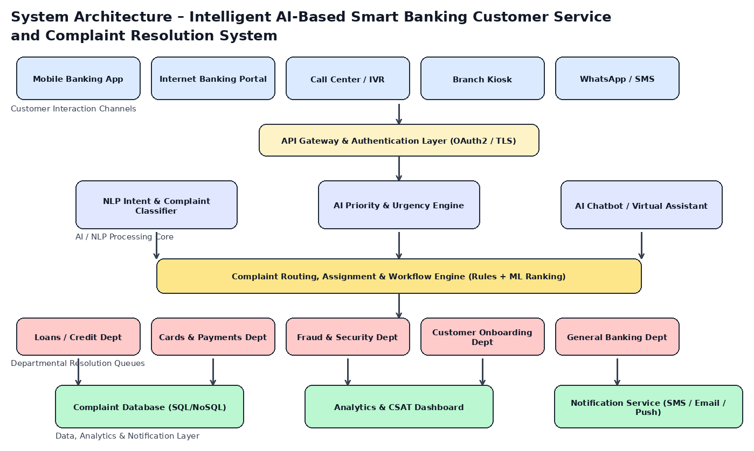
Figure 1: System Architecture of the Smart Banking Complaint Resolution Platform
3.1 Architecture Layer Description
Layer | Description
Interaction Channels | Mobile app, internet banking, call center/IVR, branch kiosk, and WhatsApp/SMS capture customer requests in a channel-agnostic format.
API Gateway | Provides authentication (OAuth2), rate limiting, and TLS termination before requests reach internal services.
AI / NLP Processing Core | Consists of an intent and complaint classifier, a priority/urgency scoring engine, and a conversational chatbot service.
Routing and Workflow Engine | Combines rule-based logic with ML-based ranking to assign complaints to the correct department and agent queue.
Departmental Queues | Domain-specific queues (loans, cards, fraud, onboarding, general banking) where human agents resolve escalated cases.
Data, Analytics & Notification Layer | Stores complaint records, powers the CSAT/analytics dashboard, and triggers SMS/email/push notifications to customers.

4. CI/CD Pipeline Architecture and Workflow
The CI/CD pipeline automates the journey of source code from a developer's commit to a live production release. It is designed to handle multiple independently deployable microservices, including the AI classification service, chatbot service, routing engine, and analytics dashboard, each with its own pipeline instance that follows the common workflow shown below.
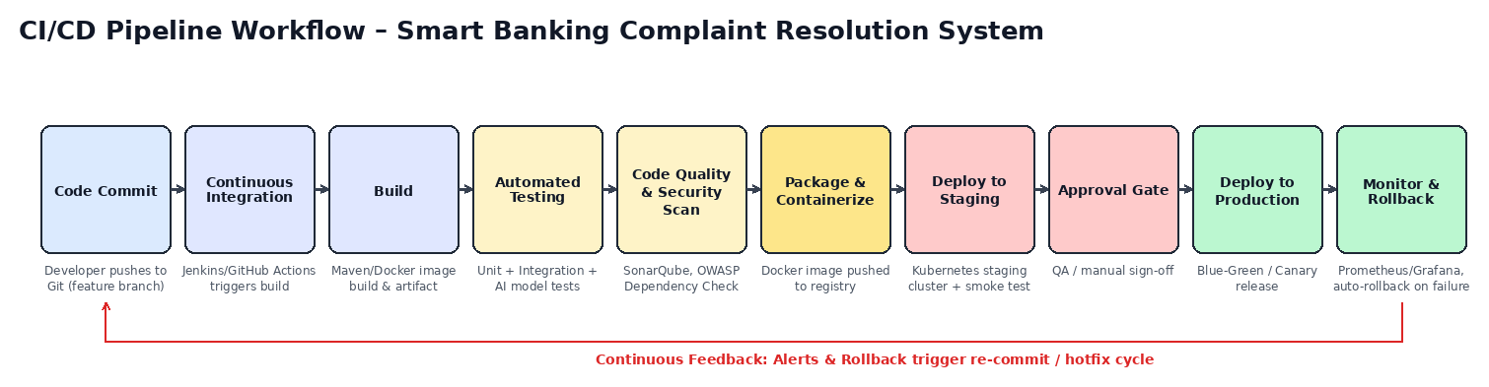
Figure 2: End-to-End CI/CD Pipeline Workflow
4.1 Pipeline Stage Description
Stage | Description
Code Commit | Developers push code to a feature branch in Git; a pull request triggers the pipeline.
Continuous Integration | Jenkins / GitHub Actions automatically pulls the latest code and initiates the build.
Build | Application and AI model artifacts are compiled/packaged (Maven/Gradle for services, pickled/ONNX for models) and a Docker image is built.
Automated Testing | Unit tests, integration tests, and AI model accuracy/regression tests run automatically against the build.
Code Quality & Security Scan | SonarQube analyzes code quality and technical debt; OWASP Dependency-Check and container scanning identify vulnerabilities.
Package & Containerize | A versioned Docker image is built and pushed to a private container registry (e.g., Amazon ECR / Docker Hub private repo).
Deploy to Staging | The image is deployed to a Kubernetes staging cluster; smoke tests and integration tests validate the release.
Approval Gate | QA and release managers review test results and sign off before promotion to production.
Deploy to Production | A Blue-Green or Canary deployment gradually shifts customer traffic to the new version.
Monitor & Rollback | Prometheus/Grafana monitor health metrics; failures trigger an automated rollback to the last stable release.

5. Tools and Technology Selection
Each stage of the pipeline uses tools chosen for their reliability, community support, and suitability for a security-sensitive banking environment. The selection and justification for each stage is summarized below.
Pipeline Stage | Tool(s) Selected | Justification
Source Code Management | Git + GitHub / GitLab | Industry-standard distributed version control with strong branch protection, code review, and audit trail support required for banking systems.
CI Orchestration | Jenkins / GitHub Actions | Highly extensible automation servers with mature plugin ecosystems for build, test, and deployment orchestration.
Build & Dependency Management | Maven / Gradle, Docker | Maven/Gradle provide reliable dependency management for Java/Spring Boot microservices; Docker ensures consistent, portable builds.
Unit & Integration Testing | JUnit, Mockito, Postman/Newman | Widely adopted frameworks for backend unit/mock testing and API-level integration testing in CI pipelines.
AI Model Testing | PyTest, MLflow | PyTest validates model input/output contracts; MLflow tracks model versions and accuracy metrics across builds.
Code Quality | SonarQube | Provides static analysis, code smell detection, and maintainability/security ratings with CI gate integration.
Security Scanning | OWASP Dependency-Check, Trivy | Detects known vulnerabilities in dependencies and container images before deployment.
Artifact Registry | Docker Hub (private) / Amazon ECR | Secure, versioned storage for container images with access control for banking-grade deployments.
Container Orchestration | Kubernetes (K8s) | Enables scalable, self-healing deployment across development, staging, and production clusters.
Deployment Automation | Helm, Argo CD | Helm charts template Kubernetes manifests; Argo CD enables GitOps-based, auditable continuous deployment.
Monitoring & Logging | Prometheus, Grafana, ELK Stack | Real-time metrics, dashboards, and centralized log aggregation for rapid incident detection.
Notifications | Slack API, Email (SMTP), SMS Gateway | Immediate alerts to DevOps teams and automated customer notifications on complaint status changes.

6. Automated Testing Strategy
Because the platform combines conventional microservices with AI/NLP models, the testing strategy covers both traditional software testing levels and AI-specific validation to ensure the classification and prioritization engines remain accurate as new versions are released.

6.1 Testing Levels
Testing Level | Tools | Purpose
Unit Testing | JUnit / PyTest | Validates individual functions and classes (e.g., priority scoring logic) in isolation on every commit.
Integration Testing | Postman/Newman, Testcontainers | Verifies communication between microservices such as the chatbot, classifier, and routing engine.
AI Model Accuracy Testing | PyTest + MLflow metrics | Compares classification accuracy, precision, and recall of a new model version against a benchmark dataset before promotion.
Regression Testing | Selenium / Cypress | Ensures existing features (complaint submission, tracking, chatbot flows) are not broken by new changes.
Load & Performance Testing | JMeter / Gatling | Simulates peak complaint volumes to validate response time and system stability under load.
Security Testing | OWASP ZAP | Scans APIs for common vulnerabilities such as injection, broken authentication, and data exposure.
User Acceptance Testing (UAT) | Manual + staging environment | Business and QA teams validate end-to-end complaint workflows before production release.

6.2 AI/ML Model Testing Considerations
• Every new model version is evaluated against a held-out validation dataset; the pipeline blocks promotion if accuracy drops below a defined threshold (e.g., 90%).
• Bias and fairness checks are run to ensure complaint prioritization does not disadvantage any customer segment.
• Data drift monitoring is scheduled post-deployment to detect when retraining is required.
• Model versions are tracked via MLflow so that any production issue can be traced back to a specific model and dataset version.
7. Code Quality, Security and Compliance Checks
As a banking application handling sensitive financial and personal data, code quality and security checks are treated as mandatory quality gates rather than optional steps, and a failed check automatically stops the pipeline before deployment.
• Static code analysis with SonarQube enforces coding standards and flags code smells, duplication, and complexity issues on every pull request.
• Dependency vulnerability scanning with OWASP Dependency-Check blocks builds that introduce known CVEs.
• Container image scanning with Trivy checks base images and libraries for vulnerabilities before pushing to the registry.
• Secrets scanning (e.g., GitLeaks) prevents API keys, database credentials, or tokens from being committed to source control.
• Mandatory peer code review and branch protection rules ensure at least one reviewer approves changes before merge.
• Compliance checks validate that data handling follows RBI data localization and PCI-DSS requirements for card-related complaints.
8. Deployment Strategy
The system is deployed across three progressively production-like environments. Each promotion between environments is gated by automated tests and, for production, an explicit approval step, minimizing the risk of introducing faulty releases into a live banking system.
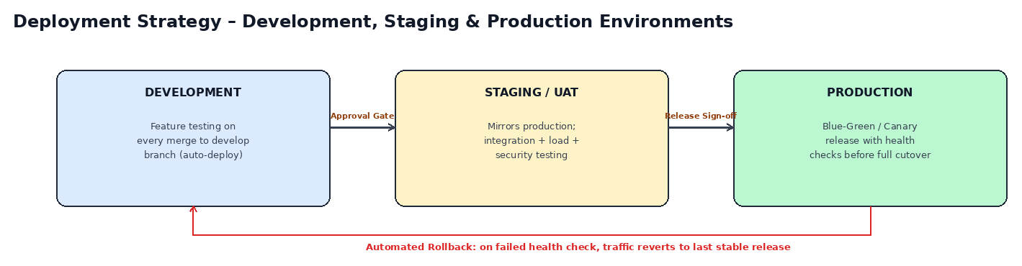
Figure 3: Development, Staging, and Production Deployment Strategy
8.1 Environment Description
Environment | Trigger | Purpose
Development | Auto-deployed on every merge to the develop branch | Rapid feedback for developers; used for feature-level testing and integration.
Staging / UAT | Deployed after CI tests pass; mirrors production configuration | Full integration, load, and security testing; business sign-off before release.
Production | Blue-Green / Canary release after approval gate | Live customer-facing environment with gradual traffic shift and real-time health checks.

8.2 Release Strategy
Production releases use a Canary deployment model: the new version initially receives a small percentage of live traffic (e.g., 5%) while key metrics such as error rate, latency, and complaint-classification accuracy are monitored. If metrics remain within acceptable thresholds, traffic is gradually increased to 100%; otherwise, the release is automatically halted and rolled back. This approach is particularly important for the AI classification service, where a faulty model could silently misroute critical complaints such as fraud reports.
9. Notification Mechanism
The pipeline and the production system both rely on automated notifications to keep the relevant stakeholders informed in real time.
Event | Recipient | Channel | Trigger Condition
Build/Pipeline Failure | DevOps / Dev Team | Slack + Email | Immediately on failure of any pipeline stage.
Deployment Success/Failure | DevOps / Release Manager | Slack + Email | On completion of staging or production deployment.
Security Vulnerability Found | Security Team | Email + Slack (high priority) | Immediately when a critical/high vulnerability is detected.
Complaint Status Update | Customer | SMS / Email / Push notification | On complaint registration, assignment, and resolution.
SLA Breach Warning | Department Manager | Dashboard alert + Email | When a complaint approaches its resolution SLA deadline.

10. Rollback Strategy
Given that the system directly affects customer-facing banking services, the pipeline is designed to detect and recover from failed releases automatically, minimizing downtime and customer impact.
• Health checks (liveness/readiness probes) run continuously after every production deployment; three consecutive failures trigger an automatic rollback.
• Argo CD retains the last known-good Helm release, allowing a one-command or fully automated revert to the previous version.
• Database migrations are written to be backward-compatible so that a service rollback does not break against a newer schema.
• For the AI classification service specifically, if live accuracy metrics (sampled against agent-verified outcomes) fall below threshold, traffic is automatically reverted to the previous model version.
• All rollback events trigger an incident notification to the DevOps and release management teams with the root-cause logs attached.
11. Sample CI/CD Pipeline Configuration
The following simplified YAML configuration illustrates how the pipeline stages described in Section 4 could be implemented using GitHub Actions for one of the system's microservices (the AI Complaint Classifier service).
name: complaint-classifier-ci-cd

on:
push:
branches: [ develop, main ]
pull_request:
branches: [ develop ]

jobs:
build-test:
runs-on: ubuntu-latest
steps:
- uses: actions/checkout@v4
- name: Build application
run: mvn -B clean package
- name: Run unit and integration tests
run: mvn test
- name: Run AI model accuracy tests
run: pytest tests/model_validation.py --min-accuracy=0.90
- name: SonarQube code quality scan
run: sonar-scanner
- name: OWASP dependency check
run: dependency-check.sh --project classifier --scan .

package-deploy-staging:
needs: build-test
runs-on: ubuntu-latest
steps:
- name: Build and push Docker image
run: |
docker build -t registry/classifier:${{ github.sha }} .
docker push registry/classifier:${{ github.sha }}
- name: Deploy to staging (Helm)
run: helm upgrade --install classifier ./chart \
--set image.tag=${{ github.sha }} --namespace staging
- name: Run smoke tests
run: ./scripts/smoke_test.sh staging

deploy-production:
needs: package-deploy-staging
if: github.ref == 'refs/heads/main'
environment:
name: production
url: https://banking-app.example.com
runs-on: ubuntu-latest
steps:
- name: Canary deploy to production
run: argocd app sync classifier-prod --strategy canary
- name: Monitor health metrics
run: ./scripts/check_health.sh --threshold 99.5
- name: Rollback on failure
if: failure()
run: argocd app rollback classifier-prod
Figure 4: Sample GitHub Actions CI/CD configuration for the AI Complaint Classifier microservice
12. End-to-End Workflow: From Code Commit to Deployment
This section walks through a complete release cycle of the Smart Banking Complaint Resolution System, tracing a single code change from commit to production, referencing the pipeline shown in Figure 2.
Step | Description
Step 1 - Commit | A developer improves the complaint priority-scoring logic and pushes the change to a feature branch, opening a pull request against develop.
Step 2 - Continuous Integration | The pipeline is triggered automatically; the CI server checks out the code and begins the build.
Step 3 - Build | The service and its dependencies are compiled, and a Docker image is built with a unique commit-based tag.
Step 4 - Automated Testing | Unit tests validate the scoring logic, integration tests confirm communication with the routing engine, and AI model tests confirm classification accuracy remains above 90%.
Step 5 - Quality & Security Gate | SonarQube and OWASP Dependency-Check run automatically; the pipeline halts if any blocking issue is found, and the developer is notified via Slack.
Step 6 - Package & Registry Push | On success, the Docker image is pushed to the private container registry with full version traceability.
Step 7 - Staging Deployment | Helm deploys the new image to the staging Kubernetes cluster; smoke tests confirm the service starts correctly and responds to sample complaint payloads.
Step 8 - Approval Gate | QA reviews staging test results and the release manager approves promotion to production.
Step 9 - Canary Production Release | Argo CD shifts 5% of live traffic to the new version while Prometheus and Grafana monitor latency, error rate, and classification accuracy.
Step 10 - Full Rollout or Rollback | If metrics remain healthy for the monitoring window, traffic is increased to 100%; if not, the system automatically rolls back to the previous stable release and alerts the DevOps team.

This workflow ensures that even a small logic change goes through the same rigorous, automated path as any other release, guaranteeing consistency, traceability, and safety for a system that directly affects banking customers.
13. Conclusion
The proposed CI/CD pipeline design enables the Intelligent AI-Based Smart Banking Customer Service and Complaint Resolution System to be built, tested, and released rapidly and safely. By combining automated integration, comprehensive testing that includes AI model validation, strict code quality and security gates, and a progressive deployment strategy with automated rollback, the pipeline minimizes the risk of defects reaching production while enabling the development team to deliver improvements to customers faster. This directly supports the project's objectives of automating complaint handling, improving response times, and enhancing overall customer satisfaction, while meeting the reliability, security, and compliance standards expected of a modern banking platform.

