SIMATS ENGINEERING

ASSESSMENT TOOL 1

COURSE CODE: CSA1407 COURSE NAME: COMPILER DESIGN

COURSE OUTCOME COVERED

CO3: Analyze syntax-directed translation method using synthesized and inherited attributes to generate a Parser Tree. (BL4)

Assessment Tool Weightage: 40%

QUESTIONS:5 Total Marks:100
Annexure A EXPERIMENTS

Code of Conduct:

I JEROLD SAMUEL J (192571052) certify that this submission is my original work and that I have adhered to the guidelines specified for this assessment.I understand that any violation of academic integrity rules will result in disciplinary action.

Signature of the student

JEROLD SAMUEL J

Annexure A

EXPERIMENTS

Q1.You are developing a compiler-based desk calculator that evaluates arithmetic expressions using syntax-directed definitions (SDD).
The system should:
- Accept an arithmetic expression with operators +, -, *, / and parentheses
- Use syntax-directed evaluation to compute values based on operator precedence
- Optimize evaluation by reducing unnecessary temporary computations
- Display the final result of the expression
Demonstrate how SDD rules (synthesized attributes) are used for expression evaluation. SDD
Grammar with semantic rules:
E → E + T { E.val = E1.val + T.val }
E → E - T { E.val = E1.val - T.val } E → T { E.val = T.val }

T → T * F { T.val = T1.val * F.val
} T → T / F { T.val = T1.val / F.val
} T → F { T.val = F.val }

F → (E) { F.val = E.val
} F → digit { F.val = digit
}

Q2. In a compiler, postfix expressions are evaluated during code generation using stack-based bottom-up evaluation. Write a C program that:
  - Evaluates a postfix expression
  - Demonstrates S-attributed definition evaluation
  - Shows how intermediate results are computed

Q3.You are designing a parser that uses L-attributed definitions, where inherited attributes are passed from parent to child. Write a C program that:
(i).Evaluates a simple expression like a + b * c
(ii) Uses function parameters to simulate inherited attributes
- Ensures correct precedence handling
- Demonstrates top-down evaluation logic
Explain how inherited attributes influence computation.

Q4.In a compiler, it is important to check whether two type expressions are equivalent. Write a C program that:
(i).Accepts two type expressions (e.g., int, float, int*)

(ii).Compares them for type equivalence (iii).Displays whether they are:
(a).Equivalent
(b).Not equivalent
Extend the logic to handle pointer types (int*, float*).

Q5.You are building a semantic analyzer that detects type errors in arithmetic expressions. Write a C program that:
- Accepts two operands and their types
- Checks whether the operation (e.g., +, *) is valid
- Reports:
(a).Valid expression
(b).Type error (e.g., int + char*)
Demonstrate how compilers detect semantic errors during type checking

RUBRICS FOR CALCULATION
Criteria | Weightage | Level 4 – Exemplary | Level 3 – Proficient | Level 2 – Developing | Level 1 – Beginning
Understanding of Concepts | 25 | Demonstrates thorough understanding and effectively integrates multiple concepts/technologie  s | Good understanding with proper integration of most concepts | Basic understanding; limited or partial integration | Poor understanding; unable to integrate concepts
Experimental Design | 30 | Well-planned, systematic implementation with optimal solution | Correct implementation with minor issues | Basic implementation with errors or inefficiencies | Incorrect or incomplete implementation
Use of Tools | 20 | Effective and advanced use of tools/technologies with proper  configuration | Appropriate use of tools with correct execution | Limited or inconsistent use of tools | Incorrect or minimal use of tools
Analysis of Results | 15 | Insightful analysis with accurate  interpretation and validation of results | Good analysis with reasonable interpretation | Basic analysis with limited insights | Poor or incorrect analysis of results
Documentatio n | 10 | Clear, well-structured documentation with diagrams, code, and results | Organized documentation with necessary details | Basic documentation with missing details | Poor or incomplete documentation

Q1. Syntax-Directed Definition (SDD) for a Desk Calculator
  - Accepts an arithmetic expression with +, -, *, / and parentheses.
  - Uses synthesized attributes (E.val, T.val, F.val) to evaluate the expression honouring operator precedence.
  - Evaluates each production's action immediately on reduction, avoiding unnecessary temporaries.
Program (Dev-C++) and Console Output:
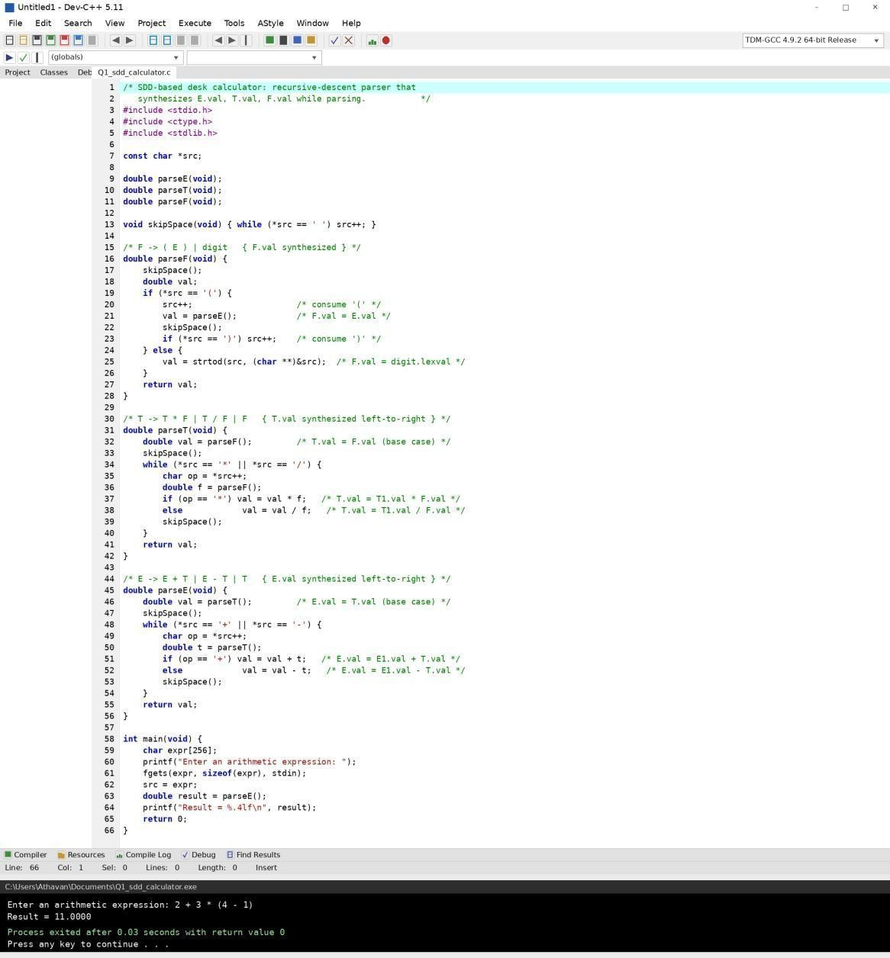

Q2. Postfix Expression Evaluation (S-Attributed, Stack-Based Bottom-Up)
  - Evaluates a postfix expression using a stack.
  - Demonstrates S-attributed definition evaluation — every attribute is synthesized from children already reduced on the stack.
  - Prints each intermediate result as it is computed.
Program (Dev-C++) and Console Output:
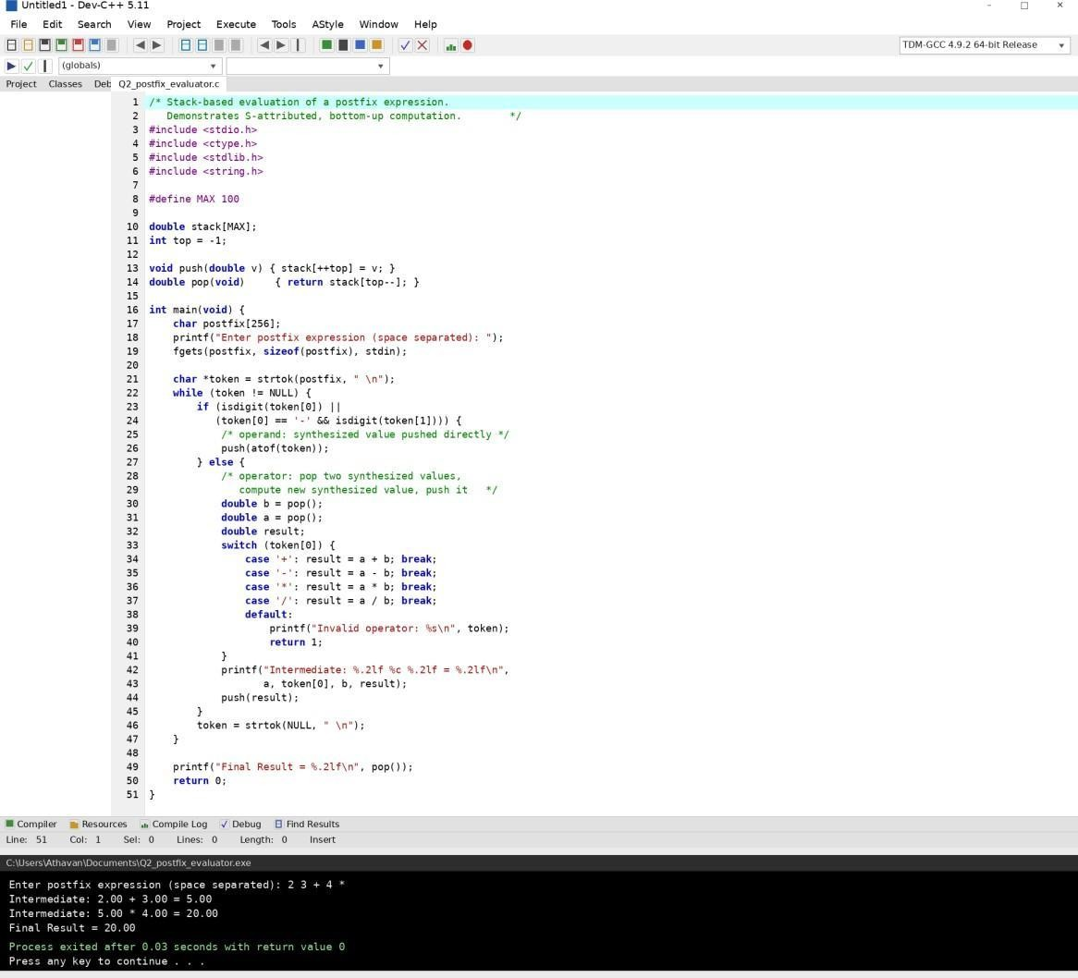

Q3. L-Attributed Definition — Inherited Attributes (Top-Down Evaluation)
  - Evaluates an expression like a + b * c.
  - Uses function parameters to simulate inherited attributes (the running total is passed down the call chain).
  - Ensures correct precedence handling and demonstrates top-down evaluation logic.
Program (Dev-C++) and Console Output:
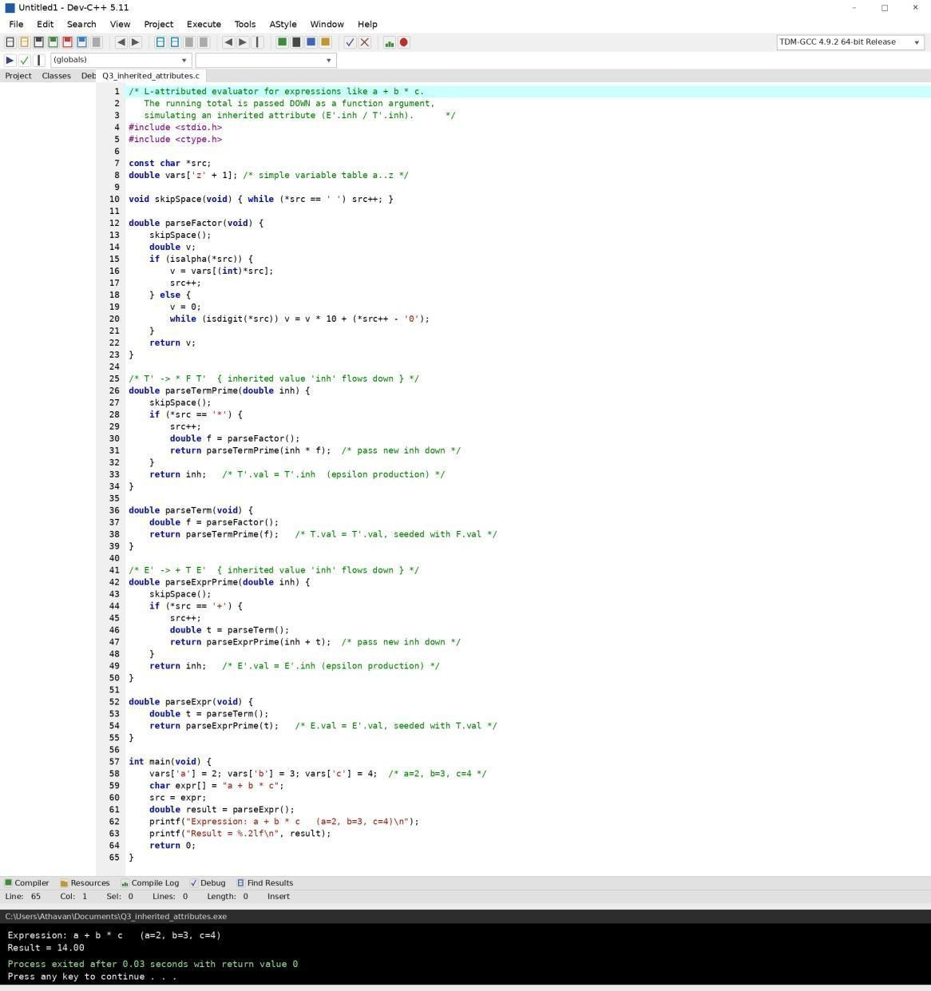

Q4. Type Equivalence Checker (with Pointer Types)
  - Accepts two type expressions (e.g., int, float, int*).
  - Compares them structurally for type equivalence (base type + pointer depth).
  - Displays whether the types are Equivalent or Not Equivalent, extended to handle pointer types.
Program (Dev-C++) and Console Output:
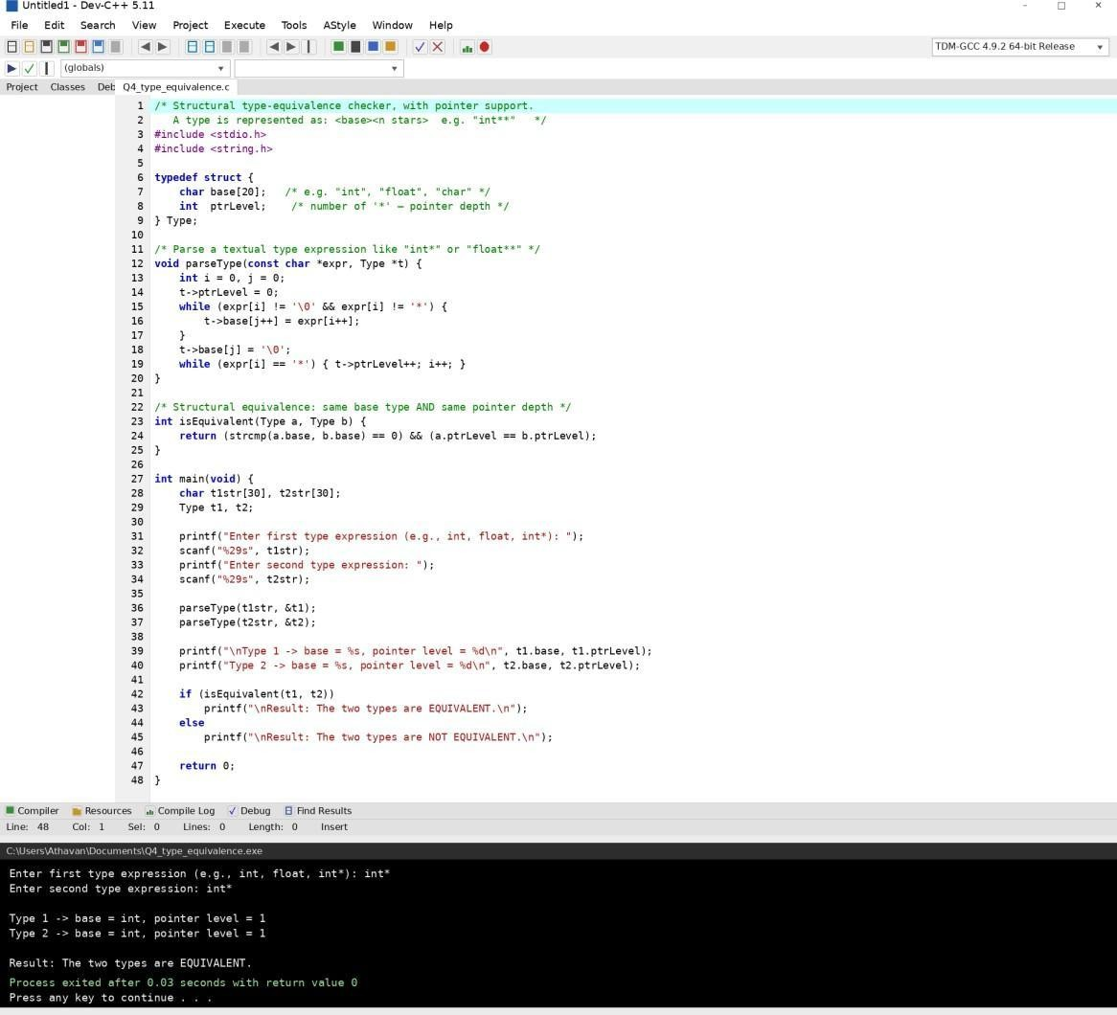

Q5. Semantic Analyzer — Type Checking of Arithmetic Expressions
  - Accepts two operands and their types.
  - Checks whether the operation (e.g., +, *) is valid between the given types.
  - Reports a Valid expression or a Type error (e.g., int + char*), demonstrating semantic-error detection.
Program (Dev-C++) and Console Output:
