Supplementary Material
Table S1: Summary of all Continuous Candidate Predictor Variables
Continuous predictor variable | Mean  (standard deviation) | Median  (25th, 75th percentile)
Listing Year | 2,014  (2.73) | 2,014  (2,012, 2,016)
Recipient Age (years) at Listing | 6.50  (6.20) | 4.31  (0.50, 12.8)
BSA (m2) at Listing | 0.83  (0.56) | 0.64  (0.33, 1.31)
BMI at Listing | 17.2  (4.64) | 16.1  (14.2, 18.8)
Listing Lab: Total Bilirubin mg/dL | 1.11  (1.75) | 0.60  (0.30, 1.10)
Listing Lab: AST U/L | 63.1  (117) | 36.0  (27.0, 53.0)
Listing Lab: ALT U/L | 58.0  (125) | 29.0  (19.0, 45.0)
Listing Lab: Creatinine mg/dL | 0.52  (0.35) | 0.44  (0.30, 0.64)
Listing Lab: Total Protein g/dL | 5.93  (1.58) | 6.10  (5.30, 6.90)
Listing Lab: Serum Albumin g/dL | 3.57  (0.73) | 3.60  (3.10, 4.10)
PRA Max at Listing | 13.0  (24.8) | 0.00  (0.00, 13.0)
Listing eGFR | 95.4  (37.3) | 92.2  (71.1, 117)
Transplant Year | 2,015  (2.70) | 2,015  (2,012, 2,017)
Recipient Age (years) at Transplant | 6.85  (6.24) | 4.88  (0.74, 13.1)
Recipient Height (inches) at Transplant | 42.7  (16.7) | 40.2  (26.6, 59.1)
Recipient Weight (pounds) at Transplant | 58.7  (53.2) | 35.3  (16.6, 94.2)
BSA (m2) at Transplant | 0.86  (0.55) | 0.68  (0.37, 1.34)
BMI at Transplant | 17.9  (4.51) | 16.8  (14.9, 19.5)
Patient in ICU at Transplant | 1.16  (24.5) | 1.00  (0.00, 1.00)
Transplant Lab: Total Bilirubin mg/dL | 0.93  (1.26) | 0.50  (0.30, 1.00)
Transplant Lab: AST U/L | 65.3  (97.0) | 39.0  (28.0, 65.0)
Transplant Lab: ALT U/L | 48.9  (96.0) | 29.0  (20.0, 45.0)
Transplant Lab: Creatinine mg/dL | 0.51  (0.39) | 0.41  (0.30, 0.62)
Transplant Lab: BUN mg/dL | 18.9  (12.4) | 16.0  (12.0, 22.0)
Transplant Lab: Total Protein g/dL | 6.34  (1.19) | 6.40  (5.60, 7.10)
Transplant Lab: Serum Albumin g/dL | 3.67  (0.72) | 3.70  (3.20, 4.20)
Transplant Lab: eGFR | 102  (38.6) | 97.1  (75.6, 124)
Cardiopulmonary bypass time (minutes) | 175  (71.6) | 161  (123, 211)
Donor ischemic time (minutes) | 219  (68.5) | 218  (181, 255)
PRA Max at Transplant | 12.7  (24.4) | 0.00  (0.00, 11.0)

Table S1: Summary of all Continuous Candidate Predictor Variables
BSA=body surface area; BMI=body mass index; AST=aspartate aminotransferase; ALT=alanine aminotransferase; PRA=panel reactive antibody; eGFR=estimated glomerular filtration rate; BUN=blood urea nitrogen
Table S2: Summary of all Categorical Candidate Predictor Variables
Categorical predictor variable | Count (percent)
Recipient Sex | - Female: 1,703 (45.0%)  - Male: 2,084 (55.0%)  - Missing: 0 (0.00%)
Race | - Black: 646 (17.1%)  - Other: 677 (17.9%)  - White: 2,464 (65.1%)  - Missing: 0 (0.00%)
Recipient Hispanic or Latino | - No: 2,944 (77.7%)  - Yes: 741 (19.6%)  - Missing: 102 (2.69%)
Recipient: Blood Type | - A: 1,377 (36.4%)  - Ab: 147 (3.88%)  - B: 529 (14.0%)  - O: 1,733 (45.8%)  - Missing: 1 (0.03%)
Recipient: Rh | - Negative: 452 (11.9%)  - Positive: 3,306 (87.3%)  - Missing: 29 (0.77%)
First listing for a heart transplant | - No: 14 (0.37%)  - Yes: 3,764 (99.4%)  - Missing: 9 (0.24%)
Primary Etiology | - Cardiomyopathy: 1,877 (49.6%)  - Congenital hd: 1,816 (48.0%)  - Other: 94 (2.48%)  - Missing: 0 (0.00%)
CHD: Hypoplastic Left Heart | - No: 2,070 (54.7%)  - Yes: 857 (22.6%)  - Missing: 860 (22.7%)
CHD: TOF/TOF Variant/DORV/RVOTO | - No: 2,737 (72.3%)  - Yes: 190 (5.02%)  - Missing: 860 (22.7%)
CHD: Single Ventricle | - No: 2,358 (62.3%)  - Yes: 1,273 (33.6%)  - Missing: 156 (4.12%)
Surgeries Prior to Listing | - No: 2,006 (53.0%)  - Yes: 1,773 (46.8%)  - Missing: 8 (0.21%)
Surgeries Prior to Listing: AP Shunt (including BT Shunt, Modified BT Shunt, Waterson Shunt, Pott's Shunt, Central Shunt, and MEE procedure) | - No: 3,643 (96.2%)  - Yes: 144 (3.80%)  - Missing: 0 (0.00%)
Surgeries Prior to Listing: Arterial switch operation | - No: 3,775 (99.7%)  - Yes: 12 (0.32%)  - Missing: 0 (0.00%)
Surgeries Prior to Listing: ASD Repair | - No: 3,733 (98.6%)  - Yes: 54 (1.43%)  - Missing: 0 (0.00%)
Surgeries Prior to Listing: Atrial switch (Senning/Mustard) | - No: 3,780 (99.8%)  - Yes: 7 (0.18%)  - Missing: 0 (0.00%)
Surgeries Prior to Listing: CABG | - No: 3,784 (99.9%)  - Yes: 3 (0.08%)  - Missing: 0 (0.00%)
Surgeries Prior to Listing: Complete AV Septal Defect Repair | - No: 3,764 (99.4%)  - Yes: 23 (0.61%)  - Missing: 0 (0.00%)
Surgeries Prior to Listing: Congenitally Corrected Transposition Repair (classic) | - No: 3,783 (99.9%)  - Yes: 4 (0.11%)  - Missing: 0 (0.00%)
Surgeries Prior to Listing: Congenitally Corrected Transposition Repair (double switch) | - No: 3,774 (99.7%)  - Yes: 13 (0.34%)  - Missing: 0 (0.00%)
Surgeries Prior to Listing: Damus Kaye Stansel (DKS) | - No: 3,738 (98.7%)  - Yes: 49 (1.29%)  - Missing: 0 (0.00%)
Surgeries Prior to Listing: d-Transposition of the Great Vessels Repair | - No: 3,766 (99.4%)  - Yes: 21 (0.55%)  - Missing: 0 (0.00%)
Surgeries Prior to Listing: Ebstein's Anomaly Repair | - No: 3,782 (99.9%)  - Yes: 5 (0.13%)  - Missing: 0 (0.00%)
Surgeries Prior to Listing: Fontan Procedure | - No: 3,279 (86.6%)  - Yes: 508 (13.4%)  - Missing: 0 (0.00%)
Surgeries Prior to Listing: Glenn Procedure | - No: 3,008 (79.4%)  - Yes: 779 (20.6%)  - Missing: 0 (0.00%)
Surgeries Prior to Listing: Hybrid Palliation | - No: 3,725 (98.4%)  - Yes: 62 (1.64%)  - Missing: 0 (0.00%)
Surgeries Prior to Listing: Norwood Stage I: BT Shunt | - No: 3,439 (90.8%)  - Yes: 348 (9.19%)  - Missing: 0 (0.00%)
Surgeries Prior to Listing: Norwood Stage I: Sano/RV-PA conduit | - No: 3,454 (91.2%)  - Yes: 333 (8.79%)  - Missing: 0 (0.00%)
Surgeries Prior to Listing: PA Banding | - No: 3,525 (93.1%)  - Yes: 262 (6.92%)  - Missing: 0 (0.00%)
Surgeries Prior to Listing: TOF/DORV/RVOTO Repair | - No: 3,744 (98.9%)  - Yes: 43 (1.14%)  - Missing: 0 (0.00%)
Surgeries Prior to Listing: Truncus Arteriosus Repair | - No: 3,773 (99.6%)  - Yes: 14 (0.37%)  - Missing: 0 (0.00%)
Surgeries Prior to Listing: Valve Replacement | - No: 3,639 (96.1%)  - Yes: 148 (3.91%)  - Missing: 0 (0.00%)
Surgeries Prior to Listing: VSD Repair | - No: 3,699 (97.7%)  - Yes: 88 (2.32%)  - Missing: 0 (0.00%)
Surgeries Prior to Listing: Other, specify | - No: 2,974 (78.5%)  - Yes: 813 (21.5%)  - Missing: 0 (0.00%)
Status at Listing: Combined Countries | - Priority: 3,072 (81.1%)  - Routine: 715 (18.9%)  - Missing: 0 (0.00%)
Was patient in or out of hospital at time of listing | - No: 974 (25.7%)  - Yes: 2,813 (74.3%)  - Missing: 0 (0.00%)
Listing: Continuous Invasive Mechanical Ventilation | - No: 2,570 (67.9%)  - Yes: 795 (21.0%)  - Missing: 422 (11.1%)
Did the patient require continuous inotropes at time of listing | - No: 1,444 (38.1%)  - Yes: 2,329 (61.5%)  - Missing: 14 (0.37%)
Ductal dependent pulmonary or systemic circulation -- by stent -- | - No: 3,643 (96.2%)  - Yes: 116 (3.06%)  - Missing: 28 (0.74%)
ABO Incompatible at Listing | - No: 2,729 (72.1%)  - Yes: 945 (25.0%)  - Missing: 113 (2.98%)
VAD at Listing | - No: 3,404 (89.9%)  - Yes: 383 (10.1%)  - Missing: 0 (0.00%)
ECMO at Listing | - No: 3,616 (95.5%)  - Yes: 171 (4.52%)  - Missing: 0 (0.00%)
No MCSD at Listing | - No: 554 (14.6%)  - Yes: 3,233 (85.4%)  - Missing: 0 (0.00%)
Listing Inf Dis Scr: HIV | - Negative: 3,616 (95.5%)  - Not done: 135 (3.56%)  - Positive: 7 (0.18%)  - Missing: 29 (0.77%)
Listing Inf Dis Scr: CMV | - Negative: 2,163 (57.1%)  - Not done: 311 (8.21%)  - Positive: 1,284 (33.9%)  - Missing: 29 (0.77%)
Listing Inf Dis Scr: CMV PCR | - Negative: 1,231 (32.5%)  - Not done: 2,336 (61.7%)  - Positive: 98 (2.59%)  - Missing: 122 (3.22%)
Listing Inf Dis Scr: EBV | - Negative: 1,511 (39.9%)  - Not done: 367 (9.69%)  - Positive: 1,871 (49.4%)  - Missing: 38 (1.00%)
Listing Inf Dis Scr: EBV PCR | - Negative: 1,180 (31.2%)  - Not done: 2,342 (61.8%)  - Positive: 141 (3.72%)  - Missing: 124 (3.27%)
Listing Inf Dis Scr: IFA Toxo | - Negative: 2,814 (74.3%)  - Not done: 809 (21.4%)  - Positive: 119 (3.14%)  - Missing: 45 (1.19%)
Listing Inf Dis Scr: HBs Ag | - Negative: 3,494 (92.3%)  - Not done: 219 (5.78%)  - Positive: 44 (1.16%)  - Missing: 30 (0.79%)
Listing Inf Dis Scr: HB core Ab | - Negative: 3,070 (81.1%)  - Not done: 584 (15.4%)  - Positive: 90 (2.38%)  - Missing: 43 (1.14%)
Listing Inf Dis Scr: HBs Ab | - Negative: 1,617 (42.7%)  - Not done: 837 (22.1%)  - Positive: 1,287 (34.0%)  - Missing: 46 (1.21%)
Listing Inf Dis Scr: Hep C Ab | - Negative: 3,491 (92.2%)  - Not done: 223 (5.89%)  - Positive: 31 (0.82%)  - Missing: 42 (1.11%)
Listing Inf Dis Scr: RPR/Syphilis | - Negative: 2,046 (54.0%)  - Not done: 1,666 (44.0%)  - Positive: 6 (0.16%)  - Missing: 69 (1.82%)
Medical History at Listing | - No: 526 (13.9%)  - Yes: 2,728 (72.0%)  - Missing: 533 (14.1%)
History at Listing: Arrhythmia | - No: 2,737 (72.3%)  - Yes: 868 (22.9%)  - Missing: 182 (4.81%)
History at Listing: Cardiac Arrest/CPR | - No: 3,245 (85.7%)  - Yes: 360 (9.51%)  - Missing: 182 (4.81%)
History at Listing: Diabetes | - No: 3,597 (95.0%)  - Yes: 8 (0.21%)  - Missing: 182 (4.81%)
History at Listing: GI/Nutrition | - No: 2,802 (74.0%)  - Yes: 803 (21.2%)  - Missing: 182 (4.81%)
History at Listing: Malignancy | - No: 3,544 (93.6%)  - Yes: 61 (1.61%)  - Missing: 182 (4.81%)
History at Listing: Neurologic | - No: 3,439 (90.8%)  - Yes: 166 (4.38%)  - Missing: 182 (4.81%)
History at Listing: Pacemaker | - No: 3,150 (83.2%)  - Yes: 455 (12.0%)  - Missing: 182 (4.81%)
History at Listing: Peripheral Myopathy/Neuromuscular disease | - No: 3,579 (94.5%)  - Yes: 26 (0.69%)  - Missing: 182 (4.81%)
History at Listing: Prenatal Diagnosis | - No: 3,222 (85.1%)  - Yes: 383 (10.1%)  - Missing: 182 (4.81%)
History at Listing: Prior Transfusions | - No: 2,508 (66.2%)  - Yes: 1,097 (29.0%)  - Missing: 182 (4.81%)
History at Listing: Renal Insufficiency | - No: 3,463 (91.4%)  - Yes: 142 (3.75%)  - Missing: 182 (4.81%)
History at Listing: Shock | - No: 3,473 (91.7%)  - Yes: 132 (3.49%)  - Missing: 182 (4.81%)
History at Listing: Other | - No: 3,065 (80.9%)  - Yes: 540 (14.3%)  - Missing: 182 (4.81%)
HX Listing: Arrhythmia: Atrial fibrillation / flutter | - No: 3,210 (84.8%)  - Yes: 137 (3.62%)  - Missing: 440 (11.6%)
HX Listing: Arrhythmia: Complete heart block | - No: 3,195 (84.4%)  - Yes: 152 (4.01%)  - Missing: 440 (11.6%)
HX Listing: Arrhythmia: Ventricular Fibrillation | - No: 3,269 (86.3%)  - Yes: 78 (2.06%)  - Missing: 440 (11.6%)
HX Listing: Arrhythmia: Ventricular Tachycardia | - No: 2,963 (78.2%)  - Yes: 384 (10.1%)  - Missing: 440 (11.6%)
HX Listing: Arrhythmia: Unknown | - No: 3,341 (88.2%)  - Yes: 6 (0.16%)  - Missing: 440 (11.6%)
HX Listing: Arrhythmia: Other | - No: 3,073 (81.1%)  - Yes: 274 (7.24%)  - Missing: 440 (11.6%)
HX Listing: GI: Failure to thrive | - No: 2,707 (71.5%)  - Yes: 626 (16.5%)  - Missing: 454 (12.0%)
HX Listing: GI: Infectious hepatitis | - No: 3,327 (87.9%)  - Yes: 6 (0.16%)  - Missing: 454 (12.0%)
HX Listing: GI: Protein losing Enteropathy | - No: 3,188 (84.2%)  - Yes: 145 (3.83%)  - Missing: 454 (12.0%)
HX Listing: Malignancy: Other | - No: 3,210 (84.8%)  - Yes: 41 (1.08%)  - Missing: 536 (14.2%)
HX Listing: Neurologic: Anoxic brain injury | - No: 3,268 (86.3%)  - Yes: 5 (0.13%)  - Missing: 514 (13.6%)
HX Listing: Neurologic: Hemorrhagic /thromboembolic stroke | - No: 3,144 (83.0%)  - Yes: 129 (3.41%)  - Missing: 514 (13.6%)
HX Listing: Neurologic: Other | - No: 3,235 (85.4%)  - Yes: 38 (1.00%)  - Missing: 514 (13.6%)
HX Listing: Pacemaker: Defibrillator/AICD | - No: 3,080 (81.3%)  - Yes: 176 (4.65%)  - Missing: 531 (14.0%)
HX Listing: Pacemaker: CRT/biventricular pacing | - No: 3,129 (82.6%)  - Yes: 158 (4.17%)  - Missing: 500 (13.2%)
HX Listing: Pacemaker: not CRT and not ICD | - No: 3,237 (85.5%)  - Yes: 50 (1.32%)  - Missing: 500 (13.2%)
HX Listing: Respiratory: Asthma | - No: 3,198 (84.4%)  - Yes: 86 (2.27%)  - Missing: 503 (13.3%)
HX Listing: Respiratory: Plastic bronchitis | - No: 3,194 (84.3%)  - Yes: 58 (1.53%)  - Missing: 535 (14.1%)
Primary Insurance | - Charitable dona: 2 (0.05%)  - Free: 134 (3.54%)  - Government: 2,084 (55.0%)  - Other: 96 (2.53%)  - Private: 1,433 (37.8%)  - Self pay: 32 (0.84%)  - Missing: 6 (0.16%)
Listed for prospective crossmatch | - No: 3,204 (84.6%)  - Yes: 403 (10.6%)  - Missing: 180 (4.75%)
Were hemodynamics done prior to listing | - No: 1,572 (41.5%)  - Yes: 2,147 (56.7%)  - Missing: 68 (1.80%)
Prior to Listing: Hemodynamic Agents Used | - No: 2,323 (61.3%)  - Yes: 599 (15.8%)  - Missing: 865 (22.8%)
Prior to Listing: Hemodynamic Agent: 100% O2 | - No: 3,148 (83.1%)  - Yes: 198 (5.23%)  - Missing: 441 (11.6%)
Prior to Listing: Hemodynamic Agent: Dobutamine | - No: 3,319 (87.6%)  - Yes: 27 (0.71%)  - Missing: 441 (11.6%)
Prior to Listing: Hemodynamic Agent: Dopamine | - No: 3,257 (86.0%)  - Yes: 89 (2.35%)  - Missing: 441 (11.6%)
Prior to Listing: Hemodynamic Agent: Isoproterenol | - No: 3,346 (88.4%)  - Missing: 441 (11.6%)
Prior to Listing: Hemodynamic Agent: Nitroglycerin | - No: 3,338 (88.1%)  - Yes: 8 (0.21%)  - Missing: 441 (11.6%)
Prior to Listing: Hemodynamic Agent: Nitroprusside | - No: 3,335 (88.1%)  - Yes: 11 (0.29%)  - Missing: 441 (11.6%)
Prior to Listing: Hemodynamic Agent: Norepinephrine | - No: 3,345 (88.3%)  - Yes: 1 (0.03%)  - Missing: 441 (11.6%)
Prior to Listing: Hemodynamic Agent: Other | - No: 3,267 (86.3%)  - Yes: 79 (2.09%)  - Missing: 441 (11.6%)
School at Listing: In School | - No: 99 (2.61%)  - Not routinely done: 2,005 (52.9%)  - Yes: 1,623 (42.9%)  - Missing: 60 (1.58%)
Was exercise test performed | - No: 3,315 (87.5%)  - Not routinely done: 262 (6.92%)  - Yes: 169 (4.46%)  - Missing: 41 (1.08%)
NYHA Class at Listing | - Not done: 1,980 (52.3%)  - Nyha 1: 22 (0.58%)  - Nyha 2: 220 (5.81%)  - Nyha 3: 497 (13.1%)  - Nyha 4: 776 (20.5%)  - Missing: 292 (7.71%)
Ross Heart Failure Class at Listing | - Not done: 2,226 (58.8%)  - Ross 1: 13 (0.34%)  - Ross 2: 126 (3.33%)  - Ross 3: 254 (6.71%)  - Ross 4: 475 (12.5%)  - Missing: 693 (18.3%)
Transplant simultaneous organ: None | - No: 17 (0.45%)  - Yes: 3,763 (99.4%)  - Missing: 7 (0.18%)
Transplant type | - Heterotopic: 12 (0.32%)  - Orthotopic: 3,772 (99.6%)  - Missing: 3 (0.08%)
Status at Transplant: Country | - Brazil: 51 (1.35%)  - Canada: 164 (4.33%)  - United kingdom: 252 (6.65%)  - United states: 3,320 (87.7%)  - Missing: 0 (0.00%)
Patient in Hospital at Transplant | - No: 1,001 (26.4%)  - Yes: 2,786 (73.6%)  - Missing: 0 (0.00%)
Status at Transplant: Combined Countries | - Priority: 3,464 (91.5%)  - Routine: 297 (7.84%)  - Missing: 26 (0.69%)
Continuous Invasive Mechanical Ventilation at Transplant | - No: 2,635 (69.6%)  - Yes: 629 (16.6%)  - Missing: 523 (13.8%)
Continuous Inotropes at Transplant | - No: 1,503 (39.7%)  - Yes: 2,265 (59.8%)  - Missing: 19 (0.50%)
ABO Incompatible at Transplant | - No: 3,437 (90.8%)  - Yes: 323 (8.53%)  - Missing: 27 (0.71%)
VAD at Transplant | - No: 2,802 (74.0%)  - Yes: 985 (26.0%)  - Missing: 0 (0.00%)
ECMO at Transplant | - No: 3,624 (95.7%)  - Yes: 163 (4.30%)  - Missing: 0 (0.00%)
Transplant: Donor Specific or Retrospective Crossmatch | - No: 458 (12.1%)  - Yes: 3,255 (86.0%)  - Missing: 74 (1.95%)
Donor Specific Antibodies (DSA) | - No: 3,201 (84.5%)  - Yes: 445 (11.8%)  - Missing: 141 (3.72%)
Hemodynamics Performed | - No: 2,726 (72.0%)  - Yes: 995 (26.3%)  - Missing: 66 (1.74%)
Hemodynamic Agent: 100% O2 | - No: 3,179 (83.9%)  - Yes: 76 (2.01%)  - Missing: 532 (14.0%)
Hemodynamic Agent: Dobuatmine | - No: 3,245 (85.7%)  - Yes: 10 (0.26%)  - Missing: 532 (14.0%)
Hemodynamic Agent: Dopamine | - No: 3,227 (85.2%)  - Yes: 28 (0.74%)  - Missing: 532 (14.0%)
Hemodynamic Agent: Isoproterenol (Isuprel) | - No: 3,252 (85.9%)  - Yes: 3 (0.08%)  - Missing: 532 (14.0%)
Hemodynamic Agent: Milrinone | - No: 2,930 (77.4%)  - Yes: 325 (8.58%)  - Missing: 532 (14.0%)
Hemodynamic Agent: Nesiritide | - No: 3,254 (85.9%)  - Yes: 1 (0.03%)  - Missing: 532 (14.0%)
Hemodynamic Agent: Nitric Oxide | - No: 3,199 (84.5%)  - Yes: 56 (1.48%)  - Missing: 532 (14.0%)
Hemodynamic Agent: Nitroglycerine | - No: 3,255 (86.0%)  - Missing: 532 (14.0%)
Hemodynamic Agent: Nitroprusside (Nipride) | - No: 3,247 (85.7%)  - Yes: 8 (0.21%)  - Missing: 532 (14.0%)
Hemodynamic Agent: PGE (Alprostadil) | - No: 3,232 (85.3%)  - Yes: 23 (0.61%)  - Missing: 532 (14.0%)
Hemodynamic Agent: PGI (Flolan) | - No: 3,254 (85.9%)  - Yes: 1 (0.03%)  - Missing: 532 (14.0%)
Was patient on inotropes, pressors, or thyroid hormones at time of transplant? | - No: 1,337 (35.3%)  - Yes: 2,397 (63.3%)  - Missing: 53 (1.40%)
Inotropes, Pressors, or Thyroid Hormones: Epinephrine | - No: 2,850 (75.3%)  - Yes: 418 (11.0%)  - Missing: 519 (13.7%)
Inotropes, Pressors, or Thyroid Hormones: Milrinone | - No: 1,123 (29.7%)  - Yes: 2,247 (59.3%)  - Missing: 417 (11.0%)
Inotropes, Pressors, or Thyroid Hormones: Neosynephrine | - No: 3,234 (85.4%)  - Yes: 18 (0.48%)  - Missing: 535 (14.1%)
Inotropes, Pressors, or Thyroid Hormones: T3 (Tri-iodothyronine) | - No: 3,185 (84.1%)  - Yes: 70 (1.85%)  - Missing: 532 (14.0%)
Inotropes, Pressors, or Thyroid Hormones: T4 (Levothyroxine) | - No: 3,230 (85.3%)  - Yes: 27 (0.71%)  - Missing: 530 (14.0%)
Technique of transplant: Bicaval | - No: 453 (12.0%)  - Yes: 3,049 (80.5%)  - Missing: 285 (7.53%)
MCSD at Transplant | - No: 2,639 (69.7%)  - Yes: 1,148 (30.3%)  - Missing: 0 (0.00%)
Table S2: Summary of all Categorical Candidate Predictor Variables
CHD=congenital heart disease; TOF=Tetralogy of Fallot; DORV=double outlet right ventricle; RVOTO=right ventricular outflow tract obstruction; AP= aorticopulmonary; BT=Blalock Taussing; ASD=atrial septal defect; CABG=coronary artery bypass graft; AV=atrioventricular; PA=pulmonary artery; VAD= ventricular assist device; ECMO=extracorporeal membranous oxygenation; MCSD=mechanical circulatory support device; AICD=automatic implantable cardiac defibrillator; CRT=cardiac resynchronization therapy

Table S3: Variable Missingness for Predictors Used in the Final Prediction Model
Predictor variable | Missing values
Predictor variable | Number | Percent | Imputed to
Medical History at Listing | 533 | 14 | yes
Transplant Lab: Serum Albumin g/dL | 422 | 11 | 3.7
PRA Max List | 326 | 8.6 | 0.00
Transplant Lab: ALT U/L | 305 | 8.1 | 29
CHD: Single Ventricle | 156 | 4.1 | no
Transplant Lab: eGFR | 123 | 3.2 | 97
Transplant Lab: BUN mg/dL | 102 | 2.7 | 16
BMI at Transplant | 80 | 2.1 | 17
Surgeries Prior to Listing | 8 | 0.21 | no
Recipient Weight (pounds) at Transplant | 7 | 0.18 | 35
Primary Etiology | 0 | 0.00 | cardiomyopathy
MCSD at Transplant | 0 | 0.00 | no
ECMO at Transplant | 0 | 0.00 | no
Transplant Year | 0 | 0.00 | 2,015
Listing Year | 0 | 0.00 | 2,014

Table S3: Variable Missingness for Predictors Used in the Final Prediction Model
PRA=panel reactive antibody; ALT=alanine aminotransferase; eGFR=estimated glomerular filtration rate; BUN=blood urea nitrogen; BMI=body mass index; MCSD= mechanical circulatory support device; ECMO=extracorporeal membranous oxygenation

Figure S1: Decision Trees for Axis Based Versus Oblique Splitting
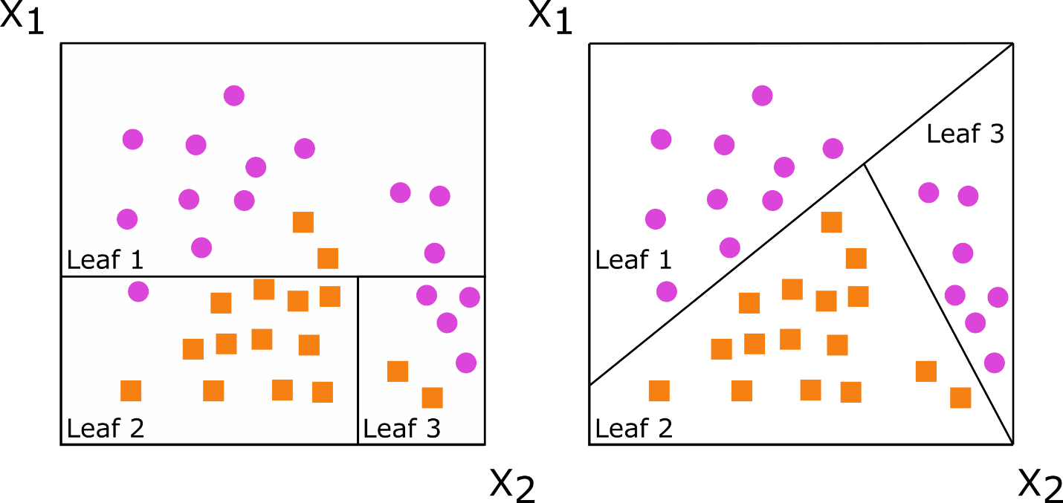
Figure S1: Decision Trees for Axis Based Versus Oblique Splitting
Decision trees for classification with axis-based splitting (left) and oblique splitting (right). Cases are orange squares; controls are purple circles. Both trees partition the predictor space defined by variables X1 and X2, but the oblique splits do a better job of separating the two classes.

Figure S2: Model discrimination (C-statistic) as a function of the number of predictor variables included in the prediction model.
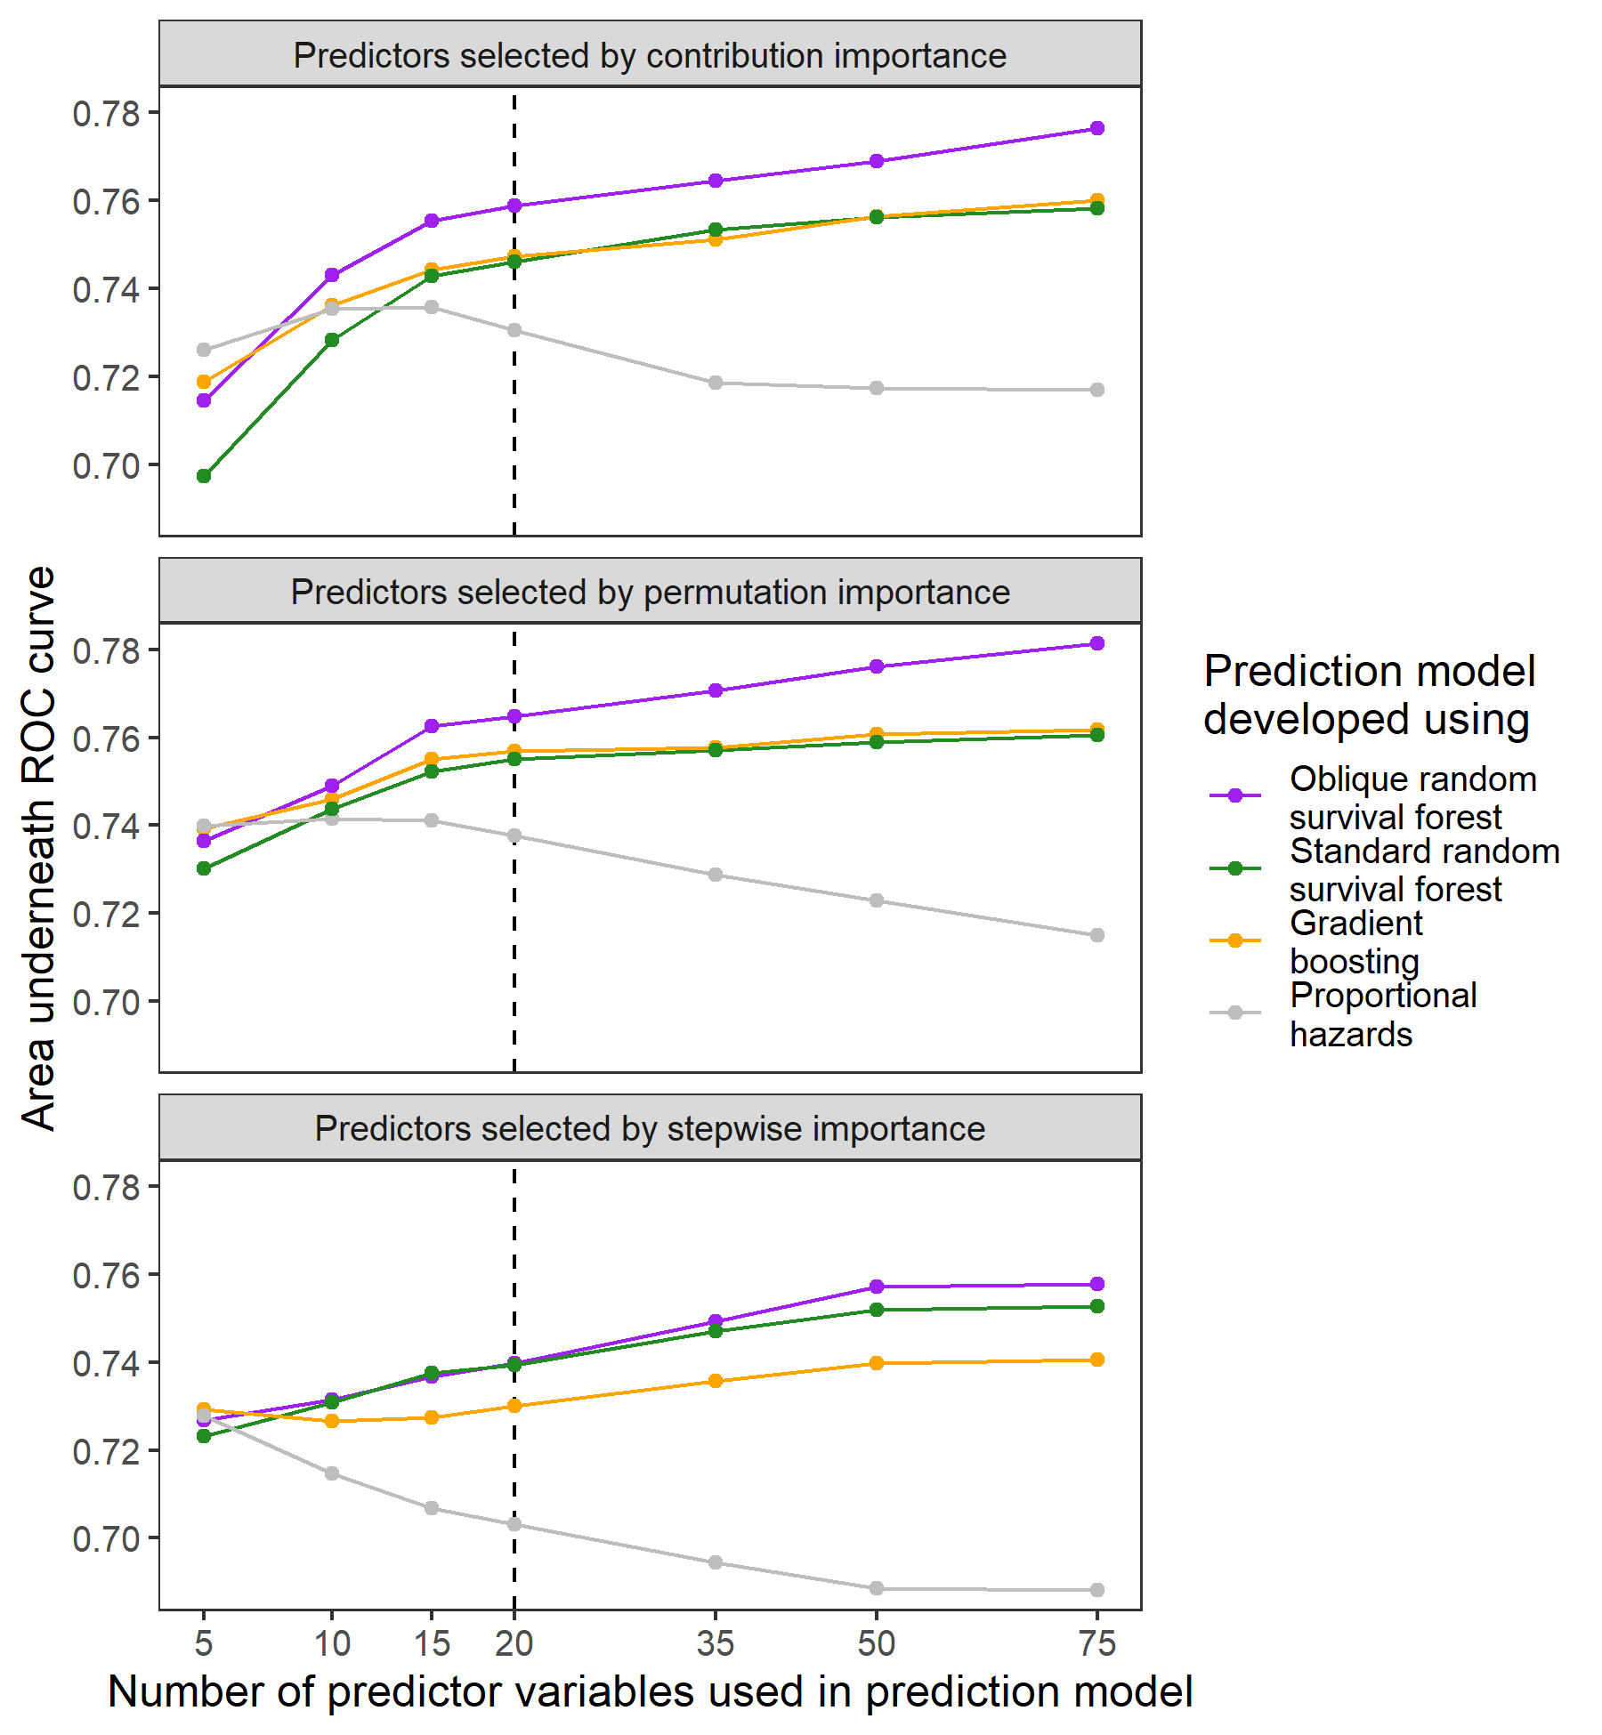
Figure S2: Model discrimination (C-statistic) as a function of the number of predictor variables included in the prediction model
Figure S3: Shapley Values for Continues Predictor Variables Used in the Final Model
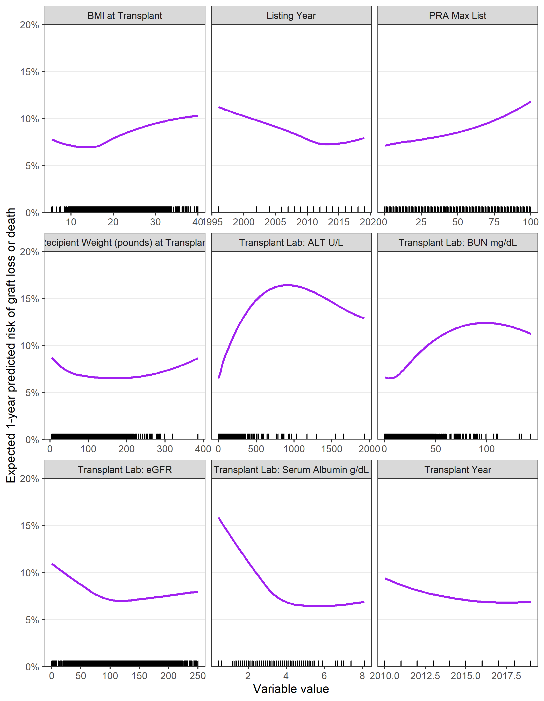
Figure S3: Shapley Values for Continues Predictor Variables Used in the Final Model
BMI=body mass index; PRA=panel reactive antibodies; ALT=alanine aminotransferase; BUN=blood urea nitrogen; eGFR=estimated glomerular filtration rate
SHAP values were plotted for each continuous predictor variable that was used in the final model as a function of the predictor.

