**Hospital Front Desk**

**Prerequisite:**

According to this service, Pojo classes has been annotated with @setter, @Getter, @NoOrgConstructor, @AllArgConstrutor using Lombok in order to avoid boiler plate code. Kindly go through the following link to complete setup in IDE. Otherwise it might throw an error.

<https://howtodoinjava.com/automation/lombok-eclipse-installation-examples/>

|  |
| --- |
| **Service Info:**  Rest Api: hospitalfrontdesk  Port : 8083  Rest Client: hospitalclient  Port: 8080 |

**Requirement 1:**

<http://localhost:8083/hospital/enquiry/appollo/Dentist>

**JSON Response:**

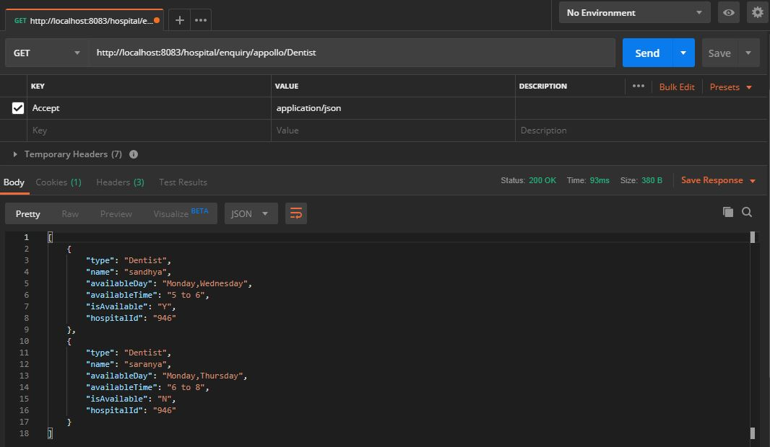

**XML Response:**

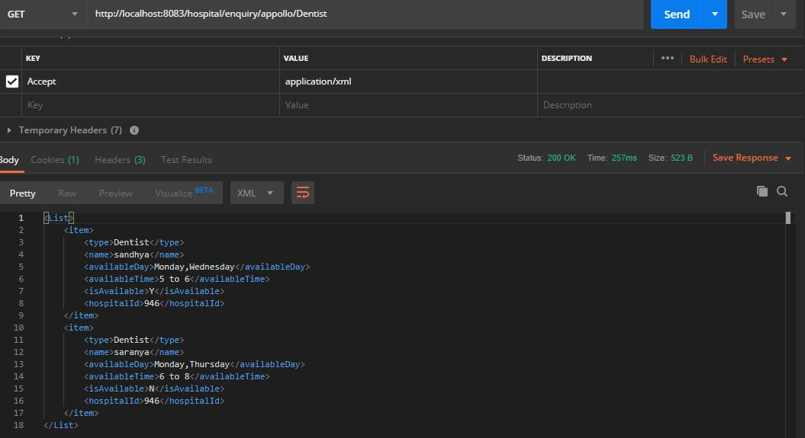

**Exception Handling:**

**Use case: Hospital not available:**

<http://localhost:8083/hospital/enquiry/billroth/Dentist>

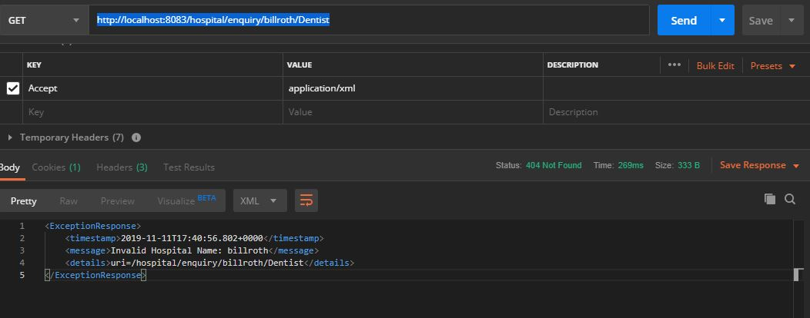

**Use case: Specialist not available:**

<http://localhost:8083/hospital/enquiry/kamachi/Dentist>

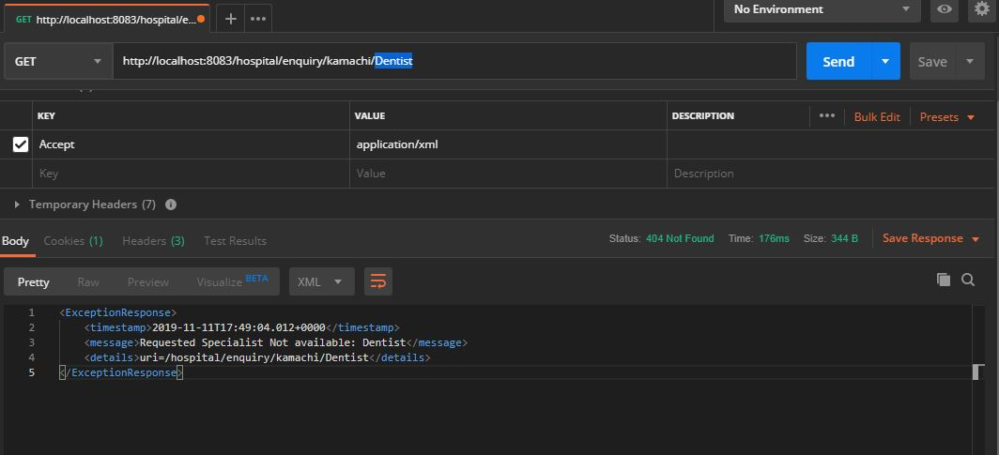

**Requirement 2:**

<http://localhost:8083/hospital/appointment/Edward/Monday/suganthi>

**JSON Response:**

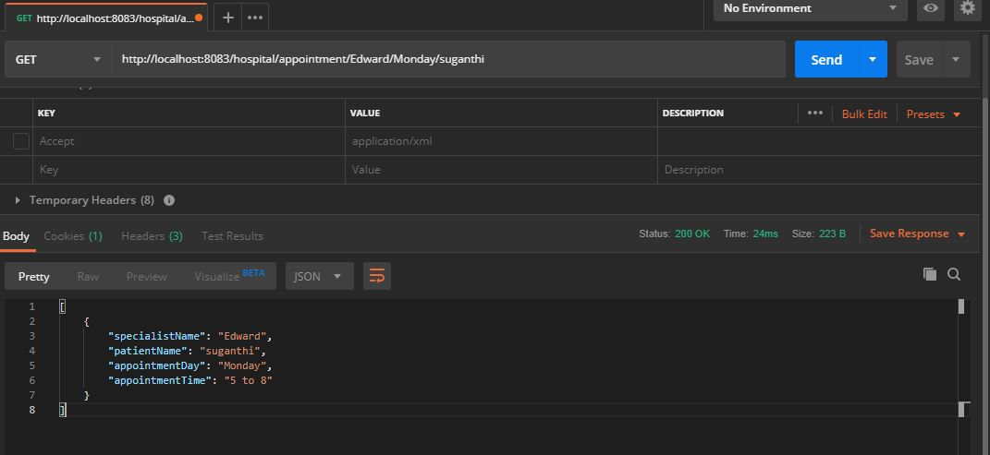

**XML Response:**

**As per the requirement, Response is restricted to json format intentionally. So xml format will not be accepted.**

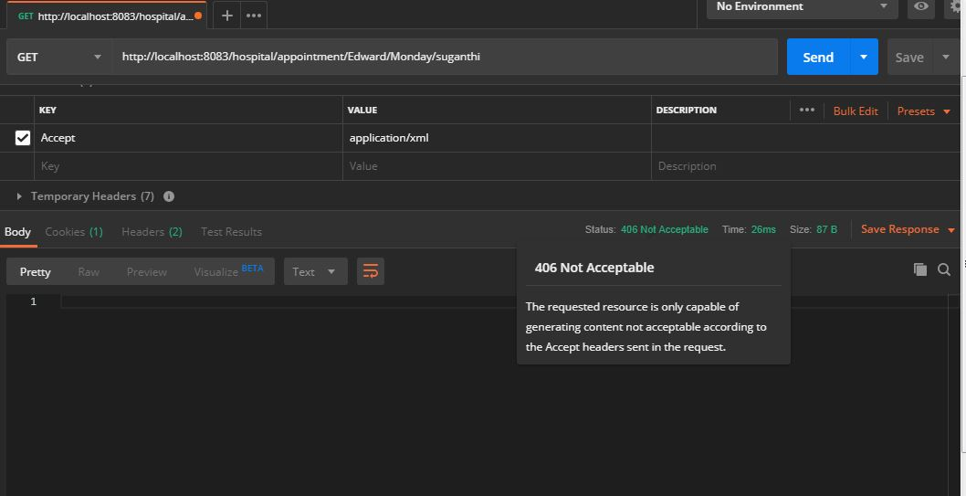

**Requirement 3:**

<http://localhost:8083/hospital/admission/kamachi>

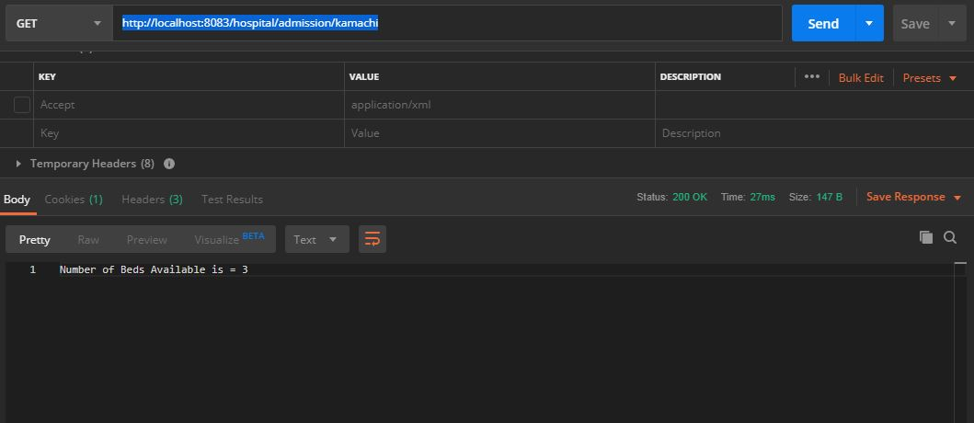

**Exception Handling:**

**Use case: Hospital not available:**

http://localhost:8083/hospital/admission/billroth

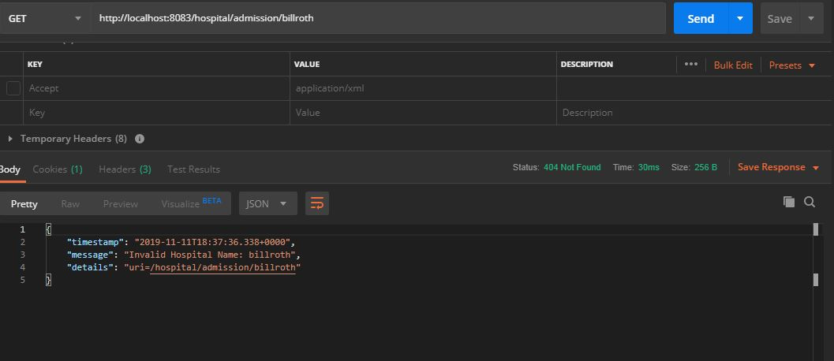

**Use case: Beds not available:**

<http://localhost:8083/hospital/admission/kaveri>

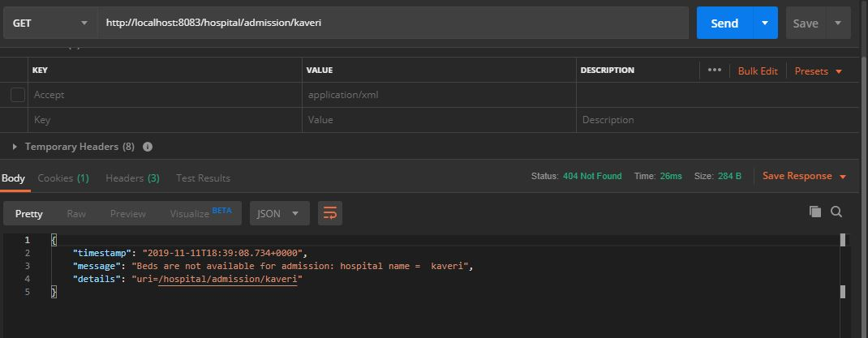

**Requirement 4:**

http://localhost:8080/hospital/client/appollo/Dentist

**Json Response:**

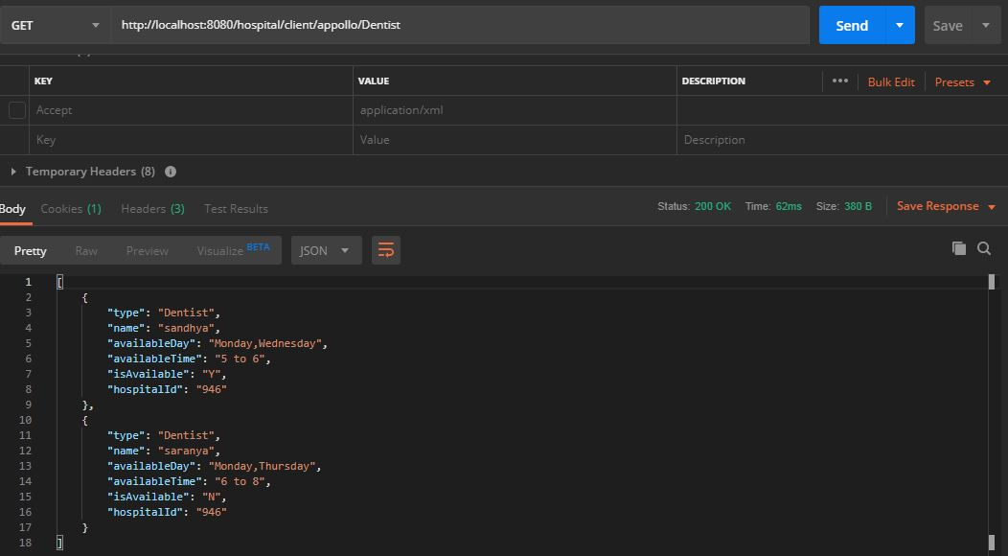

**XML Response:**

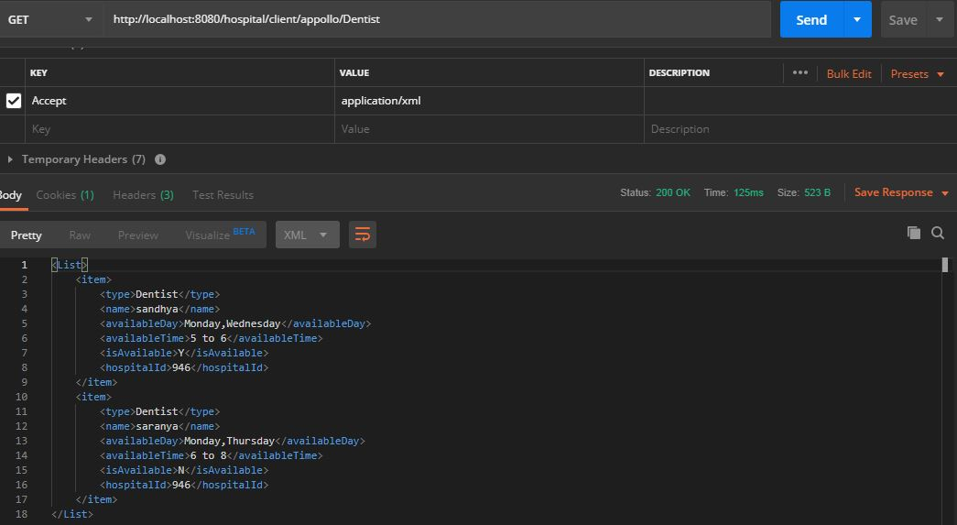

**Exception Response:**

http://localhost:8080/hospital/client/billroth/Dentist

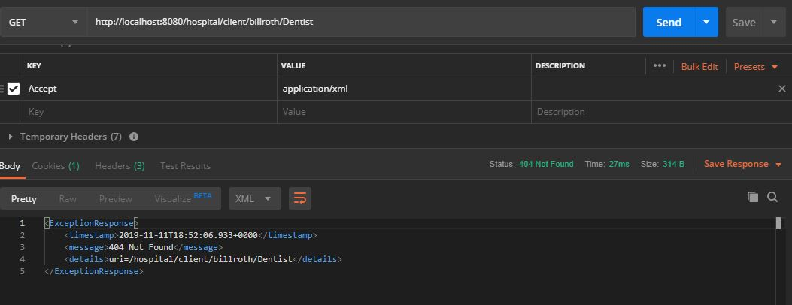

**Requirement 5:**

<http://localhost:8083/actuator>

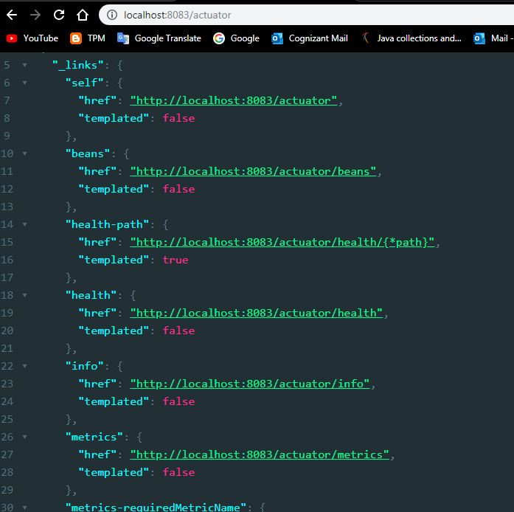

**Health Check:**

<http://localhost:8083/actuator>/health

