-- Create tables

CREATE TABLE Crime (

CrimeID INT PRIMARY KEY,

IncidentType VARCHAR(255),

IncidentDate DATE,

Location VARCHAR(255),

Description TEXT,

Status VARCHAR(20)

);

CREATE TABLE Victim (

VictimID INT PRIMARY KEY,

CrimeID INT,

Name VARCHAR(255),

age int,

ContactInfo VARCHAR(255),

Injuries VARCHAR(255),

FOREIGN KEY (CrimeID) REFERENCES Crime(CrimeID) ON DELETE CASCADE

);

CREATE TABLE Suspect (

SuspectID INT PRIMARY KEY,

CrimeID INT,

Name VARCHAR(255),

Description TEXT,

CriminalHistory TEXT,

FOREIGN KEY (CrimeID) REFERENCES Crime(CrimeID) ON DELETE CASCADE

);

-- Insert sample data

INSERT INTO Crime (CrimeID, IncidentType, IncidentDate, Location, Description, Status) VALUES

(1, 'Robbery', '2023-09-15', '123 Main St, Cityville', 'Armed robbery at a convenience store', 'Open'),

(2, 'Homicide', '2023-09-20', '456 Elm St, Townsville', 'Investigation into a murder case', 'Under Investigation'),

(3, 'Theft', '2023-09-10', '789 Oak St, Villagetown', 'Shoplifting incident at a mall', 'Closed');

INSERT INTO Victim (VictimID, CrimeID, Name,age, ContactInfo, Injuries) VALUES

(1, 1, 'John Doe',53, 'johndoe@example.com', 'Minor injuries'),

(2, 2, 'Jane Smith',32, 'janesmith@example.com', 'Deceased'),

(3, 3, 'Alice Johnson',41, 'alicejohnson@example.com', 'None');

INSERT INTO Suspect (SuspectID, CrimeID, Name, Description, CriminalHistory) VALUES

(1, 1, 'Robber 1', 'Armed and masked robber', 'Previous robbery convictions'),

(2, 2, 'Unknown', 'Investigation ongoing', NULL),

(3, 3, 'Suspect 1', 'Shoplifting suspect', 'Prior shoplifting arrests');

select *from Crime

select *from Victim

select *from Suspect

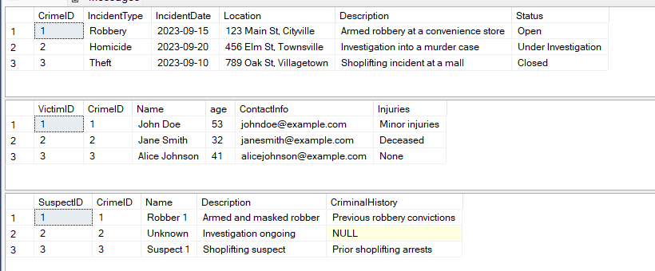

1.

Select *from Crime

where status = 'open'

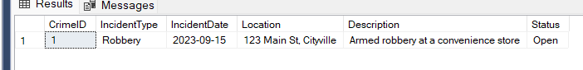

2.

Select Count(*) as Total_Incidents from crime



3.

Select Distinct IncidentType from Crime

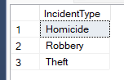

4.

Select *from Crime

where IncidentDate between '2023-09-01' and '2023-09-10'

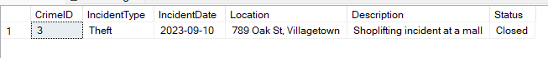

5.

Select VictimID,name,age from Victim

Order by age DESC

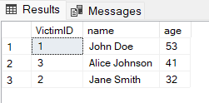

6.

Select AVG(age) as AVG_Age from victim



7.

Select IncidentType, COUNT(*) as IncidentCount

from Crime

where Status = 'Open'

GROUP BY IncidentType;

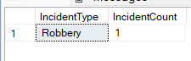

8.

Select name from victim

where name like '%doe%'

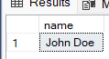

9.

Select v.name, c.status

from Victim v

join crime c on v.CrimeID = c.CrimeID

where c.status in ('Open', 'Closed')

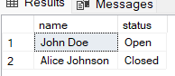

10.

select v.name,v.age,c.incidenttype

from victim v

join crime c

on v.crimeId = c.crimeID

where v.age in (32,35)



11.

select v.Name, 'Victim' AS Role

from Victim v

JOIN Crime c on v.CrimeID = c.CrimeID

where c.IncidentType = 'Robbery'

UNION

select s.Name, 'Suspect' AS Role

from Suspect s

JOIN Crime c on s.CrimeID = c.CrimeID

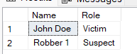where c.IncidentType = 'Robbery';

12.

select IncidentType, count(*) as open_case_count

from Crime

where status = 'open'

group by IncidentType

having count(*) >=1



13.

select c.*

from Crime c

join Suspect s ON c.CrimeID = s.CrimeID

WHERE s.Name IN (select Name from Victim);



14.

select c.*,v.name,v.ContactInfo,s.name,s.CriminalHistory

from Crime c

left join victim v on c.crimeId = v.crimeID

left join Suspect s on c.crimeId = s.crimeID



15.

Select s.*

from Suspect s

join victim v on s.crimeID = v.crimeID

where s.age>v.age

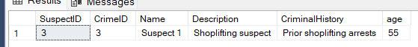

16.

select s.Name, COUNT(*) AS IncidentCount

from Suspect s

GROUP BY s.Name

having COUNT(*) >= 1;

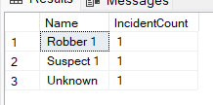

17.

select c.incidenttype, s.name

from crime c

join Suspect s on c.crimeId = s.CrimeID

where s.name = 'Unknown'



18.

19.

Select c.*,s.name

from crime c

join suspect s on c.crimeId = s.crimeID

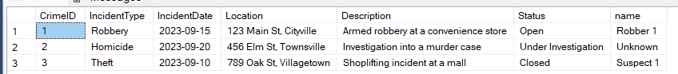

20.

select s.*, c.incidentType

from crime c

join Suspect s on c.crimeId = s.crimeID

where c.incidentType in ('Robbery','Assualt')

