**Buyer Guide Step 1: Navigating the Dashboard  
  
How to Navigate the Dashboard**

Upon logging in, you will be automatically redirected to the dashboard. This is the page that will help you keep track of your progress. Each column can be clicked to sort the data, descending and ascending. There are three sections in the dashboard:

1. List Backlinks to Buy

* This table shows the overview of the list of URLs provided by StaLinks
* It has 6 columns:
  + Buyer – The list of your sub accounts
  + New – URLs that are recently added to the system
  + Interested – URLs that you would like to buy backlinks in the future
  + Purchased – URLs that you have already purchased
  + Not Interested – URLs that you want to remove to the list
  + Total – The total URLs

1. 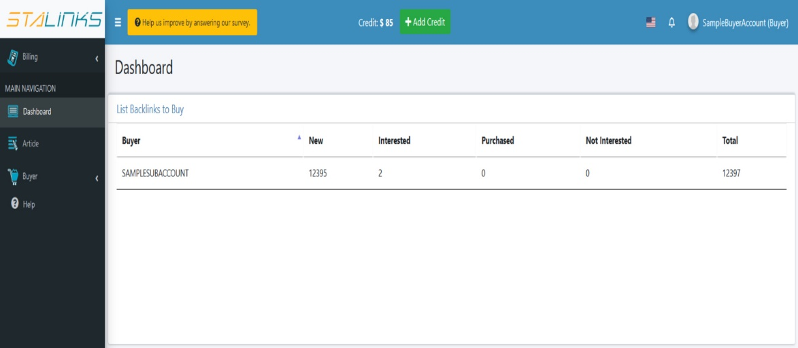Total Backlink (Buyer)

* This table contains the summary of your order status
* It has 10 columns:
  + Buyer – your username
  + Total – the total number of your orders
  + Processing – orders that are already confirmed by the seller and the writers can accept the writing of the article
  + Content in Writing – the writers are writing the content
  + Content Done – The content is done and ready to be posted
  + Content Sent – The team already sent the content to the seller
  + Issue – The order has a problem
  + Live in Process – The content is to be uploaded
  + Live – the content is already live
  + Cancelled – the order is cancelled

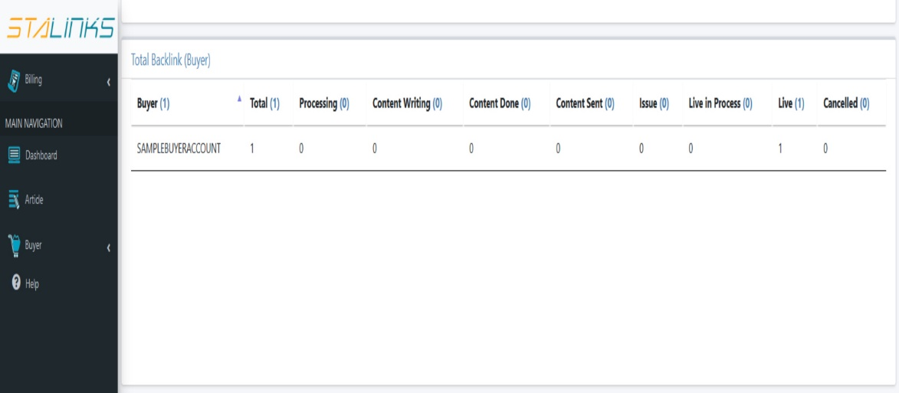

1. Purchase

* This table contains the overview of the purchases you made
* It has 4 columns:
  + Buyer – your username
  + No. of Backlinks - the number of backlinks you purchased
  + Unpaid – The payment is already on process
  + Paid – The order is already paid

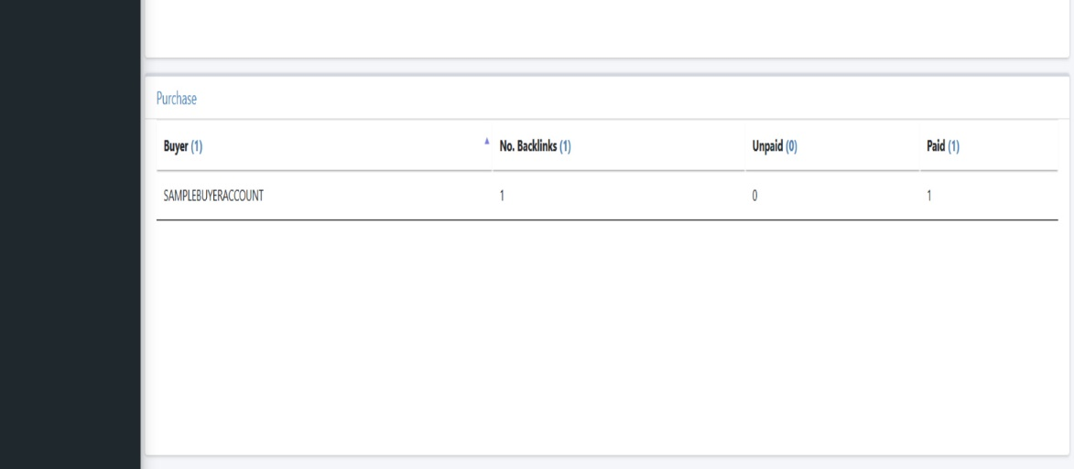

* The system will automatically send you notifications for everything that is happening to your account. Just click the bell icon located at the right section of the navigation bar to check the notifications.

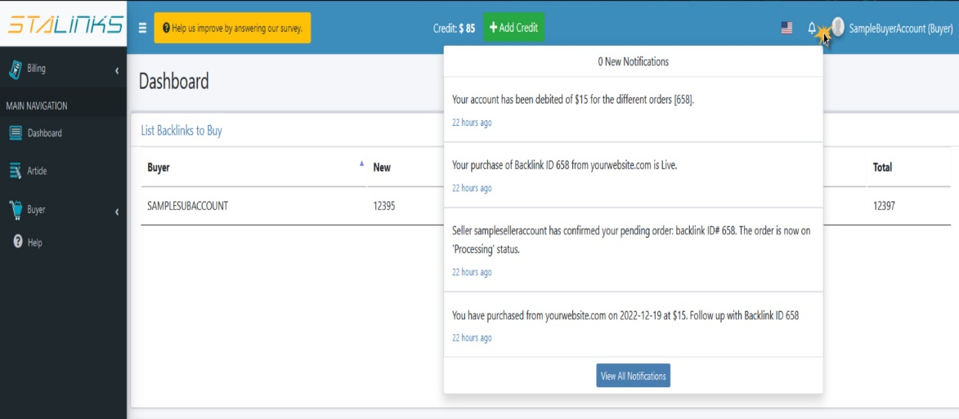

* You can also change the default language of the system. StaLinks offers 5 language translations namely: Japanese, Thai, Vietnamese, Hindi and Indonesian. Just click the flag icon located at the right panel of the navigation bar and select your desired translation.

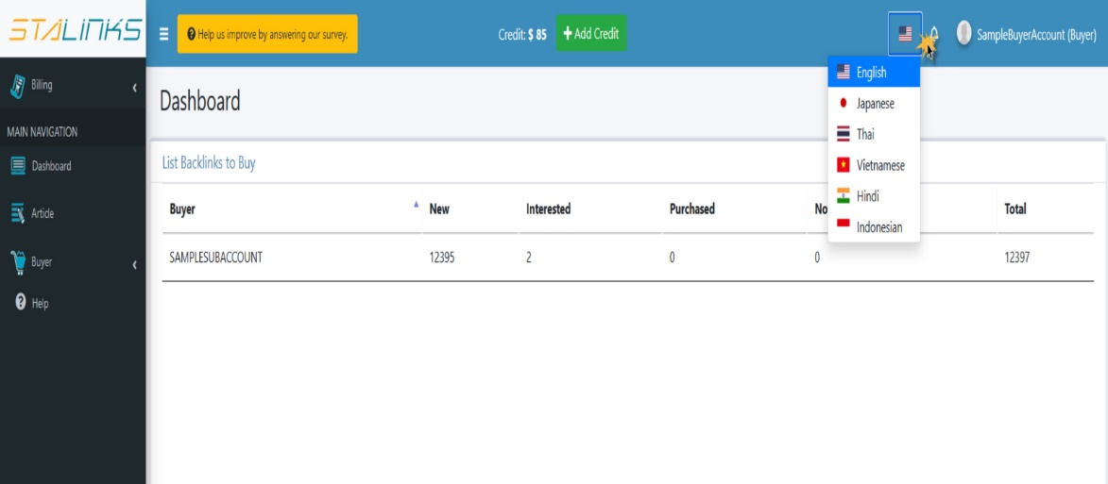

**Buyer Guide Step 2: Adding Credits  
  
How to add credits to your account to start purchasing backlinks**

To be able to purchase backlinks from StaLinks, you have to add credits to your account. Just follow the simple steps below:

1. Click the ‘Add Credit’ button located at the middle section of the navigation bar.
2. 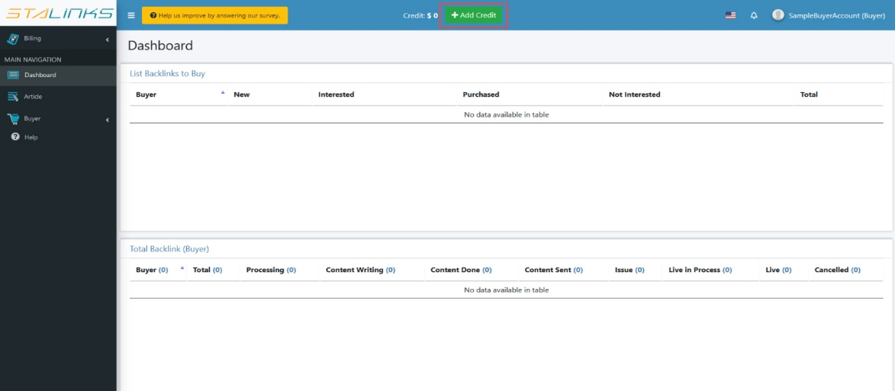The ‘Add Wallet Transaction’ form will appear containing the details needed to add credit.

* 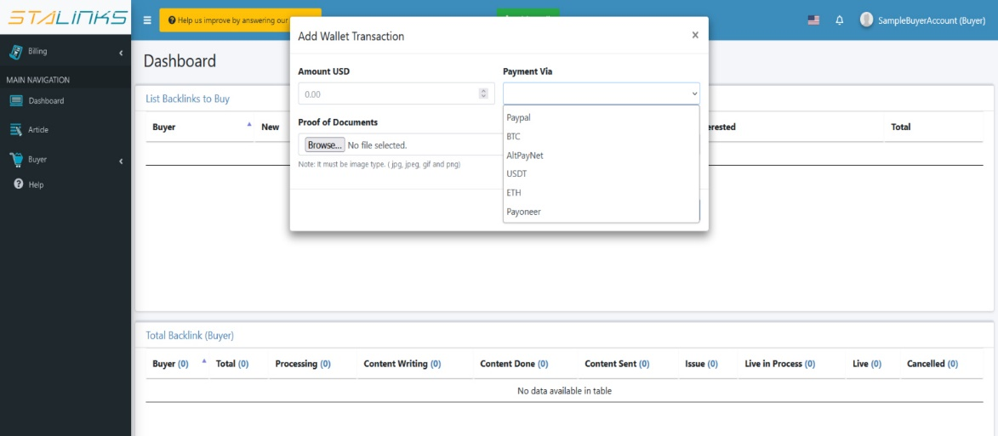Input the required details for the transaction:
  + Amount – the amount of credit in USD
  + Payment Via – The payment solution that you will use to add the credit
  + If you have selected PayPal as the payment solution, the system will automatically connect you to their platform.
  + Otherwise, please include the proof of billing for your payment.

1. Click the ‘Next’ button and wait for the confirmation of the system. After the transaction, our billing team will check and confirm your credit. You can check the status of your transaction by navigating to the ‘Wallet Transaction’ page under the Billing section of the sidebar.

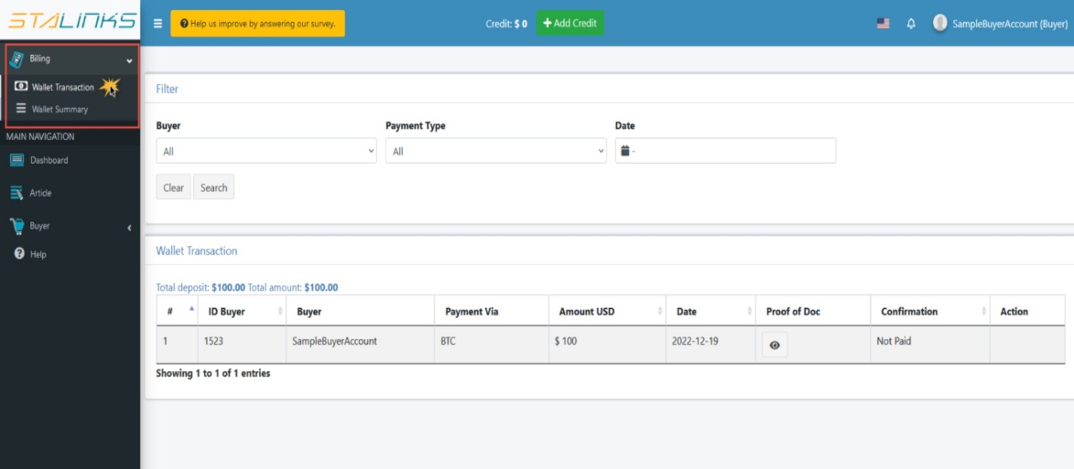

1. You can check the overall summary of your wallet by navigating to the ‘Wallet Summary’ page under the billing section of the sidebar. You can also check your remaining credits in the middle section of the navigation bar beside the ‘Add Credit’ button.

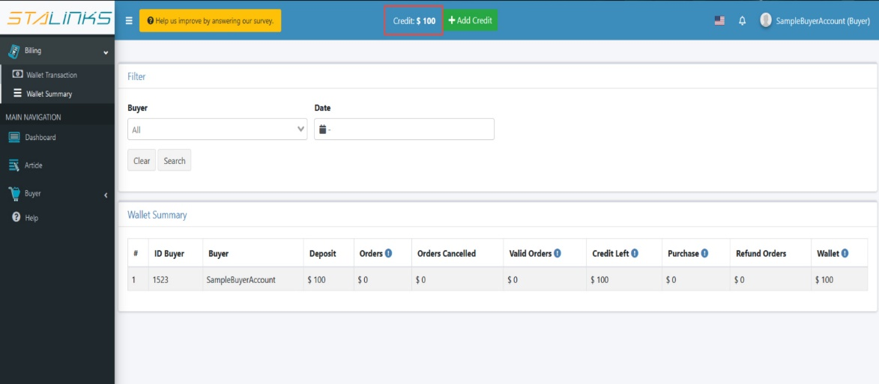

**Buyer Guide Step 3: Purchasing Backlinks  
  
How to purchase backlinks that fits your website**

After adding credits to your account, you can now purchase backlinks.

1. Navigate to the ‘List Backlinks to Buy’ page under the Buyer section of the sidebar.

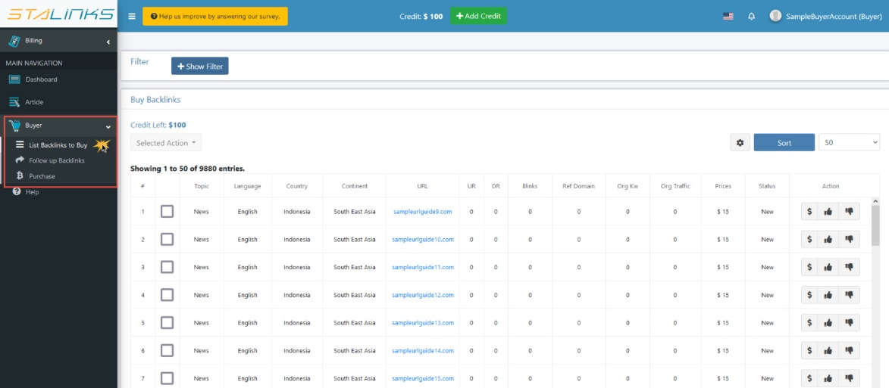

1. Use the filters and sort features to find the best backlink for your website. Consider the SEO score and price before purchasing. We also recommend to visit and check the website first.

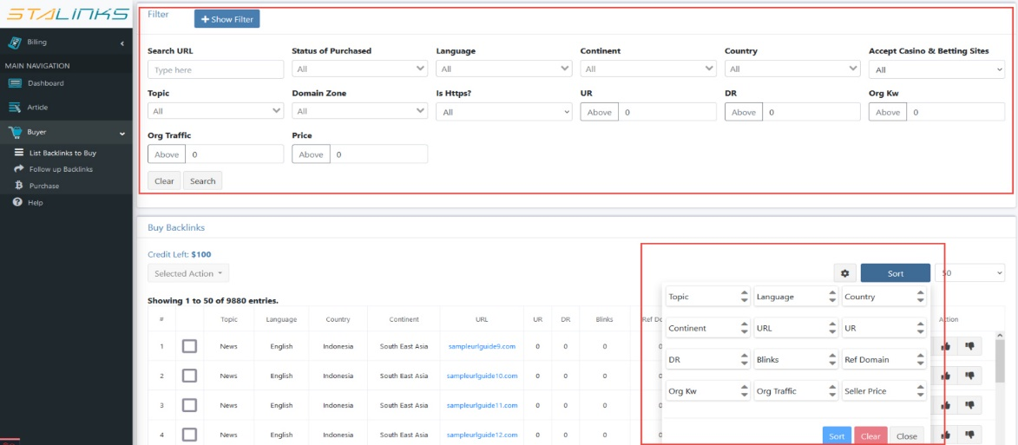

1. The ‘Buy Backlinks’ table contains the information that you need to select the correct backlinks for your website including the URL, topic, language and numerical data like UR and DR. The table also has three action buttons under the action column.

* 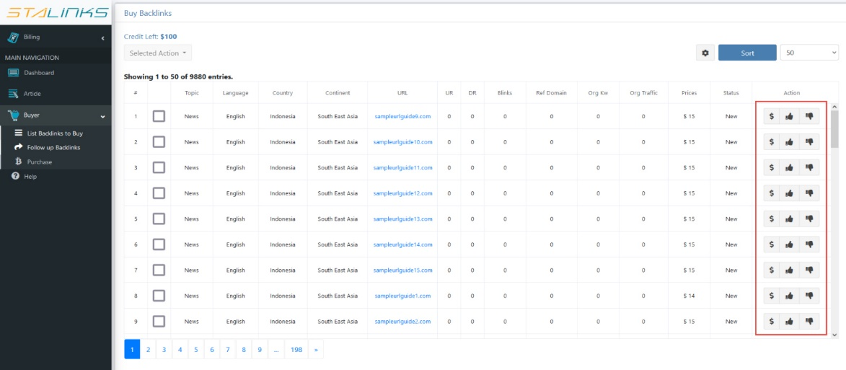Buy Button – click this button to make a direct order.
* Interested – click this button if you are considering to buy the URL in the future.
* Not Interested – click this button to remove the URL from the list.

1. The ‘Buy Backlink’ form will appear if you clicked the buy button. This form includes the details that you need to input in order to purchase a backlink.

* 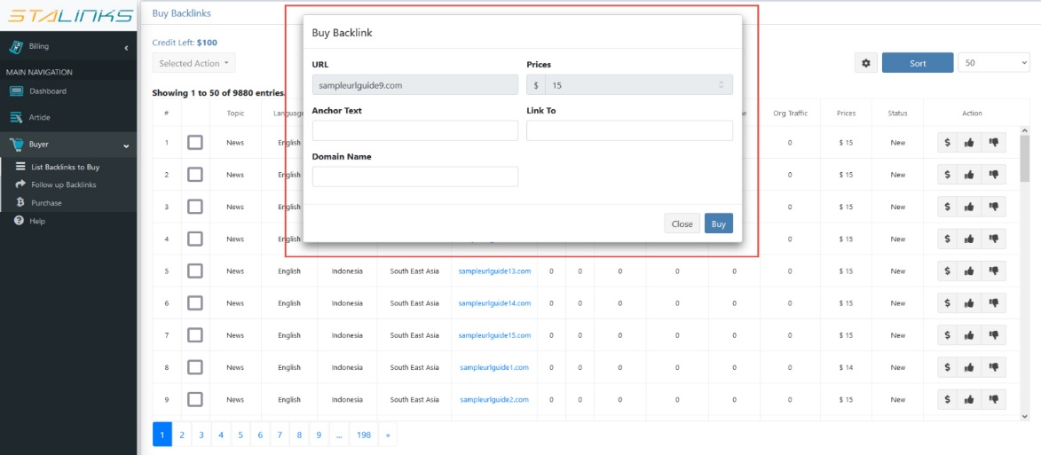Input the required details for the purchase:
  + Anchor Text – the text that will include the link.
  + Link to – e.g. yourwebsite.com/example
  + Domain Name – e.g. yourwebsite.com
* After filling up the form, click the ‘Buy’ button.

**Buyer Guide Step 4: Follow up Orders  
  
How to follow up and check your orders**

1. You can check the status of your orders by navigating to the ‘Follow up Backlinks’ page under the Buyer section of the sidebar. Use the filter function to find the specific order that you want to check. You can also download the list of your orders by clicking the ‘Download CSV’ button.

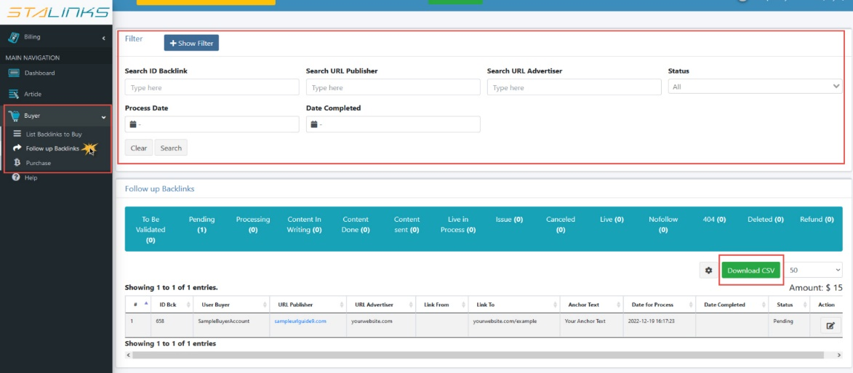

1. The ‘Follow up Backlinks’ table contains the details of your order, along with the status. Click the ‘Edit’ button under the action column to check the details of a specific order.

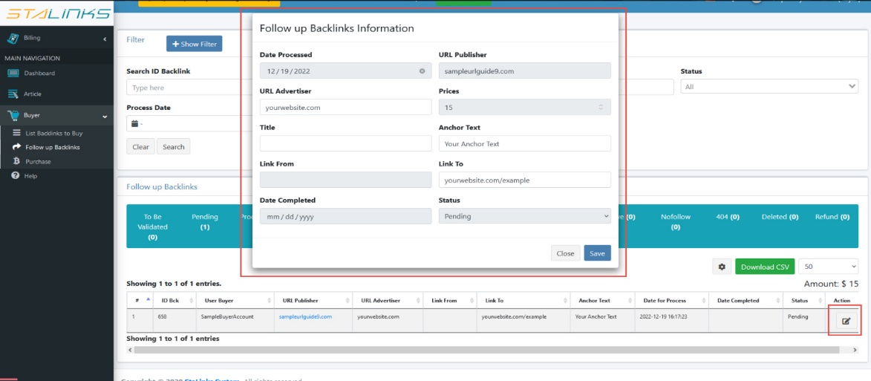

1. You can also check the articles related to your purchase by navigating to the ‘Article’ page in the sidebar.
2. 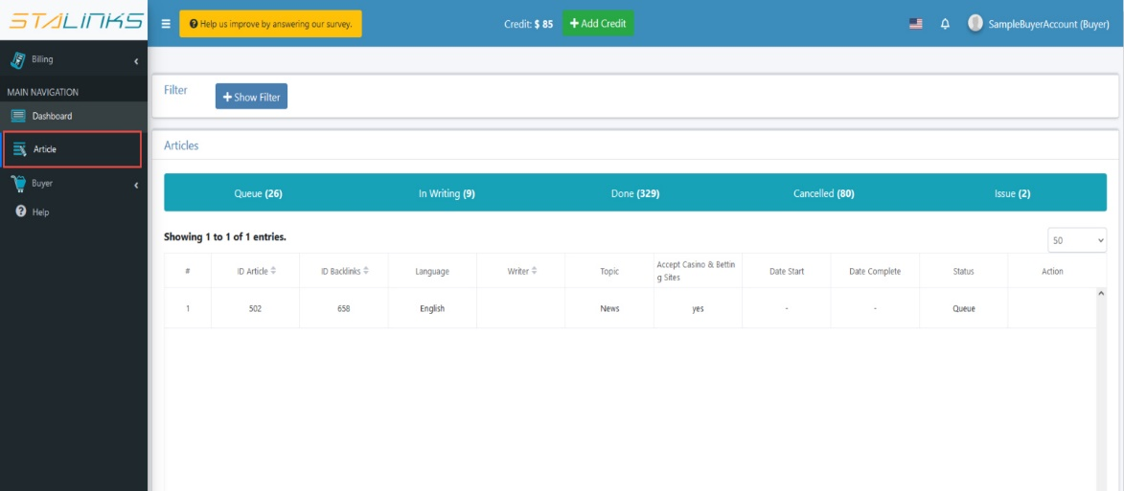Check your orders that are already in ‘Live’ status by navigating to the ‘Purchase’ page under the Buyer section of the sidebar.

