**Seller Guide Step 1: Learn about the Dashboard  
  
Learn about the dashboard**

Upon logging in, you will be automatically redirected to the dashboard. This is the page that will help you keep track of your progress. Each column can be clicked to sort the data, descending and ascending. There are three sections in the dashboard:

1. Seller List

* This table represents the numerical data about your URLs
* It has 6 columns:
  + In-charge – the person in charge of your account
  + Seller – your username
  + No. Sites – the number of URLs you have uploaded or added
  + No. Valid – the number of uploaded/added URLs that are valid
  + No. Unchecked – the number of URLs that are on queue to be checked by our QC team
  + No. Invalid – the number of uploaded/added URLs that are invalid

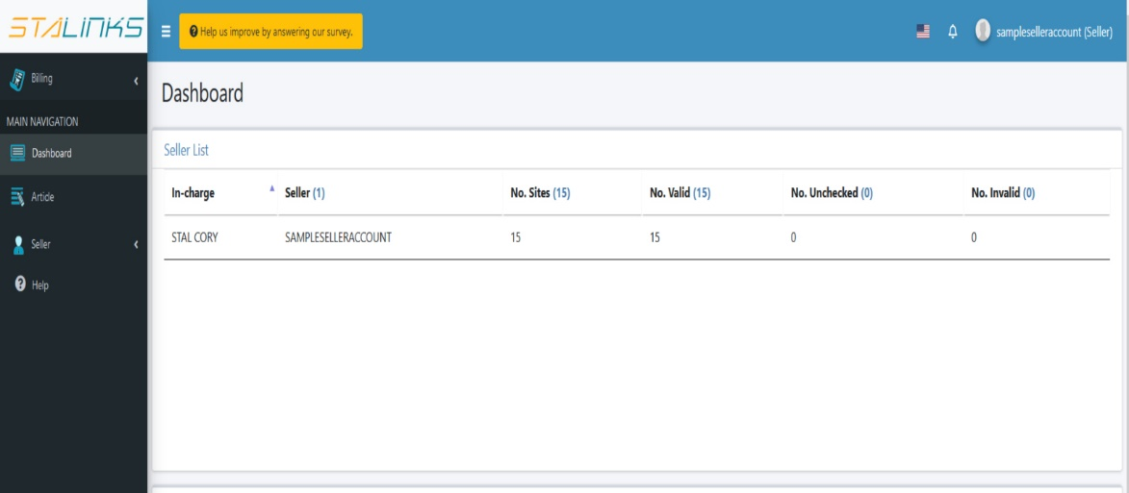

1. Total Backlink (Seller)

* This table represents the numerical data about the status of your orders
* It has 10 columns:
  + Seller – your username
  + Total – the total number of your orders
  + Processing – orders that you already confirmed and the writers can accept the writing of the article
  + Content in Writing – the writers are writing the content
  + Content Done – The content is done and ready to be posted
  + Content Sent – The team already sent the content to you
  + Issue – The order has a problem
  + Live in Process – The content is to be uploaded
  + Live – the content is already live
  + Cancelled – the order is cancelled

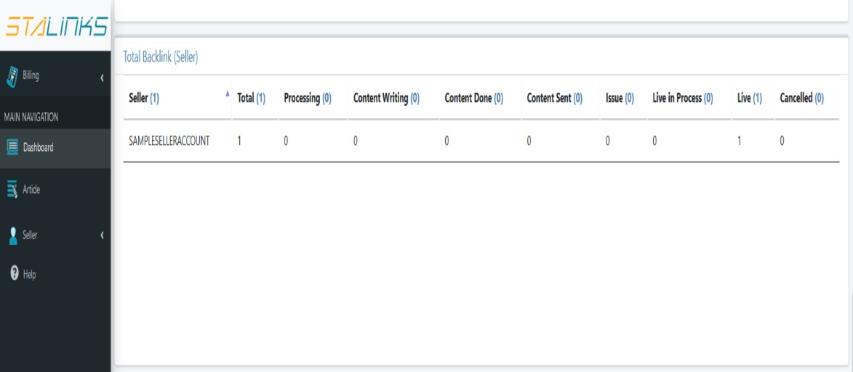

1. Incomes

* This table represents the numerical data about your orders that are already live. We always do our best to make sure that our sellers will receive their payment on time.
* It has 4 columns:
  + Seller – your username
  + No. Backlinks – the number of orders that are live
  + Unpaid – the number of orders that have a pending payment
  + Paid – the number of orders that are already paid

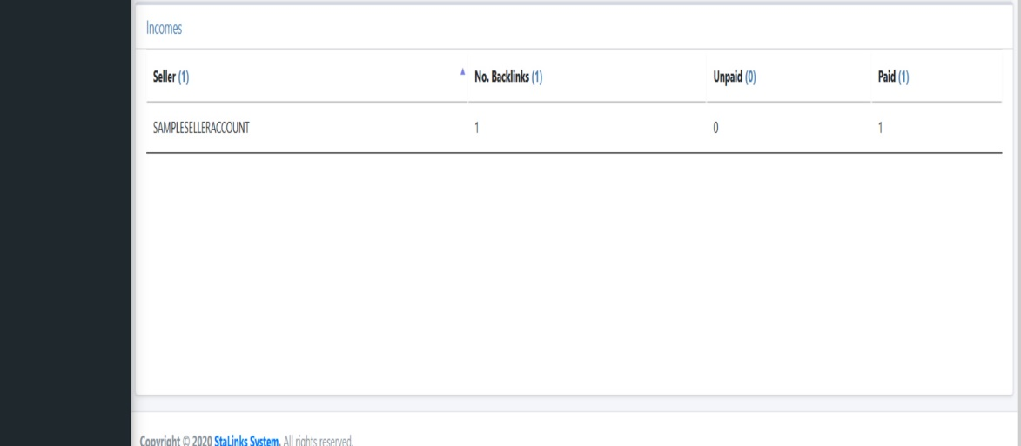

**Seller Guide Step 2: Adding URLs  
  
Learn how to upload and add URLs with price and other details**

To start earning, you need to add or upload URLs. Follow the steps below:

1. Navigate to the ‘List Publisher’ page under the Seller section of the sidebar. This page contains the list of your uploaded/added URLs. The ‘Publisher URL List’ table represent the URLs with all the necessary details to help our buyers including the topic, language, price and some numerical data like UR and DR. Please use the filter and sort functions if you want to check some specific URLs.
2. 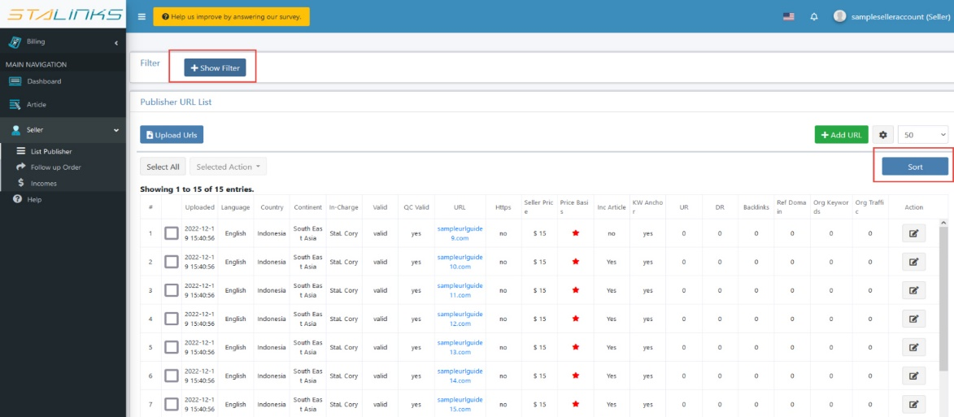You have two options in adding URLs to StaLinks, manually and via CSV upload. To add a URL manually, click the ‘Add URL’ button located at the top right side of the table. A form will appear containing the details that are required in order to add the URL. Fill up all the required details and then click the ‘Add’ button.

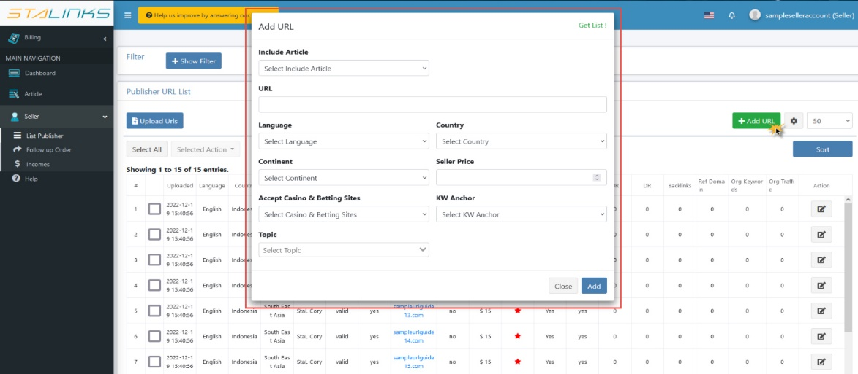

1. To add URLs via CSV upload, click the ‘Upload URLs’ button located at the top left side of the table. A pop up will appear containing all the details needed to upload the list of URLs that you want to add.

* 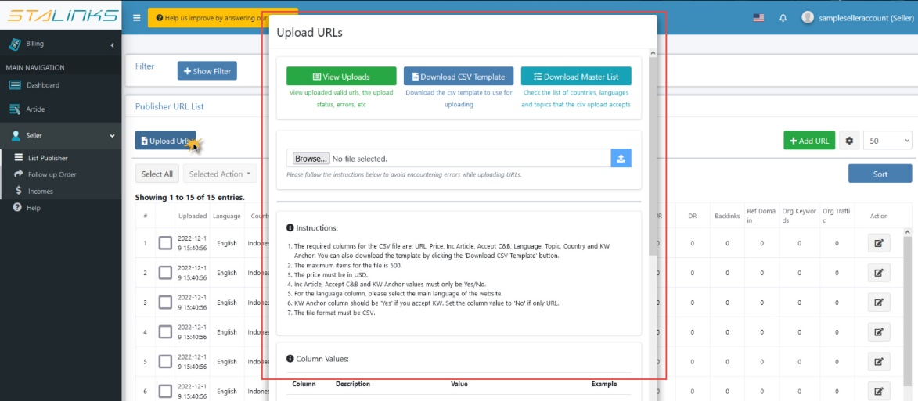The pop up has 4 sections:
* The first section contains three buttons:
  + View Uploads – click this button to view all of your uploads and their result
  + Download CSV Template – click this button to download the CSV template where you can put all of the URLs that you want to upload
  + 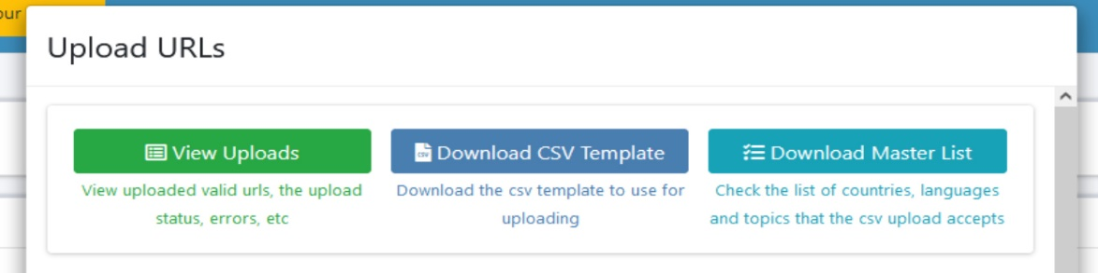Download Master List – click this button to download our master list, this is where you can check what you can input in the CSV template
* The second section contains the file input for the upload

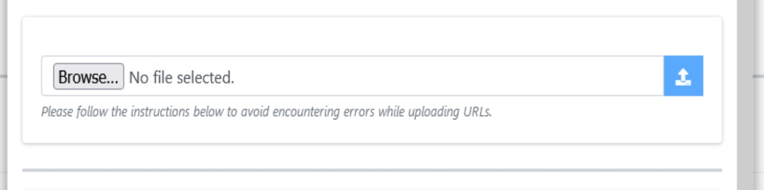

* The third section contains all the instructions and information that you need to follow to avoid errors and successfully upload URLs
* 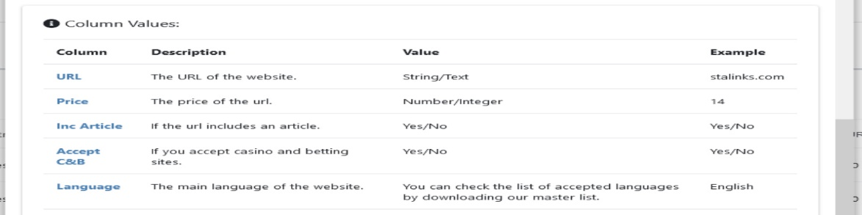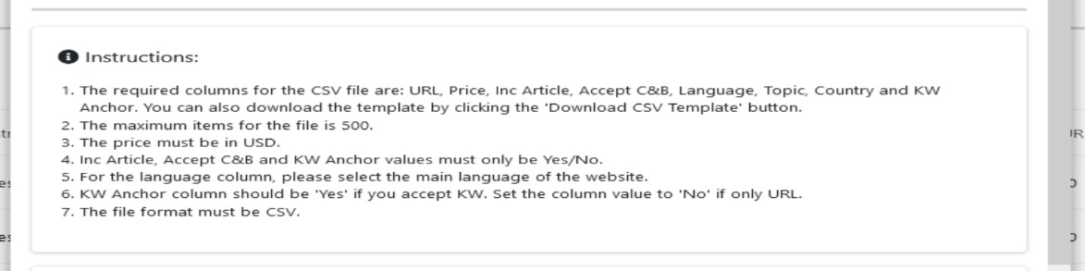The last section contains the information and example for the column values of the CSV template
* You can edit and delete your URLs info anytime.
* Our team will be the one to generate the Ahref scores for your list
* You can also check the price basis of the URL
  + Red – price is high
  + Orange – price is average
  + Green – price is good

**Seller Guide Step 3: Follow up Orders  
  
Learn how to follow up when you have received orders**

When you receive an order from a buyer, the system will automatically send you a notification about it via email and system notification.

1. When a buyer had purchased your URL, the system will notify you via email and system notification. Navigate to the ‘Follow up Order’ page under the Seller section in the sidebar. This page will show all the orders that you have receive along with the details.

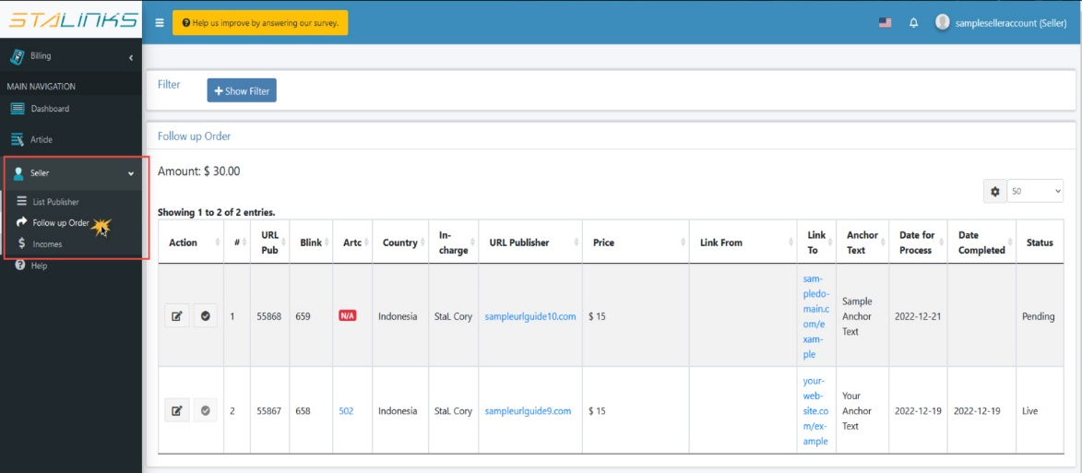

1. The first status of the order will be ‘Pending’. You need to confirm the details of the URL in order to ensure a smooth and correct transaction. To do this, click the ‘Confirm Pending Order’ button under the Action column in the table.

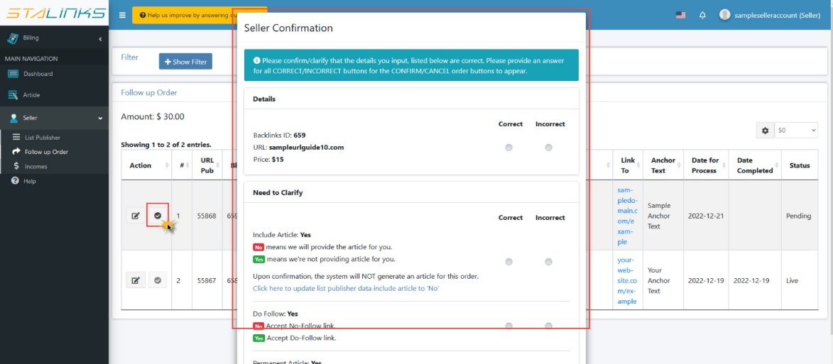

* The ‘Seller Confirmation’ form will appear. Read the instructions carefully. After all the buttons are filled out, the Cancel/Confirm button will appear.
* If the order details are confirmed and all correct, the ‘Confirm’ button will appear. Click this button to proceed with the order – the order status will be ‘Processing’
* If at least one of the order details is incorrect, the cancel button will appear. The order will be cancelled and will not proceed anymore.

1. To further check the details of each order, you can click the ‘Edit’ button under the Action column.
2. 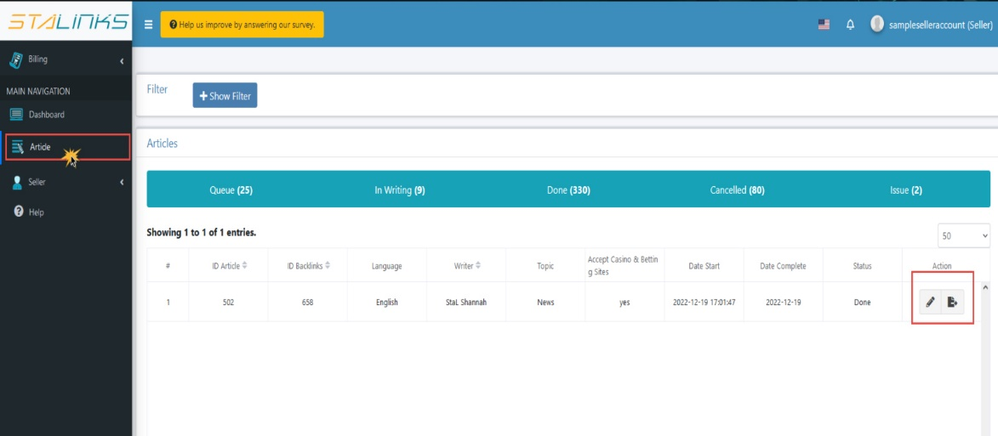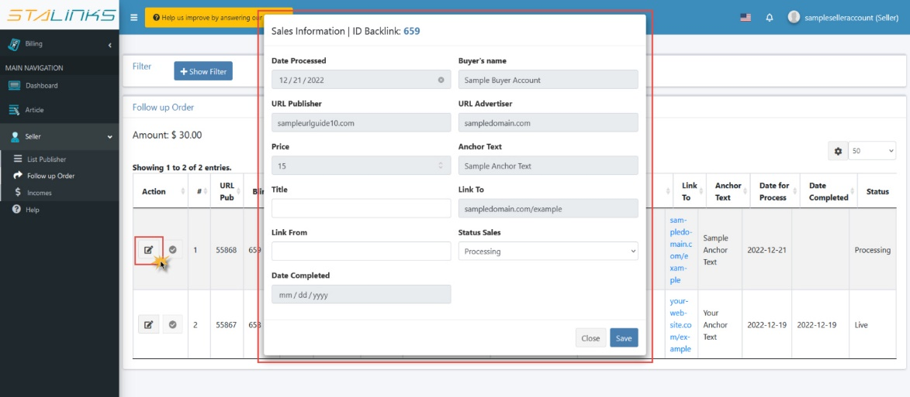You can also check the articles related to your order by navigating to the ‘Article’ page. The table has two buttons under the Action column. Click the ‘Edit’ button to review the article details and content. You can export the article to a word document when the status is ‘Done’.
3. Once the order is on ‘Live’ status, you will get paid automatically within 48 hours. You will be notified when you already received your payment.

**Seller Guide Step 4: Get Paid  
  
Learn how to view your earnings in StaLinks**

Once you have orders that is already in ‘Live’ status. It’s time to check your earnings.

1. Navigate to the ‘Purchase’ page under the Seller section of the sidebar. The table will display your orders which are now live along with other details like the price and payment status. You can also check the proof of payment by clicking the ‘View’ button under the Action column.
2. 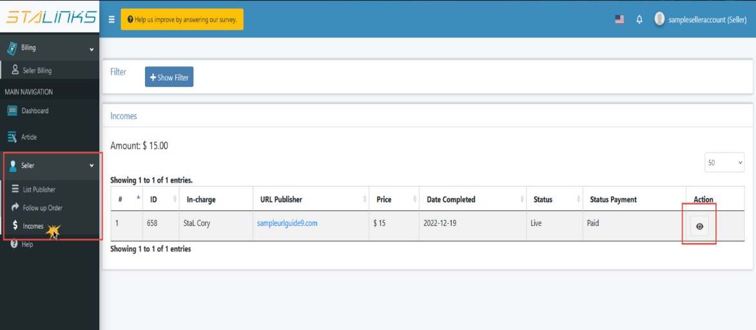You can also navigate to the ‘Seller Billing’ page under the billing section in the sidebar.

