**Writer Guide Step 1: Navigating the Dashboard**

**Learn about the dashboard**

Upon logging in, you will be automatically redirected to the dashboard. This is the page that will help you keep track of your progress. Each column can be clicked to sort the data, descending and ascending.

1. Article Summary

* This table represents the numerical data about the orders related to the articles that you accepted and their statuses
* It has 8 columns:
  + Processing – orders that the seller already confirmed and you can accept the writing of the article
  + Content in Writing – articles that you are currently writing
  + Content Done – The content is done
  + Content Sent – The team already sent the content to the seller
  + Issue – The order has a problem
  + Live in Process – The content is to be uploaded
  + Live – the content is already live
  + Cancelled – the order is cancelled

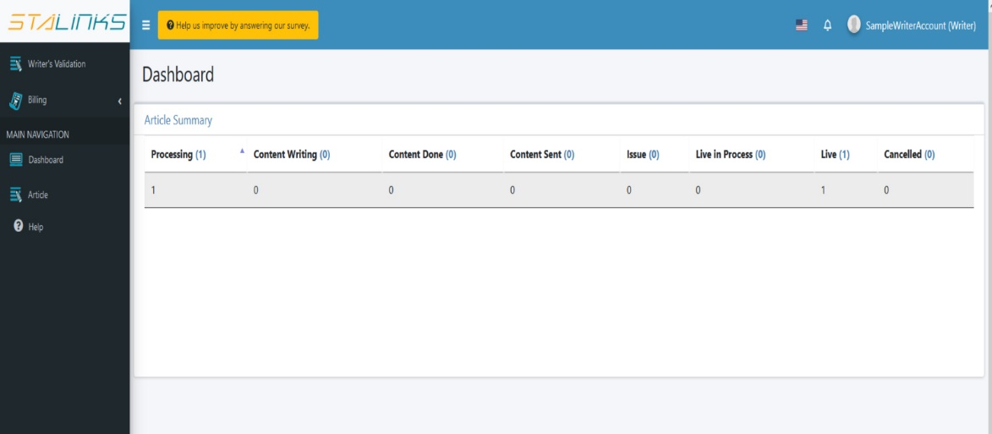

**Writer Guide Step 2: Writer Validation  
  
Learn how to be validated in order to writer an article**

Before you can start writing articles, you need to prove your writing skills by answering our writer examination.

1. 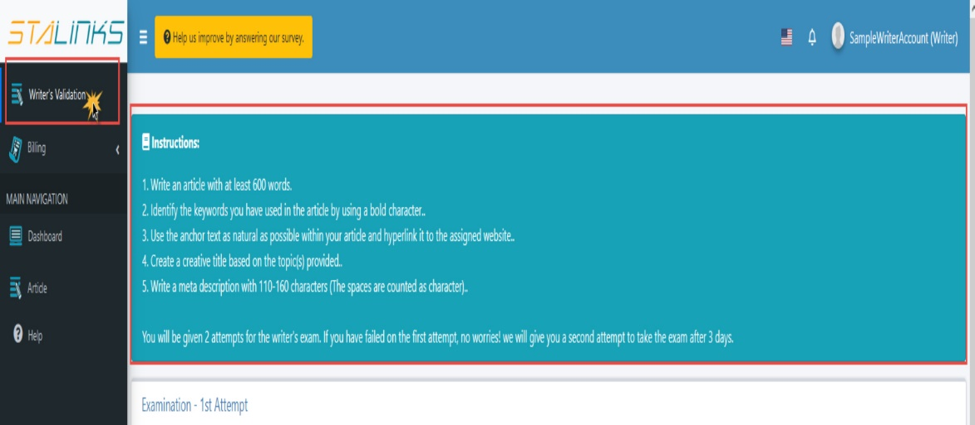You will be notified via email and system notification once your exam is ready. To check this, navigate to the ‘Writer’s Validation’ page. Follow the instructions located at the top part of the page carefully. You will be given two attempts to pass the exam.
2. Input the required details like the title, meta description and most importantly, the content. Once you are done, click the submit button down below.

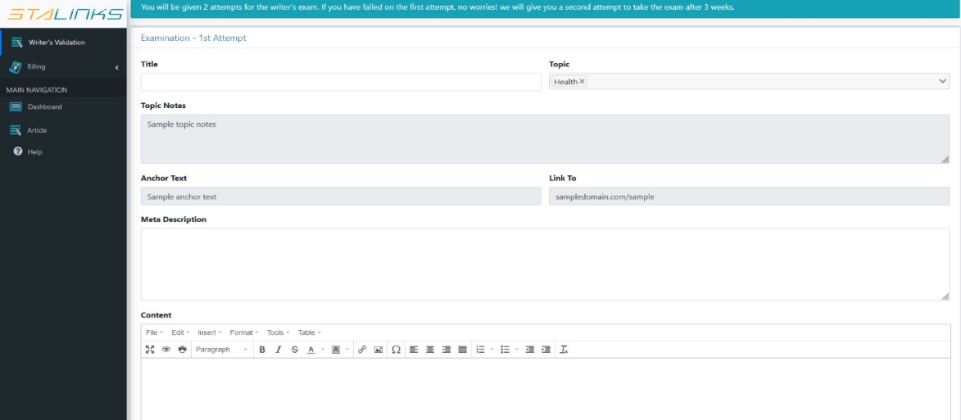

1. 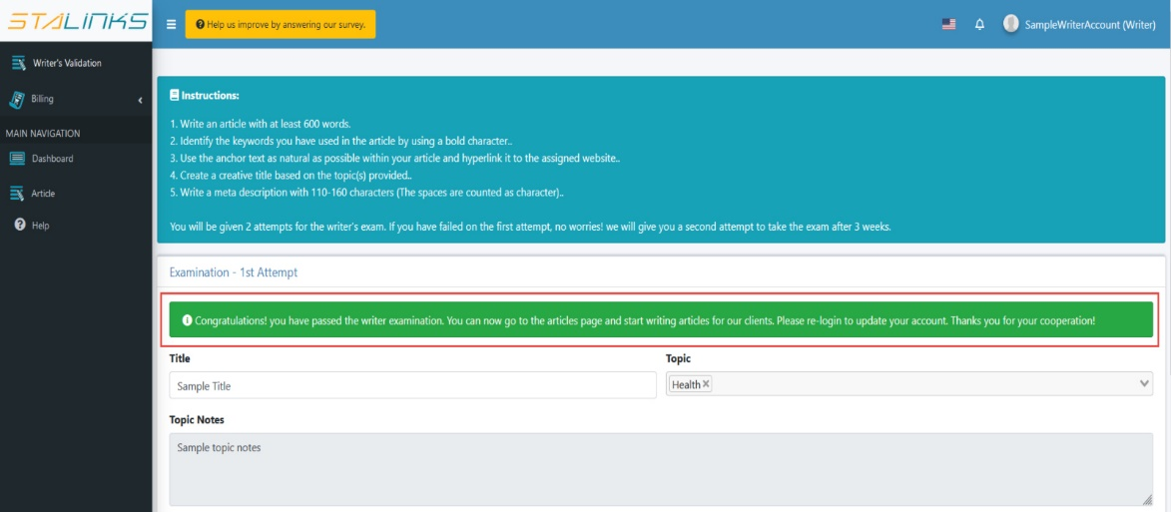You will be notified about the results of your exam via email and system notification. If you have failed your first attempt, you will be given a second attempt exam after 3 days. If you have passed the exam, you can now start writing article. Congratulations!

**Writer Guide Step 3: Writing Content  
  
Learn how to write articles**

After being validated, you can now start to write articles for the orders

1. To start writing an article, navigate to the ‘Article’ page. This page will show all the articles that are on queue and the articles that you have been working on. The list of articles will depend on the language that you have set upon registration.

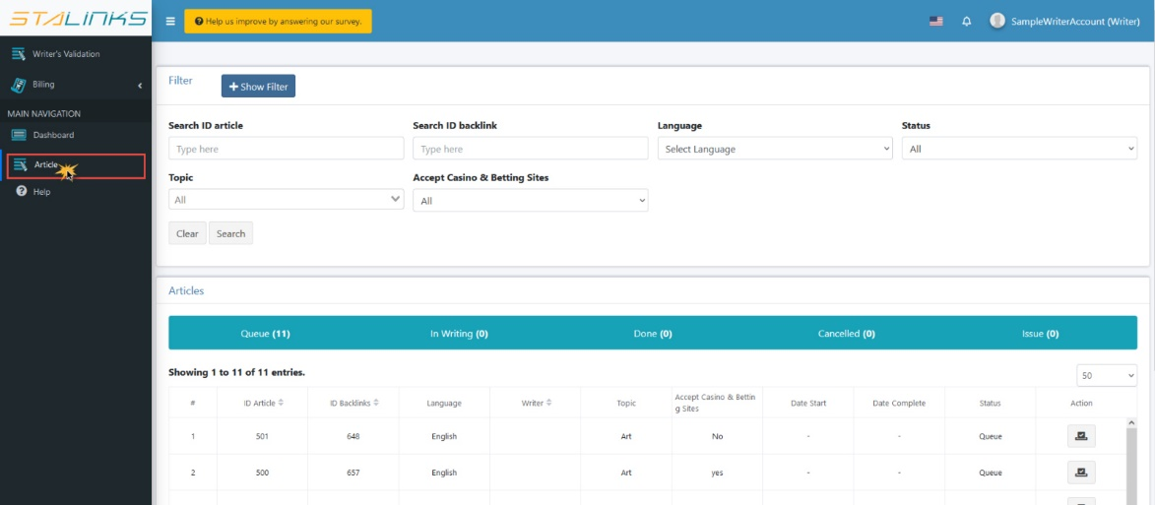

1. If you choose to work on an article that is on queue, click the ‘Accept Article’ button under the Action column. A confirmation will appear on the screen. If you choose to accept the article, click the ‘Yes’ button.
2. 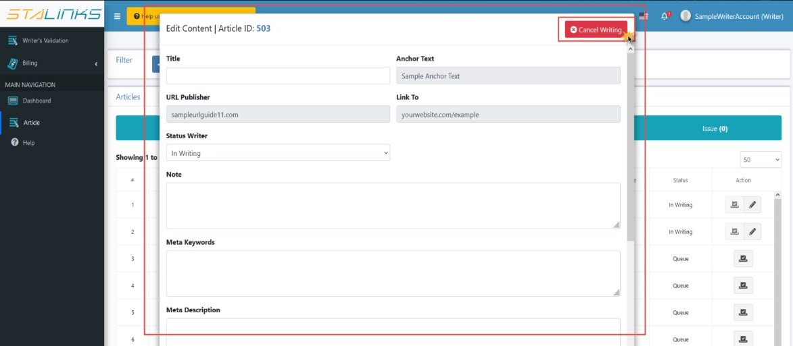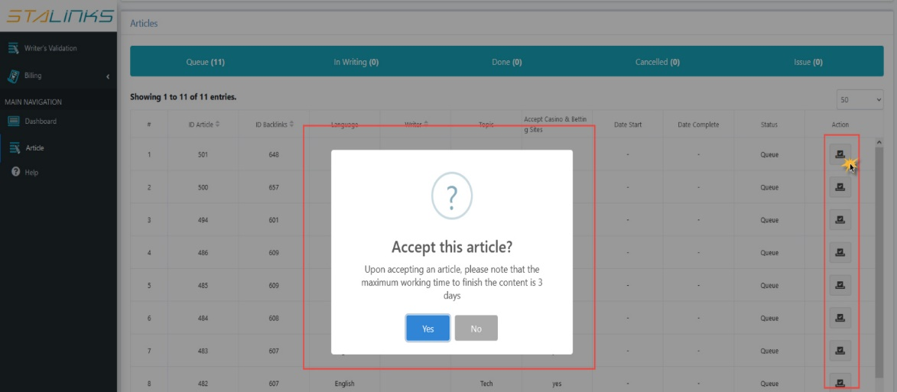Upon accepting the article, the ‘Edit’ button will now appear. Click this to see the other details for the article and to start writing content. If you wish to cancel writing the article, click the ‘Cancel Writing’ button located at the top right section of the form.
3. When writing the content, please take note of the following details: URL Publisher, Anchor Text and the website indicated in ‘Link to’. These details will shape the content for the article. Vising the URL publisher and the landing page (Link to) is recommended to get a better idea of what kind of content is published there – with this, you can write an article that fits in with the rest of the content of the website.
4. 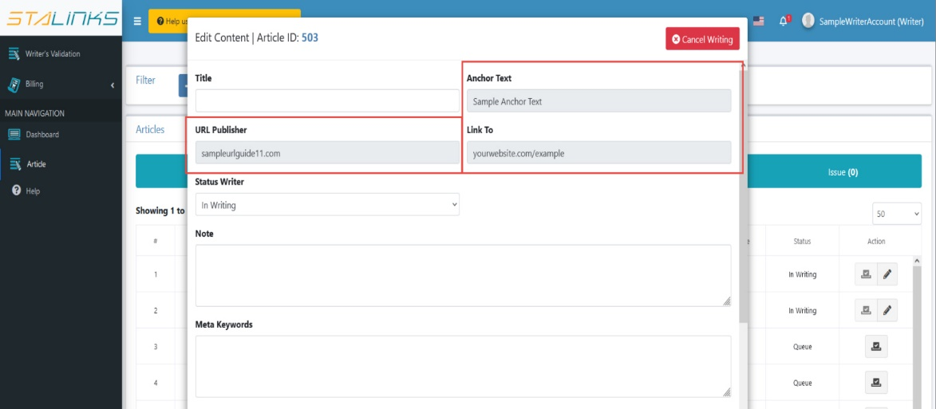You can write the content of the article directly at the content box provided in the form. You can also copy paste the text from a word document. The system’s editing tool will help you write a proper article with the tools and functions provided. Please also take note of the following important instructions:

* Use the given anchor text as your keyword. Add the correct hyperlink to your anchor text.
* Avoid plagiarism at all times. We do not approve stolen content.
* Add 1 to 2 images in your article. Make sure that the images are non-copyrighted. Please include the links of images used at the bottom of your article.

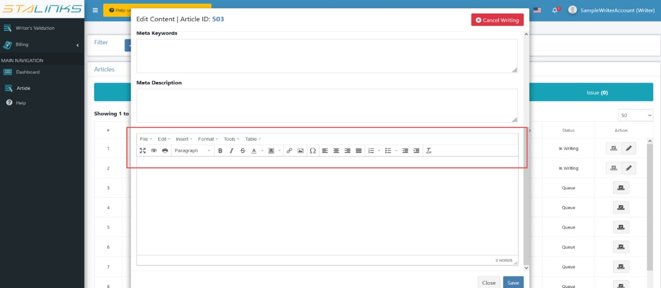

1. Make sure you have the proper header hierarchy when you write the article content. The title should be in H1, while subheadings should be in H2. To do this click the ‘Format’, then go to ‘Block’ then choose the right heading format.

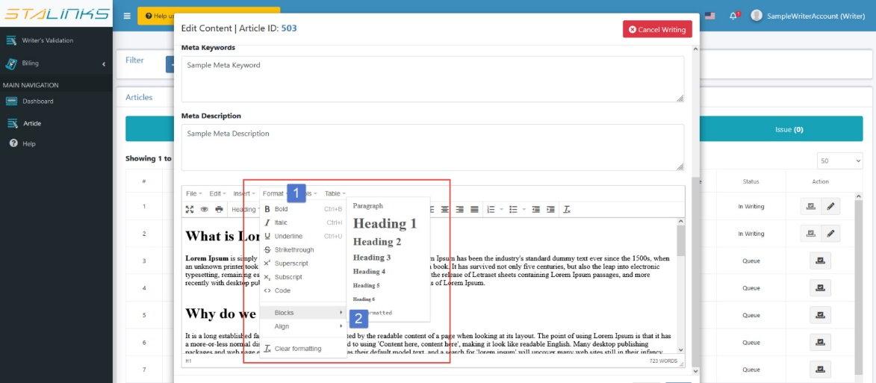

1. After your content has been completed and properly formatted, you can now add the internal link to your anchor text. To do this, highlight the anchor text and use either the ‘Insert Link’ feature in format tools, or right-click to see ‘insert’ options. On the pop up box that will appear, paste the URL in the ‘Link to’ This will embed the link into your anchor text.

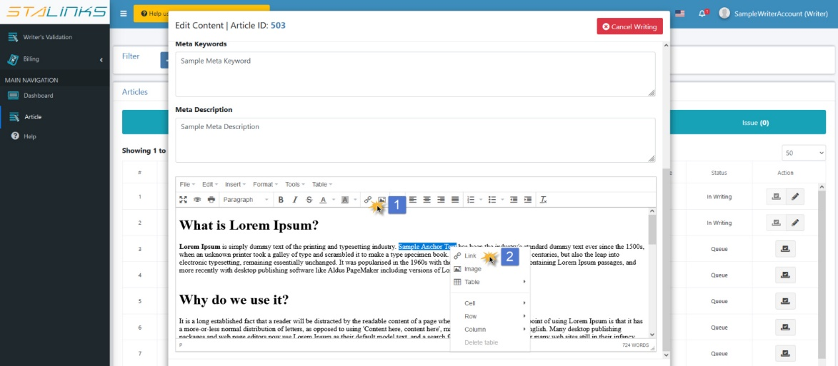

1. 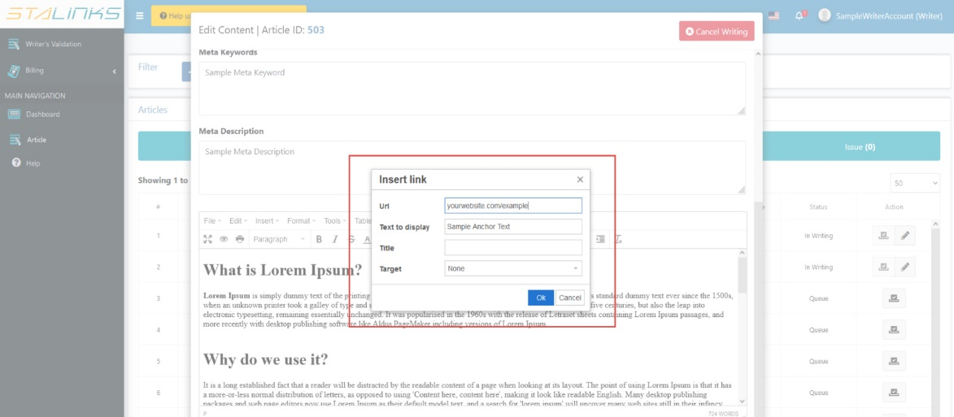 When you have finished writing the content, formatted it with the proper headings, and embedded the anchor text with the link, you can set the article’s status to ‘Done’. Do not forget to click the ‘Save’ button to save your changes and updates.

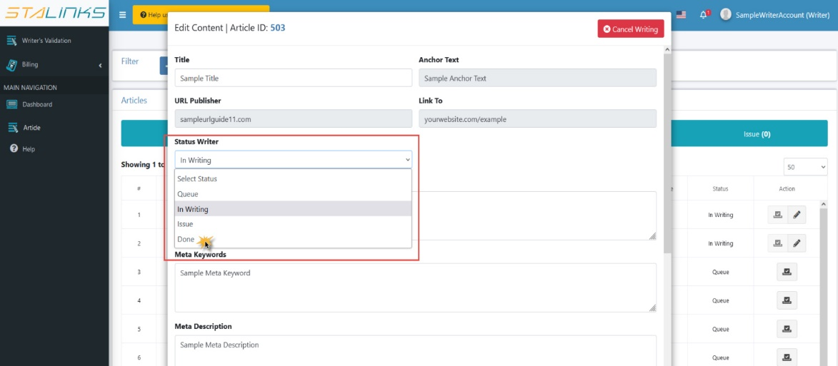

**Writer Guide Step 4: Follow up Income**

**Learn how to check your income**

When the order details relating to the articles that you have worked on goes ‘Live’, you can now check your earnings.

1. As a writer, you have two options for your pricing setup.

* PPA (Pay per Article) – you will be paid for a specific price per article
* PPW (Pay per Words) – you will be paid according to the number of words in the article with a specific rate.

You can check this by navigating to your profile page by clicking your username at the top right corner of the navigation bar.

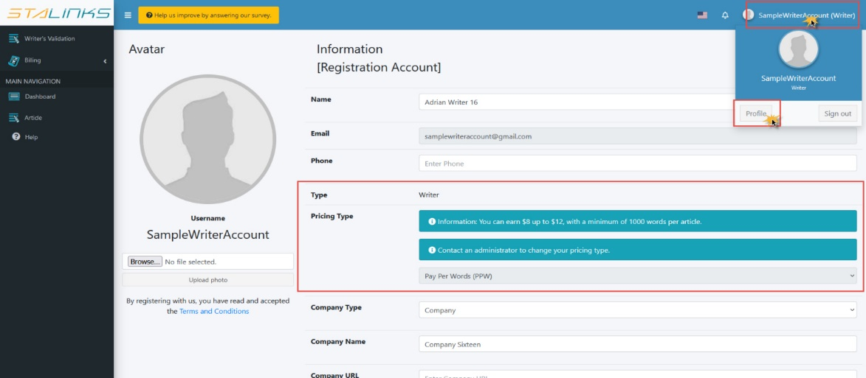

1. To check all your earnings, navigate to the ‘Writer Billing’ page under the Billing section of the sidebar. The table will display the details regarding the order like the dates, order ID, article ID, price and payment status.

