TOMCAT /Jenkins

1. Tomcat installation
   * Download tomcat file
   * Go to /apache-tomcat-9.0.14/bin
   * Lunch ./startup.sh
2. Jenkins installation
   * Copy Jenkins.war in tomcat/Webapps
   * Lunch localhost:8080/jenkins and follow Jenkins installation
3. Install GitHub
   * Go to Manage plugins



* + Add GitHub Integration plugins / gitHub Authentication plugins

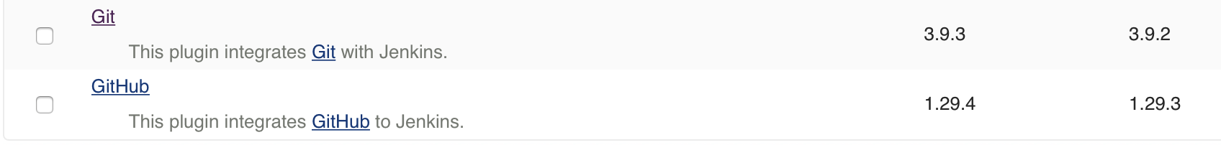

* + In Global tools configuration – Git – add path to git executable

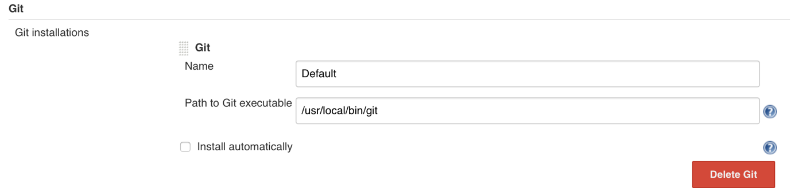

1. Create New project
   * Create a new Item Freestyle Project

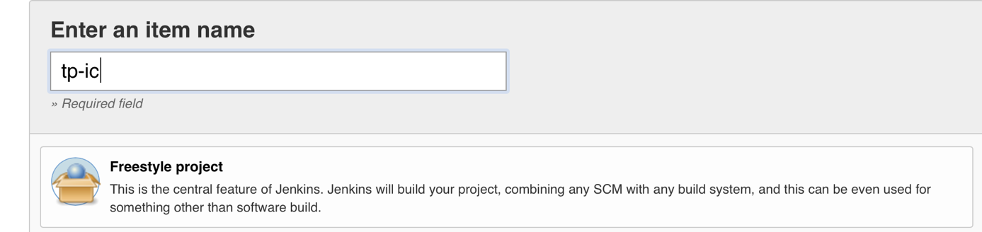

1. Configure GitHub
   * Add Git repo URL and credential - save

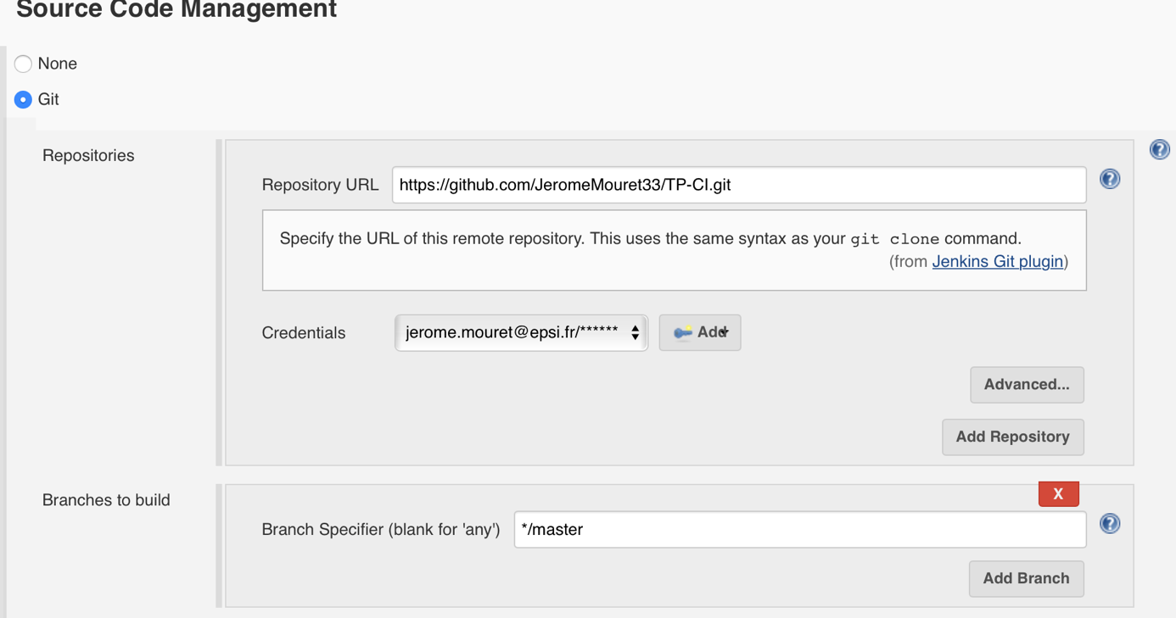

1. Build project
   * Click on Build Now

