Task 2: Blog Website Wireframe

<https://app.moqups.com/WQFpUVD253aPB4hbvUfwqRVmPqlpYcT9/edit/page/a83666e74>

<https://app.moqups.com/y9gF9SnoJdnxgs9dwxBcGtGPukftV7Ca/edit/page/ac1a5c63c>

## Home Page

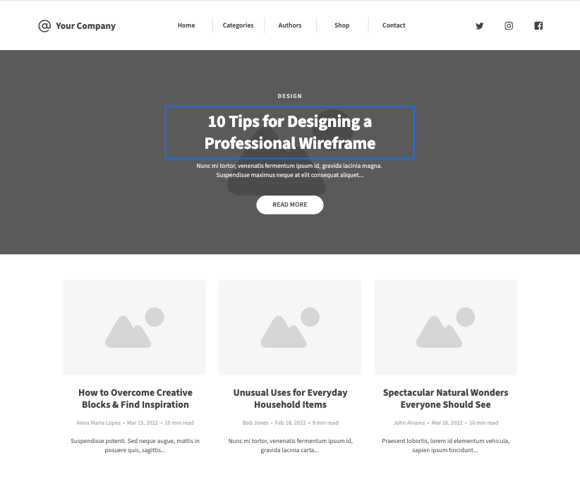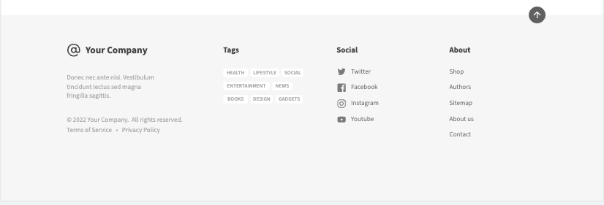

## Contact Page

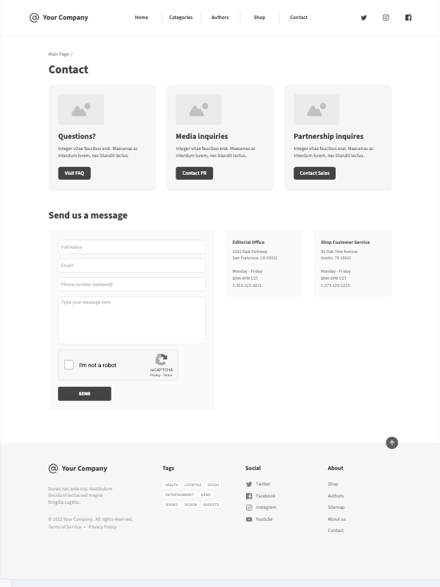

## Sign up/Log in

